USER GUIDE—
Peer Educator Tool for Informing Female Sex Workers about Contraceptive Options

Introduction
The Peer Educator Tool for Informing Female Sex Workers about Contraceptive Options (PE-FSW FP tool) is designed for use by peer educators (PEs) for the purpose of sharing information about contraception with female sex workers (FSWs). The PE-FSW FP tool and session plan (see Guide to Training on the next page) are prototypes that should be modified to suit the program needs, available contraceptive method mix, and culture of the location where it will be used (e.g., appropriate illustrations and language). Notes about possible adaptations (e.g., eliminate inclusion of practices such as extended use of combined oral contraceptive pills, if not permitted by the country guidelines) are included in the original PowerPoint file. The PE-FSW FP tool is an adaptation of a counseling tool originally developed for community health workers (CHWs) who offer family planning (FP) counseling (see next page for additional background information). A companion resource, Contraceptive Services for Female Sex Workers — Training Module for Clinicians, is also available to orient clinical staff to the unique needs of FSWs.

How to Use the PE-FSW FP Tool to Inform FSWs about Contraceptive Options*
The tool follows this general information-sharing process:
- inform the FSW peer about the goals/intentions for the discussion
- encourage the FSW peer to consider specific features/issues as she thinks about contraception
- present information so the FSW can consider which contraceptive methods and approaches for preventing pregnancy, HIV, and other STIs best suit her needs
- provide contact information for facilities as indicated by the FSW peer’s interests/concerns
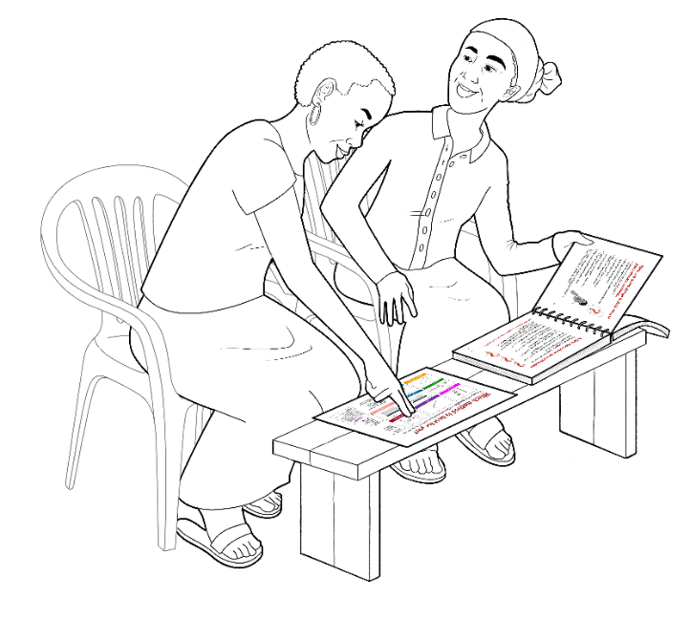
* While not specifically designed for this purpose, PEs could also use the tool during small group discussion sessions to introduce contraceptive methods to FSWs.
When used properly, the design of the tool supports
PE‒FSW interaction by facilitating eye contact, allowing equal access to easy-to-understand information, and enabling confidential discussions.

Guide to Printing the PE-FSW FP Tool
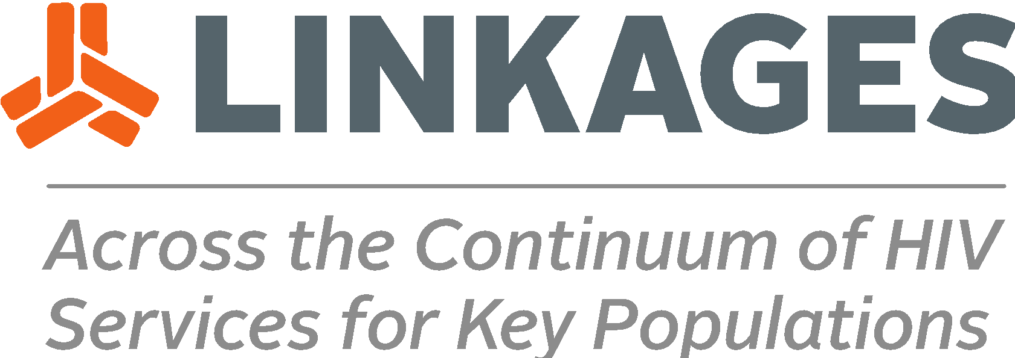
The PE-FSW FP tool should be printed in color (the information on the methods is color-coded) and copied front/back in landscape/ horizontal format (when viewing, even-numbered pages should be on the left, odd-numbered pages should be on the right). The pages should be bound on the short edge using a spiral coil so that the tool/manual will lay flat when opened. The visual aid, which includes the method choice chart and the prevention approaches (last two pages in the PowerPoint file), ideally would be printed double-sided on heavy paper and laminated—they should not be bound with the rest of the manual. Some PEs may find it helpful to create and affix tabs to the pages that they use most often.

Guide to Using the PE-FSW FP Tool
- Sit side-by-side so that the PE and the FSW peer can see each other’s face and talk privately.
- Place the visual aid directly in front of the FSW peer with the PE-FSW FP tool where both the FSW and PE can see it (see illustration).
- Point to information on the visual aid and the tool pages to help explain key information. Remind the FSW peer that the methods at the top of the method choice chart are the most effective.
- Use the color-coded bars (or added tabs) to find information and move from one section to another.
- Use pages 6–9 to tell the FSW peer what you will do during the session, learn more about the FSW peer’s needs, and explain how the FSW peer can benefit from contraception.
- Encourage the FSW peer to use the questions and information on pages 10–13 to compare the features of contraceptive methods and think about what approaches to preventing pregnancy, HIV, and other STIs might be most suited to her needs.
- Use the information on pages 14–37 to provide basic information on contraceptive methods. Use the first page of each method to provide an overview of the method. Use the second page of each method to describe how use of the method may affect FSWs.
- Use page 38 to write contact information for facilities where FSWs can seek services.

Guide to Training PEs to Use the PE-FSW FP Tool
The tool should be introduced during a structured training that includes a thorough overview of contraceptive methods and PrEP so that PEs can demonstrate knowledge and confidence when explaining contraceptive methods and approaches for preventing pregnancy, HIV, and other STIs during their interactions with FSW peers. The training intervention should also feature role plays and case studies that allow PEs to practice with the PE-FSW FP tool in multiple real-life simulations and receive constructive feedback to improve their performance. A session plan and supplemental materials to orient and train PEs to use the tool are available. On-the-job mentoring further ensures that PEs can use the tool as intended and increases the likelihood that the FSW peers can make better decisions when choosing which contraceptive method best suits their needs during a subsequent consultation with a provider.

Why use the Community Health Worker Counseling Tool for Family Planning as the basis for the PE-FSW FP tool?
The goal of the CHW prototype tool is to enhance the quality of informed choice FP counseling and service provision at the community level. Although PEs do not offer informed choice counseling, they are more frequently being tasked with sharing information on contraception along with their more traditional role of STI/HIV prevention messaging. Given that the information-sharing tasks performed by PEs are similar to those performed by CHWs, it made sense to adapt the CHW tool for use by PEs. The portability and ease-of-use also made adaptation of the CHW tool a desirable option for PEs. In 2019, the CHW prototype tool was adapted and tailored for use by PEs working with FSWs in Mali.
The concepts included in the CHW tool were drawn from several existing counseling tools, including the Guide to Family Planning for Community Health Workers and their Clients developed by the World Health Organization, 2011, and The Balanced Counseling Strategy: A Toolkit for Family Planning Service Providers, published by the Population Council, 2008.

