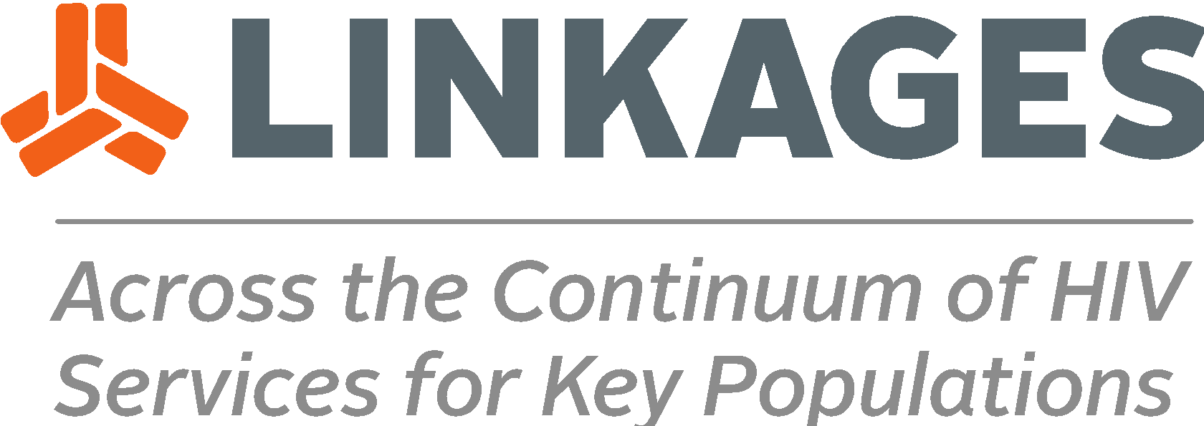
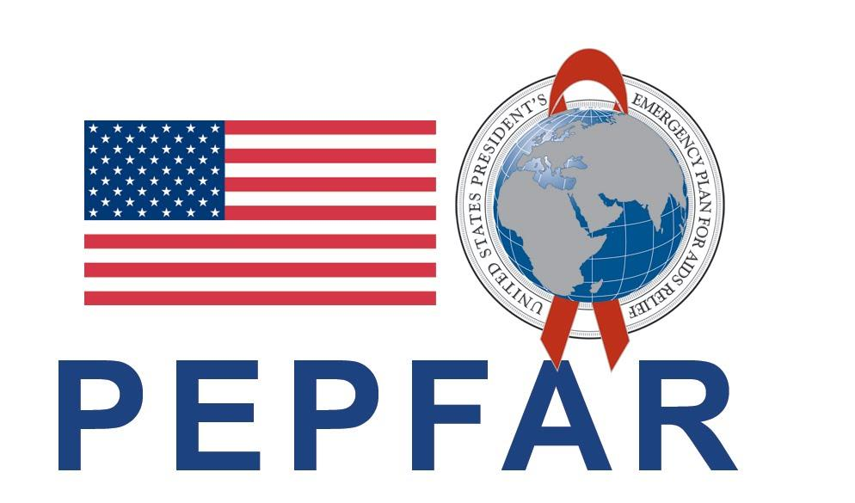
December 2020
Contraceptive Services for Female Sex Workers
Training Module for Clinicians

Contraceptive Services for Female Sex Workers
Training Module for Clinicians
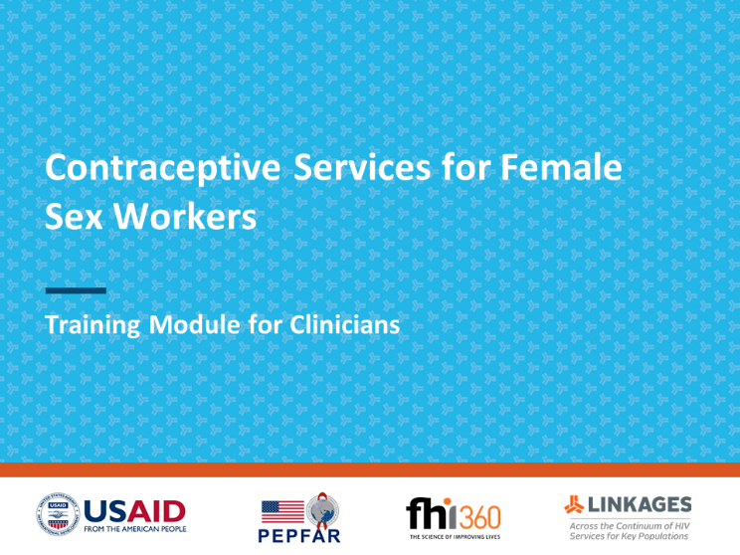
December 2020

This training resource is made possible by the generous support of the American people through the U.S. Agency for International Development (USAID) and the U.S. President’s Emergency Plan for AIDS Relief (PEPFAR) through the terms of cooperative agreement #AID-OAA-A-14-00045. The contents are the responsibility of the LINKAGES project and do not necessarily reflect the views of USAID, PEPFAR, or the United States Government. The project is led by FHI 360 in partnership with IntraHealth International, Pact, and the University of North Carolina at Chapel Hill.

MODULE: Contraceptive services for female sex workers
This module is designed to orient groups of 12–15 clinicians to the special needs and concerns of female sex workers (FSWs) seeking contraceptive services. The module can be used for training family planning (FP) providers or providers in FP/HIV integrated settings. Eligible participants must have a foundational knowledge of contraceptive methods, and experience and skill in offering informed choice counseling, determining medical eligibility for contraceptive methods, and providing methods. Strong referral links between FP and HIV services should be encouraged when women’s health needs cannot be met in one setting. Before the training, this prototype module should be modified to reflect the method mix of the country or program.
The training should be conducted in a space with small tables and chairs that can be arranged in a semi-circle for the presentations and large group activities and easily rearranged in the room for participants to practice counseling in small groups. Experienced facilitators, preferably two, are required to conduct the activities. Ideally, participants should continue to receive mentoring and constructive feedback from a program coordinator, supervisor, or peers after the training.
A companion resource, Peer Educator Tool for Informing Female Sex Workers about Contraceptive Options, is also available for programs implementing community outreach to FSWs. A user guide and session plan for training peer educators (PEs) to use the tool are also available. If the clinicians participating in this training will be supporting PEs, introduce the PE tool and clarify the roles and expectations of PEs.
Learning Objectives
By the end of the session, participants will be able to:
- Identify gender norms and how they affect FSWs’ reproductive health and access to FP services.
- Describe potential barriers FSWs face to accessing contraceptive services and ways to address these barriers.
- Identify FSWs’ contraceptive and FP needs in an unbiased, supportive, and nonjudgmental manner.
- Describe characteristics of individual contraceptive methods that could make their use more attractive to or more challenging for FSWs.
- Explain how HIV status or presence of sexually transmitted infections (STIs) can affect FSWs’ eligibility for certain contraceptive methods.
- Demonstrate the ability to counsel FSWs about contraceptive options and multiple approaches to preventing pregnancy, HIV, and other STIs (using role plays).
Time: 5–5.75 hours
Resources
- PowerPoint slide presentation with speaker notes
- Flipchart paper, markers, and tape
- Prepared flipchart with Learning Objectives (to reference throughout the session)
- Prepared flipchart with title: Informed and voluntary decision means that FSWs are entitled to…
- Prepared flipchart with title: How might gender norms negatively affect FSWs’ reproductive health and access to services?
- Four prepared flipcharts with the titles: Access barriers, Provider-related barriers, Personal barriers, and Social barriers
- “Agree”/“Disagree” signs
- Prepared flipcharts with titles: What questions can providers ask to identify unmet need for contraception? and What questions can providers ask to identify risky behaviors?
- Post-it/sticky notes (or small sheets of paper and tape)
- Instructions and Answer Key for the Pre-/Post-Intervention Knowledge Assessment (Appendix 1)
- Participant Handouts (one copy per participant)
  - Pre- and Post-Intervention Knowledge Assessment (Appendix 1, optional)
  - Participant Note-taking Sheets with Slide Miniatures (Appendix 2, optional)
  - Beliefs about Women (Appendix 3)
  - Mary’s Story (Appendix 4, optional)
  - Contraceptive Options for Female Sex Workers: Advantages, Limitations, and Eligibility Issues (Appendix 5)
  - Job Aid: Approaches to Improve Level of Protection (Appendix 6)
  - Role Play Resources for Providers Learning to Counsel FSWs—Role Instructions, Observation Checklists, Scenarios 1–3 (Appendix 7)

Session Plan—Activities and Exercises
Introduction  5 minutes  Pre-intervention knowledge assessment (optional)  15 minutes | Use slide 2 to introduce the learning objectives. Clarify that this session does not focus on the general characteristics of contraceptive methods (which is pre-requisite knowledge for participants), but rather on the aspects of contraceptive methods that may affect FSWs’ satisfaction with the method, effective use of certain methods, and medical eligibility for certain methods. Post the prepared flipchart of the objectives to refer to during the session.  If administering the Pre-intervention Knowledge Assessment, follow the guidance provided with the assessment and answer key (Appendix 1).  Disseminate the Participant Note-taking Sheets with Slide Miniatures (Appendix 2, optional).
High Unmet Need among FSWs  5 minutes | Use slides 3–4 and the speaker notes provided on the notes page to describe the unmet need for contraception among FSWs. If reliable data on condom and contraceptive use among FSWs are available from your country or community, create a slide to share that information.
FSWs’ Rights to Reproductive Health Care  10 minutes | Post the prepared flipchart with this title: Informed and voluntary decision means that FSWs are entitled to…  Solicit answers from the group and write them on the flipchart. Probe for the answers shown in the bulleted list on slide 5. (Do not show the slide yet.)  After several minutes of brainstorming and discussion, show slide 5 to reveal the possible responses. Compare the list generated by the participants with the slide and use the speaker notes provided to wrap up the discussion.
Gender Norms and Family Planning  30 minutes  Mary’s Story (optional)  15 minutes | Show slide 6. Distribute a copy of the Beliefs about Women (Appendix 3) to each participant. Instruct them to complete the handout. After participants have completed their handouts, show slide 7 and ask the participants:  - What similarities or differences do you see between your community’s beliefs about women and your personal beliefs?  - How have your community’s beliefs about women shaped your personal beliefs?  Solicit answers from the group. After a few minutes of discussion, use the speaker notes provided to introduce gender norms.  Post the prepared flipchart with this title: How might gender norms negatively affect FSWs’ reproductive health and access to services?  Solicit answers from the group and write them on the flipchart. Probe for the answers shown in the bulleted list on slide 8 (do not show the slide yet). After several minutes of brainstorming and discussion, show slide 8 to reveal the possible responses.  Use the speaker notes to describe the negative impact of gender norms on FSWs both because they are women and because they engage in sex work.  Proceed based on participants’ understanding of gender issues:  - If the participants showed an advanced understanding based on the previous discussion, skip to the end of this section and use the speaker notes to wrap up this discussion.  - If participants would benefit from a concrete example of how providers’ gender-based beliefs can negatively affect an FSW in a health care setting, complete Mary’s Story and discussion.  Optional Activity: Show slide 9. Distribute a copy of Mary’s Story (Appendix 4) to each participant. Ask for volunteers to read the story aloud.  Show slide 10 (title and questions only) and ask: How did the providers’ beliefs about FSWs affect the way they treated Mary? What were the consequences of this treatment?  Write the responses on a blank flipchart. Probe for the answers shown in the bulleted lists on slide 10. After several minutes of discussion, click the mouse to reveal the possible responses.  Show slide 11 (title and question only) and ask: Knowing that we have our own beliefs, how can we ensure that our health services are more friendly and accessible to FSWs?  Write the responses on a blank flipchart. Probe for the answers shown in the bulleted list on slide 11. After several minutes of brainstorming, click the mouse to reveal the possible responses.  If time permits, ask participants: How do you think the beliefs in your community may have affected your own ideas about Mary and how she was treated during her visit to the clinic?  Use the speaker notes provided to wrap up this section. Use this opportunity to emphasize that all women, including FSWs, have the right to reproductive health and contraception.
Barriers to Contraception  15 minutes | Post four flipcharts around the room titled: Access barriers, Provider-related barriers, Personal barriers, and Social barriers.  Show slide 12 and use the speaker notes to introduce the activity.  Give each participant a marker and ask participants to take five minutes to walk around and write ideas about what these barriers may be on the various flipcharts. Explain that if someone else has already recorded one of their ideas, don’t write it again, just put a tick mark next to it.  After five minutes, show slide 13, Access barriers, and compare the participant responses on the flipchart with the responses on the slide. Use the speaker notes to summarize the barriers.  As you go through the slides, acknowledge barriers that are based on gender and reinforce the connection of many barriers to gender norms and harmful practices such as gender-based violence.  Show slide 14, Provider-related barriers, and compare the participant responses on the flipchart with the responses on the slide. Use the speaker notes to summarize the barriers.  Show slide 15, Personal barriers, and compare the participant responses on the flipchart with the responses on the slide. Use the speaker notes to summarize the barriers.  Show slide 16, Social barriers, and compare the participant responses on the flipchart with the responses on the slide. Use the speaker notes to summarize the barriers.
Evidence of Barriers  5 minutes | Use slides 17–18 and the speaker notes provided on the notes page to describe the evidence of barriers using the examples from Nepal and Mali.  If reliable data on barriers among FSWs are available from your country or community, create a slide to share that information.
Minimizing Barriers  5 minutes | Show slide 19 (title only); ask several participants for suggestions about how providers can minimize barriers for FSWs seeking contraceptive services. Click the mouse to reveal the suggestions on this slide and slide 20; use the speaker notes to describe how providers can minimize barriers. Remind participants that providers can minimize gender-based barriers by being aware of biases that stem from gender norms and acting in a way that allows all people to exercise their rights and access services free of stigma, judgment, and discrimination.  If there are local examples of programs that have taken measures to minimize barriers, share those examples or solicit examples from the participants.
Agree or Disagree  20 minutes | Use slide 21 to introduce the activity. Post “AGREE” and “DISAGREE” signs on opposite sides of the room.  Read each statement listed below, one at a time. After each statement, instruct participants who agree or disagree to gather under the sign that reflects their feelings; those who are unsure should stay in the middle.  Challenge participants in the Agree and Disagree clusters to “defend” their choice—to clarify the reasons why they agree or disagree with each statement. Use the rationales included with each statement to ask questions and encourage discussion.  As you process each statement, make sure to acknowledge providers’ concerns, but also help them examine their own attitudes and biases. Use this opportunity to emphasize the importance of informed and voluntary choice as well as the right that all women, including FSWs, have to make their own decisions about their health and fertility. A provider’s responsibility is to offer clear, accurate, comprehensible information and help women consider the advantages and limitations of all available contraceptive options, but ultimately, clients should be encouraged to make their own choice.  Agree/Disagree statements:  - Reproductive health services for FSWs should be provided separately from other clients  Examples of the different rationales to consider:  - Those who disagree may argue that such division further stigmatizes FSWs and creates tension within communities and/or that FSWs’ contraceptive needs are similar to the needs of other women and separate services are wasteful/not necessary.  - Those who agree may argue that separate services may focus on FSWs’ needs more effectively by offering tailored, integrated services; that confidentiality could be better maintained, and that providers could have better knowledge and understanding of FSWs’ needs.  - Condoms are the most appropriate method for FSWs who want to prevent pregnancy  Examples of the different rationales to consider:  - Those who disagree may argue that FSWs often have no control over condom use and when their clients refuse to use condoms, they are exposed to the risk of pregnancy.  - Those who agree may argue that FSWs need protection from STIs/HIV as well as from pregnancy, and the condom is the only method that provides dual protection, or that using another method for pregnancy prevention can lead to less consistent condom use.  - FSWs, especially those who are HIV positive, should be offered only long-acting or permanent contraceptive methods  Examples of the different rationales to consider:  - Those who disagree may argue that providers should not make decisions for their clients and should facilitate informed and voluntary choice even when they feel strongly about which method(s) their client should or should not use.  - Those who agree may argue that FSWs who are HIV positive require the most reliable protection from pregnancy, and providers have a responsibility to ensure this kind of protection.  - FSWs’ FP needs are different from the FP needs of other women and couples  Examples of the different rationales to consider:  - Those who disagree may argue that FSWs have the same needs and desires as women in the general population and that they too may want to prevent unwanted pregnancy or plan a pregnancy.  - Those who agree may argue that FSWs’ FP needs are different because many of them are already relying on condoms for STI/HIV prevention and thus, are protected from pregnancy as well. Some might also argue that for FSWs, preventing pregnancy may be more important than planning a pregnancy, so their need for contraception/FP may be greater.  Close the activity by reminding participants to keep an open mind so that they can provide unbiased, high-quality services to FSWs.
Identifying Unique Needs of FSWs  20 minutes | Use slide 22 and the speaker notes provided on the notes page to make the case for the importance of understanding the unique needs of FSWs so that appropriate/effective services can be provided.  Use slide 23 (show title and questions in blue only) to prompt the group to brainstorm questions that may help to identify 1) FSWs in need of contraception and 2) those who are at increased risk of STIs including HIV.  Record the questions suggested by participants on the prepared flipcharts: What questions can providers ask to identify unmet need for contraception? and What questions can providers ask to identify risky behaviors? Use probing questions to ensure that the issues mentioned in the questions on the slide are addressed by the participants; clarify/add as needed before revealing the example questions on the slide.  Use slide 24 to introduce the next activity. Distribute Post-it/sticky notes (or use paper and tape). Ask each participant to write down at least one thing they can do to make their clients comfortable and encourage clients to discuss their concerns openly. Instruct participants to stick their notes on the flipchart. Read aloud the posted suggestions. If the participant responses do not include the ideas listed in the speaker notes of slide 24, ask the group to explore further together and add to the list.
FSWs’ Concerns about Contraceptive Methods  Part 1  60 minutes | Use slide 25 to introduce the next activity. Explain that now we will think about specific contraceptive methods and what their benefits or drawbacks may be for FSWs.  Distribute to each participant a copy of the handout, Contraceptive Options for Female Sex Workers: Advantages, Limitations, and Eligibility Issues (Appendix 5). Participants can also use these handouts for future reference.  Divide all participants into three small groups. Assign methods to each group: 1) oral contraceptive pills (combined oral contraceptives [COCs] and progestogen-only pills [POPs]) and injectable contraceptives; 2) implants and intrauterine devices (IUDs); 3) female sterilization and emergency contraception.  Allow groups 20 minutes to review the handout and consider how the characteristics of their assigned contraceptive methods―such as effectiveness and ease of use; requirements for initiation, continuation, and discontinuation; common side effects, and protection from STIs/HIV―can make these methods more attractive or more challenging for FSWs. Also ask the groups to consider how FSWs’ HIV status or HIV risk may affect method eligibility.  Give each group sheets of flipchart paper to write down the key points about their assigned contraceptives as they relate to FSWs. Ask each group to select a reporter who will have 10 minutes to present the key points to the large group.  After each small group presentation, ask the large group to add as needed, and/or you can facilitate a discussion by asking probing questions to make sure all key issues are addressed. Ensure that the aspects of individual contraceptive methods mentioned in the handout, Contraceptive Options for Female Sex Workers: Advantages, Limitations, and Eligibility Issues (Appendix 5), are mentioned in the presentations or in the larger group discussion. Refer to information in the handout to contribute and correct information as needed.
FSWs’ Concerns about Contraceptive Methods  Part 2  20 minutes | Use slide 26 to introduce the contraceptive method options that participants did not discuss in their small groups.  Use slide 27 and the question/possible responses in the speaker notes to present and discuss the advantages and limitations of condoms for FSWs.  Use slide 28 and the questions/possible responses in the speaker notes to present and discuss the advantages and limitations of the lactational amenorrhea method (LAM) for FSWs.  Use slide 29 and the question/possible responses in the speaker notes to present and discuss the advantages and limitations of fertility awareness methods (FAMs) for FSWs.  Use slide 30 and the question/possible responses in the speaker notes to present and discuss the limitations of spermicides for FSWs.  Use slide 31 to summarize the approaches that clients can use to protect themselves from pregnancy, HIV, and other STIs. During counseling, providers can use the job aid, Approaches to Improve Level of Protection (Appendix 6) to help clients select the approach that would work best for them.
Role Plays—Counseling FSWs  1 hour, 45 minutes | Use slide 32 to explain to participants how to use role plays to practice counseling FSWs about their contraceptive options and multiple approaches for preventing pregnancy, HIV and other STIs.  Distribute a copy of the Observation Checklist to Assess Family Planning Counseling Skills of Providers During Simulation or Practicum with FSWs to each participant (Appendix 7). Explain that the checklist summarizes the steps and skills used during a standard counseling and screening process.  Divide participants into groups of three.  Distribute a copy of the Role Instructions (Appendix 7) to each small group and carefully review the responsibilities for each of the roles—provider, FSW client, and observer. Remind clients not to share information with the provider until the provider asks. Remind the observers to use the observation checklist to make notes about the interaction so they can share feedback with the provider. Remind providers to use the techniques brainstormed earlier and the process outlined in the observation checklist to help guide the session.  Instruct each group to decide who will play the provider, client, and observer for the first scenario. Distribute the Client Information Sheet for Scenario 1 to the client, and the Observer Information Sheet for Scenario 1 and an Observation Checklist (Appendix 7) to the observer in each small group.  [Note: If this is the first time that participants are attempting this role play format, bring all the participants who are playing the client role for the first scenario together, all the observers together, and all the providers together and review their roles in the scenario. Clients must understand that they are to act as the client described in the scenario and use the information provided in the description to answer any questions that the provider asks. Providers should use a standard counseling process to help guide the session with the client but they should not read the scenario in advance; they must query the client to gather information and respond accordingly. Observers should use the checklist to record what they observe and make notes about whether the provider completes the case-specific tasks.]  Instruct the participants to conduct the scenario 1 role play in their small groups. Allow about 20 minutes for the counseling session and 10 minutes for feedback and discussion. To simplify/shorten the role plays, providers should assume that clients are eligible for the method they have chosen (there is no need to complete a method eligibility checklist for clients who may choose DMPA, COCs, POPs, implants, IUDs).  Facilitators and program staff assigned to monitor each small group should ensure that the small groups are following the instructions and offer minimal prompts to the providers and clients as necessary to ensure a worthwhile/safe learning experience. They should also help the group keep on schedule so that the small groups remain in sync.  After the role play, the small group should take a few minutes to provide constructive feedback to the provider using the discussion questions below and shown on slide 33:  - What did the provider do in this situation that was effective?  - What might the provider consider doing differently?  - How well did the provider attend to the items on the Observation Checklist and the case-specific observations included in the role play description?  - What was the client’s perspective of the interaction—was the client comfortable and were her concerns addressed?  Instruct participants to switch provider, client, and observer roles.  Distribute the Client Information Sheet for Scenario 2 to the client, and the Observer Information Sheet for Scenario 2 and an Observation Checklist to the observer in each small group. Follow the same instructions used during role play scenario 1. After the role play, provide feedback and conduct a discussion using the questions on slide 33.  Instruct participants to switch provider, client, and observer roles.  Distribute the Client Information Sheet for Scenario 3 to the client, and the Observer Information Sheet for Scenario 3 and an Observation Checklist to the observer in each small group. Follow the same instructions used during previous role play scenarios. After the role play, provide feedback and conduct a discussion using the questions on slide 33.  [Optional: If time permits, ask two volunteers to reenact their counseling session in front of the large group while all of the other participants observe and record their feedback on an observation checklist. Debrief using the discussion questions on slide 33.]  After the small groups finish the three role plays, ask the participants about their experience playing the role of providers: What was good about the counseling sessions? What could be improved? What was most challenging?  Ask about their experience playing the role of FSW clients: How were you treated? Were you allowed to ask questions? Did you feel pressured? Were you allowed to make your own decisions? Did you receive the method of your choice? Were you satisfied with the interaction?
Summary  5 minutes  Post-intervention knowledge assessment (optional)  15 minutes | Use slide 34 to summarize the key messages from the session.  If administering the post-intervention knowledge assessment, follow the guidance provided with the assessment and answer key (Appendix 1).

APPENDIX 1: Using the Pre-/Post-Intervention Knowledge Assessment

Knowledge assessments can be used as pre- and/or post-intervention measurements of participants’ knowledge about the course content. Knowledge assessment results can serve to:
- Assess current knowledge of individual participants to provide a baseline measure of knowledge (pre-test)
- Identify specific knowledge gaps within the group to support prioritizing certain training objectives over others
- Assess knowledge gained by the participants during the program (post-test)
- Assess whether the knowledge-based training objectives were met

The questions on the knowledge assessment are based on the learning objectives for the course. The knowledge assessment should take participants about 15–20 minutes to complete. It includes a mix of question formats, including multiple choice and true/false.

Assessment items are scored as follows (see answer key):
True/false: 4 points each
Fill in the blank: 1 point each
Multiple choice: 2 points each

There is a total of 50 points. Multiply total points by 2 to get the final score and convert it to a percentage. A minimum score of 80 points (80%) of a possible 100 total points is required to indicate comprehension of the basic concepts.
Administering the Pre-/Post-Intervention Knowledge Assessment
- The knowledge assessment can be used both before and after the intervention.
- Knowing the strengths and weaknesses of the group beforehand can help you plan how best to use the training time to achieve the desired learning objectives.
- When administering the knowledge assessment as a pre-test, tell participants that their task is to complete a written knowledge assessment so that they will have an objective measure of what they already know (pre-test) to compare/contrast with what they learn during the course (post-test).
- Distribute the assessment. Allow participants to review the instructions and ask questions.
- Instruct the participants to fill in the information in the box at the top; include the date, indicate pre- or post-test, and write their name.
- Encourage the participants to do their best. Collect the completed assessments.
- When administering the knowledge assessment as a post-test, tell participants that the final task is to complete a written knowledge assessment so that they have an objective measure of what they have learned and can identify areas they might still need to study. The assessment will also help the facilitator discover what the group learned and whether there are weak areas in the design/delivery of the training intervention.
- If possible, use the answer key to score the post-tests while the other participants are finishing. Participants who finish early can take a break.
- If there is not sufficient time to score the post-tests and participants are curious to learn how they scored, share the answer key and allow them to self-score the test. This activity should be done quietly and away from participants who are still taking the test.
- If possible, provide time to return the post-tests and allow participants to ask questions about answers that they do not understand. Encourage participants to find the answers in their reference materials. If participants still have questions about a specific topic, provide additional technical information as appropriate. Ensure that all tests and answer keys are returned at the end of the activity.
- For a supervisor, assessment results will help identify topics that need additional emphasis to ensure that participants can safely provide services to clients.

Date: ________________ Check one: Pre-test Post-test
Name: _______________________________________________
Knowledge Assessment on Contraception for Female Sex Workers

True or False

Circle true or false for each statement.

- It is important for providers to identify the needs True False
of the client (e.g., protection from pregnancy, HIV,
and other STIs) to provide tailored counseling.

- FSWs who are at risk of HIV can safely take COCs. True False

- Effectiveness of injectable contraceptives is reduced in
FSWs who receive rifampicin or rifabutin for treating TB. True False

- FSWs are advised to use multiple forms of protection to True False
prevent pregnancy, HIV, and other STIs.

- Common side effects from contraceptive implants can True False
include bleeding changes, such as irregular bleeding and
spotting.

- FSWs who are at risk of HIV, who are HIV-positive, or who True False
have AIDS cannot safely use implants.

- Women at high individual risk of STIs can have an True False
IUD inserted without restrictions.

- Female sterilization has no side effects and may be a good True False option for FSWs who desire it.

- FSWs, like many women, may experience intimate partner and True False
sexual violence and are entitled to post-violence care and services.

Fill in the Blank

Complete the following sentences using word(s) from this list.
emergency contraceptive pills fertility awareness methods three
five implants COCs

- ____________________ should be taken within __________ days of unprotected intercourse.

- _________________________ require partner cooperation and may not be suitable for FSWs.
Multiple Choice

For each of the following questions, circle the letter(s) of the correct answer(s).

- Female sex workers can face the following types of barriers when accessing contraceptive services:
- Personal
- Provider-related
- Access
- Social

- Which of the following is not an access barrier?
- Lack of confidentiality
- Service fee
- Travel costs
- Office hours

Answer Key: Knowledge Assessment on Contraception for Female Sex Workers

Instructions: Correct responses are in bold. Use the guidance provided to score each test item.
True or False (Each correct true or false response is worth 4 points.)
Circle true or false for each statement.
- It is important for providers to identify the needs True False 4 points
of the client (e.g., protection from pregnancy, HIV,
and other STIs) to provide tailored counseling.

- FSWs who are at risk of HIV can safely take COCs. True False 4 points

- Effectiveness of injectable contraceptives is reduced in
FSWs who receive rifampicin or rifabutin for treating TB. True False 4 points

- FSWs are advised to use multiple forms of protection to True False 4 points
prevent pregnancy, HIV, and other STIs.

- Common side effects from contraceptive implants can True False 4 points
include bleeding changes, such as irregular bleeding and
spotting.

- FSWs who are at risk of HIV, who are HIV-positive, or who True False 4 points
have AIDS cannot safely use implants.

- Women at high individual risk of STIs can have an True False 4 points
IUD inserted without restrictions.

- Female sterilization has no side effects and may be a good True False 4 points
option for FSWs who desire it.

- FSWs, like many women, may experience intimate partner and True False 4 points
sexual violence and are entitled to post-violence care and services.

Fill in the Blank (Each correct answer is worth 1 point.)

Complete the following sentences using word(s) from this list.
emergency contraceptive pills fertility awareness methods three
five implants COCs

- Emergency contraceptive pills should be taken within __five____ days of
unprotected intercourse. 2 points
- Fertility awareness methods require partner cooperation and might not be 2 points
suitable for FSWs.

Multiple Choice (Each correct answer is worth 2 points.)

For each of the following questions, circle the letter(s) of the correct answer(s).

- Female sex workers can face the following types of barriers when accessing
contraceptive services:
- Personal
- Provider-related
- Access
- Social 8 points

- Which of the following is not an access barrier?
- Lack of confidentiality
- Service fee
- Travel costs
- Office hours 2 points

APPENDIX 2: Participant Note-taking Sheets with Slide Miniatures
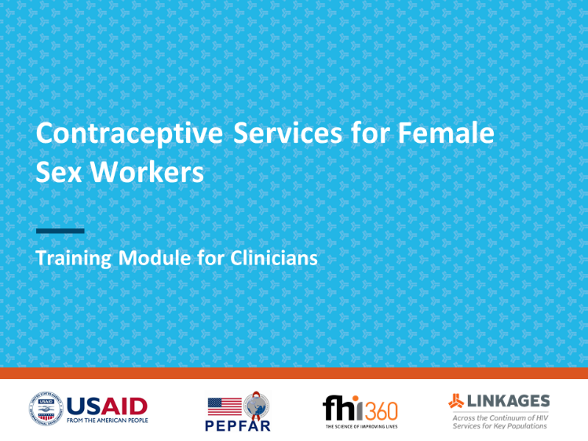
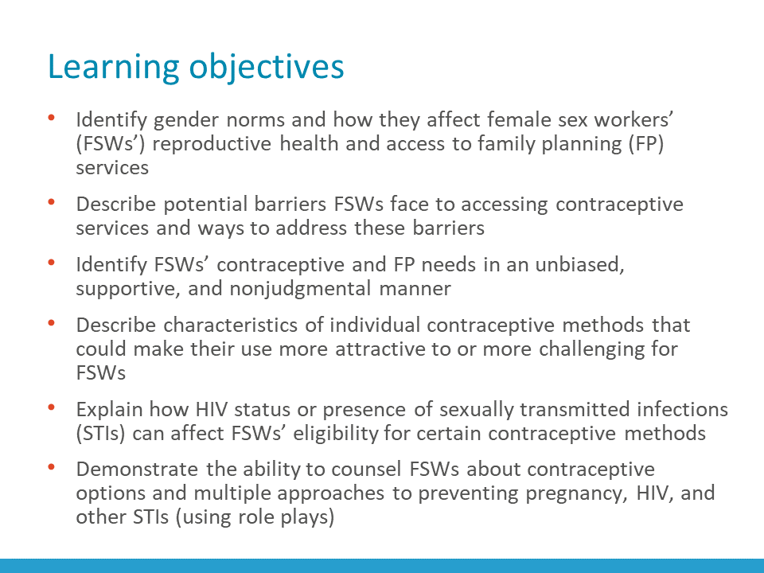
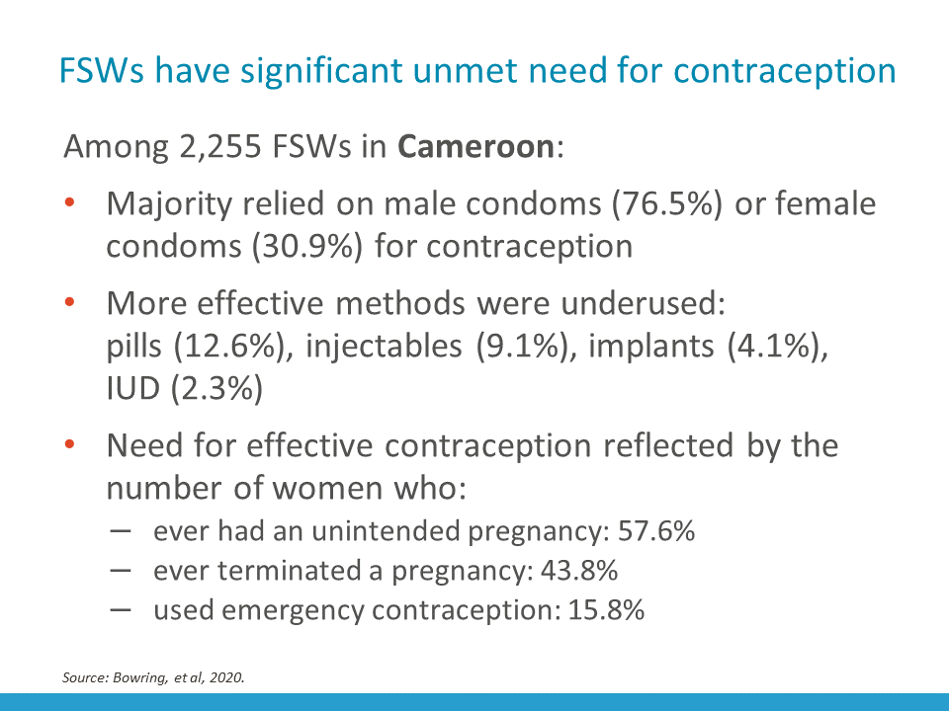
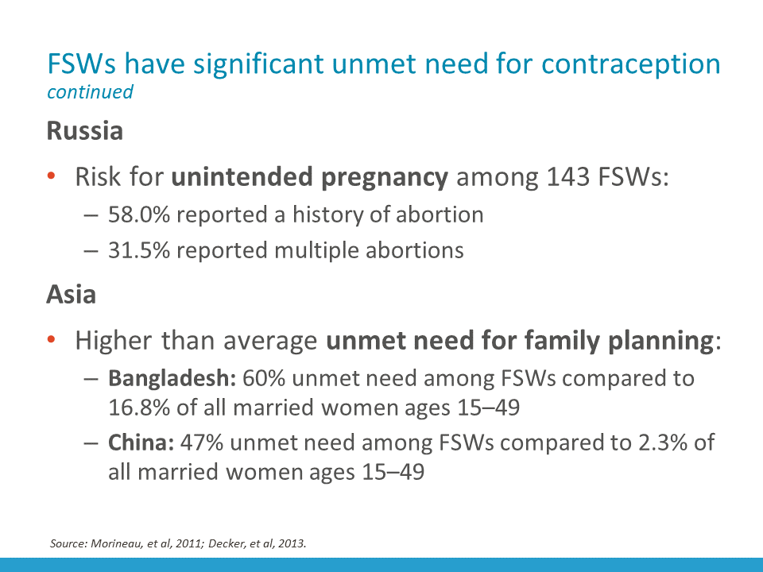
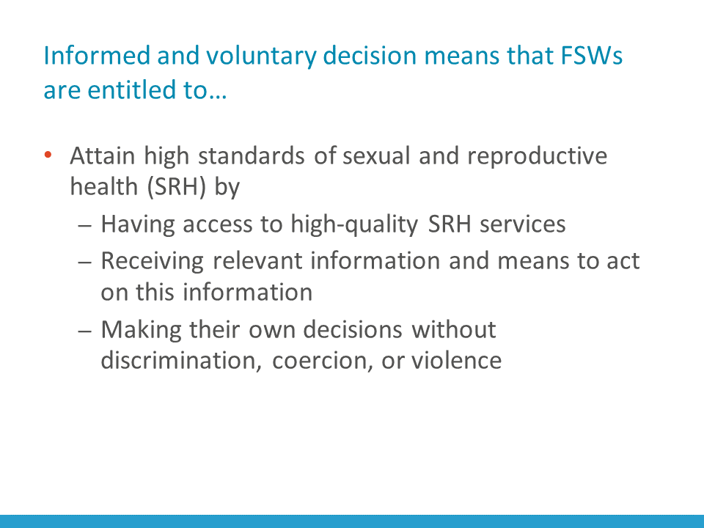
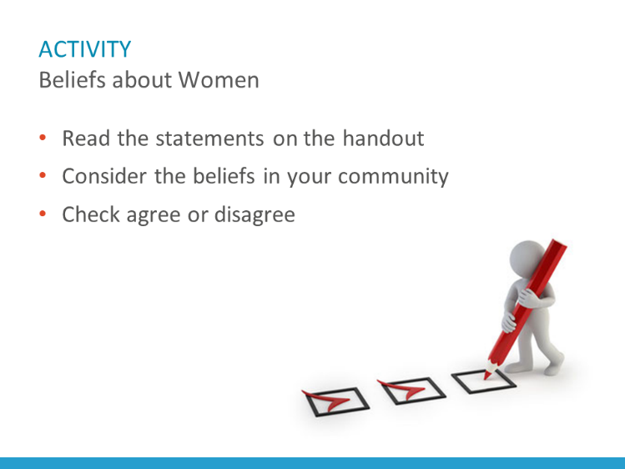
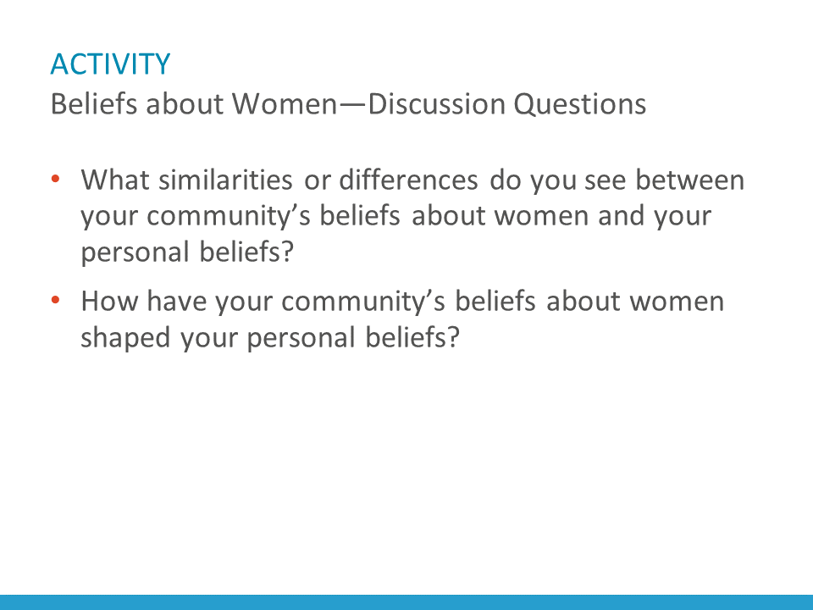
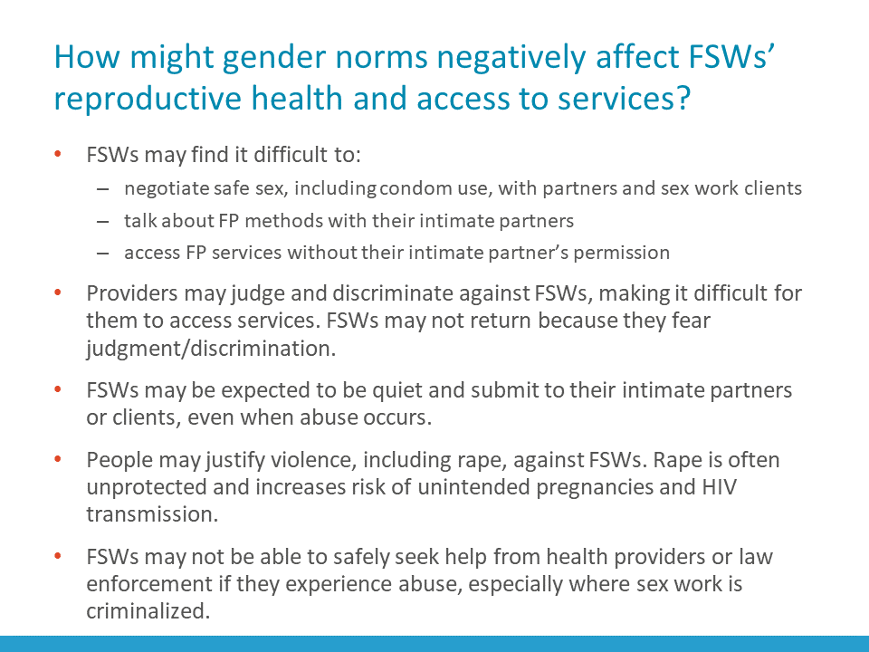
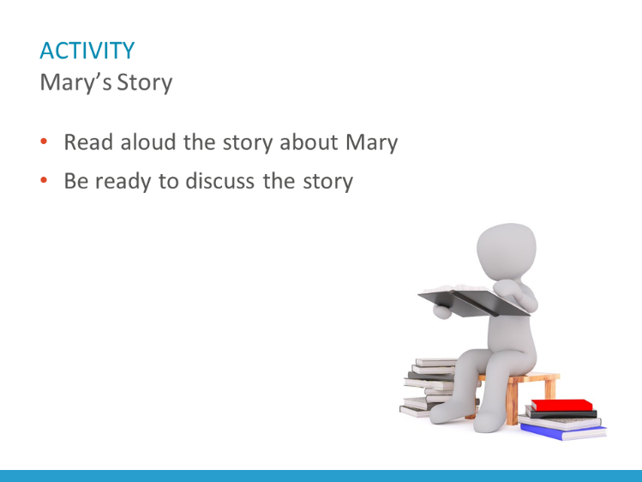
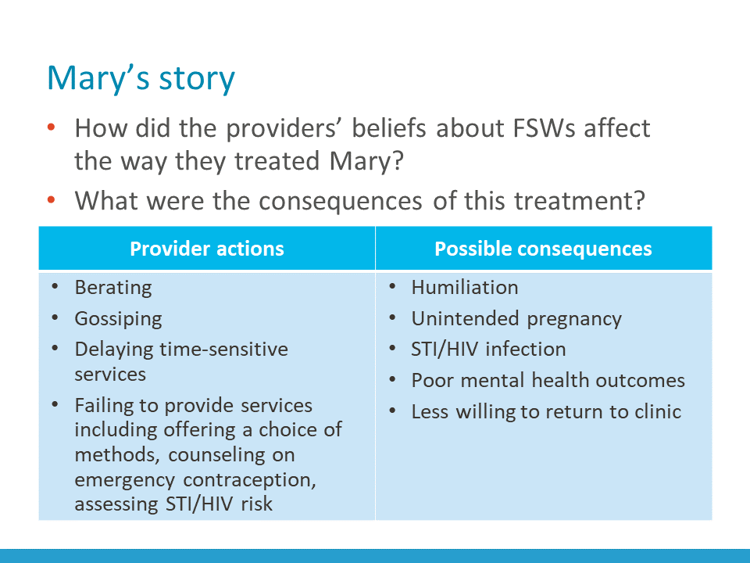
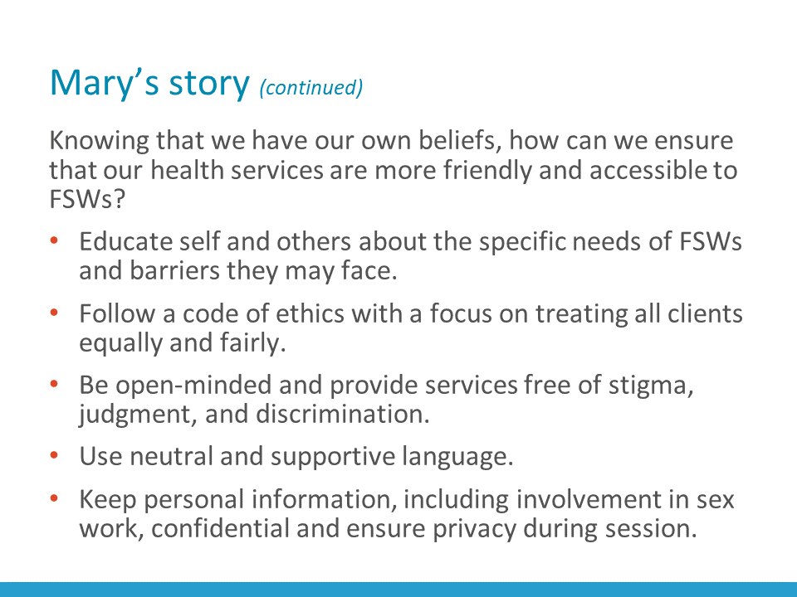
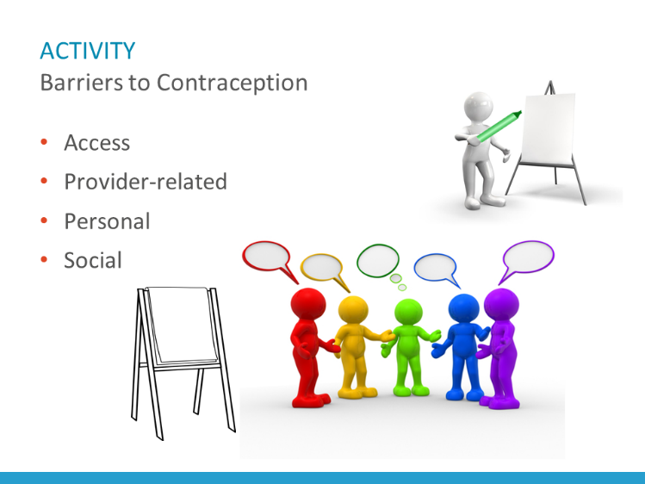
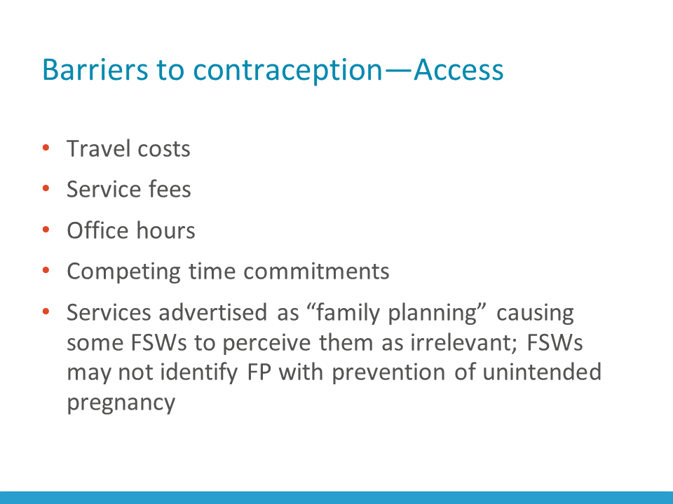
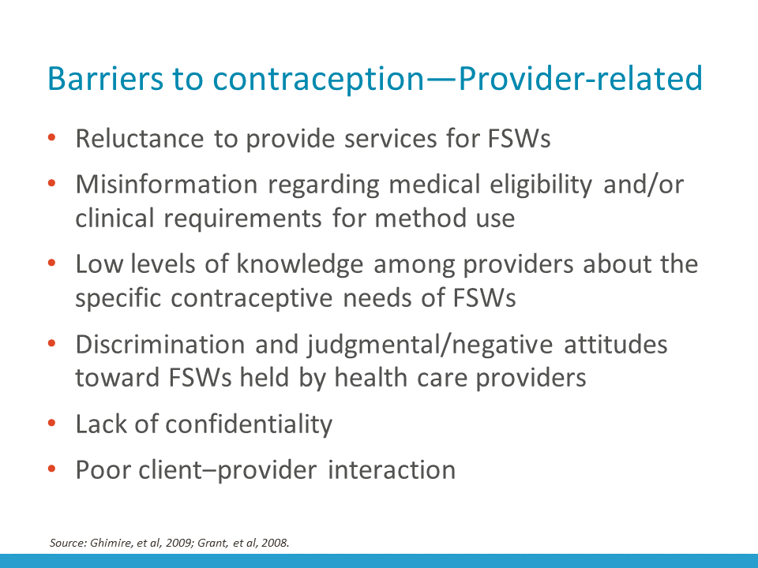
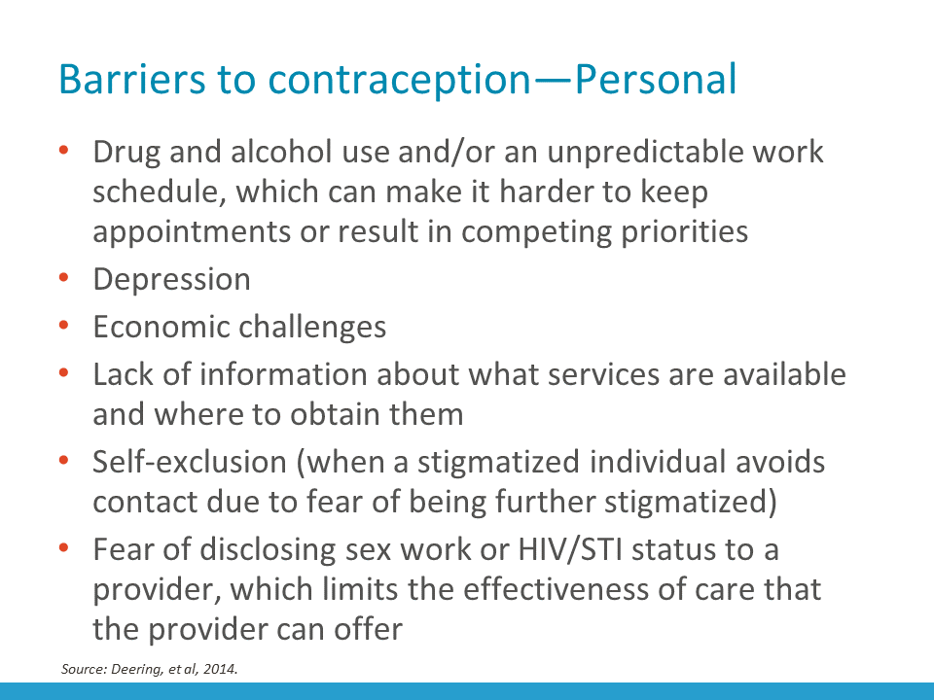
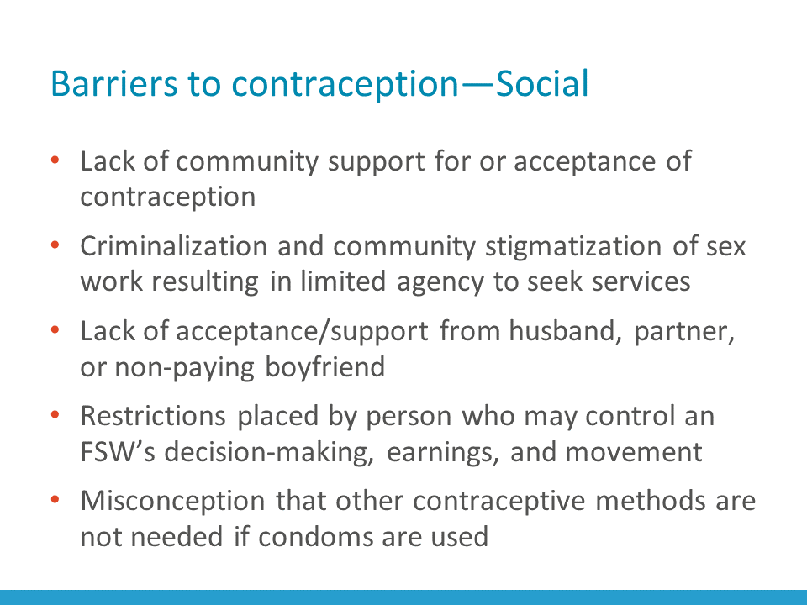
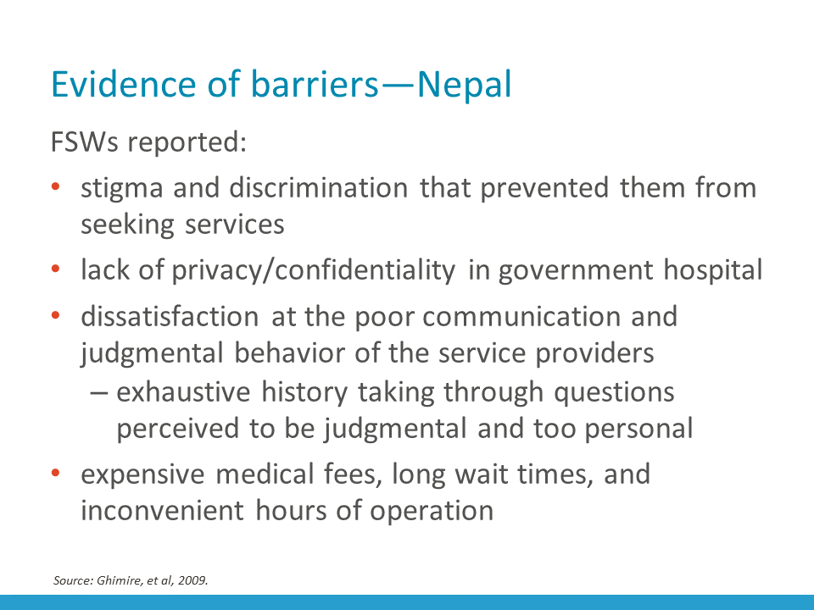
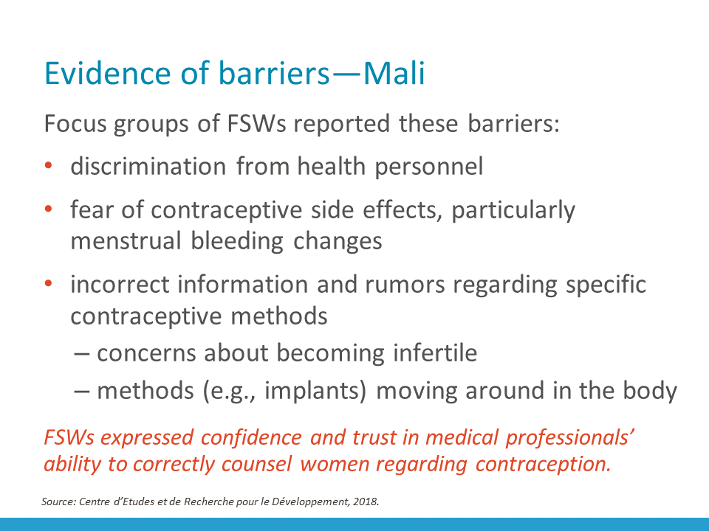
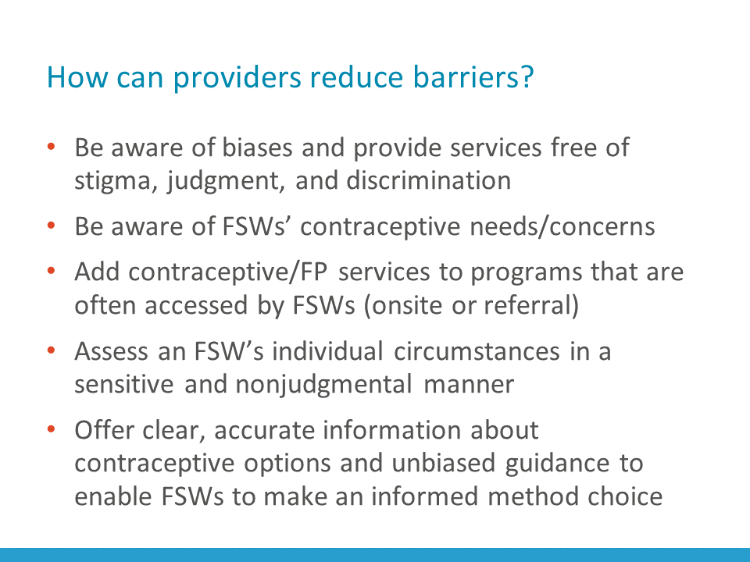
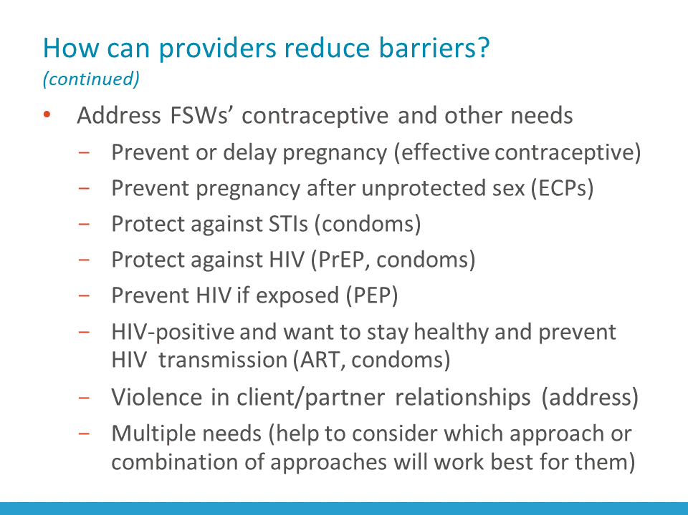
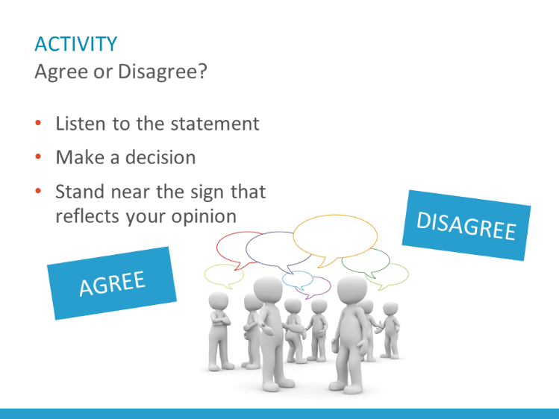
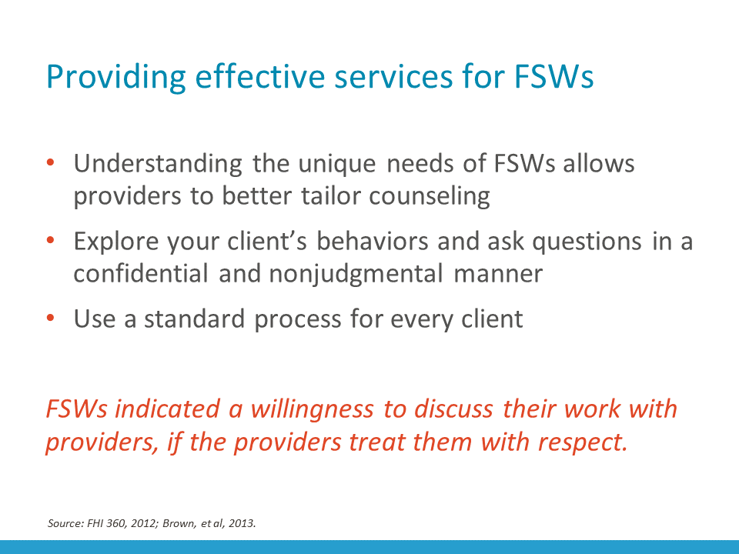
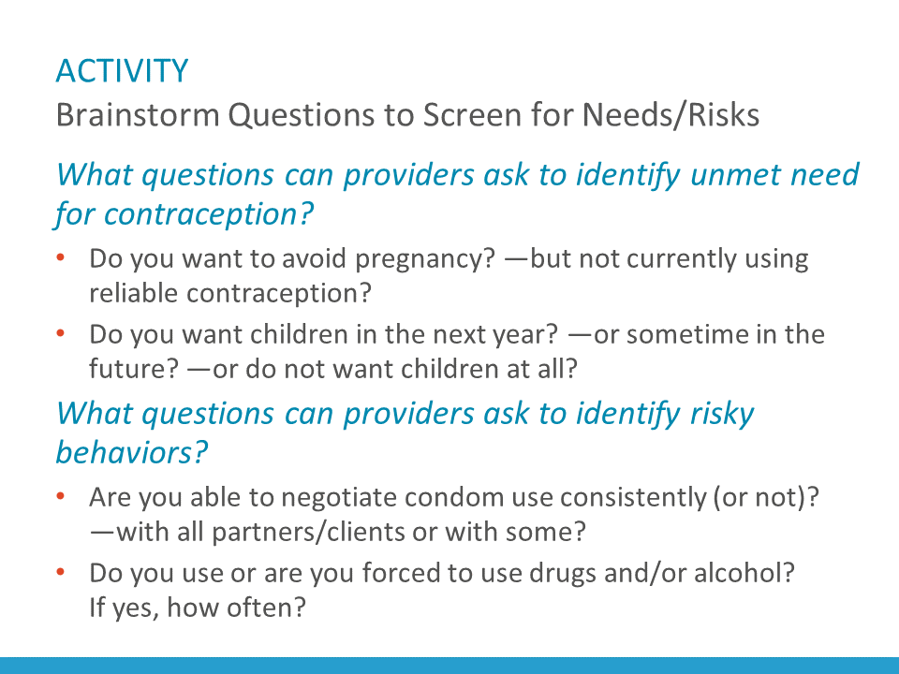
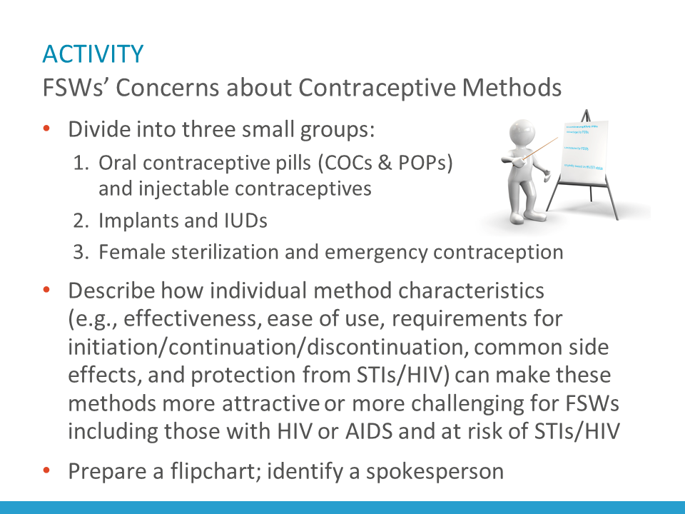
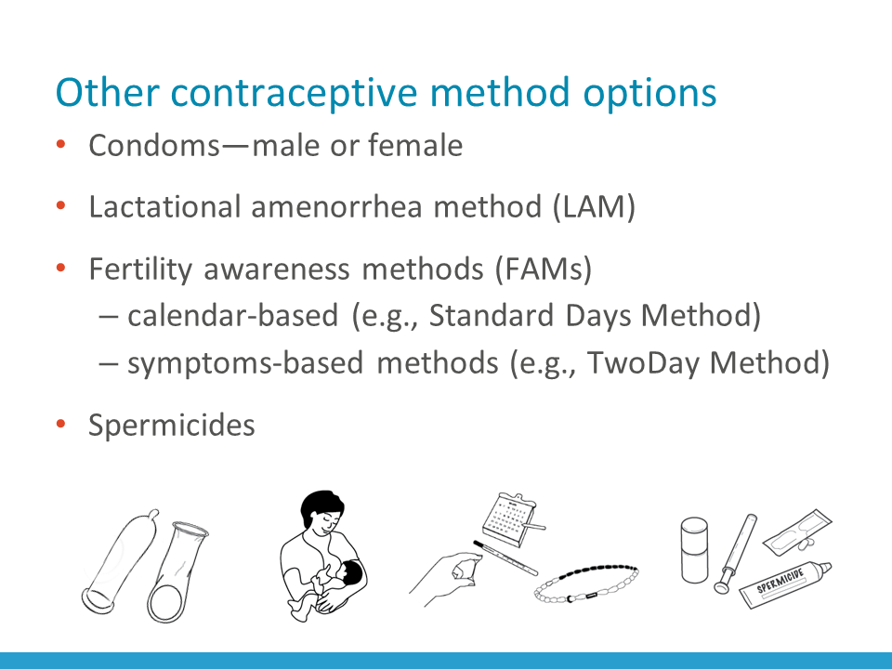
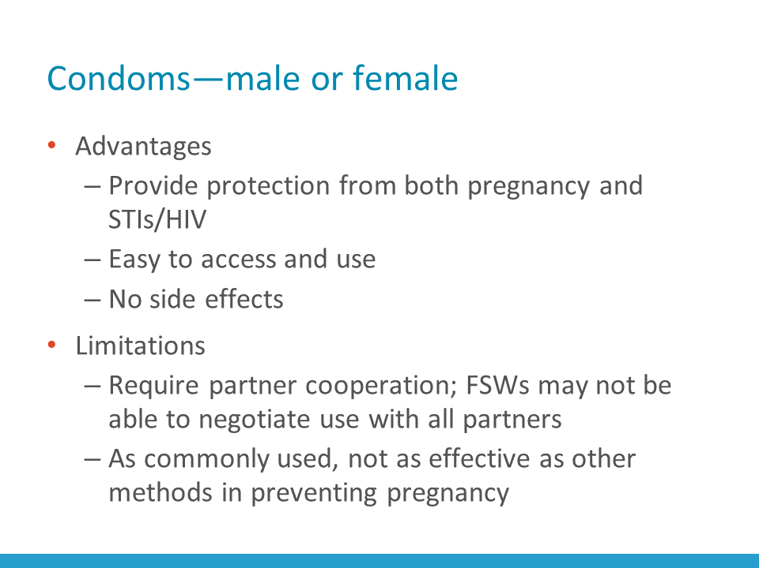
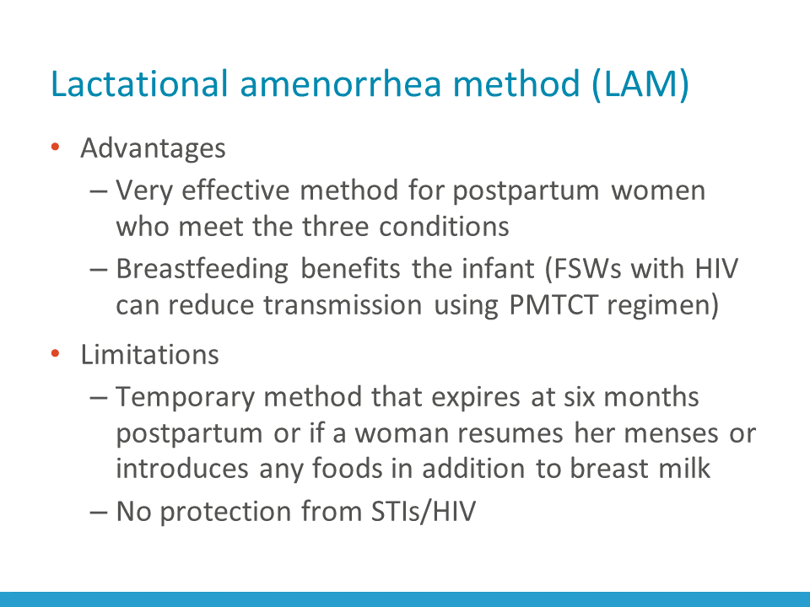
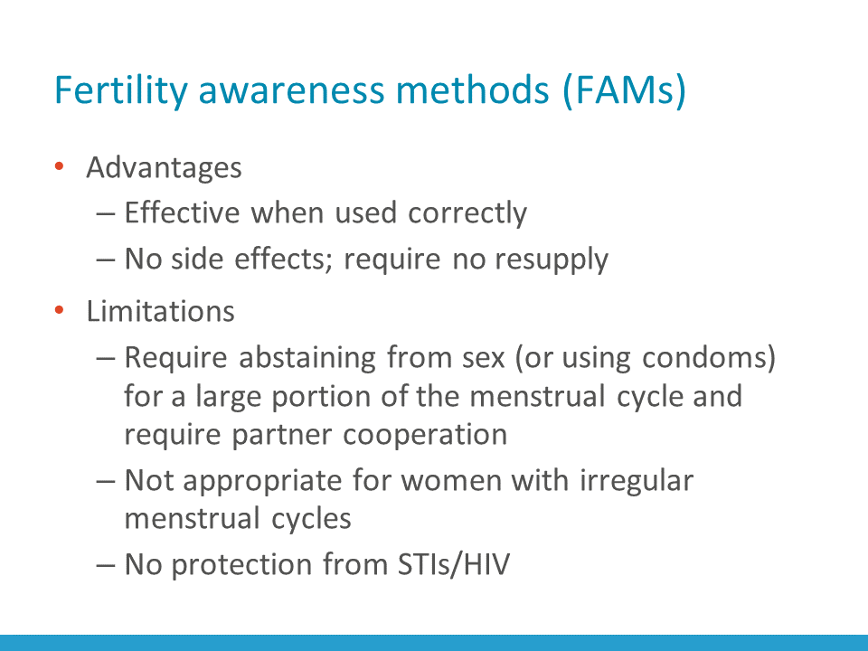
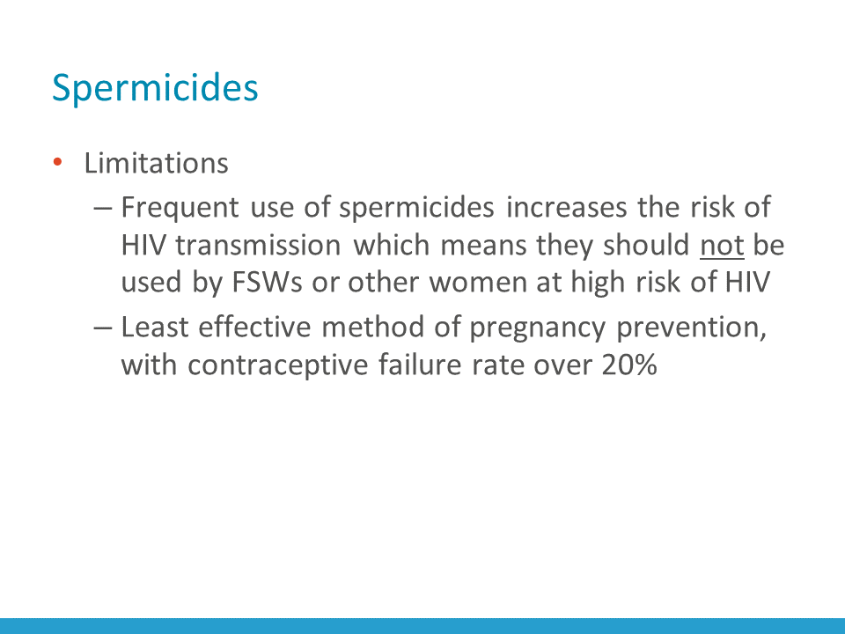
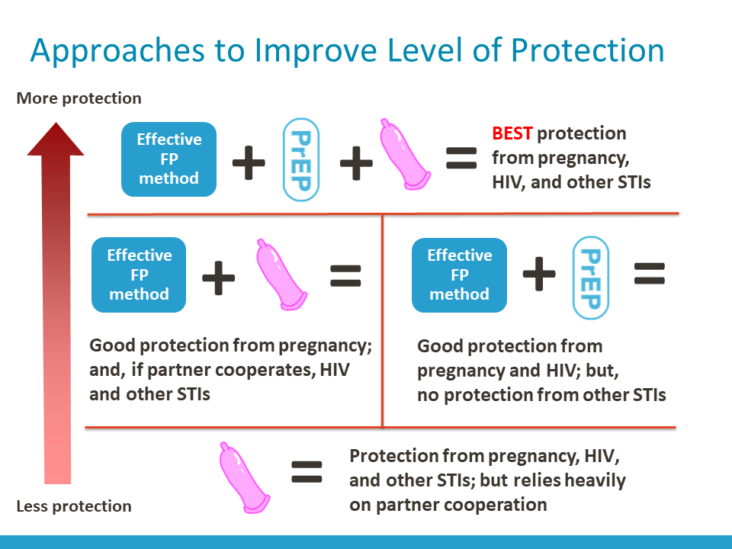
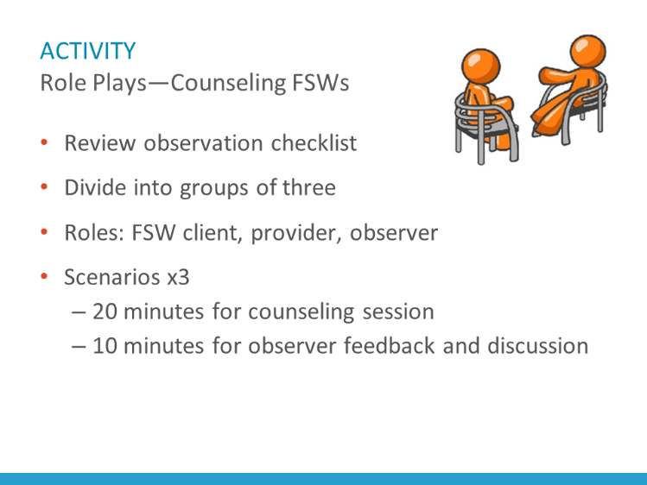
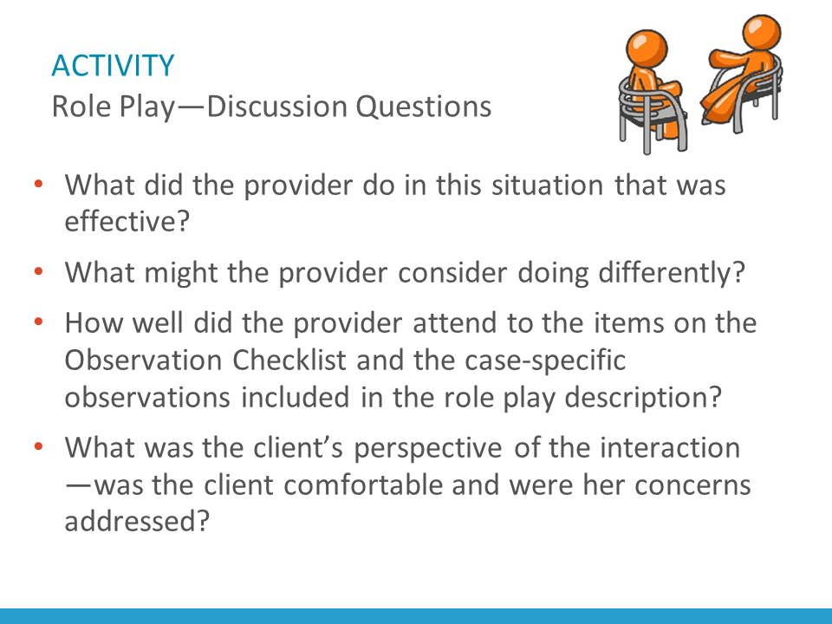
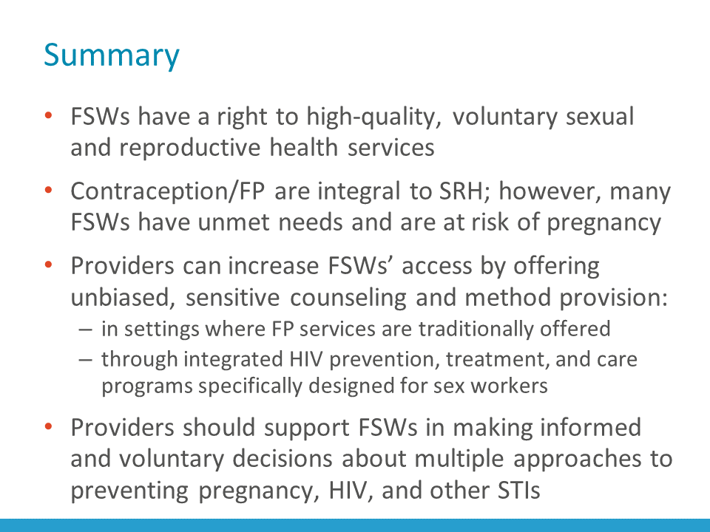
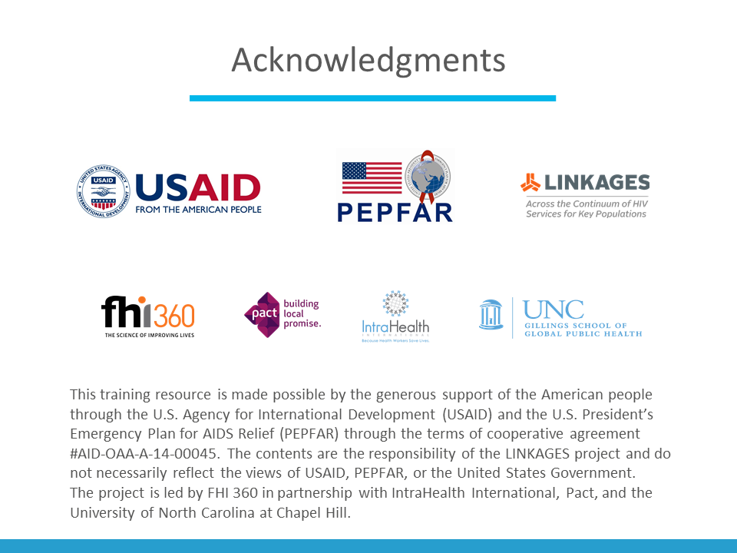

Appendix 3: Beliefs about Women
You do not have to write your name on this handout. Please read the following statements and add a checkmark in the column (Agree/Disagree) that best reflects the beliefs that are widely held in your community. Please be honest.
Beliefs | People in my community AGREE | People in my community DISAGREE
A woman’s place is in the home.
A woman’s primary purpose in life is to be a wife and have children.
If a woman wants to avoid becoming pregnant, it is her responsibility alone.
An unmarried woman who seeks contraception is “loose” or immoral.
It is shameful for women to enjoy sex and talk about sex.
Women should always obey men.
A woman should not seek health care without permission from her husband.
A woman does not have a right to refuse sex.
A woman should tolerate violence to keep her family together.
A woman who wears revealing clothes is asking to be raped.

Appendix 4: Mary’s Story

Even though she was worried about how she would be treated by the clinic staff, Mary went to the clinic to ask for emergency contraception. When she arrived at the clinic, she waited a long time. The nurse kept calling patients who had arrived after her. Eventually, Mary challenged the nurse and said, “I arrived before her. Why can’t you treat me now?” The nurse laughed and said, “Who are you to tell me what I should do? You’ll just have to wait. We know you ladies of the night! You wait all night for men, so why can’t you wait a few more minutes?” She said this in the presence of all the other patients, and Mary felt humiliated. The nurse then left and had a long talk with three other nurses, and she could see them looking in her direction and laughing.
Eventually, Mary was called in to see the doctor. Before she went into his room, the nurse had been talking to him, so Mary suspected he knew she was a sex worker. The doctor gave Mary a funny look and asked, “What is your problem?” Mary explained that she wanted emergency contraception. The doctor said, “I don’t know what you expected to happen when you are so immoral and irresponsible. It is your own fault sleeping with all these men. I will give you the pills now, but unless you change your lifestyle, they will do you no good. You should consider getting sterilized.”
Mary got her emergency contraceptive pills, but she felt humiliated. Mary decided that she would never go back to that clinic again.

APPENDIX 5: Contraceptive Options for Female Sex Workers: Advantages, Limitations, and Eligibility Issues
Contraceptive method | Advantages | Limitations | Eligibility based on HIV/STI status
Combined oral contraceptive pills (COCs) | - May be attractive to FSWs because they are generally safe, easy to use, very effective when used correctly, and do not require any lab tests or pelvic exam to initiate.  - Three to 12 months’ supply of pills can be offered at the time of a visit (depending on a country’s policies), thus minimizing the number of trips to the health facility for refills.  - FSWs may appreciate COCs because pills make menstrual periods very regular, light, and painless.  - If desired, FSWs can also choose to rely on extended use of COCs (e.g., taking only hormonal pills for 12 weeks in a row and skipping nonhormonal pills, followed by a one- week, hormone-free interval). This pill-taking regimen reduces bleeding to once every three months instead of monthly, which may be convenient.  - If fertility intentions change and pregnancy is desired, COCs could be easily stopped without a provider’s help and pregnancy may occur without a delay. | - Relying on COCs could be challenging because their effectiveness depends heavily on a woman’s ability to take a pill every day. Because FSWs may have an unpredictable work schedule, it may be harder for them to establish a routine for pill-taking and adherence could suffer.  - Because FSWs sometimes meet their clients in bars and other places of entertainment, their work often involves alcohol and drugs, which makes it harder to remember to take pills on time.  - Some COC users can experience common side effects, such as nausea, dizziness, and headaches. While not harmful, these side effects may be unpleasant and interfere with an FSW’s daily activities.  - COCs do not increase women’s risk for acquiring HIV but provide no protection from HIV and other STIs. To achieve protection from pregnancy, HIV, and other STIs, FSWs should use COCs in combination with other approaches, such as consistent and correct use of condoms and/or PrEP. Use of both condoms and PrEP provides the best protection from STIs/HIV (multiple approaches). | - Women who are at risk of HIV or who are HIV positive can use COCs safely.  - Those who developed AIDS and are receiving antiretroviral (ARV) therapy should know that COCs may be somewhat less effective in women who use certain ARVs, particularly efavirenz. These women should be counseled about the importance of taking their pill on time and using condoms in addition to COCs for enhanced protection from pregnancy. Missing contraceptive pills while on ART may further reduce contraceptive effectiveness.  - Co-infection with tuberculosis (TB) is common among people with HIV. HIV-positive women with TB who are treated with rifampicin or rifabutin should not take COCs. Rifampicin and rifabutin significantly reduce the effectiveness of COCs.

Contraceptive method | Advantages | Limitations | Eligibility based on HIV/STI status
Progestin-only oral contraceptives (POPs) | - May be attractive to FSWs while they are breastfeeding because, unlike COCs, POPs do not affect milk production.  - In breastfeeding women, POPs are very effective and safe. | - Are generally not recommended for women who are not breastfeeding. This is because in non-breastfeeding women, POPs require a very strict schedule to remain effective—they should be taken at approximately the same time every day. If delayed by more than 3 hours, the risk of pregnancy increases.  - POPs do not increase women’s risk for acquiring HIV but provide no protection from HIV and other STIs. To achieve protection from pregnancy, HIV, and other STIs, FSWs should use POPs in combination with other methods, such as consistent and correct use of condoms and/or PrEP. Use of both condoms and PrEP provides the best protection from STIs/HIV (multiple approaches). | - POPs are safe for women at risk of HIV or those who are HIV-positive.  - The effectiveness of POPs may be somewhat reduced by ART, particularly if the ART regimen contains efavirenz; women who want to take POPs while on ART should take contraceptive pills on time and use condoms for additional pregnancy protection.  - Similar to COCs, women taking rifampicin or rifabutin for treatment of TB, should not take POPs because of the reduced effectiveness of POPs.

Contraceptive method | Advantages | Limitations |  |  | Eligibility based on HIV/STI status
Progestin-only injectable contraceptives (DMPA and NET-EN) | - May be attractive to FSWs because they are safe, very effective, and easy to use (require only one injection every  2–3 months, depending on the type of injectable).  - Can be initiated without lab tests or a pelvic examination.  - Can be used privately because they require no supplies to keep at home or in one’s purse.  - After 6–12 months of use, the majority of women stop having monthly bleeding; this is not harmful and is considered convenient by many women. Monthly bleeding returns within a few months of discontinuing injectables. | - Effectiveness depends on FSWs’ ability to return to the provider for re-injection on time. If a woman is late for re-injection by more than 4 weeks (DMPA) or more than 2 weeks (NET-EN), she may become pregnant.  - An unpredictable work schedule, and/or use of alcohol and other drugs, can make it challenging for sex workers to remember a re-injection date. If FSWs are planning to use injectables, providers should help them to think about possible reminders to ensure adherence to the schedule.  - Common side effects of injectables include irregular, prolonged, and heavy vaginal bleeding during the first 6–9 months of use. Because having unpredictable bleeding could interfere with their work and limit their ability to solicit or accept clients, some FSWs can find these side effects unacceptable. Other side effects include nausea, dizziness, and weight gain.  - The effects of injectable contraceptives cannot be stopped until the drug is completely out of the body, which takes at least 4 months.  - If a woman’s fertility intentions change and she desires a pregnancy, it may take several months longer for her to achieve pregnancy after stopping injectables than after stopping any other reversible contraceptive method.  - Injectable contraceptives provide no protection from HIV/STIs. To achieve protection from pregnancy, HIV, and other STIs, FSWs should use injectables in combination with other methods, such as consistent and correct use of condoms and/or PrEP. Use of both condoms and PrEP provides the best protection from STIs/HIV (multiple approaches). |  |  | - Injectables are safe for women at risk of HIV. A large, well designed trial (ECHO trial, 2019) demonstrated that HIV risk among DMPA users is similar to HIV risk among women who use a copper IUD or contraceptive implant.  - HIV-positive women and those with AIDS can continue using injectable contraceptives without limitations. The effectiveness of injectable contraceptives is not reduced in women on ART or those who receive rifampicin or rifabutin for treating TB.
Contraceptive method | Advantages |  | Limitations | Eligibility based on HIV/STI status
Contraceptive implants (Implanon, Jadelle, and Sino-Implant) | - Implants may be attractive to FSWs because they provide highly effective, long-acting contraception.  - After implants are inserted under the skin of the upper arm, they can remain in place for 3 to 5 years (depending on implant type) and there is nothing else for the woman to remember, do, or buy to ensure highly reliable protection from pregnancy.  - Implant initiation does not require any lab tests or pelvic exam and they are very safe for the vast majority of women.  - Implants can be used privately, without anyone knowing.  - After implants are removed, fertility returns without a delay, which can be considered an advantage by women whose fertility desires have changed and who are planning pregnancy. |  | - While the side effects of implants are very mild, some FSWs may still find those challenging because the side effects can interfere with their daily activities and interactions with clients. These side effects include bleeding changes, such as irregular bleeding and spotting. However, the bleeding changes are much less pronounced than with progestin-only injectables. After the first year of use, bleeding usually becomes lighter and less frequent or stops altogether. Other side effects may include headaches, dizziness, and nausea.  - Implants cannot be initiated or stopped without a provider’s help because they require a minor surgical procedure to insert and remove. Women should be informed that stopping implants involves a trip to the clinic, which, depending on circumstances, could be far away (providers trained to insert, and especially remove, implants may not be available in a nearby health clinic).  - Implants do not increase women’s risk for acquiring HIV, but they provide no protection from HIV and other STIs. To achieve protection from pregnancy, HIV, and other STIs, FSWs should use implants in combination with other methods, such as consistent and correct use of condoms and/or PrEP. Use of both condoms and PrEP provides the best protection from STIs/HIV (multiple approaches). | - Women who are at risk of HIV, are HIV positive, or those who have AIDS can use implants safely.  - The effectiveness of implants can be somewhat reduced by some ARVs (efavirenz in particular) and TB medications. Using condoms in addition to implants is recommended in such cases to ensure reliable protection from pregnancy.

Contraceptive method | Advantages | Limitations | Eligibility based on HIV/STI status
Intrauterine devices (copper IUD) | - IUDs may be attractive to FSWs because they are as effective as sterilization, but not permanent. After insertion, IUDs provide protection for up to 12 years (depending on IUD type) and there is nothing else for a woman to remember, do, or buy to ensure protection from pregnancy.  - An IUD can be used privately, without anyone knowing.  - Copper IUDs have no hormonal side effects, such as nausea or headaches so they are not likely to interfere with everyday activities.  - After an IUD is removed, fertility returns without a delay, which can be considered an advantage by women whose fertility desires have changed and who are planning pregnancy. | - Some IUD users may experience slightly heavier and longer menstrual periods as well as more cramps during periods. This is not harmful but may be of concern to women whose periods are already heavy and/or painful.  - IUDs can be inserted and removed only by a trained health provider.  - A pelvic exam is necessary before initiation to check for signs of infection and assess the size and position of the uterus.  - IUDs do not increase women’s risk for acquiring HIV but provide no protection from HIV and other STIs. To achieve protection from pregnancy, HIV, and other STIs, FSWs should use IUDs in combination with other methods, such as consistent and correct use of condoms and/or PrEP. Use of both condoms and PrEP provides the best protection from STIs/HIV (multiple approaches). | - IUDs are generally not recommended for women at high individual risk of STIs. This is because when an IUD is inserted in the presence of a gonorrhea or chlamydia infection, it slightly increases a woman’s risk of developing pelvic inflammatory disease (PID).  - Because FSWs have multiple sexual partners, they are considered at high individual risk for STIs, which means they are NOT good candidates for IUD insertion.  - If an IUD is the only method an FSW desires, the insertion still can be considered if current gonorrhea and chlamydia infection can be ruled out by lab tests.  - The alternative approach is to treat FSWs presumptively for both gonorrhea and chlamydia before insertion. This could be a good approach for programs that already offer FSWs a presumptive treatment for STIs on a regular basis.  - After an IUD is inserted, women should be encouraged to come back in 3–6 weeks to check for the signs of infection, or sooner if they develop symptoms of infection, such as lower abdominal pain, fever, and/or unusual vaginal discharge.  - Women at risk of HIV or who are HIV-positive can generally use an IUD safely.  - Women who have AIDS should not have an IUD inserted until they are clinically well on ARV therapy.  - HIV-positive women who develop AIDS while using an IUD can continue to rely on it for pregnancy prevention.

Contraceptive method | Advantages | Limitations | Eligibility based on HIV/STI status
Female sterilization | - A safe and highly effective method for those who want to end fertility. Can be an attractive option for FSWs who are certain they do not want to have any more children. Because female sterilization is permanent, it is very important to help a woman to carefully consider her fertility intentions and if she has any doubts, reassure that she can achieve contraception as reliable as sterilization by using long-acting reversible contraceptive methods (e.g., implants) until she is absolutely sure about ending fertility.  - Female sterilization has no side effects (beyond the immediate effects associated with the procedure itself) and is a good option for FSWs who desire it. | - Female sterilization involves a surgical procedure, and while the risks are minimal, women should be counseled about and consider the risks (e.g., infection, bleeding) and benefits (e.g., reliable, permanent protection from pregnancy and all health risks associated with unplanned pregnancy) and sign an informed consent form.  - Having a surgical procedure requires recovery time (2-day rest, avoiding vigorous work) and avoiding sex for at least one week or, if pain persists, longer, which may be a problem for FSWs.  - Female sterilization does not increase women’s risk for acquiring HIV but provides no protection from HIV and other STIs. To achieve protection from pregnancy, HIV, and other STIs, FSWs should use female sterilization in combination with other methods, such as consistent and correct use of condoms and/or PrEP. Use of both condoms and PrEP provides the best protection from STIs/HIV (multiple approaches). | - FSWs who are at risk of HIV, who are HIV-positive, who have AIDS, or who are on ARV or TB therapy can safely undergo sterilization in most cases.  - In some women with AIDS, the sterilization procedure may need to be postponed until any acute conditions/opportunistic infections are resolved, or the procedure may require special arrangements (e.g., performed in a higher-level health facility).
f

Contraceptive method | Advantages | Limitations | Eligibility based on HIV/STI status
Emergency contraceptive pills (ECPs) | - While ECPs should not be relied upon for regular contraception, they may be an attractive option for FSWs who normally rely on condoms for both pregnancy prevention and HIV/STI prevention, but who had unprotected intercourse (e.g., a partner refused to use a condom, or they experienced condom breakage or slippage).  - FSWs who use methods other than condoms for pregnancy prevention can use emergency contraception when their method of choice was used incorrectly (e.g., pills were missed or they were late for their contraceptive injection).  - ECPs can be distributed in advance, so FSWs can have them handy in case unprotected intercourse occurs. Because ECPs are effective only if taken within 120 hours (5 days) after unprotected intercourse, and because the sooner they are taken, the more effective they are, it is important for FSWs to consider how fast they can access ECPs if needed. For providers, it is important to consider advance distribution of ECPs to sex workers who rely on user-dependent methods, such as condoms, pills, and injectables. | - ECPs are not as effective as ongoing contraception, so if an FSW uses ECPs frequently (e.g., every month or every few months), the provider should help her to consider how she can achieve more reliable, ongoing protection from pregnancy. For an FSW who relies on condoms alone, this means considering dual method use. If an FSW was already using a user-dependent method (such as pills or injectables) in addition to condoms, then switching to user-independent methods (such as an implant or an IUD), in addition to condoms, can provide better protection.  - ECPs do not increase a women’s risk for acquiring HIV but provide no protection from HIV and other STIs. FSWs who are concerned that they were exposed to HIV due to unprotected intercourse should be counseled to consider post-exposure prophylaxis (PEP) in addition to ECPs. They should also be counseled about the availability of PrEP for when they finish taking PEP (if they remain HIV-negative). | - FSWs who are at risk of HIV, who are HIV-positive, who have AIDS, or who are on ARV or TB therapy can use ECPs without restriction. There is no need to increase ECP dose in women on ARV or TB therapy, because ECPs contain higher doses of hormones than daily oral contraceptives. Therefore, it is unlikely that ARVs or TB medications will reduce the effectiveness of ECPs.

Contraceptive method | Advantages | Limitations | Eligibility based on HIV/STI status
Condoms | - Safe and effective when used consistently and correctly with every act of sexual intercourse and with all partners.  - Have no side effects (other than allergy to latex, which is rare).  - Easy to use (if partner negotiation is not an issue).  - Provide dual protection from both pregnancy and STIs/HIV.  - Are usually readily available. | - In everyday use, can be less effective than other contraceptive methods. This is because, while some FSWs are very successful negotiating condom use with their clients and using condoms consistently and correctly, many FSWs cannot ensure consistent use (e.g., a client refuses to use a condom or an FSW is willing to risk having unprotected sex with a partner who promises to pay more for sex without a condom). When condoms are used inconsistently, women are exposed to the dual risk of pregnancy and STIs/HIV. If a woman uses another contraceptive method in addition to condoms, she at least can be protected from pregnancy when condoms are not used. Informed choice counseling should always include a discussion of using more than one method to achieve the best protection from pregnancy, HIV, and other STIs. Providers should help FSWs to consider the benefits of using an effective contraceptive method in addition to condoms to maximize protection from pregnancy, and the benefits of using PrEP in addition to condoms to maximize protection from HIV. | - FSWs should be considered at high individual risk of STIs/HIV and are strongly advised to use condoms even when they are already using another effective contraceptive method.  - FSWs who are HIV-positive or who have AIDS should be advised to continue using condoms consistently to prevent HIV transmission to their partners and to prevent being infected with another strain of HIV.

Contraceptive method | Advantages | Limitations | Eligibility based on HIV/STI status
Lactational amenorrhea method (LAM) | - LAM can be a good method for FSWs who recently had a baby because breastfeeding exclusively for six months after delivery provides effective contraception for women who have not resumed their periods.  - LAM is very safe, requires no supplies, and has no side effects. LAM can serve as a bridge to another contraceptive method. Providers should help women relying on LAM to choose a regular contraceptive method before any one of the LAM criteria expires (a baby turns six-months old, a woman resumes menses, or she stops breastfeeding exclusively—whichever comes first). | - LAM is a temporary method of contraception and cannot be relied upon beyond the first six months after delivery. Effectiveness of LAM can expire even earlier than six months if a woman resumes her menstrual periods or introduces any foods in addition to breast milk.  - LAM does not increase a woman’s risk for acquiring HIV but provides no protection from HIV and other STIs. To achieve protection from pregnancy, HIV, and other STIs, FSWs should use LAM in combination with other methods, such as consistent and correct use of condoms and/or PrEP. Use of both condoms and PrEP provides the best protection from STIs/HIV (multiple approaches). | - Women who are HIV-positive and practicing LAM can transmit HIV to their baby through breast milk. They can significantly reduce the risk of transmission to their infant by attending a program for prevention of mother-to-child transmission (PMTCT) of HIV, adhering to a PMTCT regimen/cascade, and avoiding giving their baby any food other than breast milk until six months postpartum (because mixed feeding carries a higher risk of HIV transmission than exclusive breastfeeding).

Contraceptive method | Advantages | Limitations | Eligibility based on HIV/STI status
Fertility awareness methods (FAMs) include calendar-based (e.g., Standard Days Method) or symptoms-based methods (e.g., TwoDay Method) | - Safe.  - Effective when used correctly.  - Have no side effects and require no resupply.  - No delay in return to fertility. | - Because these methods involve abstaining from sex (or using condoms) for a large portion of the menstrual cycle and require partner cooperation, many FSWs may consider use of these methods unrealistic.  - FAMs require training on how to use correctly.  - Not appropriate for women with irregular menstrual cycles.  - FAMs do not increase women’s risk for acquiring HIV but provide no protection from HIV and other STIs. To achieve protection from pregnancy, HIV, and other STIs, FSWs should use FAMs in combination with other methods, such as consistent and correct use of condoms and/or PrEP. Use of both condoms and PrEP provides the best protection from STIs/HIV (multiple approaches). | - Women who are at risk of HIV, who are HIV-positive, who have AIDS, or who are on ARV or TB therapy can use FAMs without restrictions.
Spermicides | - Frequent use of spermicides increases the risk of HIV transmission, which means they should not be used by women at high risk of HIV (e.g., FSWs). Spermicides are also the least effective method of pregnancy prevention, with a contraceptive failure rate over 20% as commonly used.

Sources:
World Health Organization Department of Reproductive Health and Research (WHO/RHR) and Johns Hopkins Bloomberg School of Public Health/Center for Communication Programs (CCP), Knowledge for Health Project. Family Planning: A Global Handbook for Providers (2018 update). Baltimore and Geneva: CCP and WHO, 2018.
World Health Organization (WHO). Medical eligibility criteria for contraceptive use, 5th edition. Geneva: WHO, 2015.
APPENDIX 6: Job Aid

APPENDIX 7: Role Play Resources for Providers Learning to Counsel FSWs
Role Instructions
Cut along the dotted lines
Provider Instructions for Role Plays
- Pretend that you are meeting the FSW client for the first time. Ask the client for her name and age.
- Conduct a counseling session with the client using the standard process/steps outlined in the Observation Checklist, including assess the client’s reproductive health goals, concerns, STI/HIV risk, and fertility intentions; provide information; help the client make an informed choice of a contraceptive method and approaches for preventing HIV and other STIs; assess eligibility for an FP method (for the role play, assume clients are eligible), and carry out the client’s decision.
- Use a counseling tool (if available, appropriate, and technically accurate) and/or the Job Aid: Approaches to Improve Level of Protection to guide the session flow and the client’s decision-making process.
- Apply your experience and what you learned during training to address the client’s concerns.
- Pretend that there is a health center nearby to which you can refer the client, if needed.
Observer Instructions for Role Plays
Before starting the role play:
- Review the Observation Checklist so that you are familiar with the behaviors/tasks that you are observing and where they appear on the checklist.
- Review the case-specific issues on the Observer Information Sheet for the scenario. It provides ideas about how a provider might approach a session with the client described in the scenario.
While observing the interaction between the provider and the client, remember to:
- Use the Observation Checklist to take notes on what happens during the counseling session.
- Record how well the provider addresses the case-specific issues in the space at the bottom of the page.
- Be prepared to give feedback to the provider regarding how well he or she addressed the client’s needs and used a counseling tool or other resources/job aids for sharing information with the client.
Pay particular attention to whether the provider:
- Asked questions that allowed them to fully understand the client’s situation.
- Ensured that the client was comfortable and treated with respect.
- Provided accurate information about contraceptive methods and addressed concerns about methods that are common among FSWs.
- Allowed the client to make an informed decision (provider was unbiased and nonjudgmental).
- Helped the client carry out her decision.
Client Instructions for Role Plays
Before starting the interaction:
- Read the Client Information Sheet and make sure you understand your character’s situation.
- Pick a name for your character. Tell the provider your name and age.
- During the session, offer information only when the provider asks relevant questions. Use the information given in your Client Information Sheet to respond to the provider’s questions.
- Feel free to ask questions of the provider.

Observation Checklist to Assess Family Planning Counseling Skills of Providers During Simulation or Practicum with FSWs
Provider: _________________________________ Client: _________________________________ Observation # ____________________ Supervisor: _________________________________ Date: _____________________
Client’s permission to participate in practicum obtained: __________ client’s initials ___________ supervisor’s initials
Overall: Communicate Effectively and Maintain Rapport  Shows respect and avoids judging client  Maintains relaxed, friendly, attentive body posture and eye contact  Uses simple, clear language  Uses open-ended and probing questions correctly  Listens carefully to client (paraphrases and reflects)  Asks client about feelings (and shows empathy)  Describes client’s roles/responsibilities for the session  Encourages client participation  Explains what will occur during session/procedures  Ensures client understanding and corrects misunderstandings  Uses job aids appropriately  Correctly records information on data collection forms  Establish Rapport and Assess Client’s Needs and Concerns  Greets client appropriately  Ensures confidentiality and privacy and that client is comfortable  Asks about reason for visit  Asks about client’s partner(s), children, family, sexual behavior, health  Asks about plans to have children, desire for FP (e.g., spacing, limiting)  Explores STI/HIV risk and what client does to avoid HIV/STIs  Asks about violence in client or partner relationships  Provide Information to Address Client’s Identified Needs and Concerns  Informs client when needs/concerns are beyond provider capability  Advises on approaches to prevent STIs/HIV (i.e., use condoms, PrEP)  Explains benefits of FP and healthy spacing  Helps client identify FP methods suited to her needs, including ECPs  Gives information on advantages/limitations of FP methods of interest  Responds to other client questions or concerns (e.g., ART) | Yes | No | N/A | Help Client Make an Informed Decision or Address a Problem  Asks client if she has any questions about method(s) of interest  Asks client to choose a method  Uses screening checklist to determine if client can use the method  Agrees on decision or plan in partnership with client  Help Carry Out Client’s Decision  Gives contraceptive method, condoms, PrEP (or referral) as needed based on protection approach(es) selected  Explains and/or demonstrates correct use  Asks client to explain or demonstrate correct use, and reinforces client’s understanding and/or corrects client’s demonstration  Reminds client about side effects and reasons for returning  Gives supplies (as needed)  Role plays or rehearses negotiation skills and helps client plan approach  Arranges follow-up, resupply, and referral to outside services, as needed  Specific Notes/Observations Regarding Provider Performance | Yes | No | N/A
Role Play Scenario 1—FSW client who is a former COC user with two children and a steady partner; wants implant to delay pregnancy
Cut along the dotted lines
Scenario 1—Client Information Sheet | Scenario 1—Observer Information Sheet
Client description  You are a 27-year-old woman who works as an FSW.  Offer this information if/when the provider asks relevant questions:  - You currently live with your sister’s family but you have a partner who you hope to marry once he has saved enough money from his job as a mechanic to rent an apartment.  - During the day, you sell produce at a local vegetable market. In the evenings, you work at a bar with a brothel behind it.  - You are thinking about using a contraceptive implant, but someone told you that an implant can get lost inside your body and this scares you.  - You discussed your concerns with your friend, and she encouraged you to go to the community health clinic and speak with a provider.  - You have two healthy children, ages 5 and 3, with your current partner.  - You don’t want any more children until you can marry your partner.  - Your partner doesn’t know about your FSW work.  - You used COCs after you had your first child but stopped because your partner saw you taking the pills and told you that he doesn’t want you to use contraception.  - You want a method that is private, so you can use it without your partner’s knowledge.  - You have no known health problems. |  | Make note of whether the provider performs these case-specific tasks:*  - Asks about the client’s reproductive health goals, fertility intentions, and life plans.  - Asks about her experiences with contraceptive methods and if she has a preferred method in mind.  - Acknowledges her interest in an implant and addresses her concerns, explaining that implant rods cannot get lost as they are inserted right under the skin and cannot travel around the body.  - Mentions to the client that an implant can sometimes be seen/felt under the skin so her partner may notice.  - Reassures that she can still be a good candidate for an implant and provides information on its effectiveness and common side effects.  - Reviews the benefits of using multiple approaches to achieve protection from pregnancy, HIV, and other STIs.  * Refer to the Observation Checklist for a list of general steps/tasks that providers should perform during an interaction with a client.

Role Play Scenario 2— FSW client who uses ECPs after condom failure; has two children and a boyfriend and wants a method to delay pregnancy
Scenario 2—Client Information Sheet | Scenario 2—Observer Information Sheet
Client description  You are a 28-year-old woman who has been working as an FSW for 6 years.  Offer this information if/when the provider asks relevant questions:  - You always use condoms with all your clients to protect from HIV and STIs, but you don’t use another form of contraception for pregnancy prevention.  - The condom broke with your last client and you immediately used emergency contraception, but it made you nervous and you decided to visit a private clinic nearby so you can talk with a provider about what method would work best for your body.  - You have two children, ages 9 and 7, from a previous marriage.  - You have a new boyfriend and might like to have a child with him eventually; however, if you have a child now, it may jeopardize your new relationship.  - You have used DMPA in the past but didn’t like it because it caused you to have irregular and heavy menses. You are concerned that any contraceptive method that makes bleeding unpredictable will interfere with your sex work.  - You don’t know much about other contraceptive methods.  - You have no known health problems. | Make note of whether the provider performs these case-specific tasks:*  - Asks about the client’s reproductive health goals, fertility intentions, and life plans.  - Asks about her experiences with contraceptive methods and if she has a preferred method in mind.  - Acknowledges her experience with DMPA and counsels about expected bleeding changes and the fact that many DMPA users have irregular bleeding at first, but eventually develop amenorrhea (stop having menstrual bleeding).  - Discusses bleeding changes with other contraceptive methods (e.g., COCs make menses light and regular; an IUD may cause heavier, but regular menses; an implant may cause irregular bleeding, but usually to a lesser degree than DMPA). Reassures that bleeding changes are not harmful.  - Helps her to weigh potential bleeding changes against other advantages and limitations of contraceptive methods and choose the one that suits her best.  - Reviews the benefits of using multiple approaches to achieve protection from pregnancy, HIV, and other STIs.  * Refer to the Observation Checklist for a list of general steps/tasks that providers should perform during an interaction with a client.
Cut along the dotted lines
Role Play Scenario 3—FSW client who recently tested HIV-positive, initiated ART, and wants information on contraceptive method options
Cut along the dotted lines
Scenario 3—Client Information Sheet | Scenario 3—Observer Information Sheet
Client description  You are a 20-year-old woman who works as an FSW and was recently diagnosed with HIV.  Offer this information if/when the provider asks relevant questions:  - You are not married, do not have a regular, romantic partner, and don’t have any children.  - You dropped out of school 6 years ago, when your father died, and have been helping your family to earn money since then, largely by selling produce in the market or juice in the street.  - A year ago, you were approached by a man in town who promised much more money if you agreed to start working at a nearby brothel. You have been working as an FSW since then.  - You try to negotiate condom use with all of your clients after you tested positive for HIV six months ago but want more reliable protection from pregnancy.  - You started on ART shortly after you were diagnosed with HIV.  - You heard that ARVs may interfere with some contraceptive methods.  - A friend from work told you about the mobile clinic that comes to the local bar every month and offers medical counseling and services, including for STIs/HIV and contraception. Your friend suggested that you talk to a provider about how to prevent pregnancy.  - You don’t want a child right now, though you hope to have one someday.  - You have little experience with contraception—you used COCs for a few months but stopped because of the headaches and nausea.  - Having an effective method is important to you. You also want a method that doesn’t require much action on your part.  - You worry that having HIV and being on ART can prevent you from using contraception safely.  - You feel healthy even though you were diagnosed with HIV. | Make note of whether the provider performs these case-specific tasks:*  - Asks about the client’s reproductive health goals, fertility intentions, and life plans.  - Asks about her experiences with contraceptive methods and if she has a preferred method in mind.  - Acknowledges her experience with COCs and reassures about expected side effects.  - Discusses other effective contraceptive options that require little or no action, such as an IUD, implants, and DMPA.  - Reassures that women with HIV can use most contraceptive methods safely.  - Mentions that the effectiveness of an implant may be somewhat reduced by some ARVs but using condoms in addition to implants will compensate for this potential loss in effectiveness. (If after being reassured about COCs she considers using them, the same concern regarding interaction with ART applies.)  - Mentions that copper IUDs and DMPA do not interact with ARVs and remain very effective. Emphasizes that an IUD requires no action after it is inserted; but for DMPA, a woman needs to return for a reinjection every 3 months.  - Reviews the benefits of using condoms in addition to another contraceptive method (dual method use) to prevent STI/HIV transmission.  * Refer to the Observation Checklist for a list of general steps/tasks that providers should perform during an interaction with a client.

APPENDIX 8: Resources for Facilitators and Training Participants
United States Agency for International Development, World Health Organization, United Nations Population Fund. Family Planning Training Resource Package (TRP). Available: https://www.fptraining.org/
World Health Organization Department of Reproductive Health and Research (WHO/RHR) and Johns Hopkins Bloomberg School of Public Health/Center for Communication Programs (CCP), Knowledge for Health Project. Family Planning: A Global Handbook for Providers (2018 update). Baltimore and Geneva: CCP and WHO, 2018. Available: https://www.fphandbook.org/
World Health Organization (WHO). Medical eligibility criteria for contraceptive use, 5th edition. Geneva: WHO, 2015. Available: https://www.who.int/reproductivehealth/publications/family_planning/MEC-5/en/
Also available for download as mobile app: https://www.who.int/reproductivehealth/mec-app/en/
World Health Organization. Health care for women subjected to intimate partner violence or sexual violence: A clinical handbook. Luxembourg: WHO, 2014. Available: https://www.who.int/reproductivehealth/publications/violence/vaw-clinical-handbook/en/

