**Orientation to the Toolkit and Practice for Selected Tasks in Step 4 and Step 7**

**Name of Meeting**

*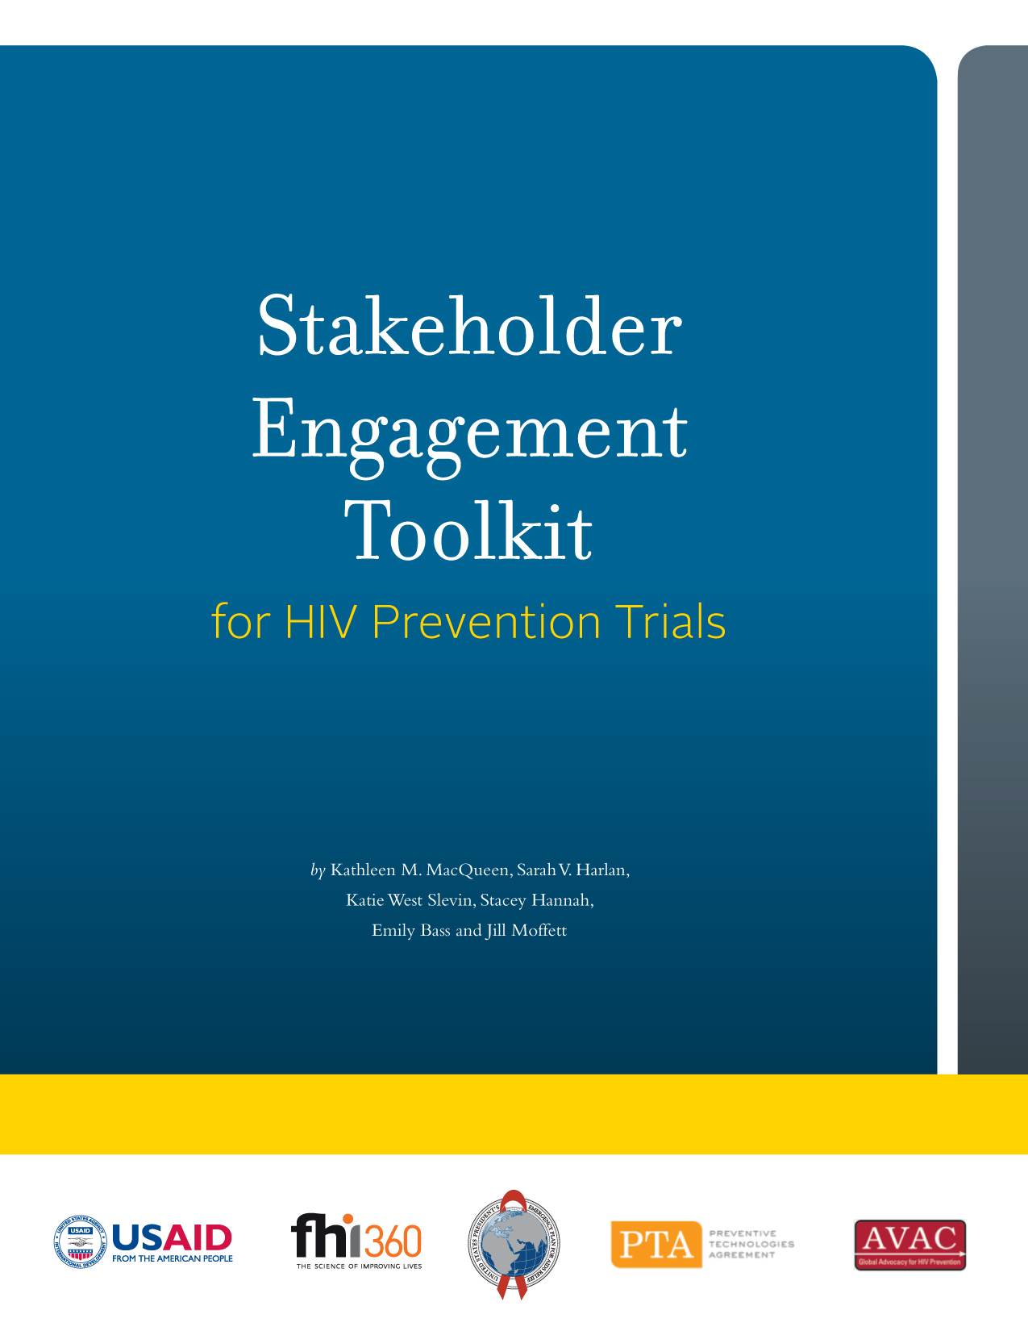***Month/Day, Year**

**Agenda**

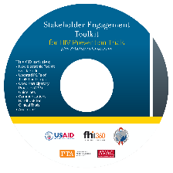

Welcome/Introductions

Overview of Objectives/Agenda

Establish Group Norms

Orientation to the Stakeholder Engagement Toolkit

*Break*

Identify/Plan for Sociocultural Factors

Assess Knowledge/Perceptions using the Agree/Disagree Activity

Establish Norms/Guidelines for Working with Stakeholder Groups

Use Role Plays to Build Stakeholder Capacity to Facilitate Agreements

Session Wrap Up and Evaluation

**Learning Objectives**

By the end of this session, participants will be able to:

* 1. Describe key features and components of the *Toolkit,* including the E-resources
  2. Identify and plan for political, cultural, religious, economic, transportation and other issues/factors that impact research and stakeholder engagement activities
  3. Using guidance and tools from the *Toolkit,* interact with stakeholder groups to:
* Assess knowledge/perceptions using the Agree/Disagree activity
* Establish group norms and guidelines
* Build capacity using participant role plays
* Facilitate agreement through group discussion

**Facilitators**

**Name,** Title, Organization

email address

**Name,** Title, Organization

email address