Contraception for Clients with HIV Curriculum
Facilitator Manual
Appendix:
Speaker Notes for Presentations

PowerPoint Presentation 1. HIV/AIDS Epidemic Disproportionately Affects Women

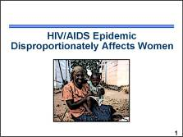 | According to the Joint United Nations Programme on HIV/AIDS, or UNAIDS, women are dispropor-tionately affected by the HIV epidemic. █  Note to facilitator:  Information about HIV/AIDS is included in the Participant Manual, page 6.  Photo credit: Rose DeBuysscher/FHI
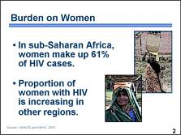 | Women account for nearly half of the almost  33.2 million adults living with HIV worldwide.  In the worst-affected region – sub-Saharan Africa – 61 percent of adults living with HIV are women. Increases in the proportion of women with HIV is also apparent in many countries in Asia, Eastern Europe, and Latin America. █  Photo credits: Nadine Burton/FHI; Eva Canoutas/FHI
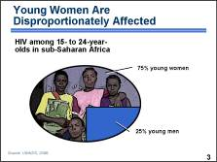 | Millions of young people are becoming sexually active each day with no access to HIV prevention services. In sub-Saharan Africa, three-quarters of all 15- to 24-year-olds living with HIV are female. The prevalence of HIV infection among young women in this region is three times that of young men. █  Photo credit: Cindy Waszak Geary/FHI
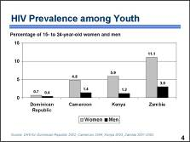 | As an example, this chart shows the prevalence of HIV among women and men, ages 15 to 24 years old, in several countries. Notice that women are considerably more affected by HIV than men of their same age. █  Note to facilitator:  Create a slide similar to this using Demographic and Health Survey (DHS) data from appropriate country(ies).
Note to facilitator: The █ in the script indicates when to click the mouse to either reveal more information on the current slide (e.g., the next bullet point) or advance to the next slide. The animations on the slides do not function when viewing the PDF versions of the presentations. To view the animations, the PowerPoint versions of the presentations must be viewed in PowerPoint or with PowerPoint Viewer (a free download available from www.microsoft.com).
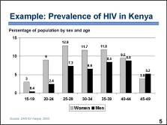 | As an example, this chart shows the prevalence of HIV in Kenya by age and sex. While HIV prevalence is highest among both men and women ages 25 to 44, women, especially young women ages 15 to 24 are considerably more affected than men of their same age. █  Note to facilitator:  Create a slide similar to this using DHS data from the appropriate country.
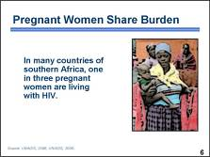 | UNAIDS also estimates that about 2.5 million of the 200 million women worldwide who become pregnant each year are HIV-positive. In many countries of southern Africa, as many as one in three pregnant women were living with HIV. █  Photo credit: Nadine Burton/FHI
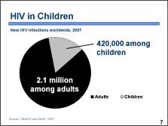 | In 2007 there were an estimated 2.5 million new infections worldwide – 420,000 of these infections were among children younger than  15 years of age. The overwhelming majority of children with HIV contract the infection from their mothers during pregnancy or delivery or through breastfeeding – often from mothers who were unaware of their serostatus. Every day, almost 1,000 children die from AIDS-related complications. █
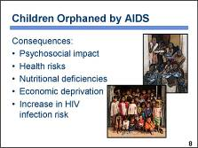 | Women’s vulnerability to HIV has a direct impact on their children and families. By 2005, about 15.2 million children younger than 17 years of age had been orphaned by the AIDS-related deaths of one or both of their parents. The vast majority of these children – 12 million – live in sub-Saharan Africa. Losing one or both parents can have dramatic psychosocial, as well as health and nutritional consequences. It can also result in severe economic deprivation. And, AIDS orphans may be at greater risk of contracting HIV infection themselves if they are forced to live in dire poverty with limited access to health care. █  Photo credits: ©2003 Yesaya Banda/Courtesy of Photoshare; Karl Grobl
PowerPoint Presentation 2. Women Are More Vulnerable to HIV

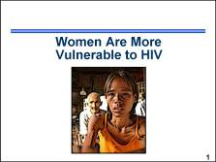 | It is true that women are more vulnerable to HIV – let us take a closer look at why that is the case. █  Note to facilitator:  Information about why women are more vulnerable to HIV is included in the Participant Manual, page 6.  Photo credit: Karl Grobl
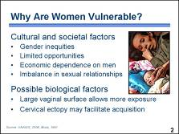 | Women’s vulnerability to HIV has several causes. █  First, women are more vulnerable to HIV infection because of cultural and societal factors. These factors include gender inequities that limit women’s opportunities, often making them economically dependent on men. Inequitable relations between men and women also make it more difficult for women to refuse unwanted sex or to negotiate safer sex. █  Women may also be more susceptible to HIV infection for biological reasons. Their exposure to HIV virus can be greater than men’s because they have a larger surface area, the vagina, exposed to sexual fluids during intercourse. A complicating factor is the preference for “dry sex” among some partners, which makes the vagina more susceptible to tears. In addition, a common physiological condition known as cervical ectopy may increase the risk of chlamydia infection, which may in turn facilitate acquisition of HIV infection. Cervical ectopy occurs when the regular (squamous) cervical epithelium on the outer surface of the cervix is replaced by thinner, more fragile (columnar) epithelium from the cervical channel. █  Photo credit: Karl Grobl
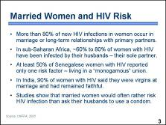 | Let us take a closer look at some of the implications of the various cultural and societal factors mentioned on the previous slide. Consider these facts: █  - More than 80 percent of new HIV infections in women occur among women who are married or in long-term relationships with primary partners. █  - In sub-Saharan Africa, an estimated 60 to 80 percent of HIV-positive women have been infected by their husbands – their sole partner. █  - At least 50 percent of Senegalese women living with HIV reported only one risk factor – living in a “monogamous” union. █  - In India, 90 percent of women with HIV said they were virgins when they married and had remained faithful to their husbands. █  - Studies show that married women would often rather risk HIV infection than ask their husbands to use a condom.  Generally, health care providers have not considered women in long-term relationships to be at risk for acquiring HIV, but as these studies show, this is not the case. Because providers believe that married women are at low risk, they often neglect to counsel them about sexually transmitted infections, or STIs, and HIV prevention. It is important that providers be aware of the many factors that make women more vulnerable so that they can help clients to understand and reduce those risks as much as possible. █

PowerPoint Presentation 3. ARV Therapy Basics in the Context of Family Planning

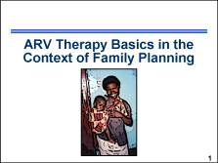 | Now we will provide a quick overview of antiretroviral, or ARV, therapy. This foundation is required for understanding how ARVs affect the contraceptive options of women with HIV, which will be discussed in detail later in the training. After the brief introduction to ARV therapy, we will also address how women on ARV therapy can benefit from contraception. █  Note to facilitator:  Information on ARV therapy basics is included in the Participant Manual, page 11. The Counseling Tool (flip book) also includes information that providers can use with clients to help describe the basic facts about ARV therapy, page 52.  Photo credit: Irina Yacobson/FHI
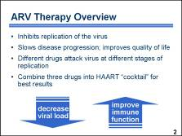 | The introduction of antiretroviral drugs as part of HIV clinical care has transformed HIV infection into a manageable chronic illness for many individuals with HIV. █  ARVs are not a cure. They cannot completely eradicate HIV. But they can inhibit replication of the virus, █ which effectively slows disease progression and improves a patient’s quality of life. █  Different ARV drugs attack HIV at different steps in the process of copying itself – first when it enters the cell and then when new copies want to leave the cell. █  To date, the best results have been achieved by combining three drugs from two different classes of antiretrovirals into a “cocktail.” The cocktail attacks at least two targets, thus increasing the chance of stopping HIV replication and protecting new cells from infection. █  This three-drug cocktail is called “highly active antiretroviral therapy,” or HAART. HAART can dramatically reduce the level of virus in the blood. As a result of this decrease in viral load, immune suppression is arrested, followed by improved immune function, which results in fewer opportunistic infections and illnesses and an overall improvement in the quality of life. █
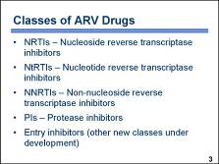 | There are several common classes of ARV drugs currently available. █  One class is NRTIs, or Nucleoside Reverse Transcriptase Inhibitors. █  Another class of ARV drugs, is NtRTIs, or Nucleotide Reverse Transcriptase Inhibitors. █  The next class is NNRTIs, or Non-Nucleoside Reverse Transcriptase Inhibitors █  followed by PIs, or Protease Inhibitors. █  Entry inhibitors and other new classes of drugs are also becoming available. █  Note to facilitator:  You may want to adapt this slide to show the drugs available in your country for all or some of the classes. Examples of drugs included in each class are listed below.  NRTIs: zidovudine (ZDV or AZT); didanosine (ddl); stavudine (d4T); lamivudine (3TC); abacavir (ABC); emtricitabine (FTC)  NtRTIs: tenofovir disoproxil fumarate (TDF)  NNRTIs: nevirapine (NVP); efavirenz (EFV, also known as EFZ); delavirdine (DLV)  PIs: indinavir (IDV), ritonavir (RTV), lopinavir (LPV); nelfinavir (NFV); saquinavir (SQV); atazanavir (ATV); amprenavir (APV)  Entry inhibitors and other new classes: enfuvirtide (T20), also known as Fuzeon  ARVs are sometimes available as fixed dose combinations (FDC) – in this case, each pill contains a certain amount of two or three different drugs (e.g., Trizivir, an FDC of ZDV+3TC+ABC).  Information on ARV drugs is included in the Participant Manual, page 13.
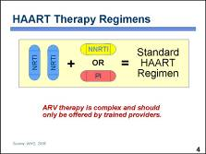 | As depicted on this slide, the standard HAART regimen contains two NRTIs and one NNRTI or a protease inhibitor. The World Health Organization, or WHO, recommends several regimens for HAART therapy using widely available ARV drugs. Other regimens, using more than three ARV drugs, are currently being explored to counter drug resistance that develops in some patients. █  Because of their side effects and the possibility of drug resistance, ARV therapy is not recommended for all patients with HIV. Several indicators are used to determine a patient’s eligibility to receive ARV therapy. Clients with HIV should be evaluated by a provider trained to determine the most appropriate course of action. █  Note to facilitator:  Information on HAART therapy is included in the Participant Manual, page 11.
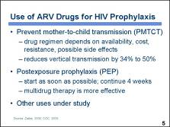 | While HAART therapy is used for the treatment of patients with advanced HIV disease, ARV drugs can also be used for the prophylaxis, or prevention, of HIV infection. █  ARV drugs play a major role in the prevention of mother-to-child transmission, or MTCT, of HIV. Pregnant women with HIV who do not have indications for full-scale antiretroviral treatment or do not have access to treatment should be offered ARV prophylaxis to prevent transmitting HIV to their newborn. Currently, there are many different drug regimens available, and their use depends on the availability of drugs, cost, in-country resistance patterns, and possible side effects. Clinical trials have demonstrated that these regimens can reduce the risk of MTCT by 34 percent to 50 percent. █  ARV drugs can also be used for postexposure prophylaxis, or PEP, in cases of known occupational exposure to HIV, such as a needle stick with infected blood, or when exposure cannot be ruled out, as in the case of rape. PEP should be started as soon as possible after the incident, ideally within hours. Dual or triple drug therapy is administered because it is believed to be more effective than a single agent. A treatment of four weeks is recommended. █  Other prophylactic uses of ARV drugs to prevent HIV infection are currently under study. █  Note to facilitator:  The ARVs zidovudine (ZDV), lamivudine (3TC), and nevirapine (NVP), have been demonstrated to be safe and effective for PMTCT prophylaxis when they are used alone (i.e., AZT or NVP) or in combination (i.e., AZT+3TC, AZT+NVP or AZT+3TC+NVP).
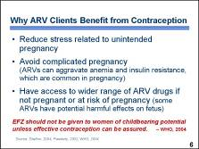 | Women with HIV who receive ARV therapy receive the same contraceptive benefits as all other women. █  Some additional benefits include:  - Removing the potential for unintended pregnancy in an already complicated life situation. Without concern about pregnancy, women can focus more on their ARV regimens and other demands related to HIV infection. █  - Avoiding complicated pregnancy. Antiretrovirals can aggravate anemia and insulin resistance that are common during pregnancy. When health is already compromised, such effects could be severe. █  - Having access to a wider range of antiretroviral therapy when a woman is protected from pregnancy. This is because some ARV drugs have harmful effects on the fetus and should not be offered to women who may become pregnant while on ARVs. █  For example, the drug efavirenz, known as EFZ or EFV, is believed to be a potent early teratogen – that is, an agent that may induce birth defects. WHO guidance states that “EFZ should not be given to women of childbearing potential unless effective contraception can be assured.”  Relationships between ARV drugs and some contraceptive methods will be discussed later in the training. █

PowerPoint Presentation 4. Role of Family Planning in Alleviating the Burden of HIV

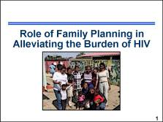 | Family planning can play an important role in helping to alleviate the burden of HIV shared by women and couples with HIV. In this activity, we will explore the role of family planning in HIV prevention, the benefits of providing family planning to women and couples with HIV, and the struggle to meet the demand for effective contraception. █  Note to facilitator:  Information on the role of family planning in alleviating the burden of HIV is included in the Participant Manual, page 15.  Photo credit: ©2003 Emmanuel Dipo Otolorin, MD/courtesy of Photoshare
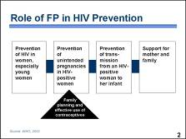 | Family planning, also known as FP, plays several roles in helping to maintain the health of individuals, families, and communities. With the AIDS epidemic growing, family planning has expanded its role by helping to prevent the spread of HIV. █  As shown in the diagram, comprehensive programs designed to prevent mother-to-child transmission of HIV, also known as PMTCT, typically employ multiple strategies that focus on preventing the acquisition and transmission of HIV and supporting the needs of a woman and her family. █  Family planning and effective use of contraceptives play an important role in these multipronged approaches by preventing unintended pregnancies among women with HIV, thus decreasing the likelihood of HIV infection in children and helping to reduce the chance that a child will become an orphan.  On the next slide we will examine the potential impact of these strategies, specifically the benefits that can be achieved when family planning services are integrated with other services. █
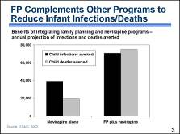 | Increasing access to family planning services for women with HIV can reduce births of children who have a high probability of being infected with HIV and dying. A study of PMTCT programs in 14 countries compared programs that offered the antiretroviral drug nevirapine to women at the time of delivery or nevirapine plus family planning services. By preventing unintended pregnancies with family planning services, the combined FP/nevirapine programs can sharply increase the number of HIV infections averted among infants from 39,000 to over 70,000, which could then significantly reduce the number of child deaths. The projected number of child deaths averted each year increases from 20,000 to 75,000 when family planning services are added to nevirapine programs. █
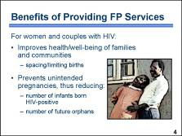 | Providing integrated reproductive health services that include family planning counseling and access to contraception to women and couples with HIV can improve their lives and those of their families.  - When FP services are accessible, clients with HIV experience the same health benefits as others in their communities. Couples can limit the size of their families to the number of children they desire and are able to care for. Women can space their children effectively and reduce the risks associated with too many pregnancies or pregnancies spaced too closely. Couples with HIV can also time a pregnancy to take place when HIV transmission risk is lowest. █  - Family planning can also reduce HIV infections among children by helping women with HIV who do not want to have children avoid pregnancy.  - Women with HIV who are concerned that they may eventually die of AIDS may decide to use contraception to avoid having children who may some day become orphans.  As we have seen, there are many benefits in providing family planning and effective contraception. Unfortunately, as we will see on the next slide, there is also a large and growing unmet need for contraception and other family planning services. █  Photo credit: ©1990 Media for Development International, from It’s Not Easy (film)/courtesy of Photoshare
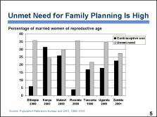 | Surveys estimate that more than 150 million married women of reproductive age worldwide have an unmet need for contraception to postpone or avoid pregnancy.  In the majority of countries in sub-Saharan Africa, more than 20 percent of married women of reproductive age have an unmet need for contraception. This chart shows the contraceptive prevalence rate for modern methods, in the blue (black) bars; and unmet need for family planning, in the green (grey) bars. As you can see, most countries in sub-Saharan Africa have a very high percentage of women with unmet need. Unmet need for contraception creates a particular hardship for women with HIV who may wish to avoid pregnancy but do not have access to contraceptives or family planning services. █  Discussion questions:  Are family planning services accessible to everyone in your community who may need them? What is the unmet need for family planning?
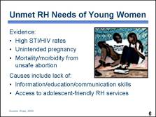 | One of the largest groups whose reproductive health needs, also known as RH needs, are not being met is young women. █  Evidence of unmet need in this group is seen in the high rates of STIs, including HIV; unintended pregnancy; and mortality and morbidity resulting from unsafe abortion. █  Some of the causes of this unmet need include a lack of information and education about sexuality, reproduction, and contraception, as well as limited skills for establishing personal goals, developing strategies, and communicating expectations with partners. Additionally, many young people do not have access to reproductive health services that are prepared to meet the specific needs of adolescents. █  Discussion question:  Where do the young people in your community obtain contraception and other reproductive health services?  Photo credit: Elizabeth Robinson/FHI

PowerPoint Presentation 5. Integrated Services Meet the Needs of Clients with HIV

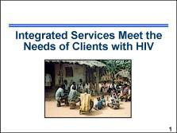 | In this activity, we will explore how integrated services can meet the needs of clients with HIV. █  Note to facilitator:  Information about the rationale for integrating FP and HIV services, including the potential benefits and challenges, is included in the Participant Manual, page 16.  Photo credit: ©2002 Elizabeth Serlemitsos/CCP/courtesy of Photoshare
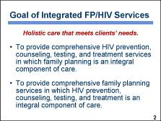 | The goal of integrated services is to provide holistic care that meets clients’ needs. Depending on the structure of the health services, integration can be achieved in a number of ways – including in vertical programs. For instance: █  In an HIV and AIDS care facility, the goal of integration is to provide comprehensive HIV prevention, counseling, testing, and treatment services in which family planning is an integral component of care. █  Similarly, in a family planning center, the goal of integration is to provide comprehensive family planning services in which HIV prevention, counseling, testing, and treatment is an integral component of care.  When feasible, some programs are adopting a comprehensive care approach to service provision – thus collapsing their vertical programs and offering all reproductive and primary care services in the same facility. The level of integration that any program can achieve must be carefully considered to ensure that it is feasible and sustainable. █
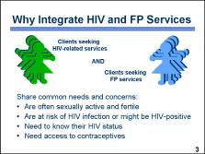 | Clients seeking HIV-related services and those seeking FP services share many common needs and concerns which may make service integration appropriate in some situations. █  Women seeking HIV-related services, such as PMTCT, counseling and testing, or ARV treatment, are often sexually active and fertile. █  A significant, though unknown, proportion of individuals seeking family planning services are at risk for HIV infection or are already HIV-positive. █  Some of these individuals know their HIV status, but many have not been tested. █  Both groups need information about and access to contraceptives and possibly information about how HIV affects their contraceptive options.  Therefore, it is important that HIV and AIDS programs provide family planning information and services or referrals. It is equally important that family planning programs take into consideration the needs of women with HIV and, at a minimum, have strong links to HIV care and treatment programs and services. █
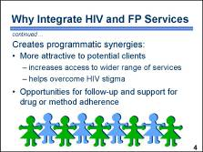 | Programmatic synergies can result from providing family planning and HIV services together. █  An entry point that provides a range of services – such as family planning; maternal and child health services; and HIV testing, counseling, and treatment – may be more attractive to clients. Clients may benefit when they can have multiple health needs addressed in a single visit by providers who are able to take a more holistic approach to client care. Combining services can also help overcome the stigma related to HIV and AIDS, which is one of the major constraints to accessing HIV services. █  In addition, offering more than one service creates richer contact opportunities for clients and providers, giving providers more occasions to followup with clients, provide information and counseling, and support drug and method adherence. It also gives clients chances to ask questions, attend to all their reproductive health needs, and become involved in their own health care.  Providing integrated services to clients with HIV requires that providers be cross-trained in a variety of issues. All providers need to know the different combinations of antiretroviral drugs that may be used to treat HIV. They also need to know which contraceptive methods are appropriate for women with HIV and AIDS and other medical conditions that affect eligibility for specific methods.  It is not always feasible or practical to provide integrated services. In such cases, a referral network should be in place and referrals to specialized services should be offered. █  Discussion questions:  Some providers express concern that integrating family planning with HIV services encourages clients with HIV to have sex. Do you share this concern? Please explain why or why not.
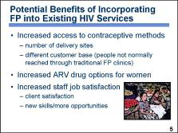 | For now, let us focus on the benefits of incorporating FP into existing HIV services – recognizing that there are comparable benefits to incorporating HIV services into existing FP programs. Some potential benefits include: █  Access to contraceptive methods can be improved because the number and type of delivery sites are increased. These sites may attract a different customer base – people not normally reached through traditional FP clinics, such as young people (single and married), men (including men who have sex with men and may also have female partners), commercial sex workers, and injecting drug users. This benefit is especially important in communities where the referral system is weak and there are barriers to accessing family planning information and methods. █  When a provider is assured that a client is using a reliable method of contraception, he or she can prescribe ARV drugs that are contraindicated for women who are or may become pregnant. █  Providers may experience increased job satisfaction and improved morale when their capacity to address the needs of their clients in a more holistic manner makes clients more satisfied with the services that they receive. In addition, the new skills that providers develop to meet the needs of clients may provide opportunities for professional growth. However, as we discuss later, these opportunities must be carefully considered to ensure that providers do not become overwhelmed by unrealistic expectations from clients or administrators. █  Photo credit: David Andrews/FHI
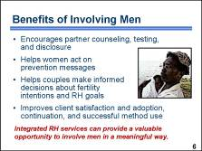 | As mentioned on the previous slide, offering integrated services may also make them more appealing to men and male partners. Individual providers and programs, whether integrated or not, should make an effort to reach out to men with reproductive health messages and services. Involving men in family planning and other RH programs could have several benefits. █  Male partner cooperation and participation can:  - Encourage male partners to seek HIV counseling and testing and support disclosure of both partners’ HIV status █  - Help women to act on HIV prevention messages delivered through RH services █  - Help couples to make joint informed decisions about their fertility intentions and reproductive health goals including STI/HIV prevention strategies █  - Improve client satisfaction and the adoption, continuation, and successful use of a contraceptive method █  Although attracting men to RH services often presents a challenge, integrated RH services offer a valuable opportunity to reach men and involve them in RH decisions in a more meaningful way. █  Discussion question:  What efforts are being made to involve men in programs and services at your facility?  Photo credit: ©1990 Media for Development International, from It’s Not Easy (film)/courtesy of Photoshare
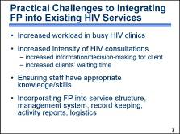 | Just as there are potential benefits to integrating family planning into existing HIV services there are also potential challenges. █  Integrating family planning services increases the workload of providers in busy facilities. Provider “burn out” due to unrealistic job expectations can become very costly for programs that fail to consider the implications – especially in facilities that regularly experience staffing shortages and high rates of staff turnover. █  Integrating family planning services can also increase the intensity of HIV consultations for both the provider and the client. It increases the amount of information that the provider must share and expands the number of issues that a client must consider and decide. As providers spend more time with each client, the clients’ waiting time also increases. █  Ensuring that a sufficient number of staff with appropriate knowledge and skills are available to meet the increased demand for the integrated services presents another challenge. To ensure high-quality family planning services, providers must develop the skills necessary to offer family planning counseling, initiate contraceptive methods, manage possible side effects, and understand when and where to refer clients who require additional help. █  Programs that integrate family planning must consider how existing services will be re-structured to accommodate the new services – which providers will offer the services, where and when will they be offered, and how community members and existing clients will learn that the services are available. Program managers and administrators must facilitate the integration of services by adapting the existing record keeping, activity reporting, and logistics systems within the facility to ensure that accurate client records are maintained; family planning commodities, supplies, and storage facilities are available; and supportive supervision to providers is offered on an ongoing basis. █  Discussion question:  What additional potential benefits or practical challenges to integrating FP and HIV services exist in your community? At the facility where you work?

PowerPoint Presentation 6. Reproductive Health Rights of Individuals with HIV

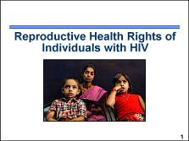 | In this session we will discuss the sexual and reproductive rights of individuals with HIV and the importance of ensuring that clients with HIV are permitted to make free and informed RH choices. We will also consider how stigma and discrimination affect whether clients with HIV can exercise their reproductive rights. █  Note to facilitator:  Information about the reproductive health rights of individuals with HIV is included in the Participant Manual, page 20.  Photo credit: ©2004 P. Mustafa/courtesy of Photoshare
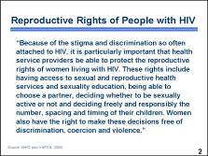 | This statement is taken from the document Sexual and Reproductive Health of Women Living with HIV/AIDS: Guidelines on Care, Treatment and Support for Women Living with HIV/AIDS and Their Children in Resource-Constrained Settings. It concisely describes the reproductive rights of women with HIV and highlights the important role that providers serve in protecting those rights and ensuring that women with HIV are not subjected to stigma and discrimination.  Please take a moment to read the statement:  “Because of the stigma and discrimination so often attached to HIV, it is particularly important that health service providers be able to protect the reproductive rights of women living with HIV. These rights include having access to sexual and reproductive health services and sexuality education, being able to choose a partner, deciding whether to be sexually active or not and deciding freely and responsibly the number, spacing and timing of their children. Women also have the right to make these decisions free of discrimination, coercion and violence.” █  Discussion question:  As a provider, is it your duty or job to protect the rights of clients with HIV? Explain your response.
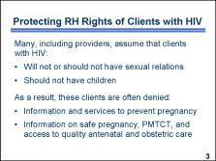 | Many people, including providers, incorrectly assume that individuals with HIV will not be interested in or involved in sexual relationships. They may also believe that people with HIV should not have children. █  As a result of these biases, women are often denied the information and services that they need to prevent pregnancy, plan a safe pregnancy, and prevent mother-to-child transmission of HIV. Provider biases combined with a client’s fear of stigma and discrimination may limit access to family planning services and antenatal and obstetric care. █
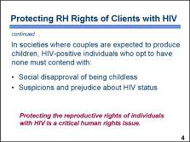 | In societies where couples are expected to produce children, HIV-positive individuals who decide to have no children must contend with social disapproval from their families and communities. In these situations, childlessness gives rise to suspicions of HIV infection and results in an individual being ostracized. █  For these reasons, protecting the reproductive rights of individuals with HIV is critical to ensuring that their basic human rights are secured. █  Discussion question:  What other factors might influence or interfere with an HIV-positive individual gaining his or her reproductive and sexual rights?
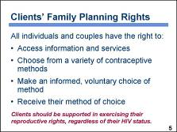 | When providing health care services, providers should respect the rights of all their clients, regardless of their HIV status. With regard to family planning, a client’s rights include the right to decide whether to use family planning and which contraceptive method to use. █  To exercise that right, all individuals and couples should:  - Have access to information and services, free of any barriers. Barriers to access can be geographic, economic, administrative, medical, psychosocial, or cognitive (that is, not knowing where to obtain services). █  - Have a variety of modern contraceptive methods from which to choose. Each person’s method preference is influenced by a number of factors that need to be considered during counseling. █  - Be supported to make an informed, voluntary choice of contraceptive method. █  - Receive the contraceptive method of their choice whenever possible. Research has shown that a woman who receives her contraceptive choice is more likely to continue using the method. █  Women with HIV should be able to exercise their reproductive rights freely, whether they choose to plan a pregnancy, space their children’s births, or limit childbearing. █
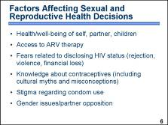 | For individuals with HIV, there are many factors that can influence sexual and reproductive health decisions – including decisions about whether or not to use contraception. █  For a woman with HIV, these factors may include her own health, her partner’s health, and her children’s health. █  It may also include whether she and her partner have access to long-term ARV therapy. █  Another important factor is whether a woman feels she can disclose her HIV status to her partner or family without risking rejection, violence, or financial loss. █  Cultural myths and misconceptions may also play a role in decision-making. For example, some women may believe that they cannot get pregnant because of HIV infection. █  Fear of disclosing their HIV status, and the stigma generally associated with condom use, makes many clients reluctant to discuss condom use with their partners. █  Gender issues often affect decisions about contraception and STI/HIV prevention. Partner opposition is one of the most common reasons women cite for not beginning or continuing to use contraception.  It is important to involve men in decision-making whenever possible because reproductive health decisions are more likely to be implemented when they are made jointly by both partners. Clear information about contraceptive methods is essential for women and couples to make an informed choice.  When providers are aware of the factors that can affect a client’s decisions and understand the power of these influences, they are better equipped to ensure that clients are making the best possible decisions. █  Discussion questions:  What other factors may affect a client’s decision to use contraception? Are there other myths related to HIV that are prevalent in your community that may affect a client’s decision to use contraception?  Note to facilitator:  Although some studies demonstrate that fertility among women with HIV may be reduced, they can still get pregnant. Evidence suggests that the most important reason for reduced fertility is co-infection with other sexually transmitted infections. STIs frequently cause pelvic inflammatory disease, which may lead to infertility. Among women whose HIV infection has progressed to AIDS, reduced coital frequency may also contribute to lower fertility.
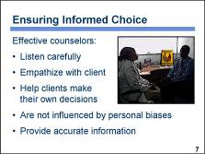 | Providers are the key to ensuring that clients’ rights are guaranteed. █  Effective counselors:  - Listen carefully to the client’s questions and concerns █  - Empathize with the client’s situation █  - Help clients make their own reproductive health decisions █ without letting personal biases influence the information they present to clients █  Such providers give clients accurate information to enable them to choose the method that best suits their needs and give information that allows clients to use their chosen method safely and effectively.  Specific issues to consider when counseling clients with HIV will be discussed in a later session. █  Photo credit: Apophia Karanja/FHI
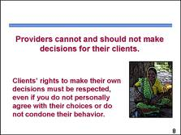 | It is of utmost importance that clients be allowed to make their own decisions. █  Clients are in the best position to decide what is right for them and their particular situation. Providers are obligated to ensure that clients can make an informed decision. Providers then must abide by that decision regardless of whether they personally agree with it or not. █  Discussion question:  In your experience, what happens when clients are not allowed to make their own decisions?  Photo credit: Irina Yacobson/FHI
PowerPoint Presentation 7. Reproductive Choices and Decisions for Clients with HIV

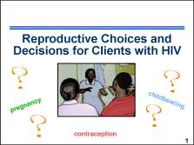 | Women with HIV and their partners often need to make a variety of reproductive health decisions about pregnancy, childbearing, and contraceptive practice. They should be free to make these reproductive choices for themselves, just as other women and couples do. However, being HIV-positive may make women more vulnerable to societal, religious, or family pressures than women without HIV. Counselors must take special care to ensure that women with HIV do not feel coerced or pressured into making certain reproductive choices.  In this session, we will look at reproductive choices and decisions and consider why some women with HIV might desire pregnancy while others want to avoid childbearing. █  Note to facilitator:  Information about the reproductive choices and decisions for clients with HIV is included in the Participant Manual, page 24. The Counseling Tool (flip book) includes pages that providers can use with clients while clients are considering whether to get pregnant or use contraception.  Photo credit: ©2001 Moctar Ouedraogo/courtesy of Photoshare
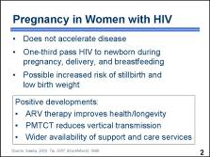 | Based on current research findings, it appears that pregnancy in women with HIV does not accelerate progression of the disease.  However, pregnancy often carries serious consequences for the infants. Without treatment, about one-third of HIV-positive mothers pass the virus to their newborns during pregnancy, delivery, and breastfeeding.  Some evidence suggests that pregnancy in women with HIV increases the risk of stillbirths and infants with low birth weight. Nonetheless, for many couples with HIV who choose to conceive, the perceived benefits of having a child outweigh the increased risk of adverse pregnancy outcome. █  Three positive developments – the impact of ARV therapy on the health and longevity of many people with HIV; the increasing availability of effective means for reducing mother-to-child HIV transmission; and wider availability of support and care services for families dealing with HIV – may encourage women with HIV to reconsider decisions about sex, relationships, and childbearing. █  Discussion questions:  What concerns have you heard about women with HIV becoming pregnant? Do these concerns reflect what research has demonstrated to be true or are they myths that need to be dispelled?
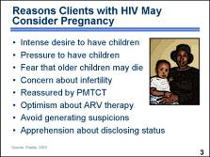 | The reasons why many women with HIV consider pregnancy include: █  - An intense desire to bear children █  - Societal, familial, and other relationship pressures to have children █  - Fear that the children they already have may die █  - Concern about reduced fertility related to HIV infection █  - Reassurance that PMTCT programs reduce the risk of having an HIV-positive child █  - Expectations of receiving ARV therapy and living long enough to see their children grow up █  - Concern that avoidance of pregnancy might generate suspicion about one’s HIV status █  - Fear that the potential consequences of disclosing one’s HIV-positive status to a partner might include violence, abandonment, and loss of finances for children █  Discussion question:  How do the reasons shown on this slide compare with the reasons generated by the small group discussion?  Photo credit: ©2004 Paul Wood/courtesy of Photoshare
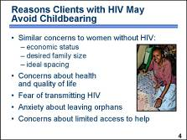 | On the other hand, many sexually active women with HIV might not want to bear children and therefore desire contraception. █  Their reasons to avoid or postpone pregnancy are often the same as those of women who are not HIV-positive: maintaining family economic status, achieving desired family size, and healthy spacing and timing of the births of their children – at least 24 months apart.  A woman with HIV may also want to avoid childbearing for other reasons, such as: █  - Concern that pregnancy will further compromise her health, especially if it is already compromised by AIDS-related symptoms. Her partner or spouse may be HIV-positive or have symptoms. In the absence of ARV therapy and treatment for opportunistic infections, the length and quality of life may be severely compromised. █  - Fear of transmitting HIV to children she might conceive. █  - Fear of leaving orphans, because HIV infection is likely to shorten her life, particularly without treatment. Parents are naturally concerned about who will care for their children if they are no longer able to do so. █  - Fear that others will be unwilling to care for the family during illness, due to AIDS-related stigma and discrimination. █  Discussion question:  How do the reasons shown on this slide compare with the reasons generated by the small group discussion?  Photo credit: ©2004 Paul Wood /courtesy of Photoshare
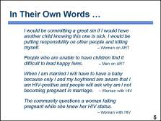 | These are statements shared by individuals with HIV. Let us take a moment to review them. █  Discussion questions:  Have any of your clients with HIV discussed concerns similar to the ones expressed here? What sort of things have you heard clients say?
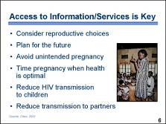 | In both resource-poor and resource-rich countries, women who learned that they have HIV reported lower desired fertility levels than did women in the general population. However, HIV-positive women’s knowledge of contraception and their access to family planning services can be limited. █  Such services help women with HIV consider their reproductive choices, plan for the future, avoid unintended pregnancy, time pregnancy when health is optimal, and reduce HIV transmission to their children. Contraceptive counseling sessions also offer opportunities for prevention counseling to reduce the chances that women will transmit HIV to their partners.  The next slide shows that, when provided access, women with HIV will use family planning. █  Photo credit: ©1998 Bulima Resource Centre/courtesy of Photoshare
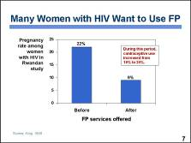 | When family planning services are made available and accessible to women with HIV, many women use them. As shown in the chart, the one-year incident pregnancy rate among women with HIV participating in a voluntary counseling and testing program in Rwanda was 22 percent before family planning was offered. After family planning services were introduced, the rate dropped to  9 percent. █  During this period, contraceptive use increased from 16 percent to 24 percent. █  Discussion question:  What are the family planning needs among women with HIV in your community?
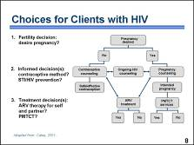 | Providers should help clients with HIV realize their reproductive health goals by structuring services that are customized to fulfill their needs, including either pregnancy counseling and services or accurate, unbiased counseling about contraception and access to the client’s method of choice. In addition, all clients should receive counseling and information about HIV and AIDS and possible treatment options. █  Depending on the circumstances, the decisions a provider should guide a woman through may include:  - A decision about fertility: Is pregnancy desired at this point in time or not? █  - If pregnancy is not desired, there are reproductive health decisions, such as which contraceptive method to choose and what to do about STI/HIV prevention. █  - If pregnancy is desired, there are decisions about how to achieve pregnancy safely with minimal risk of transmission. If pregnant, there are decisions about PMTCT and considerations related to breastfeeding and the risk of HIV transmission.  - If ARV therapy is available: Is it indicated and desired? █  Discussion question:  Think about the last client or couple that you counseled with HIV. Did your interaction facilitate a decision-making process like the one depicted here? Describe what you might do differently to ensure that clients understand the options available to them.
PowerPoint Presentation 8. Contraceptive Options for Women and Couples with HIV

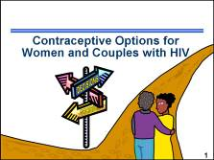 | An individual’s decisions about contraception are shaped by many factors. It is important for providers to understand these factors so that they can help women and couples with HIV make informed decisions about which method to use. In this activity, we will explore factors that may shape these decisions and discuss contraceptive options for women and couples with HIV. █  Note to facilitator:  Information on contraceptive options for women and couples with HIV is included in the Participant Manual, page 26. The Counseling Tool (flip book) also includes pages that providers can use to help clients consider which method features are best suited to an individual’s situation and to explain method effectiveness.
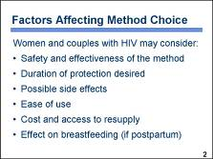 | Factors that women and couples with HIV may consider when they decide which contraceptive method to use include: █  - How safe and effective the method will be █  - Whether the method meets a desire for short-term, long-term, or permanent protection █  - Possible side effects of the method █  - How easy it will be to use █  - Whether the method is affordable and access to resupply is easy █  If a woman is postpartum, the effect that the method may have on breastfeeding could also play a role. █
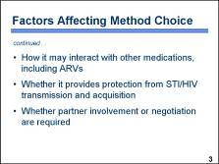 | Other factors that may affect method choice include:  - How it may interact with other medications, including ARVs █  - Whether it provides protection from STI/HIV transmission and acquisition █  - Whether partner involvement or negotiation are required █  Discussion question:  Compare the factors included on these two slides with the issues raised during the brainstorming on ideal contraceptive features. Are there any factors on the slides that were not raised during the brainstorming, and do you agree that these factors may affect method choice? [If participants agree that the factors might influence a client’s decision, add the factors to the flip chart.]
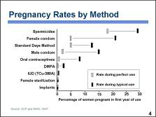 | For women who want to avoid childbearing, contraceptive method effectiveness (how well a method works) is one of the most important characteristics for choosing a method. As depicted in this chart, contraceptive failure can occur with any method; however, some methods are more effective than others. This slide shows pregnancy rates for various contraceptive methods. The grey (red) rectangles show pregnancy rates for perfect use, reflecting how often a contraceptive method fails when it is used both correctly and consistently. The black (blue) rectangles show pregnancy rates for typical use, reflecting how often a contraceptive method fails in real-life situations, when it may not always be used correctly and consistently. Typical use rates vary depending on user characteristics, user behavior, the adequacy of counseling, and access to resupply.  Differences between correct and typical use rates are greater for some methods than for others. Client-controlled methods may have low pregnancy rates with correct and consistent use but higher pregnancy rates with typical use. For example, combined oral contraceptives have a pregnancy rate of 0.3 percent when used correctly and consistently but a pregnancy rate of 8 percent with typical use. In contrast, the pregnancy rates for typical use of intrauterine devices, or IUDs, or injectable contraceptives are almost the same as those for their correct and consistent use because the effectiveness of these methods depends little on user behavior. For example, the TCu-380A IUD has a pregnancy rate of 0.6 percent with correct and consistent use and a rate of 0.8 percent in typical use. When considering the pregnancy rates for various methods, keep in mind that women who use no method at all have a risk of pregnancy as high as 85 percent over one year. █
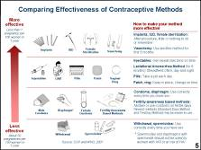 | This illustration provides a method for sharing information on contraceptive method effectiveness with clients. Clients tend to find this depiction of method effectiveness easy to understand. Given the importance of method effectiveness as a factor in clients’ decision-making about contraceptives, it may be helpful to use an aid like this when counseling clients about possible methods. █  Note to facilitator:  The Counseling Tool (flip book) includes this graphic on page 17. Fact Sheet 12. If 100 women use a method for one year, how many will become pregnant? (included with the course materials) offers an alternative for sharing information with clients about method effectiveness.
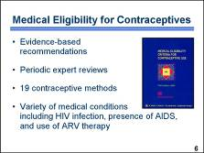 | As just reviewed, the characteristics of contraceptive methods and how these fit with an individual’s lifestyle influence a client’s decisions about method choice. Another consideration is whether the client has any medical conditions that would make the use of a particular method unsafe. █  Several years ago, WHO assembled a team of experts to review the available evidence and organize the findings in a manner that could be readily used by providers to determine a client’s medical eligibility for a particular method. The recommendations of the expert review team are summarized in the document Medical Eligibility Criteria for Contraceptive Use. We will refer to them hereafter as the MEC. █  The team of experts meets periodically to review new research findings and update their recommendations. The most recent version, the third edition, was published in 2004. Additional changes to the MEC were introduced in April of 2008. These changes are reflected in the technical information included in this Toolkit.  The document provides guidance on the safety of 19 contraceptive methods for women and men with specific characteristics or known medical conditions. These characteristics and conditions range from age, smoking, and parity to cardiovascular disease, cancer, and infections. Of particular interest to users of this curriculum are the recommendations related to infection with HIV, the presence of AIDS, and the use of ARV therapy. We will discuss these recommendations in detail as we review each method. █
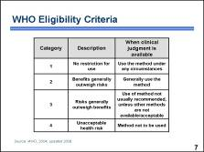 | For each contraceptive method, medical conditions are classified into categories based on the risks and benefits associated with use of the method among women with those conditions. █  The MEC uses four categories to classify medical conditions: █  - Category 1: For women with these conditions, the method presents no risk and can be used without restrictions. █  - Category 2: For women with these conditions, the benefits of using the method generally outweigh the theoretical or proven risks. Women with category 2 conditions generally can use the method, but follow-up by the provider may be appropriate in some cases. █  - Category 3: For women with these conditions, the theoretical or proven risks of using the method generally outweigh the benefits. Women with category 3 conditions generally should not use the method. However, if no better options for contraception are available or acceptable, the provider may judge that the method is appropriate, depending on the severity of the condition. In such cases, ongoing access to clinical services and careful follow-up by the provider are required. █  - Category 4: For women with these conditions, the method presents an unacceptable health risk and should not be used.  In some cases, a particular condition is assigned to one category for initiation and another for continuation of the method. In other words, the category may depend on whether a woman with the condition wishes to initiate the contraceptive method or was already using that method when she developed the condition. █
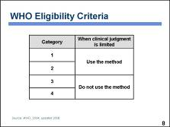 | In situations where clinical judgment is limited, such as community-based distribution programs, the four-category classification framework can be simplified into two categories. █  When simplified for these situations, categories 1 and 2 indicate that the method can be used, █  while categories 3 and 4 indicate that the woman is not medically eligible to use the method.  The next slide provides some examples from the WHO recommendations. █
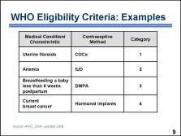 | This table includes a few examples from the WHO recommendations to demonstrate how methods and medical conditions are categorized. For instance, the recommendations state that: █  - Women with uterine fibroids who wish to use combined oral contraceptives, or COCs, can use them without restrictions, as this method presents no risk to women with this condition. █  - Women with anemia who wish to use an IUD can generally use the method because the benefits of using the IUD generally outweigh the theoretical or proven risks associated with the effect that IUD use may have on increased blood loss and anemia. Follow-up by the provider may be appropriate in some cases. █  - Women who are breastfeeding a baby less than six weeks postpartum generally should not use Depo-Provera, also known as DMPA, because of theoretical concerns that the infant may be at risk due to exposure to steroid hormones during the first six weeks postpartum when the infant’s liver may not be fully capable of metabolizing the hormone. █  - Among women with current breast cancer, the use of hormonal implants is unacceptable and should be avoided. This is because breast cancer is a hormone-sensitive tumor, and hormonal use may accelerate growth.  The Quick Reference Chart for the WHO Medical Eligibility Criteria for Contraceptive Use is included with the course materials. It provides an easy reference to some of the more common conditions or characteristics that may affect a client’s medical eligibility for three methods: COCs, DMPA, and IUDs. We will refer to it hereafter as the MEC quick reference chart. █  Discussion questions [Instruct the participants to use the MEC quick reference chart to answer the following questions and explain their responses.]:  If a breastfeeding woman with a three-week old infant wishes to use COCs, would she be medically eligible?  If a woman with diabetes and vascular disease wishes to use DMPA, would she be medically eligible?  If a client with unexplained vaginal bleeding wishes to continue using the IUD, would she be medically eligible?  If a client with no children wishes to start using COCs or DMPA, would she be medically eligible?
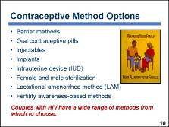 | Contraceptive options for women with HIV are similar to those of women without HIV and include barrier methods; hormonal methods; the IUD; female and male sterilization; the lactational amenorrhea method, also known as LAM; and fertility awareness-based methods. █  As we will discuss in upcoming sessions, most of these methods are appropriate for women and couples with HIV. █  Discussion questions:  From your knowledge of HIV and AIDS, are there any methods included on this list that are a surprise to you? What method(s) do you believe that couples with HIV should avoid? Why?  Illustration source: JHU/CCP and IPPF, Planning Your Family (flip chart cover)

PowerPoint Presentation 9. Condoms

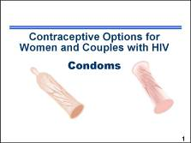 | We begin the in-depth discussion of contraceptive methods with condoms – both male and female. █  Note to facilitator:  Additional information on condoms, can be found in the Participant Manual, page 29, and on Fact Sheet 1. Male and Female Condoms, in the Participant Manual, pages 103–104. The Counseling Tool (flip book) also includes information that providers can use with clients to help describe how to use male and female condoms, pages 19–24.  Illustration credit: Salim Khalaf/FHI
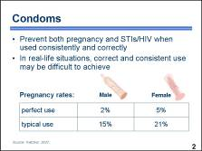 | We will start with condoms first because they are the only method that has the ability to prevent transmission of STIs/HIV and prevent pregnancy. However, the effectiveness for both pregnancy and STI/HIV prevention depends greatly on the client’s ability to use condoms consistently and correctly.  In real-life situations, correct and consistent use may be difficult to achieve. Condoms may not be used with every act of intercourse or are sometimes used incorrectly. █  When used correctly every time a couple has intercourse, the male condom has a pregnancy rate as low as 2 percent, and the female condom has a rate of 5 percent. In common use, their pregnancy rates are much higher – around 15 percent for the male condom and 21 percent for female condom. █  Note to facilitator:  Researchers attribute the 5 percent perfect-use pregnancy rate for the female condom to misreporting by users who thought that the condom was used correctly when it was not. Although the female condom may be used consistently with each act of intercourse and inserted correctly, it is possible for the male partner to insert his penis on the outside of the condom without the couple noticing it.  Illustration credit: Salim Khalaf/FHI
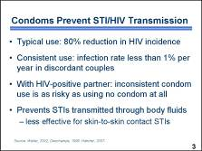 | Condoms are the only method proven to reduce the risk of all STIs, including HIV. █  One recent review of multiple studies found that typical condom use results in an 80 percent reduction in HIV incidence, a level of protection slightly less effective than for pregnancy. █  The most conclusive evidence of condom effectiveness in reducing HIV transmission has come from studies of serodiscordant couples, in which one person is HIV-positive and the other person is not. One study demonstrated that with consistent condom use, the HIV infection rate among the uninfected partners was less than  1 percent per year. █ However, in situations where one partner is definitely HIV-positive, inconsistent condom use was shown to be as risky as not using condoms at all – 13.3 percent of inconsistent users became infected compared to 14.4 percent of non-users. █  Condoms are most effective in preventing STIs that are transmitted through bodily fluids, such as HIV, gonorrhea, and chlamydia. They are less effective against STIs that are transmitted through skin-to-skin contact, such as genital herpes and warts, because the condom may not cover the entire affected area. █
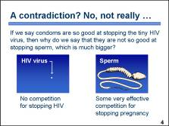 | Some may argue that advice about the effectiveness of condoms is contradictory – especially when comparing STI/HIV transmission and pregnancy prevention. We promote the condom as being very effective at stopping HIV, yet, when it comes to pregnancy prevention, we say it is not as effective. How can this be the case when the condom stops HIV and sperm the same way? This apparent contradiction exists because condoms currently have no competition for stopping HIV but, have some very effective competition for stopping pregnancy. Condoms require correct and consistent use, which depends in a large part on the cooperation of a partner, whereas some other methods of contraception require virtually no action on the part of a client and no partner cooperation to be almost 100 percent effective. With the condom’s pregnancy prevention rate at about 85 percent in typical use – they are obviously not as effective as some other methods of contraception. These facts can sometimes give the impression among providers and clients that condoms are not worth the bother. However, condoms remain the only method capable of preventing the spread of STIs/HIV – especially when used consistently and correctly. While other methods are very effective at preventing pregnancy, they have zero effect on preventing STI/HIV. For these reasons, dual method use may be a good option for individuals who wish to prevent both STIs/HIV and pregnancy. █  Discussion questions:  Have any of your clients expressed concern over this apparent contradiction? If yes, how do you explain it to them?  Illustration credit: Family Health International
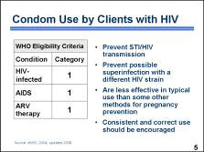 | The MEC classifies the conditions HIV-infected, the presence of AIDS, and use of ARV therapy as category 1 for condom use, meaning that condoms can be used without restrictions. █  Male and female condoms are the only methods that prevent HIV and STI transmission between partners. █  They can also prevent transmission of a different HIV strain to a person who is already HIV-positive, known as superinfection. █  As typically used, condoms are less effective for pregnancy prevention than some other methods, while other methods provide no protection from STIs/HIV. █  For these reasons, counseling of clients or couples should focus on strengthening their ability to consistently and correctly use condoms, either alone or in combination with another method, to prevent both STI/HIV and pregnancy. █
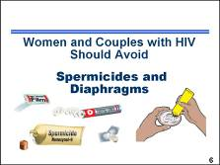 | The next several slides discuss other barrier methods which – unlike condoms – are not suitable options for clients with HIV. █  Illustration credit: Salim Khalaf/FHI
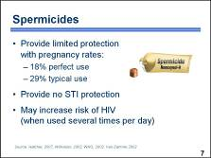 | Spermicides alone offer only limited protection from pregnancy. Failure rates for spermicides vary from 18 percent when used consistently and correctly to 29 percent with typical use. In typical use, spermicides are not used on some occasions or are used incorrectly. █  Spermicides containing nonoxynol-9 do not protect against HIV infection or other STIs. █  Spermicides may even increase the risk of HIV infection in women using these products frequently. This may be because nonoxynol-9 can disrupt the epithelium, or lining, of the vagina, thereby facilitating invasion by an infective organism. Advise women who have multiple daily acts of intercourse to choose another method of contraception. █  Illustration credit: Salim Khalaf/FHI
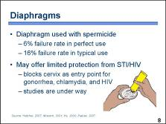 | In typical use, diaphragms are associated with relatively high rates of pregnancy. When diaphragms are used with spermicides, as recommended, about 6 percent of users experience an unintended pregnancy during the first year with correct and consistent use, while the failure rate for typical use is about 16 percent. █  It is possible that diaphragms offer limited protection from STIs, including HIV. This is because a diaphragm blocks entrance to the cervix, and gonorrhea and chlamydial infection are acquired in the cervix but not the vagina. The cervix is also an entry point for many HIV infections because the endocervical lining is thinner and more fragile than the lining of the vagina, and therefore more vulnerable to infection. Studies are under way to determine whether the diaphragm reduces the risk of transmission of HIV or other STIs. █  Illustration credit: Salim Khalaf/FHI
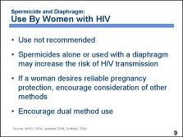 | The MEC does not recommend the use of spermicides and diaphragms with spermicides for women with HIV or AIDS. █  Women with HIV or AIDS, including those who receive ARV treatment, should generally not use spermicides because they may be at increased risk of infection with another strain of HIV, also known as superinfection. Documented instances of superinfection, while rare, have been associated with faster disease progression and failure of antiretroviral therapy. █  If a woman with HIV desires reliable pregnancy protection, she should be encouraged to consider other, more effective methods of contraception. █  Because spermicides provide no protection against transmitting STIs/HIV, and it is not clear whether and to what extent the diaphragm provides protection, condom use should be encouraged to prevent infection transmission between partners. █

PowerPoint Presentation 10. Dual Protection = prevent pregnancy + avoid STI/HIV

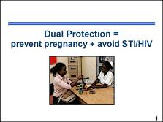 | This presentation describes dual protection – the process of preventing both pregnancy and STI/HIV infection. █  Note to facilitator:  Additional information on dual protection can be found in the Participant Manual, page 31. The Counseling Tool (flip book) also includes information on page 16 that providers can use with clients to counsel them about ways to avoid both pregnancy and STIs/HIV.  Photo credit: Richard Lord
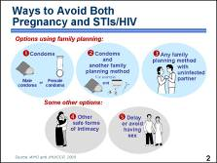 | Dual protection – avoiding pregnancy and STIs/HIV – can be achieved in several ways: █  First, consistent and correct use of condoms is very effective for contraception, and condoms are the only method that also protects against STIs/HIV. When using this option, emergency contraception should be available to prevent pregnancy should a condom accident occur. █  Second, using male or female condoms plus another family planning method – also known as dual method use – provides increased protection from pregnancy. █  Third, any contraceptive method can be used if two individuals are uninfected and each one has no other sexual partners. If a couple is discordant, the uninfected partner is at risk of HIV infection. If both partners are HIV-positive, there is some risk of reinfection with a different strain of HIV. █  Some additional options include sexual intimacy that is satisfying but does not transmit STIs or HIV – which means avoiding contact with a partner’s semen or vaginal secretions. █  Finally, delaying or avoiding sexual activity, also known as abstinence, is another safe choice. If a client chooses option 4 or 5, advise the client to keep condoms on hand should sex occur.  On the next several slides, we will discuss option 2, dual method use, in more detail. █  Note to facilitator:  When discussing option 2, reinforce that male and female condoms should not be used together. When discussing option 4, clarify that it does not include anal or oral sex without condoms, which many people dangerously believe is safe because it cannot lead to pregnancy and health workers and educational materials almost never mention it. Unprotected anal sex is especially risky, with the highest risk for STI/HIV transmission; it is also quite common, as many people use it as a traditional family planning method. Oral sex has a much lower risk of HIV transmission than anal or vaginal sex, but there is still a risk of transmission of other STIs. The risk of STI/HIV transmission is greatly reduced by using condoms during anal and oral sex.
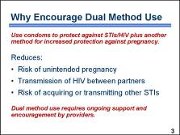 | To review, dual method use refers to a couple using a condom to protect against STIs/HIV plus using another method for increased pregnancy prevention. █  Dual method use helps to reduce:  - The risk of unintended pregnancy, especially for individuals who need reliable protection from pregnancy that is not partner dependent  - The transmission of HIV between partners, including the transmission of a different strain of HIV to a partner already infected with HIV  - The risk of acquiring or transmitting other STIs █  Dual method use may not be easy to achieve. It requires ongoing support and encouragement by providers. █
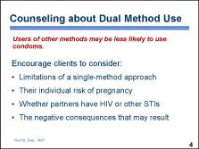 | Dual method use is an effective way to prevent both unintended pregnancy and STIs, including HIV. But studies have suggested that women with HIV who use more effective contraceptive methods are less likely to use condoms, even with a noninfected partner. █  These study results reinforce the importance of providers helping clients to understand the benefits of dual method use by considering the following:  - The limitations of a single-method approach  - Their individual risk of pregnancy and the implications of an unintended pregnancy  - Whether their partners have HIV or another STI  - The negative consequences of acquiring or transmitting HIV, especially as resistant strains of the virus emerge  When counseling about dual method use, the provider is responsible for helping clients determine what method(s) will be effective for them and how confident they are that a partner will use condoms. Providers must also help clients consider what adjustments may need to be made over time because as personal situations change, a client’s need for protection may change as well. █
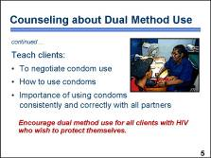 | Because clients often find it difficult to negotiate condom use with their partners, it is important for providers to teach skills for negotiation of condom use and the correct use of condoms. This is typically done using demonstrations and role-plays to simulate some of the more challenging obstacles clients may encounter when negotiating with their partners. When possible and with the client’s consent, partner or couple counseling on the importance of condom use can also be an effective approach. █  Men who may have intercourse with multiple partners should be counseled to use condoms even when a female partner is using another method of contraception. The advice to use condoms in addition to another method is particularly important for discordant couples. However, concordant couples, where both partners are HIV-positive, should also use condoms to avoid STIs and superinfection with another HIV strain.  Next, we will discuss other contraceptive methods that could be used either alone for pregnancy prevention or in combination with condoms for dual protection against pregnancy and STIs, including HIV. █  Discussion question:  In addition to discordant couples, describe other situations where dual method use may be appealing to an individual client or couple.  Photo credit: William Finger/FHI

PowerPoint Presentation 11. Hormonal Contraceptives –
Considerations for Women with HIV and AIDS

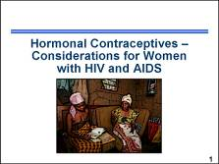 | In this session we will consider the topic of hormonal contraceptives and learn about the theoretical issues regarding the interaction between hormonal contraceptives and ARV drugs and how hormonal methods may affect HIV transmission, acquisition, and disease progression. █  Note to facilitator:  Additional information on hormonal contraceptives for women with HIV and AIDS can be found in the Participant Manual, page 38, in the PowerPoint presentations about each method (refer participants to the note-taking pages included in the Participant Manual), and on the contraceptive method Fact Sheets included in the Participant Manual, pages 105–110. The Counseling Tool (flip book) also includes pages that providers can use with clients who have HIV and AIDS to address any concerns these clients may have about using various hormonal contraceptive methods.  Photo credit: Richard Lord
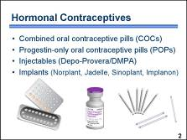 | Hormonal contraceptives include combined oral contraceptive pills that contain the hormones estrogen and progestin, and a group of methods that contain only progestin and no estrogen. This group includes progestin-only oral contraceptive pills, or POPs; injectables such as Depo-Provera (also known as DMPA); and implants such as Norplant, Jadelle, Sinoplant, and Implanon. █  Note to facilitator:  If there are other hormonal methods available in your country, include them in the list – for example, NET-EN (Norigynon) and combined injectables (Cyclofem).  Illustration credits: Salim Khalaf/FHI; Brian Morris/TenPlus Systems
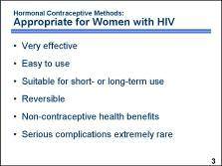 | Hormonal methods are appropriate for women with HIV, and most offer excellent pregnancy protection. █  Pregnancy rates for injectables and implants are less than one-half percent in both perfect and typical use. Oral contraceptives can also be very effective when women remember to take pills on schedule. █  Hormonal methods are easy to use, especially injectables and implants, which require very little action on the part of the client. █  Implants offer long-acting protection for up to five years, while other methods are suitable for both short- and long-term use. █  All hormonal methods are reversible, although fertility return with DMPA may take somewhat longer than with other methods. █  All hormonal methods offer some health benefits, including but not limited to reduced risk of reproductive tract cancers, anemia, and clinical pelvic inflammatory disease. █  In addition, serious complications are extremely rare with hormonal methods, especially if women meet the eligibility criteria for initiating use.  While hormonal methods are appropriate for women with HIV, several biological concerns regarding the relationship between hormonal contraceptives and HIV exist. These concerns continue to be an important area of research, as new evidence becomes available, changes to some existing family planning practices may be warranted. Now, we will look more closely at the theoretical concerns surrounding the use of hormonal contraceptives by women with HIV. █
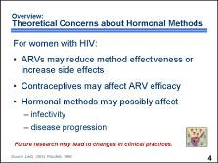 | Some antiretroviral drugs can reduce or increase blood levels of contraceptive hormones. Theoretically, lower concentrations could reduce the effectiveness of hormonal contraceptives, while higher concentrations could increase hormone-related side effects. █  Similarly, contraceptives may affect the efficacy of some ARV drugs. █  Other issues that require further research include possible effects of hormonal contraception on HIV-positive women’s infectivity and possible relationships between hormonal contraception and HIV disease progression.  It is important to balance these concerns, which are primarily theoretical, against the real risk of unintended pregnancy and its impact on maternal and infant morbidity and mortality. █  On the next several slides, we will consider each of these issues and how they might affect the use of different hormonal methods. To help reinforce which issues are theoretical – meaning that these issues are still being researched – this graphic appears on each slide where theoretical concerns are discussed. Future research may lead to changes in clinical practices. █
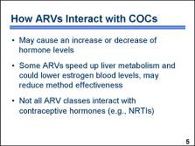 | A few, small pharmacokinetic studies have examined the use of certain ARV therapies with limited courses of combined oral contraceptives. █  These studies showed both positive and negative effects on hormone levels. █  The main concern about COCs is that some ARVs affect liver enzymes, which then speed up liver metabolism of contraceptive hormones and could lower blood levels of the hormones. The reduced concentrations of contraceptive hormones in blood theoretically may lead to reduced effectiveness of hormonal contraceptives and increased risk of pregnancy. █  Not all classes of ARVs interact with contraceptive hormones because not all ARVs affect liver enzymes. Drugs that do not affect liver enzymes, and therefore probably do not affect hormonal contraceptives, include NRTIs. Drugs that affect liver enzymes include NNRTIs some of which may reduce blood concentration of contraceptive hormones by approximately 20 percent, and ritonavir-boosted protease inhibitors which may reduce concentrations of contraceptive hormones by as much as 40 percent. █  The charts on the next two slides summarize what is known to date. █
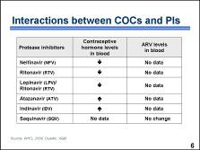 | Concerns about interactions with hormonal contraceptives focus on protease inhibitors shown here, and NNRTIs, described on the next slide. This chart summarizes the interactions that were observed in the levels of contraceptive steroids and protease inhibitors. Notice that in some cases the contraceptive steroid levels decreased while in other cases, they increased.  Limited evidence suggests that ritonavir-boosted protease inhibitors decrease blood concentrations of contraceptive hormones by as much as 40 percent. Although there is no evidence yet of the clinical significance of this interaction, scientists believe that this level of reduction in the blood concentration of contraceptive hormones is likely to reduce the effectiveness of oral contraceptives. In contrast, an increased level of contraceptive hormone may theoretically increase the risk of side effects associated with hormonal contraceptives.  At this time, there is not sufficient data on how blood levels of protease inhibitors may be affected by contraceptive hormones among women who take COCs. █  Note to facilitator:  Limited studies show that:  - Nelfinavir reduces estrogen by 47 percent and progestin by 18 percent.  - Ritinovir reduces estrogen blood level by  40 percent.  - Lopinavir/ritinovir reduces estrogen by  42 percent.  - Atazanavir increases estrogen by 48 percent.  - Indinavir increases estrogen by 22 percent.
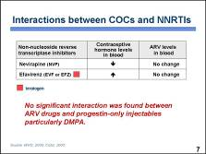 | The chart shows the effects that were observed in the levels of contraceptive steroids and NNRTI drugs when they are taken concurrently. In the case of nevirapine, one study demonstrated a 20 percent decrease in plasma concentration of hormonal contraceptives among women taking concurrent estradiol/norethindrone and nevirapine. While clinical significance of such interaction is unclear, we do know that ultra-low-dose, 20 microgram, oral contraceptives – which contain two-thirds the amount of estrogen found in regular low-dose oral contraceptives – are widely used in countries where they are approved, and highly effective if taken correctly.  In the case of efavirenz, an increase in plasma concentration of hormonal contraceptives was observed. No changes in the blood concentrations of the ARV drugs were found. █  Although most of the existing research examines the interaction between ARV drugs and combined oral contraceptives, there is limited research that looks at interactions between ARV drugs and DMPA. Based on information currently available, no significant interaction was found between ARV drugs and progestin-only injectables particularly DMPA. █  Note to facilitator:  Limited studies show that:  - Nevirapine, on average, reduces the blood level of estrogen by 20 percent.  - Efavirenz increases the blood level of estrogen by 37 percent.
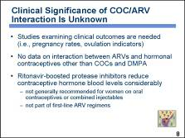 | Currently, concerns about reduced effectiveness of hormonal contraceptives due to interactions with ARV drugs are based on blood levels of contraceptive hormones and not on clinical outcomes, such as pregnancy rates or indicators of ovulation. █  Additionally, while there is limited evidence on COCs and DMPA, no studies have been completed to clarify possible interactions between ARVs and other hormonal contraceptives, including combined injectables, vaginal rings, patches, progestin-only pills, emergency contraceptive pills, progestin implants, or progestin intrauterine systems. █  It is unlikely that the effectiveness of contraceptive methods is appreciably affected when the blood levels of the hormones are only somewhat reduced, as in the case of the NNRTI, nevirapine. However, with ritonavir-boosted protease inhibitors, the reduction is considered significant enough to decrease contraceptive effectiveness. █ This is why the 2008 WHO working group decided that ritonavir-boosted protease inhibitors generally should not be used by women taking oral contraceptives or combined injectables. For other types of ARVs, more restrictive changes to clinical guidelines will not be considered unless there is sufficient evidence that the interaction increases the risk of contraceptive method failure. █  It is important to realize that ritonavir-boosted protease inhibitors are not currently recommended by WHO as part of a first-line ARV regimen and thus are not as commonly used as other ARV drugs.  Now, we will look more closely at the relationship between hormonal contraceptives, STI acquisition, and HIV transmission. █
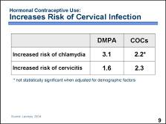 | It appears that use of hormonal contraceptives may increase the risk of acquiring cervical STI infections, which, as you will see on the next several slides, may have some implications for women with HIV. A ten-year prospective study of HIV-positive Kenyan sex workers found that use of hormonal contraceptives was associated with a significantly increased risk of cervical chlamydial infection and cervicitis, even after controlling for demographic factors and sexual behavior. Compared to women who used no hormonal contraceptives, women using DMPA had a threefold increased incidence of cervical chlamydial infection and a 1.6-fold increased incidence of nonspecific cervicitis. Women using oral contraceptive pills had more than double the increased incidence of nonspecific cervicitis. Use of hormonal contraceptives was not associated with an increased incidence of gonorrhea infection, however. █
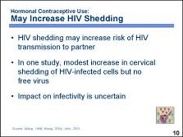 | A theoretical concern also exists that hormonal contraceptive use by women with HIV could increase HIV shedding, therefore increasing risk of HIV transmission to an uninfected partner. However, data are conflicting about such a relationship. Some studies showed no increase in HIV shedding. Other data suggest that more HIV shedding does occur when women are using hormonal contraception. █  One prospective study conducted among family planning clients in Mombasa, Kenya, detected a modest but statistically significant increase in cervical shedding of HIV-infected cells. Cervical shedding in women with HIV rose from 42 percent to 52 percent after initiation of various hormonal contraceptives. However, no difference was detected in the amount of cell-free virus in genital secretions. █  The relative impact of HIV-infected cells versus cell-free virus on infectivity is uncertain. The presence of both in maternal cervical secretions and in breast milk has been found to increase the risk of vertical transmission. █
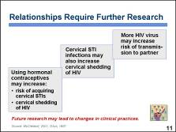 | Let us take a closer look at the relationship between the theoretical concerns raised on the last few slides. █  It appears that use of hormonal contraceptives may increase the risk of acquiring STIs and the cervical shedding of HIV. █  It is also known from research studies that cervical STIs increase HIV shedding in cervical secretions, even in women who are not using hormonal contraceptives. █  The increased amount of virus may in turn increase the risk of HIV transmission to a sexual partner. █  While some concern about an increased risk of HIV transmission among users of hormonal contraceptives is warranted, more data are needed before any changes to current service delivery guidelines are considered. █
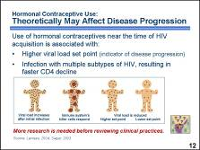 | Some studies have also raised concerns that hormonal contraceptives may affect disease progression in women with HIV. In a prospective cohort study of HIV acquisition among 1,337 sex workers in Mombasa, Kenya, the use of DMPA at the time of HIV infection was associated with a higher viral load set point.  Viral load set point is an important indicator of HIV disease progression. █ As illustrated in this simple graphic, after a person initially becomes infected, his or her viral load increases. █ The killer cells of the immune system respond to the HIV virus by attacking infected cells, █ lowering the viral load to a certain level. This level is known as the viral set point. The higher the viral load set point, the faster HIV-related deterioration of the immune system occurs. Thus, the Mombasa study findings suggest that DMPA use may hasten the natural course of HIV infection. █  Similarly, Kenyan sex workers using hormonal contraceptives near the time of HIV acquisition were more likely to be infected with multiple genetically diverse subtypes of the same virus than sex workers not using hormones. Infection with multiple subtypes appears to be related to a higher viral set point and to faster CD4 decline, which is another key indicator of HIV disease progression. █  Many of the studies on hormonal contraception and HIV disease progression have been conducted among sex workers in Kenya, and some of the findings have not been corroborated by other studies. Therefore, further research among other populations of women in other geographic locations is needed before any changes to service provision guidelines are made. █
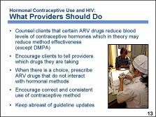 | Given what is currently known about hormonal contraception and HIV, providers should: █  - Counsel their clients that certain ARV drugs reduce the blood concentration of contraceptive hormones, which theoretically may reduce the effectiveness of hormonal contraceptive methods – with the exception of DMPA.  - Encourage clients to always tell their health care providers which medications they are taking. Although a client may not currently be using any drugs that compromise method effectiveness, at some point she may need to switch contraceptive methods to be eligible for other treatment regimens, for example, if ritonavir is added to her ARV regimen. █  - When possible, prescribe ARV drugs that do not interact with hormonal contraceptives. █  - If this is not possible, encourage women to be very careful about using the methods correctly and consistently, and to consider using condoms for additional protection. █  - Keep abreast of updates to clinical practice guidelines. As new research on these and other related topics becomes available, technical experts and policy-makers will make appropriate changes to clinical practice guidelines. For example, the available research on HIV disease progression and possible increased risk of transmission among hormonal contraceptive users is not conclusive. Until additional research on these topics can provide decisive information, there is no reason to change clinical practice or to counsel clients about these theoretical concerns. █  Photo credit: Karl Grobl

PowerPoint Presentation 12. Combined Oral Contraceptive Pills (COCs)

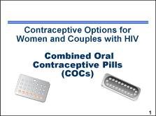 | Oral contraceptives have been used by women for more than 30 years to prevent millions of unintended pregnancies throughout the world. They are currently used by more than 84 million women worldwide, half of whom live in developing countries. █  Note to facilitator:  Note-taking pages for this presentation are included in the Participant Manual, page 43. Additional information on COCs can be found on Fact Sheet 2. Combined Oral Contraceptives (COCs), in the Participant Manual, pages 105–106. The Counseling Tool (flip book) also includes information on pages 25–28, that providers can use with clients who are interested in using COCs. The Checklist for Screening Clients Who Want to Initiate Combined Oral Contraceptives and the MEC quick reference chart are tools that can be used to help determine which clients are medically eligible to use COCs.  Illustration credit: Salim Khalaf/FHI
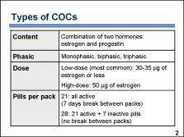 | COCs can differ in hormone content, dosage, and number of pills per pack. █  All combined pills contain both synthetic estrogen, usually ethinyl estradiol, and one of the various types of progestin. █  The most common combined pill is monophasic, where the hormone content is constant in all  21 active pills. COCs also exist as biphasic and triphasic pills, where the ratio of estrogen to progestin varies among the active pills two or three times during the cycle. There are no clinically significant differences in effectiveness or safety between multiphasic and monophasic pills. █  Both the type and the amount of hormone contained in each formulation of pill are related to its potential for side effects. High-dose pills containing 50 to 150 micrograms (µg) of estrogen were commonly used until the late 1970s. Today, those pills have been replaced by low-dose pills which generally contain 30 to 35 µg of ethinyl estradiol. Some types of low-dose pills contain as little as 20 µg of estrogen. █  COCs are packaged with either 21 or 28 pills per pack. The 21-pill pack contains only active pills and requires women to take a seven-day break between packs. The 28-pill pack contains 21 active pills and seven inactive or hormone-free pills. These inactive pills often contain iron and are included to minimize the risk of women forgetting to start a new pack of pills on time after a seven-day break. The seven-day period, when no active pills are taken, is called the “hormone-free interval.” █  Discussion questions:  What brands of pills are available in the facility where you work? Describe the various brands of pills available using the characteristics in the slide (e.g., Lo-Femenal is a monophasic combined pill that comes in 28-day packs. Each of the white tablets in the pack contain 30 µg ethinyl estradiol and 300 µg norgestrel. The seven brown tablets contain ferrous fumarate). [If participants identify pill brands that are progestin-only and/or packaged for emergency contraception, be sure to clarify the differences between those products and COCs.]
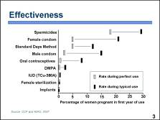 | Combined oral contraceptives are very effective when taken correctly and consistently. This chart compares the pregnancy rates for COCs with the rates for other contraceptive methods. The grey (red) rectangles show pregnancy rates for correct and consistent use, reflecting how often a contraceptive fails when it is used both correctly and consistently. The black (blue) rectangles show pregnancy rates for typical use, reflecting how often a contraceptive fails in real-life situations, when it may not always be used correctly and consistently.  In the case of COCs, there is a substantial difference between pregnancy rates for correct and consistent use and typical use. As the chart shows, the pregnancy rate for correct and consistent COC use is less than one percent. However, under typical use conditions, the pregnancy rate is about eight percent. █
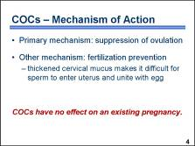 | The primary mechanism of action of COCs is the suppression of ovulation. The release of an egg, which commonly occurs in the middle of the menstrual cycle, is prevented by COCs. █  In the very rare cases where ovulation may occur, another contraceptive mechanism of COCs acts to prevent fertilization. COCs have an effect on the cervical mucus. The progestin contained in COCs causes the cervical mucus to become thick and prevents sperm penetration; the sperm cannot pass through the cervix and fertilization cannot take place. █  COCs do not work by disrupting an existing pregnancy and have no adverse effect on a woman or a fetus if accidentally taken by a woman who is already pregnant. █  Discussion questions:  In your community, what do women believe about how pills work? For women who are interested in this method, how will you explain the mechanism of action?
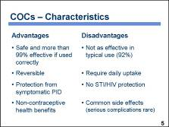 | The safety and effectiveness of contraceptive pills have been proven through extensive studies – in fact, COCs are the most widely studied drug ever prescribed. When used correctly and consistently, their pregnancy prevention rate is greater than  99 percent. █  Unfortunately, in typical use, COCs are often not used correctly. This results in lower effectiveness of about 92 percent. █  The protection offered by contraceptive pills is reversible, and when pills are discontinued, fertility returns quickly, making them good options for planned childbearing. █ However, because the effects of COCs wear off rapidly, oral contraceptives require daily pill taking. █  Oral contraceptives provide some protection from symptomatic pelvic inflammatory disease (PID), █ but offer no protection from the acquisition of sexually transmitted infections (STIs) that affect the lower reproductive tract. █  Contraceptive pills have many non-contraceptive health benefits. █ They also have some side effects that some women find difficult to tolerate. Oral contraceptives are associated with adverse health risks for a small number of women, but these are extremely rare.  On the next few slides, we will consider the non-contraceptive health benefits and common side effects in greater detail. █  Discussion questions:  Which advantages and disadvantages do you think women in your community find most important when making a choice to use COCs? Why do you think those are the most influential? Do you notice any differences in preferences among subgroups of women (e.g., youth, women with multiple children, women with HIV)?
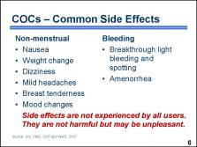 | Women who take COCs can experience certain side effects. Although these side effects may be unpleasant or unacceptable for some women, they are generally not medically harmful. █  Common side effects include nausea, sudden weight changes among a few women when they start or stop COCs, dizziness, mild headaches, breast tenderness, and mood swings. █  Combined pills may also cause bleeding changes. Most women experience a reduction in the amount of menstrual bleeding. The majority of women have regular menstrual bleeding while taking COCs; however, some women may experience amenorrhea while others have breakthrough bleeding – that is, bleeding between periods. This bleeding ranges from spotting to light bleeding episodes. Because some cultures or religions restrict sexual and religious activities during menstruation, breakthrough bleeding may interfere with a woman’s daily life. Breakthrough bleeding is generally not harmful to a woman’s health. Studies show COCs have no negative effect on hemoglobin or iron levels and may even help prevent iron-deficiency anemia. █  Not all side effects are experienced by all COC users, and many users do not experience any. Typically, side effects diminish within a few months after a woman begins COC use. Because these side effects may have an important impact on users’ experience with COCs, they should be addressed during counseling. █  Discussion questions:  Which potential side effects do you think women in your community find most influential when making a choice to use COCs? Why do you think those are the most significant?
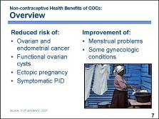 | Combined pills offer many benefits. █  COCs have been shown to reduce the risk of ovarian cancer, cancer of the endometrium, and functional ovarian cysts. They are known to lower a woman’s chances of having an ectopic pregnancy and acquiring symptomatic pelvic inflammatory disease or PID. █  They can also improve menstrual problems and some gynecologic conditions such as endometriosis or heavy painful menses.  We will discuss some of these benefits in detail in the next slide. █  Photo credit: Richard Lord
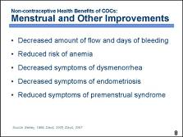 | Studies show that combined oral contraceptives decrease the amount of menstrual flow and the number of days of menstrual bleeding. They help make cycles more regular and predictable.  About 90 percent of women taking COCs experience regular monthly cycles, and the amount of bleeding is reduced, on average, by 50 percent. █ Because less bleeding occurs each month, and because some inactive pills contain iron, pill users have a reduced risk of iron-deficiency anemia. █  COCs are also prescribed for treatment of gynecologic conditions including dysmenorrhea, which is painful and prolonged menses, and endometriosis. █ Endometriosis is a condition in which endometrial tissue is found outside the uterus, leading to lower abdominal pain. By suppressing the growth of extrauterine endometrial tissue, COCs can decrease the symptoms of endometriosis. █  COCs can also reduce premenstrual syndrome, or PMS, the unpleasant symptoms many women experience before their periods, such as fatigue, anxiety, tension, and cramps. █  Discussion question:  To your knowledge, have any of your clients ever based their decision to use COCs on the non-contraceptive health benefits? Please explain.
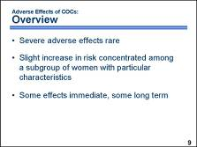 | COCs have been associated with some serious adverse effects, or complications, which occur very rarely. █  These potential adverse effects include the risk of cardiovascular disease, breast cancer, cervical cancer, and liver cancer. Studies show that contraceptive pills do not increase the risk of any form of cancer or cardiovascular disease for most women, but there may be a slight increase in risk among a small subgroup of women with particular characteristics; for example, women who have risk factors for cardiovascular disease, such as smoking, being overweight, or having family history of cardiovascular disease. Medical eligibility criteria are designed to help identify women who should not use the method because they have conditions that make use unsafe. █  Some adverse effects, such as cardiovascular problems, may occur immediately, while others take years to occur. These adverse effects will be discussed in more detail on the following slides. █  Discussion question:  To your knowledge, have any of your clients ever based a decision not to use COCs on concerns about adverse effects? Please explain.
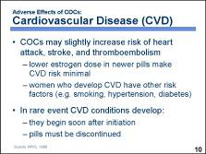 | The estrogen component of the combined pill may slightly increase the risk of cardiovascular disease, or CVD, including thromboembolism, myocardial infarction or heart attack, and stroke. However, these circulatory system diseases are rare in young women. █ In addition, the estrogen component of the pill has been progressively reduced over the past few decades. Because of their lower estrogen content, currently used low-dose pills do not present a significant cardiovascular risk for most women. █  It is now known that reproductive-age women who experience events such as heart attack, stroke, and thromboembolism typically have other risk factors for these conditions, such as hypertension, diabetes with vascular conditions, or smoking. COC use among women with these risk factors increases the risk of serious cardiovascular disease outcomes. However, COCs rarely lead to CVD problems among women without risk factors. █  In the rare event that cardiovascular conditions or complications develop, they may begin soon after a woman initiates COC use and will require her to discontinue taking pills. Later in this presentation, we will discuss specific symptoms that may indicate cardiovascular disease. █
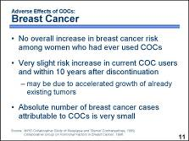 | Several studies, including a multicenter collaborative study by WHO, show no overall increase in the risk of developing breast cancer at any age among women who have ever used COCs. █  More recently, the Collaborative Group on Hormonal Factors in Breast Cancer published a study that includes a reanalysis of data from  54 independent studies conducted in 25 countries. The study found a very slight increase in the risk of breast cancer in women while they were taking COCs and during the 10 years after stopping the use of COCs. Researchers speculate that these findings may be due to an accelerated growth of already existing tumors or to an earlier detection of breast cancer in COC users. █  Because breast cancer is relatively uncommon during the reproductive years when women are most likely to use COCs, and because the potential elevations in risk are small, the absolute number of breast cancer cases potentially attributable to COCs is also small and could be offset by the known protective effect of COCs against ovarian and endometrial cancer. █
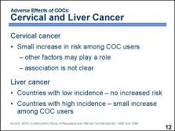 | Studies have also found a small increase in the risk of acquiring cervical cancer among COC users.  Cervical cancer risk is affected by multiple factors, including smoking, high-risk sexual behaviors, and initiating sex at young age. Since cervical cancer is primarily associated with a sexually transmitted organism called human papilloma virus, or HPV, women who engage in high-risk sexual practices are more likely to be infected with this virus and as a result may be more likely to get cervical cancer.  Because cervical cancer risk is affected by many factors, it is difficult to isolate the role of COCs. It is not clear whether the association between COCs and cervical cancer is due to the biological effects of COCs or whether COC users engage in high-risk sexual behaviors more often than non-COC users. █  Evidence on COCs and liver cancer is limited and varies depending on the background prevalence of the disease in the population. In developing countries, the incidence of liver cancer is higher due to other risk factors such as hepatitis B. Studies of combined oral contraceptives conducted in countries where liver cancer is common show no increased risk with short-term use. Data on long-term use in those countries are too scarce to draw firm conclusions.  In countries where liver cancer is very rare, studies have shown a small increased risk associated with long-term COC use. █
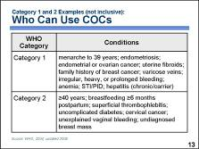 | COCs are safe for the overwhelming majority of women. The MEC identifies a number of medical conditions that do not prohibit COC use. █  According to the MEC, COCs can be used without any restrictions by women with category 1 conditions. For example, COCs can be used freely by women who are: past menarche and younger than 40 years; have endometriosis; endometrial or ovarian cancer; uterine fibroids; family history of breast cancer; varicose veins; irregular, heavy, or prolonged bleeding; iron-deficiency anemia; or an STI or PID. COCs are also safe for women who may have chronic hepatitis or be carriers of the hepatitis virus but do not have acute hepatitis disease. █  For women with category 2 conditions, the advantages of using the method outweigh the theoretical or proven risks. Thus, COCs can generally be used by women with category 2 conditions, but careful follow-up may be required in some cases. Examples of such conditions include being 40 years old or older, breastfeeding after six months postpartum, superficial thrombophlebitis, uncomplicated diabetes, cervical cancer, unexplained vaginal bleeding, and undiagnosed breast mass.  In settings where clinical judgment is limited, category 2 conditions are treated in the same manner as category 1 conditions, meaning that women with either category 1 or 2 conditions should be able to obtain and use COCs without restrictions. █  Discussion questions:  Use the MEC quick reference chart (included with the course materials) to find:  - Other Category 1 conditions that are not included in this slide (e.g., women who have no children, non-migrainous headaches/to initiate use, malaria, non-pelvic tuberculosis (TB), thyroid disease, cervical ectropion, high risk of HIV or HIV-infected, AIDS but not on ARVs, and use of antibiotics other than rifampicin or rifabutin)  - Other Category 2 conditions that are not included in this slide (e.g., smoking and less than 35 years old, non-migrainous headaches/to continue use, migraines without aura and less than 35 years old/to initiate use, sickle cell anemia, cholestasis related to pregnancy, acute hepatitis/to continue use, and taking NNRTIs for ARV therapy)  Remind participants that the quick reference chart is not a comprehensive listing of all the conditions that WHO has categorized. Participants can review the WHO guidelines for a comprehensive list and explanations.
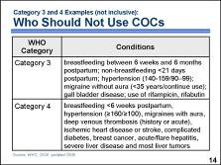 | While COCs are safe for the majority of women, a small number of women with certain characteristics or medical conditions are not considered good candidates for COC use. █  According to the MEC, COCs are not generally recommended for women with category 3 conditions, when theoretical or proven risks usually outweigh the advantages of using the method. Some examples of these conditions include: breastfeeding between six weeks and six months after delivery, non-breastfeeding and less than 21 days postpartum, blood pressure of 140–159/90–99 mm Hg, migraine without aura in women younger than 35 years who wish to continue use, symptomatic gallbladder disease when medically-treated and/or current, and use of the antibiotics rifampicin or rifabutin. Women with these conditions should not use COCs unless other, more appropriate methods are not available or acceptable. Careful follow-up will be required. █  Women with category 4 conditions should not initiate and use COCs because of unacceptable health risks. Examples of these conditions include: breastfeeding during the first six weeks postpartum; blood pressure of 160/100 mm Hg or higher; migraines with aura; history of or acute deep venous thrombosis; ischemic heart disease or stroke; complicated diabetes; current breast cancer; acute/flare hepatitis (category 3 or 4 depending on severity); severe cirrhosis; malignant liver tumors; or benign liver tumors, with the exception of focal nodular hyperplasia (which is a tumor that consists of scar tissue and normal liver cells).  In settings where clinical judgment is limited, category 3 conditions are treated in the same manner as category 4 conditions, meaning that women with either category 3 or 4 conditions should not initiate and use COCs. █  Discussion questions:  Use the MEC quick reference chart (included with the course materials) to find:  - Other Category 3 conditions that are not included in this slide (e.g., smoking less than  15 cigarettes/day and more than 35 years old, migraines without aura and more than 35 years old/to initiate use, known hyperlipidemias, cholestasis related to OCs, and taking ritonavir for ARV therapy)  - Other Category 4 conditions that are not included in this slide (e.g., smoking more than 15 cigarettes/day and more than 35 years old, migraines without aura and more than 35 years old/to continue use, complicated valvular heart disease)  Remind participants that the quick reference chart is not a comprehensive listing of all the conditions that WHO has categorized. Participants can review the WHO guidelines for a comprehensive list and explanations.
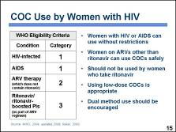 | Let us take a closer look at the conditions and categories pertaining to clients with HIV or AIDS.  WHO advises that women with HIV who may or may not have AIDS can use COCs without any restrictions – category 1. According to WHO, women with AIDS who are on antiretroviral therapy generally can use COCs as long as their antiretroviral regimen does not contain ritonavir or ritonavir-boosted protease inhibitors. █  While the evidence on interactions between COCs and ARVs is still very limited, there are some data that suggest that ritonavir reduces the blood levels of contraceptive hormones to a much greater extent than other ARV drugs. ARV drugs other than ritonavir, are classified as category 1 or category 2; category 1 includes NRTIs and category 2 includes NNRTIs and PIs other than ritonavir. However, because ARV therapy is a multi-drug regimen and the regimen always contains a category 2 drug, ARV therapy – so long as it does not contain the drug ritonavir – is classified as a category 2 meaning that women on ARV therapy can generally use COCs although follow-up may be required in some cases. █  If a woman on ARVs other than ritonavir chooses COCs, providing the standard low-dose pills, containing 30 to 35 micrograms of estrogen, is appropriate if she will take them consistently. Although some providers suggest using high-dose COCs with 50 micrograms of estrogen to compensate for a theoretical reduction in effectiveness, no studies have compared the effectiveness of high-dose versus low-dose COCs in women on ARV therapy. Also, higher-dose COCs may result in more side effects or complications. █  A sensible approach may be to use condoms consistently as a backup method of contraception while taking low-dose COCs.  Regardless of the method chosen, counseling on condom use should be an integral part of contraceptive counseling for women with HIV because the condom is the only method that prevents STI/HIV transmission between partners. █
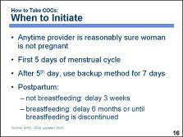 | A woman can start taking COCs anytime a provider is reasonably sure she is not pregnant. █  No backup method is necessary if a woman initiates COC use during the first five days after the onset of her menstrual period. Since it takes time for COCs to become fully effective, initiating use during the first five days allows them to fully suppress follicular development and prevent ovulation, ensuring that there is virtually no danger of pregnancy. █  If a woman starts COCs after the fifth day of her menstrual cycle, there is a chance she may ovulate before COCs become fully effective, so she should use a backup method for seven days. █  A woman who is not breastfeeding may begin COCs three weeks after delivery, when the increased risk of blood clotting associated with pregnancy subsides.  If breastfeeding, postpartum women may begin COCs at six months postpartum but preferably should wait until breastfeeding is discontinued. █  Discussion question:  In addition to a pregnancy test, what steps can a provider take to be reasonably sure that a client is not pregnant?  Note to facilitator:  Take this opportunity to introduce the checklists How to Be Reasonably Sure a Client Is Not Pregnant and the Checklist for Screening Clients Who Want to Initiate Combined Oral Contraceptives, included with the course materials. Mention that they will have opportunities to practice with these checklists during the counseling activities later in the training.
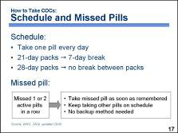 | After a woman starts taking COCs, she should take one pill each day, preferably at the same time of day. Failing to take the pill daily increases the risk of pregnancy. Women using the 21-pill pack take a seven-day break from pill taking each month. The 28-pill pack users take seven inactive pills during the hormone-free interval and do not take a break between pill packs. █  Women need advice about what to do if they forget to take a pill. If a woman misses one or two active pills in a row or starts a new pack one or two days late, she should take one missed pill as soon as she remembers. She should take the next pill in the pack at the regular time. Depending on when she remembers that she missed a pill(s), she may take  2 pills on the same day – one at the moment of remembering and the other at the regular time – or even at the same time. A backup method of contraception is not necessary when only one or two pills are missed. █  Note to facilitator:  The missed pill instructions on this slide apply to pills containing 30–35μg ethinyl estradiol – the most common formulation around the world. If very low-dose pills (containing 20μg or less ethinyl estradiol) are also available and used in your country, follow these instructions:  - If the woman misses one active pill (containing 20μg or less ethinyl estradiol) or starts a pack one day late, she should follow the guidance above for missing active pills (containing 30–35μg ethinyl estradiol) or starting a pack late.  - If the woman misses two or more active pills in a row (containing 20μg or less ethinyl estradiol) or if she starts a pack two or more days late, she should follow the guidance on the next slide for missing three or more active pills in a row (containing 30–35μg ethinyl estradiol) or starting a pack three or more days late.
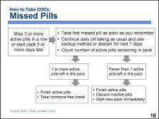 | Missing three or more active pills in a row – or starting a new pack three or more days late – increases a woman’s risk of unintended pregnancy. █ In this case, a woman should take a pill as soon as she remembers and continue taking pills, one each day. She should also either abstain from sex or use a backup form of contraception, such as condoms, until she has taken active pills for seven days in a row. █  She should also count how many active pills are left in the pack. If she has at least seven active pills, she should complete the pack and take her standard hormone-free break. █ If the woman does not have seven active pills remaining, she should finish the remaining active pills, discard the inactive pills, and start a new pack immediately. In this case, the woman will not bleed at her regular time.  If a woman misses three or more pills in a row in the first week and has unprotected sex, she may wish to consider the use of emergency contraception.  If a client continually forgets to take pills, she should talk with a provider. She may need to either learn strategies for becoming a more effective pill-taker or consider using another method. █  Discussion question:  What strategies do you share with your clients to help them remember to take their pills on schedule?
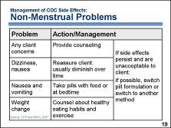 | Thorough counseling at the time COCs are provided often reduces the anxiety some women may feel when they experience side effects. If side effects do occur and are bothersome to the client, the first step of management is to address the client’s concerns through follow-up counseling. █  If a client experiences nausea or dizziness, it may be useful to tell the client that these symptoms do not indicate any dangerous conditions and usually diminish over time. █  Taking pills on a full stomach or at bedtime may help prevent nausea and vomiting. █  Counseling about healthy eating habits and exercise may help clients control their weight. █  If side effects persist, and are unacceptable to the client, health care providers may recommend switching to a different pill formulation or to another contraceptive method. █  Discussion questions:  What strategies do you use to ensure that your clients are prepared to deal with side effects (e.g., be sure that client is aware of potential side effects during counseling so that she can make a fully informed choice)? How do you balance alerting clients to potential side effects without creating too much concern (e.g., assure client that not all women experience side effects and that of the women who do, there are often things that can be done to alleviate the inconvenience)?
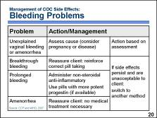 | If a client complains about changes in her menstrual cycle, providers should first try to assess the cause. If the client’s vaginal bleeding or amenorrhea is unexplained and suspicious – for example, if she developed these symptoms after using COCs for some time without having any menstrual side effects – the provider should check if the client is pregnant. If a woman experiences two consecutive cycles of amenorrhea, the possibility of pregnancy should be ruled out. The bleeding may also indicate a reproductive tract infection, uterine cancer, or other serious problems. Once a provider is reasonably sure that disease and pregnancy are not present, the provider may consider more common causes of bleeding and amenorrhea among COC users and follow the recommendations for addressing these conditions. █  In the case of breakthrough bleeding, the provider should first make sure the client is taking the pills correctly, without missing pills. If so, providers can explain that COCs make the uterine lining thinner, and it may start shedding early, resulting in this type of bleeding. The provider can assure a woman that this bleeding does not mean that anything is wrong and usually diminishes with time. █  If the breakthrough bleeding continues to be unacceptable to the client, or if the bleeding is prolonged, the provider may want to consider giving her ibuprofen, up to 800 mg three times per day for five days, or an equivalent amount of another non-steroidal anti-inflammatory drug other than aspirin. If available, providers may also switch the woman to another brand of pills with a more potent progestin, such as levonorgestrel. █  Amenorrhea may simply be a sign that the pills are working effectively. Reassure the client that it does not indicate a health problem and no medical treatment is necessary. █  If side effects persist and are unacceptable to the client, the provider should help her to choose another contraceptive method. █  Discussion question:  Do you use any different strategies to ensure that your clients are prepared to deal with possible bleeding changes (e.g., ask them to consider how their day-to-day schedule of activities might be disrupted by breakthrough or prolonged bleeding or amenorrhea)?
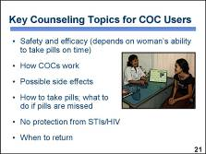 | After a client makes an informed choice to use combined oral contraceptive pills, and the provider determines that she has no known conditions that would prohibit use, the provider and client should discuss how to use COCs in greater detail and address any additional questions that the client may have about the characteristics of COCs. Specifically, they should discuss: how safe and effective COCs are, how efficacy is affected by a woman’s ability to take pills on time, how COCs work, possible side effects, how to take pills correctly, and what to do when pills are missed. The client and provider should also discuss the fact that COCs do not protect against STIs/HIV. During counseling, the provider should help the client to assess her risk of acquiring or transmitting infection and discuss the benefits and feasibility of condom use to reduce that risk. Providers should explain how to use condoms correctly and consistently and, if needed, help women develop strategies to negotiate condom use with their partners. Finally, the provider should discuss when to return – which is described in more detail on the next two slides. █  Photo credit: Karl Grobl
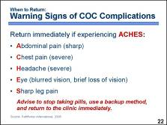 | On rare occasions, women who use COCs can develop serious complications, usually due to thrombosis or thromboembolism – a blood clot that may form in the blood vessels of the heart, brain, leg, or abdomen. Warning signs of such complications include: severe abdominal pain; severe chest pain or shortness of breath; severe headache with dizziness, weakness, numbness, or eye problems, such as temporary vision loss or blurred vision; and severe pain in the calf or thigh. █  If a woman taking COCs experiences any of these symptoms, she should stop taking pills, begin using a backup method and return to the clinic immediately. █  Discussion question:  What strategies do you use to ensure that your clients understand the warning signs of complications (e.g., a memory jogger other than ACHES that is more suited to women in your community – perhaps something in the local language)?
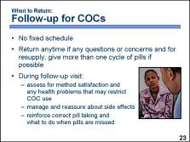 | Follow-up visits do not have to occur on a fixed schedule. █  In fact, scheduled follow-up visits are not necessary, but clients should be advised to return to the clinic anytime they have questions or concerns. Generally, consultation within the first two to six months can improve continuation among women experiencing common side effects, since this is when such problems are most likely to occur.  A follow-up visit is also a good time to replenish a woman’s supply of pills and her backup method, if needed. Whenever possible, the provider should give a woman more than one pack of pills and advise her to come for resupply before she runs out. █  During follow-up visits, the provider should ask if the client is satisfied with the method and if she has noticed any health problems that developed or got worse since she began taking COCs. If the woman has common side effects, the provider can reassure the client that they are not harmful and discuss ways to manage these side effects. If the client has developed any conditions that are considered contraindications for COC use, or if the client finds side effects unacceptable, the provider should help her to choose another method.  The provider should also assess whether a client is taking pills correctly and reinforce instructions on what to do when a pill or pills are missed. █  Discussion question:  In addition to follow-up visits at the clinic, what strategies do you or other providers at your facility use to support method continuation among clients (e.g., follow-up home visits by community health workers to address questions and resupply, reinforcing correct method use during other contacts such as well-baby visits)?  Photo credit: Richard Lord

PowerPoint Presentation 13. Injectable Contraceptives

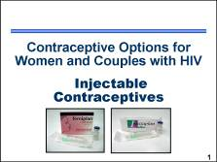 | Injectable contraceptives are safe and highly effective. Providers find that injectables are easy to administer, and many women find that they are convenient to use. More than 24 million couples throughout the world now use injectable contraceptives, and their use is increasing rapidly. █  Note to facilitator:  Note-taking pages for this presentation are included in the Participant Manual, page 49. Additional information on injectable contraceptives can be found on Fact Sheet 3. Progestin-Only Injectables, in the Participant Manual, pages 107–108. The Counseling Tool (flip book) also includes information on pages 29–32 that providers can use with clients who are interested in using progestin-only injectables. The Checklist for Screening Clients Who Want to Initiate DMPA or NET-EN and the MEC quick reference chart are tools that can be used to help determine which clients are medically eligible to use progestin-only injectables.  Photo credit: FHI (packaging from socially marketed DMPA in Kenya and Uganda)
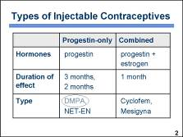 | Injectable contraceptives contain female sex hormones that are injected into muscle and released into the blood gradually, thereby providing contraception over a period of time. How long each type of injectable remains effective after an injection depends mainly on the types and amounts of hormones it contains.  There are two types of injectable contraceptives: █  - Progestin-only injectables contain only progestin, which is a synthetic form of the female sex hormone progesterone. They are administered every two or three months, depending on the product. █  - Combined injectables contain both progestin and estrogen. They are administered once per month. █  In this presentation we will focus on progestin-only injectables and specifically on DMPA, as it is more commonly used throughout the world. █  Discussion question:  What brands of progestin-only injectables are available in the facility where you work?
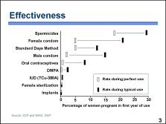 | Injectables are among the most effective methods of contraception. Typical one-year pregnancy rates in clinical trials are 0.3 percent or lower for both progestin-only and combined injectables. This chart compares the pregnancy rates for injectables with the rates for other contraceptive methods. The grey (red) rectangles show pregnancy rates for correct and consistent use, reflecting how often a contraceptive fails when it is used both correctly and consistently. The black (blue) rectangles show pregnancy rates for typical use, reflecting how often a contraceptive fails in real-life situations, when it may not always be used correctly and consistently.  In the case of injectables, there is very little difference between pregnancy rates for correct and consistent use and typical use. As the chart shows, other reversible contraceptive methods, such as barrier methods or oral contraceptives, may have low pregnancy rates with correct and consistent use but much higher rates with typical use.  With injectables, all a woman needs to do is receive her next injection on time. Because the effectiveness of injectables does not depend on daily user compliance, the pregnancy rates for injectables are quite low even with typical use.  Use of injectables results in about the same pregnancy rate as sterilization, a nonreversible method. The only other reversible methods with similar effectiveness in typical use are intrauterine devices, also known as IUDs, and progestin-only subdermal implants. █
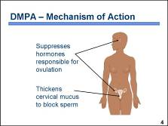 | Injectable contraceptives prevent pregnancy in at least two ways. Their primary mechanism of action is to suppress ovulation. The hormones in injectable contraceptives cause the hypothalamus and the pituitary gland to reduce production of the hormones that are necessary for ovulation. When there is no ovulation, there is no egg to be fertilized.  In addition, injectable contraceptives cause the cervical mucus to become thicker. The thicker mucus acts as a barrier to sperm, making it more difficult for sperm to enter the uterine cavity. In the unlikely event that a woman does ovulate, this mucus barrier greatly reduces the chance that the egg will be fertilized.  Injectables also thin the endometrium. Theoretically, this could reduce the chance that a fertilized egg would be implanted. However, injectable contraceptives are so effective in preventing ovulation and fertilization that there is little chance a fertilized egg will be present in the uterus. Thus, thinning of the endometrium is unlikely to play a role in the contraceptive effectiveness of injectables. █  Discussion questions:  What do women in your community believe about how injectables work? In the event that there are misconceptions about how injectables work, how can you explain the mechanism of action in simple terms?
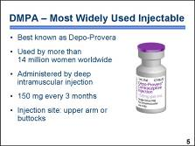 | DMPA, best known commercially as Depo-Provera, is used by an estimated 14 million women worldwide. Women using DMPA receive a deep intramuscular injection once every three months at a dose of 150 milligrams.  Injections may be given in the deltoid muscle of the upper arm or the gluteus muscle of the buttocks. The deltoid is generally more accepted by women and is more easily accessed by the provider. The choice should depend mainly on the woman’s preference.  The active ingredients in DMPA are suspended in water, so the vial must be lightly shaken to dissolve any sediment at the bottom. The injection site should not be massaged after the injection because that causes the hormone to be absorbed more rapidly than desired.  Following an injection, the hormone level remains high enough to prevent pregnancy for at least three months. █  Illustration credit: Brian Morris/TenPlus Systems
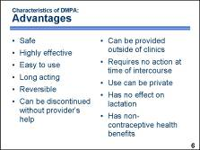 | DMPA offers a number of advantages. █ It can be used safely by most women, █ and it is among the most effective contraceptives available – pregnancy rates among injectable contraceptive users are .3 per 100 women during the first 12 months of use. █  It is easy to use correctly and consistently, in part because it requires no daily routine. █  DMPA is long acting. It is a reversible method of contraception, and it can be discontinued without the provider’s help. To discontinue, a woman simply stops receiving injections, and the level of DMPA in her blood gradually decreases. █  DMPA can be provided at convenient locations, such as at pharmacies or in homes, so its use need not require regular clinic visits. █  Use of DMPA requires no action at the time of sexual intercourse. Because no supplies are kept at home, its use can be private. █  DMPA has no effect on lactation, so it can be used by women who are breastfeeding. █  Another advantage is that it provides health benefits in addition to contraception. █  Discussion question:  Among your clients using DMPA, which advantages do you believe most influenced their decision and why?
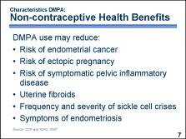 | In addition to preventing pregnancy, DMPA provides these health benefits to users:  - Reduced risk of endometrial cancer  - Reduced risk of ectopic pregnancy  - Reduced risk of symptomatic pelvic inflammatory disease, or PID  - Helps protect against uterine fibroids  - Reduced frequency and severity of sickle cell disease crises  - Reduced symptoms of endometriosis  DMPA is believed to have other health benefits, but these have not yet been confirmed by research. Because DMPA suppresses ovulation, it is also thought to prevent ovarian cysts. █
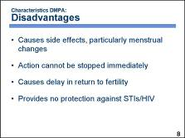 | The main disadvantage of DMPA is that it has common side effects – in particular, it causes menstrual changes in most users. These changes include prolonged or irregular bleeding or amenorrhea, which is the absence of menses. █  Because DMPA is long acting, its action cannot be stopped immediately if side effects develop or if the user wishes to become pregnant. After a woman’s last injection of DMPA, its level in the blood decreases gradually. █ For this reason, it takes longer for fertility to return after discontinuation of DMPA than after discontinuation of other contraceptive methods. █  Like other hormonal methods, DMPA offers no protection against sexually transmitted diseases, including HIV infection. █  Discussion questions:  Which disadvantages do you think women in your community find most influential when deciding to avoid using DMPA? Do the reasons for avoiding DMPA seem to vary between different subgroups of women (e.g., youth, women with multiple children, women with HIV)?
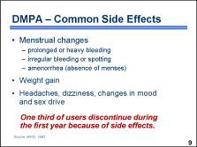 | The most commonly reported side effects of DMPA are menstrual changes, including prolonged, heavy, or irregular bleeding, spotting, and amenorrhea. █  DMPA users also commonly report weight gain. █  Less commonly reported side effects are headaches; dizziness; mood changes, such as anxiety; and changes in sex drive.  Typically, over 90 percent of DMPA users report at least one side effect during the first year of use. In most cases, none of these side effects result in health risks. Nonetheless, some side effects, such as changes in bleeding, may have serious practical and social consequences for women. █  In a large, multinational study conducted by WHO, about one-third of DMPA users discontinued this method in the first year because of side effects. The side effects that most commonly led to discontinuation were menstrual changes: 15 percent of users discontinued because of prolonged, heavy, or irregular bleeding; and about 12 percent discontinued because of amenorrhea. About 2 percent discontinued because of weight gain, and about 5 percent discontinued because of other side effects. █  Discussion questions:  Which potential side effects do you think women in your community find most influential when making a choice to use injectables? Why do you think those are the most significant?
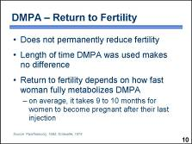 | DMPA does not permanently reduce fertility. However, it usually takes about four months longer for a woman to achieve pregnancy after discontinuing DMPA than after discontinuing other reversible contraceptive methods. █  The length of time a woman has used DMPA makes no difference in return to fertility. █  How long it takes for fertility to return depends on how long it takes the woman to metabolize fully the DMPA from her last injection. Because women differ in how they metabolize DMPA, there is considerable variability in how long it takes to become pregnant after discontinuation. █  On average, women can become pregnant nine to ten months after the last DMPA injection. Some women may become pregnant as soon as four months after the last injection, but a small percentage may take as long as 18 months. The difference in fertility between former DMPA users and former users of other contraceptives disappears approximately 16 months after discontinuation.  Because of the delay in return to fertility, women should be counseled to consider discontinuing DMPA several months before the time they want to conceive. They should be reassured that DMPA does not cause permanent infertility. █
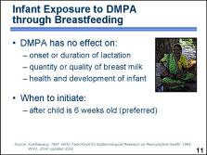 | DMPA has been used extensively by women who are breastfeeding. Studies have shown that DMPA has no adverse effects on:  - The onset or duration of lactation  - The quantity or quality of breast milk  - The health and development of nursing infants  DMPA is excreted through breast milk. A breastfeeding infant swallows a small amount of DMPA, which enters the child’s circulatory system. In newborn infants, the liver may not yet be mature enough to metabolize the DMPA received through breast milk. █  Therefore, it is recommended that a woman who is breastfeeding wait until her child is six weeks old before using DMPA. However, some providers prefer to initiate DMPA use immediately postpartum in cases where it would be difficult for the woman to return for the injection at the appropriate time. █  Photo credit: Irina Yacobson/FHI
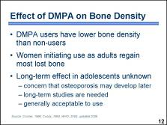 | Most studies have found that DMPA users have lower bone density than non-users, especially women age 21 or younger. A woman’s bones normally reach their maximum density during the teen years, but use of DMPA during adolescence prevents this. █  Women who start using DMPA as adults appear to regain most of the lost bone after they stop using DMPA. █  However, it is not yet known whether bone loss in adolescents and young women is completely reversible. If not, young women who use DMPA could have an increased risk of developing osteoporosis later in life. Long-term studies are needed to determine whether DMPA use increases the risk of osteoporosis, especially in women who begin using DMPA at a young age. Currently, DMPA use is considered to be generally acceptable for young clients, because the benefits of using the method outweigh the theoretical risk of osteoporosis. █
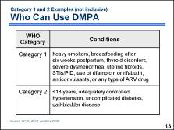 | DMPA is safe for the overwhelming majority of women. The MEC identifies a number of medical conditions that do not prohibit DMPA use. █  According to the MEC, DMPA can be used without any restrictions by women with category 1 conditions. For example, DMPA can be used freely by women who are heavy smokers; breastfeeding a baby older than six weeks; or have thyroid disorders, severe dysmenorrhea, uterine fibroids, or sexually transmitted infections, including current PID; or are using the antibiotics rifampicin or rifabutin, or anticonvulsants, or any type of ARV drug. █  For women with category 2 conditions, the advantages of using the method outweigh the theoretical or proven risks. Thus, DMPA can generally be used by women with category 2 conditions, but careful follow-up may be required in some cases. Examples of such conditions include being 18 years old or younger; having adequately controlled hypertension, uncomplicated diabetes, or any form of gall-bladder disease.  In settings where clinical judgment is limited, category 2 conditions are treated in the same manner as category 1 conditions, meaning that women with either category 1 or 2 conditions should be able to obtain and use DMPA without restrictions. █  Discussion questions:  Use the MEC quick reference chart (included with the course materials) to find:  - Other Category 1 conditions that are not included in this slide (e.g., women who are 18 to 45 years old; women who have no children, non-migrainous headaches, superficial thrombophlebitis, complicated valvular heart disease, malaria, non-pelvic tuberculosis (TB), iron-deficiency or sickle cell anemia, endometrial or ovarian cancer, cervical ectropion, endometriosis, mild cirrhosis, cholestasis related to pregnancy, hepatitis; or are at high risk of HIV, are HIV-infected, or have AIDS).  - Other Category 2 conditions that are not included in this slide (e.g., women who are more than 45 years old; have migraines without an aura; migraines with aura/to initiate use; a history of deep venous thrombosis (DVT); known hyperlipidemias; cervical cancer; an undiagnosed breast mass; an irregular, heavy, or prolonged bleeding pattern; mild cirrhosis; cholestasis related to OCs).  Remind participants that the quick reference chart is also not a comprehensive listing of all the conditions that WHO has categorized. Participants can review the WHO guidelines for a comprehensive list and explanations.
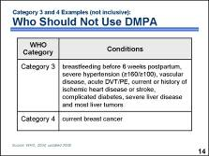 | While injectables are safe for the majority of women, a small number of women with certain characteristics or medical conditions are not considered good candidates for DMPA use. █  According to the MEC, DMPA is not generally recommended for women with category 3 conditions, when theoretical or proven risks usually outweigh advantages of using the method. Some examples of these conditions include: breastfeeding before six weeks postpartum; severe hypertension with blood pressure of 160/100 mm Hg or higher; vascular disease; acute deep venous thrombosis or pulmonary embolism (DVT/PE) – unless on established anticoagulant therapy; current or a history of ischemic heart disease or stroke; complicated diabetes; severe cirrhosis; malignant liver tumors; or benign liver tumors, with the exception of focal nodular hyperplasia (which is a tumor that consists of scar tissue and normal liver cells). Women with these conditions should not use DMPA unless other, more appropriate methods are not available or acceptable. Careful follow-up will be required. █  Women with category 4 conditions should not initiate and use DMPA because of unacceptable health risks. The only category 4 condition, or absolute contraindication for DMPA initiation and use, is current breast cancer. Women with a past history of breast cancer, with no evidence of disease for five years, are category 3.  In settings where clinical judgment is limited, category 3 conditions are treated in the same manner as category 4 conditions, meaning that women with either category 3 or 4 conditions should not initiate and use DMPA. █  Discussion question:  Use the MEC quick reference chart (included with the course materials) to find:  - Other Category 3 conditions that are not included in this slide (e.g., migraines with aura/to continue use, unexplained vaginal bleeding)  Remind participants that the quick reference chart is also not a comprehensive listing of all the conditions that WHO has categorized. Participants can review the WHO guidelines for a comprehensive list and explanations.
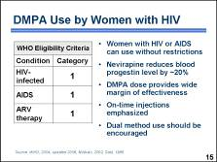 | Let’s take a closer look at the conditions and categories pertaining to clients with HIV or AIDS.  According to the MEC, DMPA can be used without restrictions by women with HIV, who may or may not have AIDS, and women on any type of ARV regimen – category 1. █  It has been demonstrated that nevirapine reduces the blood progestin level by about 20 percent. However, these reductions are most likely not enough to affect contraceptive efficacy. █  A dose of DMPA is high enough to provide a very wide margin of effectiveness. For example, a WHO study comparing 100 mg versus the usual 150 mg dose found that the lower dose also had excellent contraceptive effectiveness. If any reduced effectiveness occurs, it is likely to be at the end of the three-month dosing period, when blood levels of DMPA decrease. █  DMPA reinjection can generally be given as much as four weeks late. Providers should encourage all women to receive the next injection by the end of the three-month period to ensure maximum effectiveness. █  Women with HIV who choose to use DMPA should be counseled about dual method use and should consider using condoms in addition to hormonal methods. Condoms provide both additional protection from pregnancy in the event of late reinjection and protection from STI/HIV transmission between partners. █
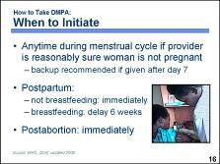 | DMPA can be initiated anytime during the menstrual cycle as long as the provider can be reasonably sure the woman is not pregnant. If DMPA is initiated during the first seven days of the menstrual cycle – where day one is the first day of bleeding – no backup contraceptive method is necessary. If the first injection is given at any other time, use of a backup contraceptive method for seven days following the injection should be considered. █  DMPA can be initiated immediately postpartum if the woman is not breastfeeding. Ideally, women who are breastfeeding should not start using DMPA until six weeks postpartum, because of the theoretical concern that newborn infants may not be able to metabolize DMPA received in breast milk. █  DMPA can be initiated immediately postabortion. █  Note to facilitator:  Take this opportunity to introduce the Checklist for Screening Clients Who Want to Initiate DMPA or NET-EN, included with the course materials. Mention that they will have opportunities to practice with these checklists during the counseling activities later in the training.  Photo credit: Angela Akol/FHI
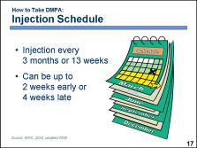 | A woman should receive an injection of DMPA once every three months or 13 weeks. The window for subsequent injections – how early or late the injection can be given while maintaining effective contraception – is up to two weeks early or four weeks late. If a woman returns more than four weeks late, she can receive an injection if the provider is reasonably sure she is not pregnant. The use of backup contraception for seven days should be considered, and the woman should be counseled that delaying injections increases the risk of pregnancy.  Women on ARV therapy should be encouraged to receive the next injection by the end of the three-month period. █  Discussion question:  How can you help clients return for reinjection on schedule?
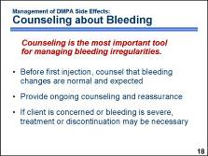 | Counseling is the most important tool for the management of prolonged, irregular, or heavy bleeding resulting from DMPA use. █  Women who are considering using DMPA should be counseled that such changes in bleeding are normal and expected and that they are not signs of disease or health problems. █  After injections begin, counseling and reassurance should be provided as needed. █  However, if the user continues to be concerned or if the bleeding is severe, medical treatment or discontinuation of DMPA may be necessary, especially in cases where the woman has pre-existing anemia. Women’s concerns over prolonged or heavy bleeding should never be disregarded or considered unimportant.  Counseling often may be the only intervention necessary. █  Discussion question:  Do you use any particular strategies to ensure that your clients are prepared to deal with bleeding changes (e.g., asking them to consider how their day-to-day schedule of activities might be disrupted by breakthrough or prolonged bleeding or amenorrhea)?
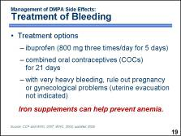 | If, despite counseling and reassurance, a woman finds spotting or light bleeding to be unacceptable, but the woman wants to continue using DMPA, treatment may be considered. █ Treat with a nonsteroidal, anti-inflammatory drug (NSAID), such as ibuprofen, to decrease uterine bleeding. The most commonly recommended dose is 800 milligrams three times per day until bleeding diminishes. Providers should advise women to take NSAIDs with food, not on an empty stomach. Aspirin should not be used because its anticoagulant effect can promote bleeding. █  For many women, prolonged or heavy bleeding diminishes with continued DMPA use. However, if a woman finds prolonged or heavy bleeding to be unacceptable, or if a provider is concerned that the bleeding is a threat to the woman’s health, the woman should discontinue the injectable and choose another method. In the interim, the provider may want to administer a low-dose combined oral contraceptive one pill per day for 21 days, if estrogen is not contraindicated. █  Very heavy bleeding occurs in 1.5 to 2 percent of DMPA users. If a woman experiences very heavy bleeding, it is important for the provider to rule out pregnancy, miscarriage, or gynecological problems such as fibroids. Providers must recognize that they may need to refer such women to higher levels of health care, especially if injections are being provided in a non-clinical setting. Providers should be aware that uterine evacuation, such as dilation and curettage, or D&C, is not indicated or necessary for DMPA-related bleeding. █  Women experiencing prolonged or heavy bleeding may be given iron supplements to prevent anemia. █
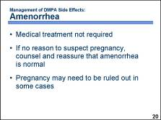 | Some women consider amenorrhea to be an advantage of using DMPA, but others may be concerned about this side effect. Amenorrhea associated with DMPA use does not present a health risk or require medical treatment. █  If the provider has no reason to suspect pregnancy, counseling and reassurance are the only tools needed for management of amenorrhea. Women need to be reassured that amenorrhea is normal for DMPA users and does not indicate pregnancy. Women may also need to be reassured that the absence of menses does not mean that toxic blood is building up inside their bodies, that they have become infertile, or that they have reached premature menopause. █  However, if a woman becomes amenorrheic soon after her first injection, the provider may need to rule out pregnancy. The woman may already have been pregnant when she received her first injection. It also may be necessary to rule out pregnancy if a woman experiencing amenorrhea was more than four weeks late for an injection. █  Discussion questions:  How do women in your community tend to view amenorrhea? If amenorrhea tends to be a concern for your clients, what can you do or say to help alleviate that concern?
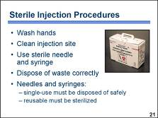 | An important requirement for any program offering injectable contraceptives is to ensure that injections are provided under sterile conditions, to prevent infection or disease transmission. Providers must use an aseptic injection technique, following these steps: █  - Wash hands before each injection.  - Clean the injection site, using a new piece of cotton for each client.  - Use a sterile needle and syringe for each injection.  - Dispose of non-sharp waste, such as used cotton swabs or gauze, in a leak-proof container with a tight-fitting lid or in a plastic bag, kept separate from the general trash. █  - Single-use needles and syringes are preferred. Where single-use needles or syringes are used, providers must ensure that they are not reused and are disposed of safely. Where reusable needles or syringes are used, providers must ensure that adequate sterilization procedures are used. █  Photo credit: DELIVER/John Snow, Inc.
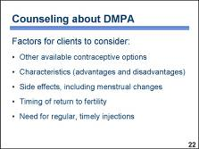 | A client’s satisfaction with any contraceptive method depends greatly on counseling. This is especially true with injectables.  When a woman chooses an injectable contraceptive, the provider must be sure that she has carefully considered these factors:  - All available contraceptive options  - The characteristics of the injectable and how its use may affect her lifestyle  - Anticipated menstrual changes and other potential side effects  - The timing of return to fertility after injections are discontinued  - The need for regular, timely injections █
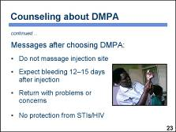 | Once a woman has decided to use an injectable contraceptive, it is important that she be counseled on these points: █  - She should not massage the injection site after the injection as that can cause the DMPA to be absorbed too quickly. █  - She should expect bleeding to occur 12 to 15 days after the injection. █  - She should return if she has problems or concerns, especially if she experiences bright flashes in her vision, also known as a migraine aura, that occur before bad headaches; unusually heavy or long bleeding – bleeding that is more than eight days long or twice as heavy as usual; or yellow skin or eyes that may indicate jaundice. █  - She should keep in mind that injectables do not protect against STIs including HIV and should therefore consider using condoms to avoid infection. █  Photo credit: Angela Akol/FHI
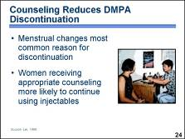 | With injectable contraceptives, the quality of counseling has an especially large effect on whether women discontinue the method because of side effects. Menstrual changes are the most common reason for discontinuation of injectables. █  Women are much more likely to continue using injectables if they have received adequate counseling about the possibility and meaning of side effects. For example, in one study of DMPA, women who had been counseled about side effects were more than three times as likely to continue using the method as women who had not been counseled. The sites that provided better counseling had lower discontinuation rates. █  Photo credit: David Borasky/FHI
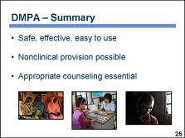 | In conclusion, injectables have characteristics that make them a desirable method for many women:  - They are safe. They are as effective as sterilization. They are easy to use correctly. █  - They can be delivered in nonclinical settings. █  Appropriate counseling plays a key role in the provision of injectable contraceptives. While it is relatively simple to train providers to administer injectables correctly, providers also need to be trained to counsel clients about the characteristics of each type of injectable contraceptive, with special attention to side effects. Providers should also be trained to manage side effects.  Family planning programs that offer injectable contraceptives benefit their clients by increasing their options for contraception. █  Photo credits: S.J. Staniski, ©2004 Melissa May/courtesy of Photoshare, Richard Lord

PowerPoint Presentation 14. Implants, POPs and Emergency Contraception

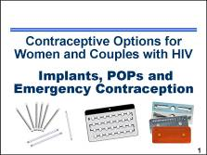 | Implants and progestin-only pills are a safe and highly effective contraceptive option for most women including those with HIV. Emergency contraceptive pills, although not intended to be used as a “regular” method of contraception, provide an important alternative for preventing unintended pregnancy after unprotected intercourse. This presentation provides a concise overview of these methods. █  Note to facilitator:  Note-taking pages for this presentation are included in the Participant Manual, page 56. Additional information on progestin-only implants and emergency contraceptive pills (ECPs) can be found on Fact Sheet 4. Progestin-only Implants, pages 109–110, and Fact Sheet 5. Emergency Contraceptive Pills (ECPs), pages 111–112, in the Participant Manual. The Counseling Tool (flip book) also includes information on pages 33–35 and pages 42–44 that providers can use with clients who are interested in using implants or emergency contraception.  Illustration and photo credits: Salim Khalaf/FHI; WHO; NorLevo® also known as Vikela®, Duofem®, and Vika®/Laboratoire HRA Pharma; Postinor-2®/Schering;  Plan BTM/Duramed Pharmaceuticals, Inc.
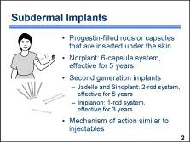 | Contraceptive implants consist of hormone-filled rods or capsules that are inserted under the skin in a woman’s upper arm. █  The first contraceptive implant system developed was the Norplant system, which consists of six thin, flexible capsules made of silicone. Each rod is 2.4 mm in diameter and 34 mm in length and contains 36 mg of the progestin levonorgestrel. █  Second generation contraceptive implants include Jadelle, Sinoplant, and Implanon. Jadelle was designed to deliver the same daily dose of levonorgestrel that Norplant delivers but is two rods instead of six and is effective for five years. Sinoplant is nearly identical to Jadelle but contains more levonorgestrel. Implanon – a single-rod system – continually releases a low, steady dose of the progestin etonogestrel for a period of up to three years. New implant systems with fewer rods make insertion and removal much easier and produce less discomfort for users compared with Norplant’s six capsules. █  The mechanism of action of implants is similar to the mechanism of action of progestin-only injectable contraceptives. █  Discussion questions:  How common is use of implants among women in your community? What is the most common type of implant used by your clients?  Illustration credits: WHO; Salim Khalaf/FHI
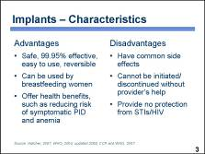 | There are several advantages of contraceptive implants.  - They are safe, more than 99% effective in preventing pregnancy, and easy to use. While implants provide long-lasting, reliable contraception, women who want to become pregnant can have implants removed anytime and their fertility is restored.  - They contain no estrogen, so they can be used by women who are breastfeeding or have health conditions that might preclude use of contraceptives containing estrogen.  - In addition, they are believed to provide non-contraceptive health benefits including prevention of iron deficiency anemia. █  There are also some disadvantages of implants.  - They have common side effects, especially bleeding changes.  - They cannot be initiated or discontinued without a provider’s help because a minor surgical procedure is required for both insertion and removal.  - Like other hormonal methods, implants provide no protection against STIs including HIV. █  Discussion questions:  Which characteristics do you think women in your community find most important when considering implants? What could you do to help ease concerns, or do you believe that the clients made the correct decision for their circumstances?
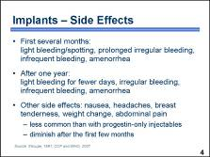 | Many women using contraceptive implants report irregular bleeding patterns. Although usually not medically harmful, these bleeding irregularities may be unacceptable for some women.  The most common irregularities include irregular light bleeding or spotting and prolonged bleeding. Typically, the frequency of these bleeding changes, especially irregular and prolonged bleeding, decreases with time and is less of a problem by the end of the first year. █  Other side effects, such as nausea, headaches, breast tenderness, weight changes, and abdominal pain due to enlarged ovarian follicles, may be experienced by some women. These side effects are less common than with progestin-only injectables and tend to go away without treatment within the first few months. If abdominal pain is severe, it should be evaluated immediately, as it may be a sign of an ectopic pregnancy. █  Discussion question:  Among your clients who use implants, what has been their most common experience with side effects?
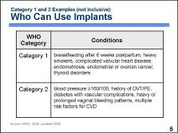 | Implants are safe for the overwhelming majority of women. The MEC identifies a number of medical conditions that do not prohibit implant use. █  According to the MEC, implants can be used without any restrictions by women with category 1 conditions. For example, implants can be used freely by women who are breastfeeding a baby older than six weeks, are heavy smokers, have complicated valvular heart disease, endometriosis, endometrial or ovarian cancer, or thyroid disease. █  For women with category 2 conditions, the advantages of using the method outweigh the theoretical or proven risks. Thus, implants can generally be used by women with category 2 conditions, but careful follow-up may be required in some cases. Examples of such conditions include blood pressure above 160/100 mm Hg, history of deep venous thrombosis/pulmonary embolism (DVT/PE) or on established anticoagulant therapy, diabetes with vascular complications, heavy or prolonged vaginal bleeding patterns, or multiple risk factors for cardiovascular disease.  In settings where clinical judgment is limited, category 2 conditions are treated in the same manner as category 1 conditions, meaning that women with either category 1 or 2 conditions should be able to obtain and use implants without restrictions. █  Discussion question:  Use the MEC quick reference chart (included with the course materials) to compare the differences in contraindications between methods that contain estrogen and those that contain only progestin. What differences do you notice in the categorization of conditions for the various methods?  The progestin-only methods are much less restrictive, especially for conditions like breastfeeding six weeks to six months postpartum, older women who smoke a lot, hypertension, migraine headaches, history of deep venous thrombosis, complicated valvular heart disease, and known hyperlipidemias.  Remind participants that the quick reference chart is also not a comprehensive listing of all the conditions that WHO has categorized. Participants can review the WHO guidelines for a comprehensive list and explanations.
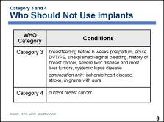 | While implants are safe for the majority of women, a small number of women with certain characteristics or certain medical conditions are not considered good candidates for implant use. █  According to the MEC, implants are not generally recommended for women with category 3 conditions, when theoretical or proven risks usually outweigh advantages of using the method. These conditions include: breastfeeding before six weeks postpartum; acute deep venous thrombosis or pulmonary embolism – unless on established anticoagulant therapy; unexplained vaginal bleeding prior to evaluation; a history of breast cancer; severe cirrhosis; malignant liver tumors; benign liver tumors, with the exception of focal nodular hyperplasia (which is a tumor that consists of scar tissue and normal liver cells); or systemic lupus disease – if not on immunosuppressive treatment. █  Women who develop ischemic heart disease, have a stroke, or have migraine headaches with an aura while using implants should generally not continue using the method.  Women with category 3 conditions should not use implants unless other more appropriate methods are not available or acceptable. Careful follow-up will be required. █  Women with category 4 conditions should not initiate and use implants because of unacceptable health risks. The only category 4 condition, or absolute contraindication for implants initiation and use, is current breast cancer.  In settings where clinical judgment is limited, category 3 conditions are treated in the same manner as category 4 conditions, meaning that women with either category 3 or 4 conditions should not initiate and use implants. █  Note to facilitator:  Take this opportunity to introduce the Checklist for Screening Clients Who Want to Initiate Contraceptive Implants, included with the course materials. Mention that they will have opportunities to practice with these checklists during the counseling activities later in the training.
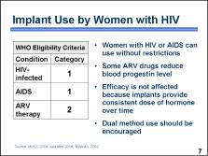 | According to the MEC, implants can be used without restrictions by women with HIV who may or may not have AIDS – category 1.  Women on ARV therapy can generally use implants although follow-up may be required in some cases. Although progestin blood levels are slightly reduced by some ARVs, these reductions are probably not enough to affect contraceptive efficacy. █ This is because Norplant, Jadelle, and Implanon provide consistent dose of hormone over time. █  However, women with HIV who choose to use implants should be counseled about dual method use and should consider using condoms in addition to hormonal methods. Condoms provide both additional protection from pregnancy in the event that the effectiveness of implants is reduced by some ARVs and protection from STI/HIV transmission between partners. █  Note to facilitator:  WHO classifies NRTI’s as category 1; and NNRTI’s and the PI – ritonavir, as category 2 for implants. Because ARV therapy is a multi-drug regimen and the regimen always contains a category 2 drug, ARV therapy is classified as a category 2 meaning that women on ARV therapy can generally use implants although follow-up may be required in some cases.
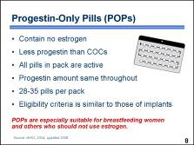 | Progestin-only pills, or POPs, contain no estrogen and only 25 to 30 percent of the progestin in combined pills. All pills in a POP pack are active and have the same amount of progestin. POP packs can range from 28 to 35 pills per pack. The medical eligibility criteria for POP use are similar to those of implants. █  Because POPs contain no estrogen, they are especially suitable for women who breastfeed since this type of pill does not affect milk supply and quality. POPs are also well suited for women for whom the use of estrogen is not recommended, such as women at risk of cardiovascular disease and women who smoke. █  Illustration credit: WHO
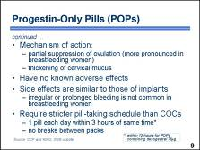 | Unlike COCs, which generally suppress all ovarian activity, the effect of POPs on ovulation varies from woman to woman and from cycle to cycle. There are also some differences in the way POPs work in breastfeeding and non-breastfeeding women. In women who are breastfeeding, lactation works together with POPs to suppress ovulation more consistently. POPs also thicken cervical mucus, which acts as a barrier to sperm. █  Unlike COCs, POPs are not known to be associated with any adverse reactions. █  The side effects of POPs are similar to those of implants. However, if a woman is breastfeeding, she is much less likely to have irregular or prolonged bleeding episodes and more likely to have amenorrhea. █  The effectiveness of POPs depends on a very strict pill-taking schedule. Progestin-only pills must be taken within three hours of the same time every day – or within 12 hours for POPs containing 75mcg of desogestrel – because their contraceptive effect declines dramatically after 24 hours. Progestin pills should be taken daily with no break between packs. █
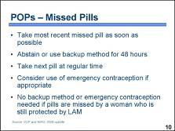 | If a woman delays taking a progestin-only pill by more than three hours – 12 hours for POPs containing 75mcg of desogestrel – or misses one or more pills, she should take the most recent missed pill as soon as she remembers, █ and abstain from intercourse or use a backup method of contraception for the next 48 hours. █ The next pill should be taken at the regular time, even if that means taking two pills in one day or even at the same time. █  A woman who missed POPs may consider using emergency contraception if appropriate. For example, if her only intercourse after she forgot to take a pill or pills was not more than five days ago, she may be a good candidate for emergency contraception. █  POP users who are breastfeeding, amenorrheic, and within six months postpartum are still protected by the lactational amenorrhea method and do not need to use another backup method or emergency contraception if they miss pills. █
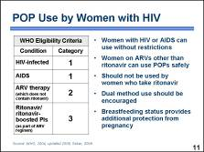 | WHO advises that women with HIV who may or may not have AIDS can use progestin-only pills without any restrictions – category 1. █ According to WHO, women with AIDS who are on antiretroviral therapy generally can use POPs as long as their antiretroviral regimen does not contain ritonavir or ritonavir-boosted protease inhibitors. █ While the evidence on interactions between POPs and ARVs is still very limited, there are some data that suggest that ritonavir reduces the blood levels of contraceptive hormones to a much greater extent than other ARV drugs. ARV drugs other than ritonavir, are classified as category 1 or category 2; category 1 includes NRTIs and category 2 includes NNRTIs and PIs other than ritonavir. However, because ARV therapy is a multi-drug regimen and the regimen always contains a category 2 drug, ARV therapy – so long as it does not contain the drug ritonavir – is classified as a category 2 meaning that women on ARV therapy can generally use POPs although follow-up may be required in some cases. █  Because of the possibility of reduced effectiveness, however, POPs may not be the most appropriate choice for some women on ARV therapy, particularly those who have difficulty remembering to take a pill on time. A sensible approach may be to use condoms consistently as a backup method of contraception while taking POPs. █  Also, because POPs are mainly recommended for breastfeeding women, many POP users will have additional protection from pregnancy because of their breastfeeding status. Regardless of the method chosen, counseling on condom use should be an integral part of contraceptive counseling for women with HIV because the condom is the only method that prevents STI/HIV transmission between partners.  Although not included in detail in this presentation, other medical eligibility criteria for POPs are similar to medical eligibility criteria for implants.  Next, we will address the use of emergency contraceptive pills by women with HIV. █
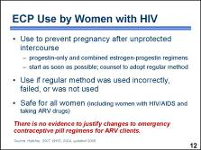 | Emergency contraceptive pills, or ECPs, are the most common method of emergency contraception and refer to the special regimens of oral contraceptives used to prevent pregnancy after unprotected intercourse. It does not provide any protection from STI/HIV transmission.  Two common regimens of ECPs are:  - progestin-only regimen  - combined estrogen-progestin, or Yuzpe regimen  If taken within 120 hours – five days – after unprotected intercourse, ECPs reduce the risk of pregnancy. The sooner ECPs are started, the more effective they are. Providers who offer emergency contraception should also help women to choose a regular contraceptive method and counsel them about how to use the method correctly and when to begin using it. █  Emergency contraception may be considered in a number of situations when unprotected intercourse takes place. These situations include occasions when a regular contraceptive method was used incorrectly or failed – such as when a condom breaks – or when no contraceptive method was used, including coercive sex or rape. █  Emergency contraception is safe and should be available to all women, including women with HIV or AIDS, or those on ARV therapy. █  Currently, no data are available on the extent and outcomes of interaction between emergency contraceptive regimens and ARVs. Because emergency contraception contains higher doses of hormones than regular oral contraceptives, its efficacy may not be significantly affected by ARV drugs. Even if the amount of hormones is reduced, ECPs still should provide some level of protection from unwanted pregnancy. There is no basis for changing clinical recommendations for ECP use in women with HIV who are receiving ARV therapy or who may receive ARV drugs as a prophylactic treatment after being raped or having coerced sex with an HIV-positive partner. █
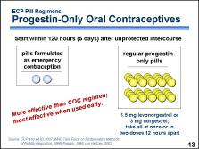 | For emergency contraception, the special regimen of progestin-only pills is more effective and produces fewer side effects than the special regimen of combined oral contraceptives. A woman using specially formulated progestin-only pills, such as Postinor, for emergency contraception should take two pills, containing 0.75 mg of levonorgestrel each, within 120 hours – or 5 days – after unprotected intercourse – the sooner the better.  Research indicates that, when used within 24 hours of unprotected intercourse, the levonorgestrel-containing pills prevent 95 percent of expected pregnancies. When used within 72 hours of unprotected intercourse, these pills prevent about 85 percent of expected pregnancies. █  In countries where pills containing 0.75 mg of levonorgestrel are not available, women wanting emergency contraception can use regular progestin-only pills formulations containing levonorgestrel or norgestrel. In these formulations, however, each pill contains only a small amount of the hormone required for emergency contraception. Depending on the amount of the hormone in each pill, a woman would have to take 40 or 50 POPs containing levonorgestrel to make a full ECP dose. It may be difficult for a client to take 40 or 50 pills at once, and it is often more practical to split it into two doses twelve hours apart. Studies have shown that effectiveness is the same if pills are taken as one dose or two doses. █  Discussion questions:  Does your facility offer the specially packaged progestin-only ECPs? If so, what brand? Have any of your clients used ECPs? What were the results?
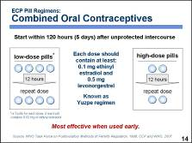 | The Yuzpe is a special regimen of combined oral contraceptives. This regimen has been studied extensively and shown to be safe and effective. When used correctly, this regimen of emergency contraceptive pills prevents about 75 percent of expected pregnancies.  Two doses of pills should be taken: the first within 120 hours or five days after unprotected intercourse and the second 12 hours later. Each of the two doses should contain at least .1 milligram of ethinyl estradiol and .5 milligrams of levonorgestrel, which can be obtained by taking four “low-dose” pills, containing 0.03 mg of ethinyl estradiol each, or five “low-dose” pills, containing 0.02 mg of ethinyl estradiol each. If “high-dose” pills, containing  0.05 mg of ethinyl estradiol each are used, two pills should be taken for each dose. █ To be most effective, ECPs should be taken as soon as possible after unprotected intercourse.  The mechanism of action is not well understood and may be related to the time it is used during a woman's cycle. It is believed that the main effect is the inhibition or delay of ovulation. It may also interfere with fertilization and/or implantation process. Once implantation has occurred, emergency contraceptive pills are not effective. █  Discussion question:  How often, if ever, are the combined emergency contraceptive regimens used at your facility?
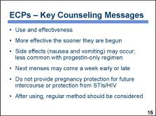 | It is important to counsel women about emergency contraception and to make sure they know where ECPs are available. How to use the method and its effectiveness in preventing pregnancy should be discussed. Providers should also make sure that the client understands that: █  - ECPs are more effective the sooner they are taken after unprotected intercourse. █  - Unpleasant, but harmless, side effects such as nausea and vomiting may occur. Side effects are much less common with the progestin-only regimen. █  - Depending on when ECPs are taken, the next menses may begin up to one week earlier or later than expected. █  - ECPs do not provide protection from pregnancy for subsequent acts of unprotected intercourse following emergency treatment, and they do not protect against STIs, including HIV. █  - Use of a regular contraceptive method should be considered. ECPs may be less effective than ongoing contraceptive methods. Also, it is unknown whether the repeated use of ECPs presents health risks. █  Discussion question:  Where can your clients access emergency contraceptive pills? From you? From another health facility? From a pharmacy?  Remind participants to impress upon their clients that having the pills available for use in emergencies – before unprotected intercourse occurs – is the most desirable option.

PowerPoint Presentation 15. Intrauterine Device (IUD or IUCD)

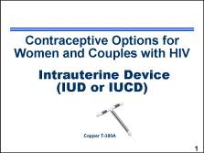 | The IUD, also known in some places as the intrauterine contraceptive device or IUCD, is one of the world’s most widely used family planning methods. It is the second most commonly used form of contraception, with the first being female sterilization. The IUD is the most common form of reversible contraception, used by about 100 million women worldwide. Currently, sixty-seven percent of IUD users live in China. However, IUD acceptance is growing in other parts of the world. █  Note to facilitator:  Note-taking pages for this presentation are included in the Participant Manual, page 62. Additional information on IUDs can be found on Fact Sheet 6. Intrauterine Devices, in the Participant Manual, pages 113–114. The Counseling Tool (flip book) also includes information on pages 36–38 that providers can use with clients who are interested in using IUDs. The Checklist for Screening Clients Who Want to Initiate Use of the Copper IUD and the MEC quick reference chart are tools that can be used to help determine which clients are medically eligible to use IUDs.  Illustration credit: Salim Khalaf/FHI
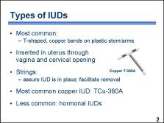 | Most IUDs being inserted today are shaped like a T with copper wires or bands on the plastic stem and arms. In the late 1960s, researchers found that adding copper to the plastic frames made IUDs more effective than earlier devices. The copper released into the uterine cavity increases the contraceptive efficacy of the IUD. █  The IUD is inserted into a woman’s uterus through her vagina and then the cervical opening. █  Almost all brands of IUD have one or two strings tied to them. The strings hang through the opening of the cervix into the vagina. The user can check that the IUD is still in place by touching the strings. A provider can remove the IUD by pulling gently on the strings with forceps. █  Among copper IUDs, the TCu-380A is currently one of the most widely used in the world. █  Less widely available are hormonal IUDs that steadily release small amounts of progestin, such as levonorgestrel.  This presentation will focus on TCu-380A IUD. █  Discussion questions:  How common is IUD use among women in your community? What is the most common type of IUD among your clients?
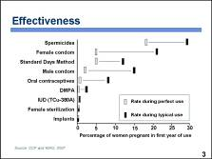 | IUDs are among the most effective methods of contraception, with failure rates of less than 1 percent. This chart compares the pregnancy rates for the IUD with the rates for other contraceptive methods. The grey (red) rectangles show pregnancy rates for correct and consistent use, reflecting how often a contraceptive fails when it is used both correctly and consistently. The black (blue) rectangles show pregnancy rates for typical use, reflecting how often a contraceptive fails in real-life situations, when it may not always be used correctly and consistently.  In the case of the IUD, there is practically no difference between pregnancy rates for correct and consistent use and typical use. As the chart shows, other reversible contraceptive methods, such as barrier methods or oral contraceptives, may have low pregnancy rates with correct and consistent use but much higher rates with typical use.  With the IUD, the woman does not need to do anything, although it is advisable to check for IUD strings once a month to make sure it is in place. Because the effectiveness of IUDs does not depend on daily user compliance, the pregnancy rates for the IUD are extremely low even with typical use.  Use of the IUD results in about the same pregnancy rate as sterilization, a nonreversible method. █
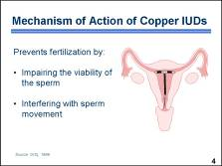 | All the mechanisms of action of copper-bearing IUDs are still not completely understood. However, researchers believe that the main mechanism of action of copper-bearing IUDs is the prevention of fertilization. The presence of the IUD in the uterine cavity creates a local inflammatory reaction that appears to prevent sperm from reaching the fallopian tubes. In addition, copper-bearing IUDs release copper inside the uterus and the fallopian tubes, enhancing the debilitating effect on sperm. Studies have generally found that sperm are not as viable in IUD users, compared with other women.  Originally, it was thought that IUDs produced changes in the uterus that either destroyed a fertilized egg or prevented a fertilized egg from implanting in the uterus. However, it appears that the IUD effectively interrupts the reproductive process before implantation by preventing fertilization. The evidence suggests that fewer sperm reach the site of fertilization in women using IUDs than in women who are not using the device, and, for women using copper devices, the sperm may not be able to fertilize the egg. In two studies of women using mainly copper IUDs, there was evidence of fertilization in less than 1 percent of their cycles. In those few cases where fertilization does occur, the IUD may prevent pregnancy by interfering with implantation in the uterine cavity. However, in most cases the evidence has shown that copper IUDs act prior to fertilization. █  Discussion question:  Among your clients, what misunderstandings, if any, are there about how IUDs work?
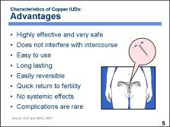 | In addition to being highly effective and safe, the IUD has other characteristics that make it a good choice for many women. Use of an IUD does not interfere with intercourse. It is easy to use and requires little action on the part of the user and no active participation by a partner. The user only needs to check the IUD strings regularly to make sure the device is still in place.  The IUD is long lasting and easily reversible. The most commonly used IUD, the Copper T-380A, can remain in place for up to 12 years and possibly longer. If a woman wants to have a baby or to use another form of contraception, the IUD can be easily removed by a provider. Return to fertility typically occurs very soon after an IUD is removed. It has also been shown that the IUD can be used by women who have never had a baby without having any negative effect on their future fertility.  Copper-releasing IUDs act locally on the reproductive tract and have no systemic effects. For this reason, IUDs can be used safely by breastfeeding women. Serious complications are rare with IUD use. █  Illustration credits: Salim Khalaf/FHI; WHO
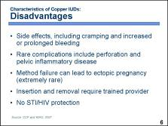 | Although current IUDs are very safe and effective, they are not suitable for all women. IUDs may cause side effects that some women find unacceptable, including cramping and heavy, possibly prolonged bleeding. A very small number of IUD users may experience more serious complications, such as perforation or pelvic inflammatory disease. Like any method of contraception, there is a risk of method failure. Some clients expel their devices and fail to notice until they become pregnant. A method failure may result in a uterine pregnancy or an ectopic pregnancy, which is a pregnancy that occurs outside the uterus. The IUD should be inserted and removed by trained provider, so women who want to initiate or discontinue IUD use cannot do it on their own. Also, like many other contraceptive methods, the IUD offers no protection from STIs including HIV. █  Discussion questions:  What would make IUDs appealing to women and couples in your community? What could make clients decide against the IUD? What, if anything, could you do to help ease their concerns?
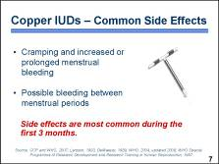 | IUDs may cause side effects that some women find unacceptable. Some women may experience pain and cramping during menses, heavier menstrual bleeding, and menstrual irregularities. Spotting and cramping between menstrual periods often last for two to three months after an IUD is inserted. Also, some women who use IUDs report that their menstrual periods last longer or are heavier. Menstrual blood loss may be 50 percent greater during the first months after insertion of a copper IUD, but usually decreases within 12 to 24 months.  Heavier menstrual bleeding could be a problem for women with anemia. It is estimated that as many as 40 percent of women in developing countries may be anemic. According to the MEC, IUDs can generally be used by women with anemia, but more careful follow-up may be required. █  Bleeding changes are the main reason for IUD discontinuation, although these effects do not necessitate IUD removal. Side effects are more common during the first months after insertion of a copper IUD but usually decrease with time. █  Discussion question:  Among your clients who use IUDs, what has been their most common experience with side effects?
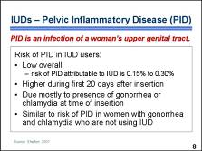 | Pelvic inflammatory disease, also known as PID, is an infection of a woman’s upper genital tract. █  Overall risk of PID associated with the IUD is very low, although there is a somewhat increased risk of PID during the first 20 days after insertion. Sexually transmitted infections (STIs), such as gonorrhea and chlamydia, are the reason some women develop PID. When the IUD is inserted through an infected cervix, there is a chance that it will carry the infection from the lower to the upper genital tract. However, women with undiagnosed and untreated gonorrhea or chlamydia who are not using the IUD develop PID as well. Based on available evidence, it appears that PID rates are similar among women with STIs with or without the IUD being inserted, and the IUD itself contributes very little to the risk of PID. █
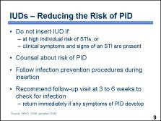 | An IUD user’s risk for developing PID can be reduced even further if providers follow important guidelines. █  Screen women for risk of STIs. While women at risk of STIs can generally use an IUD, more careful follow-up after insertion may be recommended. However, providers should try to screen out women at high individual risk of STIs. This category of women may include those with more than one sexual partner, those whose partner has multiple sex partners, or those whose partners have symptoms of STIs. █  Carefully screen women for any symptoms and signs of current STIs. In many cases, good clinical judgment is sufficient to rule out an infection with gonorrhea and chlamydia. Ruling out the possibility of a current STI by medical history and physical examination is essential prior to providing the IUD. Laboratory tests are not required prior to IUD insertion, but they could be offered when available and when the provider has difficulty ruling out an infection by clinical judgment alone. IUDs should never be inserted in women with current STIs. Women at high individual risk of STIs should generally not have an IUD inserted unless other methods are unavailable or unacceptable to the client and careful follow-up is possible. █  Counsel all users about the risks of PID. Emphasize that behaviors that place a woman at greater risk for STIs also increase her risk of PID. █  Strictly follow infection prevention procedures to reduce the risk of introducing bacteria into the uterus. Antibiotic prophylaxis at the time of IUD insertion is generally not recommended. However, in settings where the prevalence of cervical gonococcal and chlamydial infections is high and screening for STIs is limited, prophylaxis may be considered. █  Most service delivery guidelines recommend that the client return after the first the menses or about three to six weeks after the IUD is inserted to check for the presence of infection. Advise the client to return immediately if she experiences symptoms, such as fever or low abdominal pain, during the first month after insertion. █
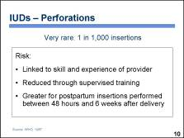 | Although rare, the woman’s uterus or cervix can be perforated when an IUD is inserted. When perforation occurs, it is a potentially serious event. According to WHO, rates of perforation at the time of insertion are generally 1 in 1,000. Perforation of the uterus by an IUD other than during the insertion procedure is also very rare. █  The risk of perforation is directly linked to the skill and experience of the provider. Thus, WHO recommends that, whenever possible, providers perform at least 50 to 60 pelvic examinations and 10 to 15 IUD insertions under supervision before inserting an IUD without supervision. Carefully following the instructions for IUD insertion will also reduce the risk of a perforated uterus. The risk of perforation is greater for postpartum insertions performed between 48 hours and four weeks after delivery, as the uterus returns to its normal size. For this reason, it is recommended that postpartum insertions be done within the first 48 hours after delivery or after four weeks. █
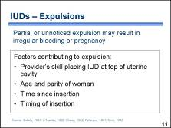 | The expulsion of an IUD is not in itself a medical complication. However, a partially expelled device could result in irregular bleeding. Further, an expelled or partially expelled IUD that goes unnoticed leaves the client believing she is protected from pregnancy when she is not. Providers should understand the factors that can contribute to the risk of an IUD being expelled. █  Several factors influence expulsion rates, including the skill of the provider, the woman’s age and parity, the length of time since insertion, and the timing of insertion. Many studies indicate that the provider’s ability to place the IUD correctly at the top of the uterine cavity, or fundus, may be the most important factor in determining the risk for expulsion. In some studies, higher expulsion rates were associated with providers whose skills were inadequate. Studies also show that younger women who have never given birth are more likely to expel an IUD than older women with children. In general, the risk of IUD expulsion is greatest during the first few months after the IUD is inserted, while the woman’s body is adjusting to the device; thereafter, the risk decreases. However, contractions of the uterus during the first few months after the insertion or during later menstrual periods can push the IUD downward, expelling it either partially or totally. It is recommended that users check after each menses for the presence of IUD marker strings to ensure that the IUD is still in place. Also, postpartum IUD insertions carry a higher risk of expulsion than interval insertions.  On the next several slides we will look specifically at IUD use by women with HIV. █
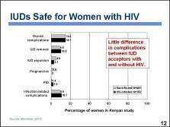 | Research has found that women with HIV can use IUDs safely. A study conducted in Kenya examined over a two-year period the health of two groups of women who received an IUD: 486 women who were HIV-negative, and 150 women with HIV infection. Researchers looked for problems after insertion, such as IUD removal due to infection, bleeding, and pain; IUD expulsion; pregnancy; and pelvic inflammatory disease.  As you can see in this chart, the percentage of women reporting complications after IUD insertion was almost identical for the two groups – 14.7 percent among women with HIV and 14.8 percent among women without HIV. The percentage of women reporting problems related to some type of infection, including pelvic tenderness and IUD removal for infection or pain, was 10.7 percent among those who were HIV-positive and 8.8 percent among those who were HIV-free. While women with HIV tended to have slightly more problems related to infection, they were not significantly different from women in the noninfected group. █  In short, little difference in side effects and infection-related complications was seen between HIV-infected and noninfected IUD acceptors. Overall, 85 percent of women had no problems with IUD use. These findings suggest that the IUD is an appropriate contraceptive method for women with HIV. This is especially true for women who want to limit births for an extended period of time or where access to sterilization services might be limited. █
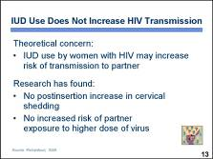 | A theoretical concern about IUD use by women with HIV is that it could increase cervical shedding of HIV, thus increasing the risk of transmission to a sexual partner. █  In a study conducted in Kenya, researchers calculated rates of cervical shedding of HIV-infected cells before IUD insertion and four months after insertion. Results showed no significant differences in cervical shedding among women with HIV before and after insertion. In other words, current evidence suggests that IUDs do not raise the amount of virus to which a woman’s sexual partner is exposed. █
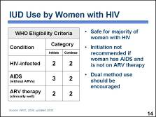 | The MEC states that women with HIV can generally initiate and continue to use an IUD – category 2. This chart shows the specific WHO recommendations:  - An IUD can be provided to a woman with HIV if she has no symptoms of AIDS.  - A woman who developed AIDS while using an IUD can continue to use the device.  - A woman with AIDS who is doing clinically well on ARV therapy – meaning that the symptoms of AIDS are controlled by the ARVs – can both initiate and continue IUD use. █  While IUD users who develop AIDS can continue using the method, IUD initiation is generally not recommended in women who already have AIDS. WHO determined that IUD initiation in such women should be a category 3 because of the theoretical risk that advanced immunosuppression could increase the risk of IUD-related complications, unless a woman is on ARV therapy. █  While the IUD offers highly effective protection from pregnancy, it does not guard against STI and HIV transmission between partners. As with other methods, providers who counsel sexually active, HIV-positive clients about their contraceptive options should always encourage condom use in addition to another contraceptive method.  The next two slides describe the WHO categories for IUD use among women with conditions other than HIV and AIDS. █
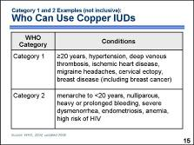 | The IUD is safe for the overwhelming majority of women. The MEC identifies a number of medical conditions that do not prohibit IUD use. █  According to the MEC, the IUD can be used without any restrictions by women with category 1 conditions. For example, the IUD can be used freely by women who are older than 20 years, have hypertension, deep venous thrombosis, current or history of ischemic heart disease, migraine headaches, cervical ectopy, or breast disease, including breast cancer. █  For women with category 2 conditions, the advantages of using the method outweigh the theoretical or proven risks. Thus, the IUD can generally be used by women with category 2 conditions, but careful follow-up may be required in some cases. Examples of such conditions include being younger than 20 years, never giving birth or nulliparous, heavy or prolonged bleeding patterns, severe dysmenorrhea, endometriosis, iron deficiency and sickle cell anemia, and at high risk of becoming HIV-infected.  In settings where clinical judgment is limited, category 2 conditions are treated in the same manner as category 1 conditions, meaning that women with either category 1 or 2 conditions should be able to obtain and use an IUD without restrictions. █  Discussion questions:  Use the MEC quick reference chart (included with the course materials) to find:  - Other Category 1 conditions that are not included in this slide (e.g., smoking, non-migrainous headaches, superficial thrombophelitis, diabetes, malaria, non-pelvic tuberculosis (TB), thyroid disease, known hyperlipidemias, uterine fibroids without cavity distortion, irregular bleeding patterns without heavy bleeding, cirrhosis, gall bladder disease, cholestasis, hepatitis, liver tumors, and use of antibiotics).  - Other Category 2 conditions that are not included in this slide (e.g., complicated valvular heart disease; continued use with cervical, endometrial, or ovarian cancer; continued use with unexplained vaginal bleeding; initiate use with increased risk of or infected with some types of STIs; continue use with all STIs/PID, HIV-infected, AIDS; and initiate or continue use if use clinically well on ARV therapy).  Remind participants that the quick reference chart is not a comprehensive listing of all the conditions that WHO has categorized. Participants can review the WHO guidelines for a comprehensive list and explanations.
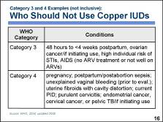 | While the IUD is safe for the majority of women, a small number of women with certain characteristics or certain medical conditions are not considered good candidates for IUD use. █  According to the MEC, the IUD is not generally recommended for women with category 3 conditions, when theoretical or proven risks usually outweigh the advantages of using the method. Some examples of these conditions include: being between 48 hours and 4 weeks postpartum; ovarian cancer for initiation only – women who develop ovarian cancer while using the IUD can continue using it while awaiting treatment; high individual risk of STIs; and AIDS in cases where ARV therapy is not available or the woman is not clinically well while on ARVs. Women with these conditions should not use the IUD unless other more appropriate methods are not available or acceptable. Careful follow-up will be required. █  Women with category 4 conditions should not initiate IUD use because of unacceptable health risk. Examples of such conditions include: pregnancy; postpartum or postabortion sepsis; unexplained vaginal bleeding, prior to evaluation; uterine fibroids with cavity distortion; current PID; purulent cervicitis; endometrial or cervical cancer or pelvic tuberculosis for initiation only – women who develop endometrial or cervical cancer or pelvic tuberculosis while using the IUD can continue using it while awaiting treatment.  In settings where clinical judgment is limited, category 3 conditions are treated in the same manner as category 4 conditions, meaning that women with either category 3 or 4 conditions should not initiate and use the IUD. █  Discussion question:  Ask participants to look carefully at the quick reference chart and compare the categories for the hormonal methods with that of copper IUDs. What patterns do they notice? (e.g., for many conditions where hormonal contraceptives are a category 3 or 4 – hypertension, stroke, heart disease, breast cancer, and severe liver disease – the copper IUD is a category 1 or 2)
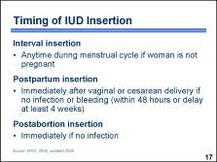 | An interval insertion can be performed anytime during the menstrual cycle, as long as the woman is not pregnant. Some providers recommend the IUD be inserted during the last few days of menstruation when the cervical opening is a little larger than usual and it is certain the woman is not pregnant. However, it is easier to examine for signs of reproductive tract infections when a women is not menstruating. Therefore, IUDs can be inserted at the client’s convenience if the provider can be reasonably sure she is not pregnant. █  An IUD can be inserted postpartum. This assumes the provider has received adequate training in the procedure, the woman has been counseled appropriately prior to delivery, and there is no infection or bleeding. The IUD can be placed manually in the uterus immediately after a cesarean section delivery or a vaginal delivery. An IUD insertion following a vaginal delivery can be done during the first 10 minutes after delivery of the placenta. Early postpartum insertions within the first 48 hours are also considered safe. Otherwise, it is best to wait until the woman is at least four weeks postpartum, when the uterus returns to its normal size. █  An IUD can be inserted immediately after a first-trimester abortion if there is no infection. Immediate insertion can also be performed after pregnancies of 16 weeks or more, but must be conducted by a specially trained provider or be delayed for at least four weeks. █  Note to facilitator:  Take this opportunity to introduce the Checklist for Screening Clients Who Want to Initiate Use of the Copper IUD, included with the course materials. Mention that they will have opportunities to practice with these checklists during the counseling activities later in the training.
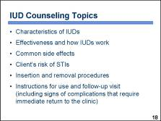 | A client’s satisfaction with any contraceptive method depends greatly on counseling. If the client chooses an IUD, the following specific issues must be discussed in detail during the counseling session:  - The characteristics of IUDs  - The effectiveness of IUDs and how they work  - Common side effects  - An assessment of the client’s risk of STIs  - Insertion and removal procedures  - Instructions for use, including signs of complications that require an immediate return to the clinic, and plans for a follow-up visit █
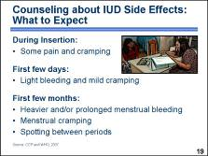 | Counseling about side effects is important when helping women to choose a contraceptive method. When women know what to expect, there is less chance that they will discontinue the method later on. Providers should explain that the IUD has some common side effects that a woman may or may not experience. These side effects could be unpleasant but are not harmful to a woman’s health and usually diminish after a few months. █  The provider should tell the woman that she may experience pain and cramping during the insertion and may experience light bleeding and continued mild cramping for a few days following insertion. █  Heavier and prolonged menstrual bleeding, as well as menstrual cramping and spotting between periods, are common but usually temporary. Studies have shown that usually these events are tolerable and do not necessitate removal of the IUD. Providers need to reassure the woman that these side effects do not indicate a serious medical problem and can be alleviated by taking ibuprofen, paracetamol, or other pain reliever – except aspirin – as needed. █  Photo credit: Karl Grobl
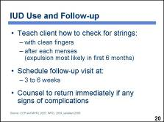 | Another element of counseling is discussion of IUD use and follow-up care. █  Teach the client how to check for her IUD by feeling for the strings. Make sure that she knows to wash her hands thoroughly before inserting her fingers into her vagina. If she is unwilling or unable to check with her hand, she can be counseled to inspect carefully the pads she uses during menses to check for a possible expelled IUD. Emphasize the importance of routinely checking for strings after each menses, especially during the first six months, since this is when the IUD is most likely to be expelled. The client should be advised to use a backup method of contraception, such as condoms, and visit the provider as soon as possible if she notices the strings are missing. █  Schedule the client for a return visit three to six weeks after the insertion to check the position of the IUD strings and to check for signs of infection. If she has no problems at the time of her checkup or during the following months, she only needs to return to the clinic if she experiences problems or has concerns. █  Advise the client to return to the clinic immediately if she experiences any signs of possible complications. █  Discussion question:  How do you help clients remember when to check their strings and when to return to the clinic?
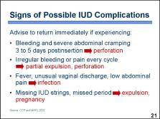 | During counseling, providers need to discuss with the client the signs of possible IUD complications and advise her to return immediately if any of the following signs or symptoms appear.  - Bleeding or severe abdominal cramping during the first three to five days after insertion – this could indicate that the uterus or cervix may have been perforated when the IUD was inserted. █  - Irregular bleeding or pain in every cycle – this could indicate an IUD dislocation, partial expulsion, or perforation. █  - Fever and chills, unusual vaginal discharge, or low abdominal pain – these could indicate an infection, which is a concern especially during the first month after the IUD is inserted. This is when PID, although rare, is most likely to develop. █  - Missing IUD strings or a missed menstrual period – these could indicate IUD expulsion and pregnancy, either uterine or ectopic. █
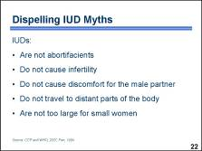 | Both providers and clients may have false beliefs about IUDs. Replacing rumors with facts will help the user be more comfortable and satisfied with the method and more likely to continue using it. █  Some women may be concerned that the IUD is an abortifacient, or prevents pregnancy by aborting a fertilized egg. However, as discussed earlier, research has shown that the primary mechanism of action of copper IUDs is to prevent fertilization. █  Another myth is that modern IUDs cause infertility. As discussed earlier, infertility is mainly caused by PID. Providers can largely reduce a woman’s risk of developing PID by screening clients for current STIs or high individual risk of STIs and carefully following infection prevention procedures during insertion. █  Women may have heard that IUDs cause discomfort for the man during intercourse. Occasionally, a man may feel the IUD string, but this should not cause him any pain or discomfort. Counseling the man may be appropriate in such cases. If the male partner finds the string unacceptable, the provider can cut the strings shorter if the client requests it. Clients should understand, however, that if the strings are too short, they may retract into the uterus and the woman may not be able to feel them when checking for the IUD. █  Another myth is that the IUD can leave the uterus and travel to other parts of the body, such as the brain or the heart. On rare occasions, an IUD can perforate the uterus, but it will remain in the abdominal cavity. █  An additional myth is that Copper T IUDs are too large for small women. Studies comparing the TCu-380A to the smaller MLCu-250 show that this is not true. █  Discussion questions:  What other myths about IUDs exist in your community? How can you dispel those myths?
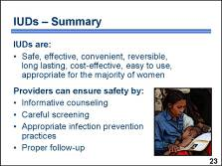 | In conclusion, IUDs are a safe, effective, and convenient method of reversible contraception. They are long lasting, cost-effective, easy to use, and appropriate for the majority of women. █  Health care providers play an important role in making sure that IUDs are used safely. Accurate and appropriate client education and counseling, careful screening of potential users, appropriate infection prevention techniques, and follow-up care can help prevent possible complications associated with IUD use. Counseling is especially important to help clients be alert to any possible problems and can also improve client satisfaction with the device. █  Photo credit: Karl Grobl

PowerPoint Presentation 16. Male and Female Sterilization

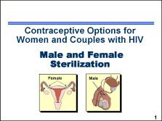 | This presentation provides a brief overview of male and female sterilization, which are contraceptive methods that women and couples with HIV may choose to use. █  Note to facilitator:  Note-taking pages for this presentation are included in the Participant Manual, page 69. Additional information on male and female sterilization can be found on Fact Sheet 7. Male and Female Sterilization, in the Participant Manual,  pages 115–116. The Counseling Tool (flip book) also includes information on page 41 that providers can use with clients who are interested in male and female sterilization.  Illustration credit: Salim Khalaf/FHI
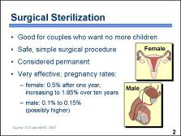 | For women and couples with HIV who have decided to have no more children, female or male sterilization may be a good option.  Female sterilization is a safe, simple surgical procedure that involves cutting and closing off both fallopian tubes. It can usually be done with local anesthesia, although some conditions and circumstances may require use of general anesthesia.  Female sterilization is considered permanent and is very effective, with a pregnancy rate of about  0.5 percent during the first year. Over a period of ten years, pregnancy rates increase to 1.85 percent.  Male sterilization involves making a small opening in the man’s scrotum and closing off both tubes that carry sperm from his testicles. It provides permanent contraception and is very safe and effective, with pregnancy rates between 0.1 percent and 0.15 percent during the first year. Some studies reported vasectomy failure rates as high as 3 percent to 5 percent when using sperm count as the indicator of failure instead of pregnancy. █
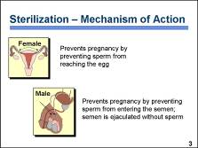 | In order for fertilization to occur, the egg and sperm must unite inside the fallopian tube. By occluding and cutting a section of the fallopian tubes, female sterilization prevents sperm from reaching the egg and thus, prevents pregnancy. █  Vasectomy interrupts the continuity of the tubes that carry sperm from the testes, where they are produced, to the urethra, where they mix with semen. It thus prevents the sperm from entering the semen. As a result, during sexual intercourse, semen is ejaculated without sperm. █
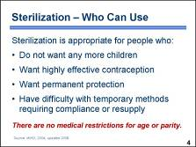 | Sterilization is safe and appropriate for a wide range of people. It can be ideal for women and men who have decided they do not want any more children and who want a highly effective contraceptive method that is permanent. It is also an excellent choice for couples or individuals who have difficulties with methods requiring compliance or resupply. █  There are no medical restrictions on age or parity. █
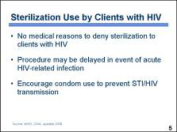 | The MEC states that there are no medical reasons to deny sterilization to a client with HIV. █  If a woman or man has an acute AIDS-related illness, sterilization should be delayed until the condition has improved. Because sterilization is a surgical procedure, any acute HIV-related opportunistic infection may complicate or prolong recovery. █  Because neither male nor female sterilization offers protection from STIs/HIV, couples should be counseled about condom use for STI/HIV prevention. █
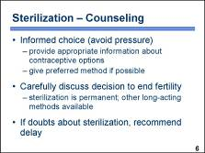 | As with any family planning method, it is essential that the client be free to exercise an informed, voluntary choice. Even the mildest forms of pressure must be avoided. Providers should give appropriate information about all available contraceptive options and give the preferred method if possible. █  Providers should take special care with clients interested in sterilization and carefully discuss the decision to end fertility. Clients who consider sterilization should have a thorough understanding of the alternative long-acting methods available. █  If a client has any doubts, it is best to recommend delaying the procedure and encouraging the use of other contraceptive methods until a clear decision is made. █
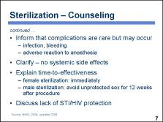 | Counselors should also:  - Inform clients about possible complications of sterilization procedures. Such complications are infrequent, but they do occasionally occur and may include infection or bleeding, and in the case of female sterilization, adverse reaction to general anesthesia. █  - Clarify that unlike some other contraceptive methods, sterilization has no systemic side effects. █  - Explain time-to-effectiveness. While female sterilization is effective immediately, male sterilization is not. Because it takes time for the vas to become completely clear of sperm, couples should be counseled to use another contraceptive method for 12 weeks – three months – following vasectomy. Although guidelines have typically recommended a waiting period of 12 weeks or 20 ejaculations, recent research has shown that the 12-week waiting period is significantly more reliable. The success of vasectomy also may be determined by sperm analysis, if available. █  - Discuss the lack of STI/HIV protection. Providers can help clients to assess their risk of STI/HIV transmission and encourage those at risk to use condoms in addition to sterilization. █
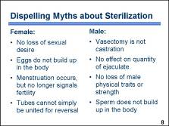 | A number of myths and misunderstandings exist regarding female and male sterilization. █  Some women fear that sterilization will cause them to be less feminine or lose their sexual desire. However, sterilization does not affect appearance or normal sexual function in any way. Some women may even feel their sexual desire increase because they are no longer worried about becoming pregnant. Another myth is that eggs will build up in the body. Sterilized women continue to produce eggs, but the eggs degenerate and are reabsorbed. Women need to understand that after sterilization, menstruation will still occur as previously, although it no longer signals fertility. Also, women may falsely believe that the tubes can be simply united to restore fertility. Reversal is a very complex and expensive procedure that is rarely available, and success is not guaranteed. █  In the case of male sterilization, many men incorrectly equate vasectomy with castration – the physical removal of the testes – and a loss of sexual desire. However, male sterilization is not castration and does not affect normal sexual function or the quantity of ejaculate. Some men may falsely believe that vasectomy will cause them to lose male physical traits or strength. However, after vasectomy the production of hormones related to sexual behavior and physical traits remains the same. Another common misconception is that sperm will build up in the body. As with female eggs, sperm do not build up in the body but are reabsorbed on a continual basis. █  Discussion questions:  What other myths about sterilization are common in your community? How can you dispel these myths?
PowerPoint Presentation 17. Fertility Awareness-based Methods

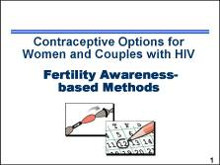 | This presentation provides a brief overview of fertility awareness-based methods that some women and couples with HIV may choose to use. █  Note to facilitator:  Note-taking pages for this presentation are included in the Participant Manual, page 71. The Counseling Tool (flip book) also includes information on page 40 that providers can use with clients who are interested in using fertility awareness-based methods.  Illustration credit: Institute for Reproductive Health
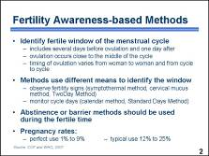 | Fertility awareness-based, or FAB, methods involve the identification of the fertile window of the menstrual cycle, during which a woman can become pregnant. It includes several days before ovulation, the day of ovulation, and one day after. The timing of ovulation varies among women and across cycles for the same woman. █  FAB methods rely on different means to identify the fertile window – it can be done by observing fertility signs (such as cervical secretions and basal body temperature) or by keeping track of cycle days. █  FAB methods should be used in combination with abstinence or barrier methods during the fertile time. █  Because the effectiveness of these methods depends on a woman’s ability to identify fertile days correctly and on partner cooperation, pregnancy rates for FAB methods, as commonly used, may be high – up to 25 percent, depending upon the method used. Newer methods, such as Standard Days Method, or SDM, are easier to use, which makes correct use more likely.  The rest of this presentation focuses on the SDM because it is more feasible to offer in many service delivery settings than other FAB methods. █
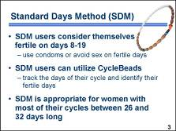 | The Standard Days Method is a relatively new and easy-to-learn fertility awareness method. All users of the SDM consider themselves fertile on days 8-19 of each cycle, and use condoms or avoid sex on those days. █  They identify the fertile window of their cycle by tracking the days of their cycle using a string of color-coded beads called CycleBeads®. To use CycleBeads, a woman moves a rubber ring one bead each day to identify where she is in her cycle. The color-coded beads indicate whether she is on a fertile or infertile day. When the rubber ring is on any of the white beads, it signifies a fertile day, and thus the couple should avoid unprotected sex. █  The SDM is appropriate for women who have most of their menstrual cycles between 26 and 32 days long. The developers of the SDM used a computer simulation that took into account the variations of cycle length and variations in the timing of ovulation within the cycle. They combined the fertile windows of the shortest and longest cycles, which resulted in a fertile window encompassing days 8 and 19 of the cycle. While no individual woman is fertile for 12 days, this longer window ensures that the fertile days of every woman with cycles between 26 and 32 days in length are included. █  Illustration credit: Institute for Reproductive Health
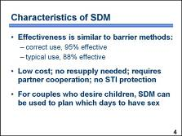 | For women with most of their cycles within the 26-32 days range, SDM is about as effective as barrier methods. In a clinical trial in Bolivia, Peru, and the Philippines, typical use of the SDM resulted in 12 pregnancies per 100 women in one year of use. Among those who used the method correctly, 5 of every 100 women became pregnant in one year. █  SDM is a low-cost method that requires no resupply. For it to be effective, partner cooperation is crucial. Some couples may find this a challenge, while others appreciate the man’s involvement in family planning. Like all other methods except condoms, SDM also offers no protection from sexually transmitted infections. █  For couples who are trying to achieve pregnancy, SDM can help them plan which days to have sex. █
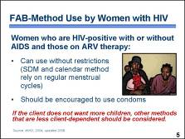 | According to the MEC, women who are HIV-positive who may or may not have AIDS and those on ARV therapy can use FAB methods without restrictions, although women who want to use the SDM or calendar method should have regular menstrual cycles. █  Women and couples relying on FAB methods should be counseled that they are not protected from STI and HIV transmission and should be encouraged to use condoms even on days when risk of pregnancy is low. █  Because FAB methods rely on a client’s ability to use them consistently and correctly, as well as on partner cooperation, couples with HIV who do not want to have children may consider other, less client-dependent methods of contraception. █  Photo credit: ©2004 Paul Wood/courtesy of Photoshare
PowerPoint Presentation 18. Lactational Amenorrhea Method and Infant Feeding Options

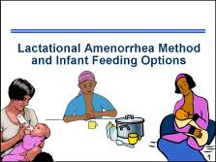 | This presentation provides an overview of the lactational amenorrhea method – a method of contraception that can be used by women who are planning to exclusively breastfeed their infants. A brief description of the infant feeding options available to women with HIV will also be covered. █  Note to facilitator:  Note-taking pages for this presentation are included in the Participant Manual, page 74. Additional information can be found on Fact Sheet 8. HIV and Breastfeeding, in the Participant Manual, pages 117–118. The Counseling Tool (flip book) also includes information on page 39 and page 13 that providers can use with clients who are interested in using the lactational amenorrhea method and exploring various infant feeding options.  Illustration credit (breast express): Karen Dickerson/FHI
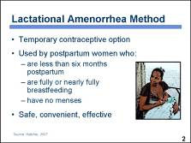 | The lactational amenorrhea method, also known as LAM, is a temporary contraceptive option █ used for up to six months postpartum by women who are fully or nearly fully breastfeeding and who continue to have no menses. █  It is safe, convenient, and highly effective. Women who meet all three criteria for using LAM have only a 1 percent to 2 percent chance of getting pregnant. █  Photo credit: Marina McCune/FHI
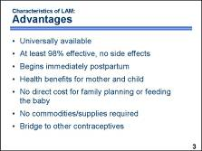 | There are several advantages of the lactational amenorrhea method: █  - LAM is universally available to all breastfeeding women. █  - It is at least 98 percent effective and has no side effects. █  - Protection begins immediately postpartum. █  - There are proven health benefits of breastfeeding for the mother and infant. Breastfeeding provides the healthiest food for the baby. The antibodies that are passed from mother to child through the breast milk protect the baby from some infectious diseases. Breastfeeding also protects the baby from life-threatening diarrhea and helps develop a close relationship between mother and baby. █  - It is cost-efficient because there is no direct cost for family planning or feeding the baby. █  - No commodities or supplies are required for clients or for programs that offer family planning. █  - LAM can be used temporarily while a breastfeeding woman decides whether to use another contraceptive method. By providing convenient contraception during the early postpartum period, LAM gives the woman time to consider her options, bridging from LAM to her next chosen method. █
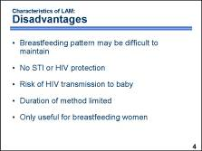 | However, as with all contraceptive methods, there are also disadvantages that providers should discuss with users. The disadvantages of LAM include: █  - Full or nearly full breastfeeding may be inconvenient or difficult for some women, especially working mothers. █  - There is no protection against sexually transmitted diseases, including HIV. █  - If the mother has HIV, there is a chance that breast milk will pass HIV to the baby; although transmission risk is not as high as with mixed feeding. █  - The duration of the method is limited to six months postpartum or when any of the other two LAM criteria change. █  - LAM is a method that can only be used by breastfeeding women. █
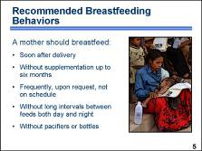 | One of the keys to successful use of LAM is maintaining breastfeeding practices that will ensure LAM’s success. Providers should emphasize the following optimal breastfeeding practices to the mother: █  - Breastfeed as early as possible after delivery. This immediate gratification for the infant establishes a behavior, breastfeeding, which is easily reinforced. A delay of even a few hours can hinder the successful establishment of breastfeeding. █  - Breastfeed without supplements until the infant is about six months of age. This will help to prolong the period of lactational amenorrhea. █  - Breastfeed frequently, on request, not on schedule. A baby will seek as much breast milk as he or she needs. A fixed feeding schedule can be difficult to maintain due to changing nutritional needs and this can frustrate both the mother and the baby. █  - Avoid long intervals between feedings. If the mother and the baby are regularly separated for four to six hours or more, the duration of lactational amenorrhea will decrease. For this reason, breastfeeding at night must be maintained. █  - Avoid using pacifiers and bottles if you give the baby expressed milk. Pacifiers diminish a baby’s need to suckle for comfort. Bottle use may confuse the infant and can lead the baby to reject the breast. Bottle use also increases the risk of gastric infection; feeding expressed breast milk by cup and spoon is preferable. █  Discussion question:  What breastfeeding customs exist in your community and are they in keeping with these recommendations?  Photo credit: Karl Grobl
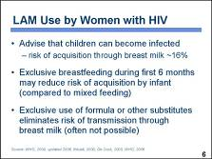 | Women with HIV need to know that any children they bear may become infected with the virus during breastfeeding. The average risk of acquiring HIV infection through breast milk is at least 16 percent. █  If there is no safe alternative form of milk, an HIV-positive mother should give her infant only breast milk. Exclusive breastfeeding means that no other food or drink, not even water, is given to an infant for the first few months of life. There is some evidence that exclusive breastfeeding during the first three months of life may carry a lower risk of HIV transmission than mixed feeding. Limiting exclusive breastfeeding to the first six months may also reduce the risk of HIV transmission. █  When replacement feeding is acceptable, feasible, affordable, sustainable and safe, WHO recommends that HIV-positive mothers avoid all breastfeeding. An HIV-positive mother can eliminate the risk of HIV transmission through breast milk by using infant formula, heat treating/pasteurizing expressed breast milk, acquiring breast milk from a milk bank, or by using a wet nurse. However, she must have ongoing access to a sufficient, clean supply of this alternative form of milk, which is often not possible in many settings. █
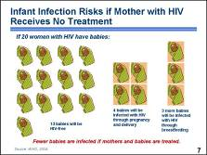 | This graphic depicts what happens if 20 women with HIV have babies but receive no treatment. █ Thirteen babies will be free of HIV. █ Four babies will be infected with HIV during pregnancy or delivery, █ and three more babies will be infected with HIV during breastfeeding. Women who are considering LAM as a method need to be aware of this risk. █  If mothers and babies receive prophylactic treatment, fewer babies will be infected.  Women who are eligible for and receiving standard ARV therapy during pregnancy, delivery, and breastfeeding also have a reduced risk of transmitting HIV to their babies. These women do not require prophylactic ARV treatment around the time of delivery but their babies should receive it. █  Illustration credit: WHO, 2006.
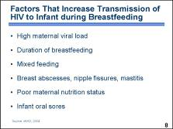 | There are specific factors that may put a woman at higher risk of transmitting HIV to her infant during breastfeeding. One factor is the amount of HIV virus in the mother’s blood and breast milk, known as the viral load. The risk of transmission is greatest when the viral load is high, which is often the case with recent HIV infection or advanced HIV and AIDS. █  Other factors include:  - Duration of breastfeeding – the longer the mother continues to breastfeed, the higher the chance of HIV transmission █  - Mixed feeding, such as foods or fluids in addition to breast milk █  - Breast abscesses, nipple fissures, mastitis – all may increase a baby’s exposure to HIV █  - Poor maternal nutrition status – may affect the strength of the immune system and lead to a higher viral load █  - Oral disease in the infant, such as thrush or sores █
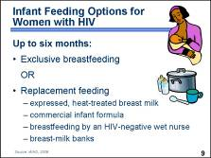 | Exclusive breastfeeding is recommended for women with HIV for up to six months unless they have access to acceptable, feasible, affordable, sustainable, and safe replacement feeding. Exclusive breastfeeding means giving only breast milk and no other liquids or solids, not even water, with the exception of drops or syrups including vitamins, mineral supplements, or medicines. Women who exclusively breastfeed can also choose to rely on the lactational amenorrhea method for contraception. █  Women who have access to acceptable, feasible, affordable, sustainable, and safe replacement feeding may choose not to breastfeed. Replacement feeding can include: █  - Expressing and heat-treating breast milk – removing the milk from the breasts manually or with a pump, then heating it to kill HIV. This method of feeding requires resources for heating and storing the milk, time to prepare the feeds, and a supportive environment. █  - Commercial infant formula – specially formulated powdered milk made specifically for infants and sold in stores or provided by programs to prevent HIV transmission to infants. █  - Wet-nursing – having another woman breastfeed a baby, in this case a woman who tested HIV-negative. █  - Breast-milk banks – places where donor milk is pasteurized and made available for infants. █  Discussion questions:  What types of support or options for replacement infant feeding exist in your community? How do women access them?
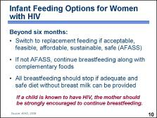 | At six months, the woman should stop breastfeeding but only if acceptable, feasible, affordable, sustainable, and safe replacement feeding is available. █  If replacement feeding is not available, continuation of breastfeeding with complementary foods is recommended. █  All breastfeeding should stop once a nutritionally adequate and safe diet without breast milk can be provided. █  In cases where an infant or young child is known to be HIV-positive, the mother should be strongly encouraged to continue breastfeeding because it has been shown to improve child survival. █
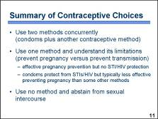 | This concludes our discussion of contraceptive methods for women with HIV. As we have reviewed, women with HIV have many contraceptive methods from which to choose. Given the available methods, the contraceptive options can be summarized as follows: █  Use two methods concurrently, condoms plus another contraceptive method. █  Use one method and understand the limitations of the various methods to prevent pregnancy and to prevent transmission of the virus. Methods that are more effective for pregnancy prevention offer no STI/HIV protection. Condoms – the only method that provides protection from HIV and other STIs – are less effective, as commonly used, at preventing pregnancy than some other modern contraceptive methods. For these reasons, providers should offer counseling to encourage correct and consistent use of condoms. █  Use no method and abstain from sexual intercourse, which may be a sensible option for some individuals, especially adolescents. █

PowerPoint Presentation 19. Client-Provider Interaction – Client-Centered Counseling

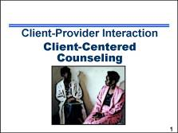 | As we have discussed, clients with HIV have reproductive health choices that are similar to clients who do not have HIV; they may be planning families, evaluating contraceptive options, or considering the advantages and disadvantages of having a child.  The role of the provider is to offer the counseling and support that clients with HIV need to ensure that they can make informed choices that take into account the impact that HIV disease can have on these decisions.  This presentation provides a brief overview of the fundamental features of counseling that all providers should consider when offering RH services to any client, regardless of HIV status. The final section of the presentation highlights the specific aspects of counseling that providers should consider while helping clients with HIV make informed decisions related to their reproductive health and describes how participants can use the flip book to facilitate the counseling process. █  Note to facilitator:  Information about counseling is included in the Participant Manual, page 82. The Counseling Tool (flip book) is designed to facilitate the counseling process for clients with HIV; encourage participants to become familiar with the various topics included in the flip book so that they can use it appropriately during their counseling sessions. Ask participants to have their flip books available so that when instructed, they can refer to them during this presentation.  Photo credit: ©1993 CCP, from Challenges in AIDS Counseling (film)/courtesy of Photoshare
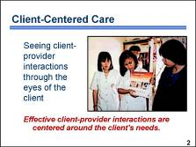 | When providers are able to see client-provider interactions through the eyes of their clients, they can better appreciate how to address clients’ needs appropriately. █  Client-provider interactions begin when a client first comes into contact with a service delivery system, and they continue throughout the client’s contacts with various components and representatives of the system. In some cases, the first interaction the client has with the service delivery system may be with a facility that is difficult to reach, has a long waiting line, has an insufficient number of chairs in the waiting area, and provides little advance information about the services offered at the facility. These experiences can affect the client’s attitudes and views about family planning and other reproductive health issues, even though they do not involve direct interactions with a person working in the service delivery system.  Although a client’s initial impressions of the facility and physical features can have a very strong influence – and therefore should be carefully evaluated and addressed – in this presentation, we will focus on direct interactions between clients and the people working in the service delivery system. █  Discussion questions:  As I read a scenario about a client’s visit to a clinic, pretend that you are the client and be ready to discuss your impressions.  Imagine that you are a woman from a small village coming to the primary health care clinic for the first time. You have five young children; three are at home and two are with you. You speak a language that is particular to your region of the country, and you are not very comfortable speaking or reading English, the language spoken in the area around the capital. You walk over an hour to the clinic. When you arrive at the clinic you see a few women waiting and speaking to each other in English. They seem not to notice you. There is another woman sweeping the waiting area who looks at you vacantly. Behind a desk is a young man who seems to be the receptionist.  - How did it feel to be this client?  - How would you want to be treated if you were this client?  - To improve the quality of service – and the client’s initial impressions of the service delivery system – what could you do, as a member of the clinic staff, to reduce the anxiety just described?  Photo credit: ©1992 CCP/courtesy of Photoshare
 | Because interactions with people are such an important aspect of a client’s experience, all staff should be encouraged to maintain appropriate interpersonal skills. Several characteristics can help make the interactions between clients and the service delivery staff more effective and positive. █  Showing respect for clients is important. All clients are entitled to respect, regardless of educational level, age, sex, ethnic group, or income. Caring about the needs of the client – and putting oneself in the situation of the client – is essential. Some refer to this characteristic as having empathy for clients, regardless of their situation and needs. Empathy can help build trust between the client and provider. █  Communication skills are essential, particularly listening skills. █  Staff members need to accept values that are different from their own. Effective providers will not impose their own values on their clients. █  Service staff must be open-minded and maintain an impartial attitude toward all clients, regardless of age, marital status, ethnicity, sex, religion, race, educational level, or sexual orientation. An understanding of the local culture allows staff members to interact appropriately without unknowingly offending clients. █  Discussion questions:  Describe how you show empathy for clients. Describe how you handled a situation in which you were able to relate effectively to a client who might otherwise have been uncomfortable at your facility. How did you recognize the client’s situation – wariness or anxiety – and what did you do to accommodate his or her needs?  Photo credit: ©2004 Melissa May/courtesy of Photoshare
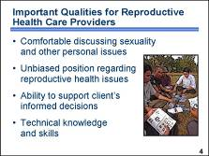 | Counselors and reproductive health service providers should possess all of the qualities discussed in the previous slide. Several other characteristics are also important. █  Providers of reproductive health services should be comfortable in discussing sexuality and clients’ feelings and fears. Too often, family planning providers discuss contraception using complex biological terms, or HIV counselors discuss STI prevention without addressing sexuality issues. Reproductive health issues must be discussed in a straightforward, nonjudgmental manner so that clients feel comfortable sharing their true concerns. Topics such as the number of partners, how to achieve intimacy without sexual intercourse, how to negotiate safer sex and condom use with a partner, how side effects may affect sexual relations, and how to deal with domestic violence in a sexual relationship are very personal and cannot be appropriately addressed unless the provider is comfortable and willing to deal with these concerns. █  Providers need to maintain unbiased, evidence-based positions regarding reproductive health issues. Effective counselors will not impose their opinion on a client; they maintain a neutral approach to providing guidance even if they favor or dislike a particular contraceptive method, or personally believe that women with HIV should not get pregnant. █  Providers should be supportive of a client’s informed decisions, even though the decision may not be what the provider would choose. For example, a couple with HIV may desire children and elect not to use contraception. In this instance, it is the obligation of the provider to counsel the couple about how to safely achieve pregnancy while maintaining their health and taking measures to ensure the health of the baby. █  Providers also need up-to-date technical knowledge and a willingness to change their viewpoints as more scientific information becomes available. New research data may affect how a provider counsels a woman about her reproductive health options, so it is imperative that a provider maintain his or her technical knowledge and skills. █  Photo credit: Karl Grobl
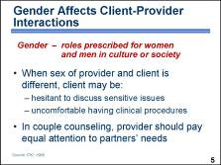 | Gender is an overarching concern that affects the interactions between all service delivery staff and clients. █ It refers to the roles prescribed for women and men in a particular culture or society. Providers need to be aware of how gender roles affect client-provider interactions, be mindful of those implications, and adapt their behavior accordingly. █  When the provider and client are of a different sex, issues involving gender roles may arise. In some cultures, a woman is not supposed to talk about sexual issues, and those women who do discuss such issues are considered impure or promiscuous. A study in Bolivia found that women are often too embarrassed or ashamed to discuss sexual issues with their husbands, and find such a discussion even more difficult with a male provider.  Similar issues can arise for male clients consulting a female provider. Men may think it is not proper to discuss sexual issues with women. For example, men considering vasectomy may fear it will cause impotence but may not raise this concern with a woman. Providers need to help men voice their fears and provide explanations that can be easily understood. █  Gender roles can also affect the client-provider interaction during clinical procedures. For example, many female clients are not comfortable with a male provider doing a pelvic exam. If a female provider is not available, a male provider should have a female assistant in the room during the procedure, if possible. █  Gender issues also affect couple counseling. A counselor may primarily address the man, either presuming that he is more knowledgeable, makes all the important decisions for the family, and controls the use of family planning, or simply out of traditional styles of showing respect. In many cases, however, the woman knows more about these subjects and may need the counselor’s encouragement to express her opinions. █  Discussion questions:  Describe any gender concerns that you have observed while providing reproductive health services. What are the implications (constraints or benefits) of these? What has been your experience counseling couples and what influence did gender and related cultural traditions have on the interaction?
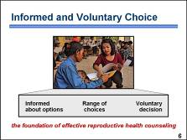 | Informed and voluntary choice █ is the foundation of effective sexual and reproductive health counseling. Well-informed clients who voluntarily make knowledgeable decisions from a range of possible options are more likely to be satisfied.  To be informed, clients need to have clear, accurate, and specific information. Clients also need to be able to understand clearly how information applies to their own reproductive health needs and influences their preferences.  To make a choice, clients need to have a range of options and understand the potential benefits and disadvantages of each option as it relates to their individual situations. For example, a range of choices may include to try and become pregnant or to use contraception to temporarily delay or permanently prevent pregnancy; to use two contraceptive methods or rely on condoms only; to involve a partner in the decision-making process or not; to take an HIV test or not; or to share a positive test result with a partner, a family member, or no one.  Regardless of the issue, clients need to be encouraged to make their own choices and should not be pressured or coerced to make a particular decision. █  Photo credit: Karl Grobl
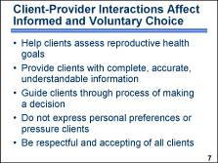 | Let us examine how interactions between a client and provider can affect whether a client’s decisions are informed and voluntary. █  Clients may need the help of providers in assessing their reproductive health goals. Some clients may have already established their goals and made decisions based on previous experience or information from neighbors, family members, peers, the media, health care providers, and family life education. Other clients may not have established firm goals and need assistance sorting through many issues before they can establish individual goals. Reproductive health goals may include delaying a first pregnancy, spacing births, not having more children, preventing acquisition or transmission of RTIs/STIs/HIV infection, maintaining health and fitness if HIV-positive, getting screening or treatment for cervical cancer, achieving balanced nutrition, having a healthy pregnancy, or any number of other RH-related objectives. The initial assessment should help determine what the client’s primary and secondary goals may be so that the provider and client can work together to achieve those goals. █  During interactions with clients, providers are expected to offer complete, accurate, and easy-to-understand information. Providers should clarify any misunderstandings that clients may have. A provider must also be careful to give the appropriate amount of information so that the client can absorb it and use it to make the right decision. █  Providers should be prepared to guide clients who have difficulty making a decision or who do not seem to have a preference. When guiding the decision-making process, the provider must be careful to present information and options in a neutral manner to avoid limiting the client’s choices or inappropriately influencing a client’s decisions. █  During interactions with clients, providers should not express personal preferences or pressure a client to make a particular choice. When a client makes a choice, the provider should accept it and not try to change the client’s mind or help the client to make a “better” decision, unless the client’s preference is not appropriate for medical reasons. █  During all interactions with clients, providers should be respectful and accepting. Interacting with a provider who is disrespectful and intolerant compromises a client’s right to receive the health care to which he or she is entitled. █
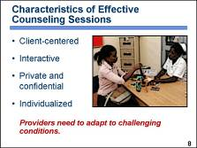 | Counseling is the process by which providers can ensure that clients make voluntary and informed decisions about their reproductive health. █  The most important aspect of effective counseling is centering the interaction on the needs and desires of the individual client. █  Counseling should always be interactive. This means the provider should not only ask questions but also encourage the client to ask questions. Providers need to listen to and respond to the client’s concerns and encourage discussion. Effective counseling involves the client actively in every part of the process. █  Reproductive health counseling should be private and confidential. Many of the issues discussed, such as sexuality, are highly sensitive. Clients will be more comfortable and talk more when they know that others will not overhear or learn about the conversation. █  Reproductive health counseling should be individualized for each client. Needs and preferences vary extensively by age, parity, lifestyle, life stage, number of sexual partners, risk of sexually transmitted diseases, and other factors. Counselors should avoid standard lecture-type information and other approaches that result in less attention to the particular circumstances of the person being counseled.  For some individuals, counseling might be more effective if the client’s partner is included. Couple counseling can result in better continuation rates. Some women, however, may choose to keep contraceptive use secret from a partner to avoid conflict or even violence. █  Some conditions pose particular challenges to good counseling, such as crowded clinics, settings that make privacy difficult, limited staff and time, and long waiting lines. Providers will have to adapt to these conditions in order to incorporate elements of good counseling. Using educational materials in the waiting area or group educational sessions for general background information can save time during individual counseling. When privacy is an issue, providers may be able to take clients outside or use barriers to create a private space. █  Discussion question:  Provide an example from your personal experience that shows how you were able to adapt to a challenging situation that improved counseling for your client(s).  Photo credit: Richard Lord
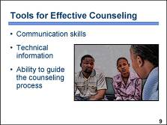 | The next section of this presentation describes the tools providers need to be effective reproductive health counselors. █  Tools include:  - A proficiency in interpersonal communication skills to facilitate interactions with clients █  - A general and specific knowledge of a variety of reproductive health topics – this technical knowledge will vary based on a provider’s job function, their individual areas of expertise, and the service mandate of the facility where they work █  - An understanding of and ability to guide a client through the stages of the counseling process  The word “counseling” refers to all three of these dimensions of the interaction – communication skills, technical information, and the stages of the counseling process. During reproductive health counseling, the three dimensions operate simultaneously. █  Photo credit: Richard Lord
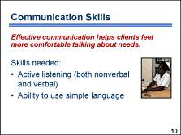 | The importance of effective communication between the provider and client cannot be overemphasized. Providers need communication skills that encourage clients to feel comfortable talking about and exploring their needs. █  The next several slides discuss specific communication skills needed by providers. These skills include active listening skills, which are both nonverbal and verbal, as well as the ability to explain technical information using simple language and avoiding medical terminology. █  Photo credit: Richard Lord
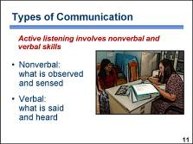 | During an effective counseling session, a provider uses active listening skills. Active listening involves listening carefully to what a client says, responding in a way that encourages the client to continue communicating, and observing nonverbal cues to how the client is feeling. Active listening involves both nonverbal and verbal communication.  Nonverbal communication refers to what is communicated without words, or what is observed. We often communicate how we are really feeling through gestures or facial expressions. Providers need to be aware of the nonverbal messages they are conveying and to recognize nonverbal messages from clients. Nonverbal skills play a role in building trust between the client and provider so that they can work together.  Verbal communication refers to the words that are said and heard, as well as sounds that are not words. These sounds include phrases such as “uh-huh,” which communicate support and approval in some cultures. █  Photo credit: Karl Grobl
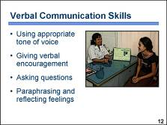 | There are certain verbal communication skills that providers can use to let clients know that they have been heard, understood, and respected. These skills help the provider to learn about the client’s needs so that they are able to share information at a level that is appropriate for the client. █  A tone of voice that communicates warmth and caring, rather than judgment or disapproval, is essential. This can help to build rapport and trust between provider and client. █  Verbal encouragement from a provider helps clients feel comfortable and confident, and it will encourage them to talk honestly about their situations and needs. █  Asking appropriate questions is another important skill. The most effective questions are open-ended or probing. These questions require a more elaborate answer than a simple “yes” or “no.” █  Paraphrasing what the client has said, or restating the message in simple words, can help the client know that he or she has been heard. It will also ensure that the provider understands what the client is saying. In paraphrasing or restating the message, a provider might pay particular attention to reflecting back the client’s feelings. █  Discussion question:  What question, statement, or topic of conversation do you use to help shy clients open up to you?  Photo credit: Karl Grobl
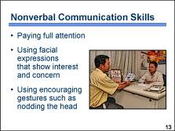 | Providers need to be aware of the nonverbal cues they are giving and what these cues communicate to the client. Nonverbal cues that indicate caring about the client’s needs are important. █  Positive nonverbal cues include giving full attention to the client. For example, by facing or leaning toward the client, providers indicate they are interested in what the client is saying. Taking brief notes about what the client is saying communicates that what the client says is important. The notes can be used by the provider during the counseling session to help the client reflect on issues that may influence the client’s ultimate decision. █  Using facial expressions that show interest and concern, such as smiling at appropriate times, will help the client to relax and be more comfortable. █  Using encouraging gestures will show clients that what they are saying is important and will encourage them to talk about themselves. Encouraging gestures by providers will vary by culture but could include nodding the head, for example. Some nonverbal cues, such as maintaining eye contact, may be appropriate in some cultures but seen as threatening in others. An example of a negative nonverbal cue would include frowning or looking away when a client mentions multiple partners or premarital sex. █  Discussion question:  What nonverbal cues or gestures do you use during your counseling sessions to help put clients at ease?  Photo credit: Karl Grobl
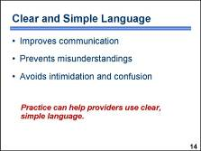 | Using clear and simple language is one of the most important skills for improving communication between providers and clients.  Providers are accustomed to using technical language. Even when making the effort to use nontechnical terminology, providers often use more complicated words and sentences than clients understand. If clients do not understand what the provider says, they may not make the best decision for their situation, may not follow instructions properly, and may become dissatisfied with their decision.  Clients may feel intimidated or confused by language they do not understand and may not ask for clarification. █  Providers may need practice in using clear and simple language. █  Discussion question:  Describe how you determine whether a client is understanding what you have said.
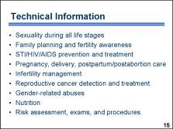 | Providers offering integrated reproductive health care need the ability to address the various life circumstances and life stages of their clients. Whether a provider needs general or in-depth knowledge in a particular area depends on a provider’s job function within the health care system.  Some of the reproductive health areas addressed in an integrated care setting may include:  - Sexuality during all life stages for both men and women – adolescence, preconceptional, antepartum, postpartum, perimenopause, and postmenopause  - Family planning and fertility awareness – including healthy timing and spacing of pregnancies, counseling for informed choice, and provision of a variety of contraceptive methods  - Prevention and treatment of STIs/HIV/AIDS, including preventing mother-to-child transmission  - Pregnancy, delivery, postpartum, and postabortion care  - Infertility management – counseling and services  - Reproductive cancer detection, education, and treatment  - Gender-related abuses, such as domestic violence  - Nutrition to maintain health  - A variety of assessments, examinations, and procedures for diagnosis and treatment  When a provider does not directly offer a service they should – at a minimum – be able to recognize a client’s concern and refer the client to another provider or facility that can address the client’s needs. █  Discussion question:  Think about how you would address a client’s needs in each of these reproductive health areas.
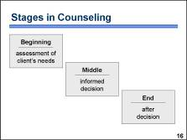 | Every human interaction has a beginning, middle, and end. During the counseling process, the exchange between a provider and a client also follows these three stages. Thinking in terms of the beginning, middle, and end can help a provider and client work together, in a realistic time period, to help a client make an informed decision and achieve satisfaction. Strong communication skills and appropriate technical information are important during each stage.  The beginning stage involves greeting the client and doing the initial assessment. In the middle stage, the client makes an informed decision or reaffirms a decision previously made. During the end stage the provider summarizes key information, clarifies questions, and reinforces how a client will implement their decision(s).  The amount of time required to complete a stage varies. When the information is tailored as much as possible to the client’s particular needs, time is saved by omitting information that is not relevant to the client. Job aids, such as screening checklists, patient history cards, and flip charts, can facilitate the process of assessing client needs and sharing information.  The next several slides describe the stages of the process in greater detail. █
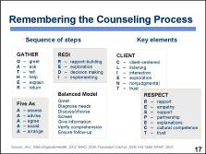 | A number of guidelines have been developed to help providers remember the counseling process. These guidelines have many features in common and tend to follow the same general pattern for the beginning, middle, and end stages of a counseling session. Frequently these guides employ a mnemonic device – using the first letter of a word to serve as a memory aid to help providers remember the steps or essential components of a counseling session. █  Some devices that providers may be familiar with include:  GATHER: Greet, Ask, Tell, Help, Explain, Return. █  REDI: Rapport-building, Exploration, Decision making, Implementing. █  Five As: Assess, Advise, Agree, Assist, Arrange. █  The Balanced Model – a counseling model developed to improve the quality of care offered by family planning providers – includes these steps: greet the client warmly, diagnose needs with the client, discuss and choose a method with client, screen for contraindications, give detailed information, verify comprehension, and ensure follow-up. █  Other mnemonic devices spell key elements, rather than stages of the counseling process. Examples include:  CLIENT: Client–centered, Listening, Interaction, Exploration, Nonjudgmental, Trust. █  RESPECT: Rapport, Empathy, Support, Partnership, Explanations, Cultural competence, Trust.  Some providers may want to develop their own way to remember the key aspects of counseling. Other providers may choose not to follow a fixed set of steps because they feel that the unique dynamic between each client and provider must unfold differently. Regardless, program managers must ensure that providers can interact with clients in a manner that appropriately addresses the needs of the clients while efficiently utilizing the resources of the health care system. █  Discussion questions:  What counseling process do you use? What devices do you use to remember the steps? How have you adapted the counseling process that you initially learned to accommodate the services that you now offer?
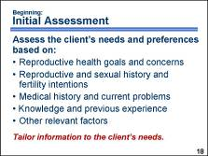 | In the next few slides we will further explore the stages in counseling and how the Counseling Tool (flip book) can support a counseling session.  In the beginning stage, the provider welcomes the client and describes the basic structure of the counseling session. [refer to flip book page 1] The provider then assesses the needs and preferences of the client. Providers often ask a brief series of common questions designed to identify those needs. The amount of detail discussed during the beginning stage will vary depending on a number of factors, including whether the client is new or returning and the complexity of the client’s needs. The beginning stage typically includes: █  - Determining a client’s reproductive health goals and concerns – why the client came to the health facility. [refer to flip book page 2] █  - Documenting basic information such as age, lifestyle, marital status, and reproductive and sexual history and fertility intentions. This tells the provider how many children the client has had or desires, how many partners he or she may have, a client’s risk for disease acquisition and unintended pregnancy, and how these issues may influence the client’s decision-making process. [refer to flip book page 3] █  - Making sure a client has no medical problems that would affect a client’s range of options or be a factor warranting consideration during the decision-making process. In general, providers can determine this by asking basic health-related questions during a brief medical history without using tests. [refer to flip book page 3] █  - Finding out what knowledge or previous experience the client may have related to the issue. This information in particular will help the provider know how to focus the discussion and use time wisely. [refer to flip book page 3] █  - Uncovering specific factors related to a client’s individual situation, such as whether she is breastfeeding, whether the client’s partner approves or disapproves, or whether the client is abused by a partner or family member should be evaluated for their impact on the client’s decision. The larger social and cultural context within a community can also influence a client’s decision. [refer to flip book page 3]  To streamline the initial assessment, the basic information and medical history may be incorporated into the client’s patient record or an assessment tool. Collecting this type of information is especially important for first-time clients. In the case of returning clients, it is helpful if the provider can review the information to ensure that it is still correct. █  The information gathered during the initial assessment should be used to tailor the rest of the counseling session to the client’s individual needs. Each session will be different. The next two slides explore the stages of a counseling session in which a client has indicated, during the initial assessment, that she would like to make an informed decision about using a contraceptive method. █  Note to facilitator:  Use the example included in the Facilitator Manual, Activity 10.2, to help participants consider how the flip book can be used in a counseling session.
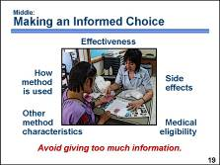 | When counseling a client to make a decision about contraception, the major tasks of the middle stage are to discuss information about contraceptive methods, to help the client make an informed choice, and to ensure that the client is medically eligible to use that method.  The needs of the individual client assessed during the beginning stage should guide the discussion. For a first-time client who does not know which method she or he wants, the provider will need to be more thorough. Some clients may have gained accurate knowledge and information on methods during prior educational sessions, while others may have incomplete or inaccurate information from unreliable sources. Interactive discussions, complemented with visual aids and samples of methods, can help a client fully understand the choices. [refer to flip book pages 14–17] However, it is important to avoid giving too much information because the client may not be able to absorb all of it. For clients who know what method they want, the interaction should be focused on confirming their choice and screening to ensure that the client is medically eligible to use the method. [refer to flip book for pages specific to each method and use medical eligibility checklists when providing COCs, DMPA, IUDs, and implants]  Technical information shared during this stage may include: effectiveness of a method, the mechanism of action, how the method is used, non-contraceptive benefits, side effects, possible complications, and other method characteristics that are pertinent to the client’s individual situation.  If clients have not made a choice earlier, they should be able to do so by the end of this stage. If the client is still unsure, the provider can suggest trying a method temporarily. If unhappy with the method later, the client can return and choose another method. █  Photo credit: ©2004 Melissa May/courtesy of Photoshare
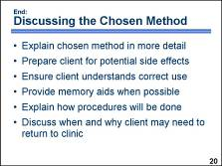 | After a client makes an informed method choice, the discussion moves to the end stage, █ in which the provider discusses the chosen method in detail to ensure that the client’s decision is fully informed. [refer to “possible questions to ask” included throughout the method pages of the flip book to help a client think about how the method will work in their situation] █  It is especially important to review the potential side effects of the method and to encourage the client to consider how she or he would deal with those side effects. █  At this point, the provider should explain in detail how to use the method correctly. The provider should check to be sure clients understand how to use the method by asking them to repeat instructions back. █  When discussing correct method use, contraceptive samples and written and visual memory aids, such as pamphlets, flipcharts, and drawings should be used. Whenever possible, especially for more complex issues, memory aids such as booklets or written instructions should be given to clients to take with them. For example, memory aids can help a client know what to do if she forgets to take a pill or can help a couple determine the fertile time in the month. █  For methods that involve a procedure, such as insertion of an IUD or an implant, providers need to explain exactly how the procedure will be done and give clients an opportunity to ask explicit questions. █  Providers need to be sure clients know when to return if a follow-up visit is necessary and encourage them to return if they have questions or concerns, need resupply, experience any warning signs of complications, or want to change methods. █  Discussion questions:  How do you help your clients think honestly about how side effects might affect their ability to use a method? How do you help your clients remember instructions?
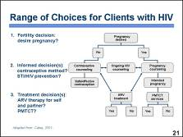 | As we discussed during an earlier session [activity #4.7], the range of basic options for clients with HIV is similar to that of clients who do not have HIV. However, infection with HIV adds another level of complexity to the client’s decision-making process, which makes ensuring that the client is appropriately informed – and can adequately weigh the options – more complicated. Providers must structure their services, especially counseling sessions, to help clients with HIV understand their options and realize their reproductive health goals. As depicted in the diagram, this may include facilitating decisions around pregnancy, contraception, ARV therapy, preventing mother-to-child transmission, and other related issues that are pertinent to a client’s reproductive health.  The remainder of this presentation focuses specifically on counseling clients with HIV. However, you will notice that there is much in common between clients with HIV and those without. █
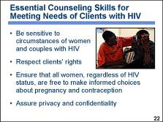 | Because of the special circumstances of clients with HIV, counseling should be conducted with particular sensitivity. █  As with any client, providers must demonstrate respect for clients’ rights. █  Providers should always remember that every woman, regardless of her HIV status, has the right to make a free and informed decision about whether and when she becomes pregnant or whether to use contraception and which method to use. [refer to flip book page 6 for assistance counseling clients who are making a decision about their reproductive intentions] █  Providers should always ensure privacy and confidentiality, as this may be a significant concern for clients with HIV. █  Photo credit: ©2003 Amelia Shaw/Agence des Jeunes Producteurs, from Deye Mon [Behind the Mountain] film/courtesy of Photoshare
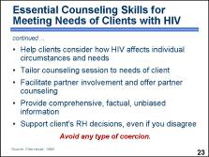 | Providers should also help each woman or couple consider how HIV affects their individual circumstances and needs. █  The discussion during the counseling session should be driven by the needs expressed by the client. █  As much as possible, providers should facilitate the efforts of women to involve their partners. Women may need assistance with building communication skills and with developing strategies to address sensitive situations. As appropriate, providers should offer to meet jointly with a couple or alone with the woman’s partner. [refer to flip book page 46 for tips on talking with partners] █  A provider should offer comprehensive, factual, unbiased information and seek to dispel any misinformation. Providers should also avoid using inappropriate terminology that can stigmatize clients with HIV. █  When counseling a woman or couple with a known or suspected HIV infection, providers should support the clients’ decisions, even if they do not agree with those decisions. For example, a counselor may believe that permanent contraception is the best option for all women and men with HIV, but this belief should not influence the counseling. █  Providers must ensure that they do not coerce clients. Intimidating clients and forcing decisions has no place in counseling. █  Discussion question:  Describe any other skills that you use, or special considerations that you take into account, when counseling clients with HIV.
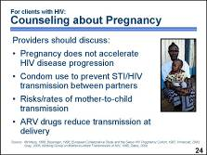 | Providers who counsel clients with HIV who are considering pregnancy should explain that pregnancy does not appear to accelerate HIV progression, even among women not receiving antiretroviral therapy. [refer to flip book page 7–13 for assistance counseling clients who are considering pregnancy] █  Although pregnant women do not need contraception, condom use should be encouraged to prevent the transmission of HIV and other STIs between partners. For discordant couples where the male partner is positive, it is also very important to continue using condoms during pregnancy. Although evidence is inconsistent, one large study demonstrates that pregnant women may have higher risk of HIV acquisition. █  Providers should also emphasize the risk of transmitting HIV from mother to child. Rates of mother-to-child HIV transmission range from  15 percent to over 40 percent in the absence of antiretroviral treatment. █  Providers should advise that ARV treatment around the time of delivery can substantially reduce HIV transmission risks during childbirth and immediately postpartum. [refer to flip book page 9 and pages 12–13 for information about preventing mother-to-child transmission] █
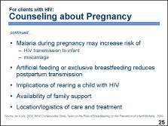 | Other issues the provider should address during counseling include:  - Infection with malaria during pregnancy may increase the risk of HIV transmission to the infant and also lead to miscarriage. █  - The fact that artificial feeding or exclusive breastfeeding for the first six months can reduce postpartum HIV transmission to the child. However, it is important to keep in mind that while artificial feeding can reduce HIV transmission, it increases the risk of the infant dying from other infectious diseases, particularly in the first two months of life. [refer to flip book page 13 for information about infant feeding options for mothers with HIV] █  - The implications of rearing an HIV-positive child, including the course of the child’s infection and likelihood of premature death. █  - The need to consider whether family members will be available to raise children if the mother dies of AIDS, as may happen without treatment. █  - Where to go for care and treatment during and after pregnancy. [refer to flip book page 12 for information about care and treatment during pregnancy and delivery] █
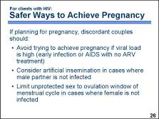 | Even in low-resource settings, there are a number of steps that a discordant couple can take to avoid HIV acquisition and transmission while trying to achieve pregnancy. When counseling discordant couples who desire pregnancy, encourage them to: [refer to flip book page 10 for information about “safe” methods of conception] █  - Avoid trying to achieve pregnancy if viral load is high; there are two periods when high viral load is typical – during early HIV infection and among people with AIDS who are not receiving ARV treatment – although an individual’s viral load can be high at other times as well. █  - Consider artificial insemination in cases where the male partner is not infected. █  - In cases where the female partner is not infected, limit unprotected sex to the time during the woman’s menstrual cycle when she is ovulating and most likely to conceive. It is also very important to continue using condoms after conception to avoid contracting HIV during the time the woman is pregnant and breastfeeding. This is because when a person is newly infected with HIV, the viral load is very high and the risk of transmitting HIV is increased. Therefore, if a woman acquires HIV while pregnant or breastfeeding, the likelihood of transmitting HIV infection to the infant is greater. [refer to flip book page 11 for information about finding the fertile time of the menstrual cycle] █  Discussion question:  What other issues have you talked about with clients who had HIV and were considering pregnancy?
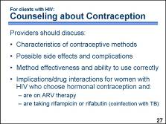 | When counseling women with HIV about their contraceptive options, providers should consider the client’s medical eligibility for particular contraceptive methods and:  - Provide an overview of method characteristics, including possible side effects and complications of available contraceptive methods. [refer to “facts you should know” information included throughout the method pages of the flip book to help clients learn about the methods of interest to them] █  - Discuss the effectiveness of available contraceptive methods and how effectiveness may be affected by a client’s ability to use a method correctly, such as remembering to take a pill daily. Because unintended pregnancy often presents greater challenges for women with HIV, they may want to choose a client-independent method. [refer to flip book page 17 and Fact Sheet 12. If 100 women use a method for one year, how many will become pregnant? (included with the course materials) for information on the relative effectiveness of various contraceptive methods] █  - Help women who plan to use hormonal contraception consider the implications of possible interactions between contraceptive hormones and ARV drugs. For women taking particular ARV drugs, these interactions include the potential for reduced contraceptive effectiveness or increased hormonal side effects. █ Also, make sure that women with HIV who are planning to use oral contraceptives are not taking the antituberculosis antibiotics, rifampicin or rifabutin. Coinfection with tuberculosis is common among patients with HIV, and these antibiotics speed up the metabolism of contraceptive hormones, reducing the effectiveness of oral contraceptives. █
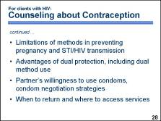 | The provider should also:  - Discuss the limitations of methods to prevent pregnancy and STI/HIV transmission, emphasizing that methods that are most effective in preventing pregnancy do not offer protection from HIV and other STIs. █  - Emphasize the advantages of dual protection, including dual method use particularly for discordant couples and for those with multiple partners. When a client chooses one of the more effective methods for pregnancy prevention, encourage the client to also use condoms to prevent STI/HIV transmission. [refer to flip book page 16 for information on dual protection] █  - Help a client consider her partner’s willingness to use condoms, discuss possible condom negotiation strategies, and offer couples’ counseling. [refer to flip book page 46 for tips on talking with partners] █  - Ensure that women know when to return for regular follow-up; if they have questions, concerns, or problems with the method, and if they need resupply. In the event that a client’s chosen method cannot be provided on-site, refer the client to a facility where the method is offered. [refer to flip book page 45 for advice on making and implementing a plan and dealing with challenges] █  Discussion question:  What other issues have you talked about with clients who had HIV and were considering starting a contraceptive method?
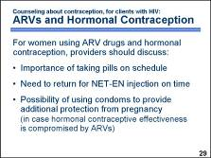 | The issues that should be addressed when a woman on ARV treatment plans to use hormonal contraception include: █  - The ability to take oral contraceptive pills correctly. Because some ARV drugs decrease blood concentration of contraceptive hormones, the risk of contraceptive failure may be greater if a woman forgets to take pills. [refer to flip book page 25 for information about the importance of taking COCs correctly and consistently due to interactions with certain ARVs] █  - The need to come back for the next NET-EN injection on time. Although the next injection usually can be given as much as two weeks late, in the presence of ARV therapy it is safer to follow a strict injection schedule. [refer to flip book page 29 for information about the importance of returning for injections on time] █  - Willingness to use condoms to ensure additional protection from pregnancy because the effectiveness of hormonal contraceptives – other than DMPA which provides a wide margin of effectiveness in each dose – may be compromised by ARV therapy. Focusing on the pregnancy prevention role of condoms may help when negotiating condom use with a partner. █  Discussion question:  What other issues have you talked about with clients who had HIV, were taking ARVs, and were interested in starting a hormonal contraceptive method?
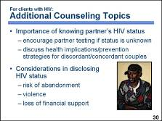 | During counseling a provider should explore whether a client knows his or her partner’s HIV status. When a partner’s HIV status is unknown, a provider should encourage clients to bring their partners for counseling and testing or provide referrals. Knowing a partner’s HIV status is important when making decisions about whether to have a child, what contraceptive methods to use, and how best to prevent STI/HIV transmission. Health implications and prevention strategies should be discussed for situations when either one or both partners has HIV infection. █  A provider should also discuss whether the client has disclosed her HIV status to her partner or family. If a woman’s status is undisclosed, counselors should help her determine whether disclosure of HIV status or use of contraceptives would pose a risk of abandonment, violence, or loss of financial support for herself and her children. █  Photo credit: ©2004 Paul Wood/courtesy of Photoshare
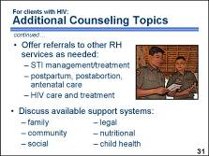 | Depending on the individual situation and needs of the client, the provider should be able to offer referrals to other reproductive health services if they are not provided on-site. These services may include STI management and treatment; postpartum, postabortion, and antenatal care; and HIV care and treatment services, including ARV therapy and prophylaxis. [refer to flip book page 52 for information about healthy living with HIV] █  Providers should also discuss what family, community, social, legal, nutritional, and child health supports are available to clients. If clients are interested in these services, discuss how to access them and provide written referrals if needed. [refer to the last page of the flip book and encourage participants to write in the contact information necessary for making referrals to various services available in their community] █  Discussion question:  What types of support systems are available in your community for clients with HIV? Encourage participants to record the contact information for available community services on the last page of their flip books so that they can easily locate it when making referral recommendations for their clients.  Photo credit: Karl Grobl
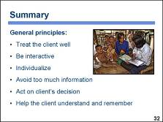 | The interactions that providers have with clients are the primary means for ensuring that clients receive high quality care that meets their needs.  For effective client-provider interaction during counseling, providers need communication skills and technical knowledge, as well as an understanding of the counseling process.  Each counseling session will be different depending on the client’s situation, health history, knowledge, and individual goals. █  In all counseling sessions, the following general principles, that have been discussed throughout this presentation, should be employed: █  - Treat the client well █  - Be interactive throughout the session █  - Individualize to address the client’s personal needs and unique situation █  - Give an amount of information the client can remember █  - Act on the client’s decision – whether that means offering a method, completing a test or procedure, or providing a referral █  - Use and provide take-home materials and other memory aids – and, as appropriate, create an individualized plan for the client █  Photo credit: Karl Grobl

PowerPoint Presentation 20. Postexposure Care and Prophylaxis for Providers

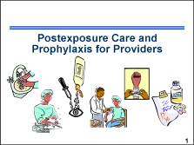 | This presentation provides an overview of the risks of being infected with HIV after occupational exposure and the procedures that should be followed after possible exposure, including immediate care and prophylaxis with ARV drugs. █  Note to facilitator:  Information about postexposure care and prophylaxis for providers is included in the Participant Manual, pages 97–99.
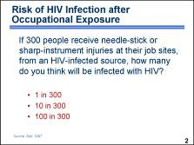 | Discussion question:  If 300 people receive needle-stick or sharp-instrument injuries at their job sites, from an HIV-infected source, how many do you think will be infected with HIV? █  [Ask for participant responses to the question before clicking the mouse to reveal the correct information.]  Answer: The risk of becoming infected with HIV following a needle-stick or sharp-instrument injury is about 1 in 300. Most injuries do not result in infection. █
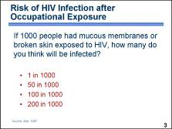 | Discussion question:  If 1000 people had mucous membranes or broken skin exposed to HIV, how many do you think will be infected? █  [Ask for participant responses to the question before clicking the mouse to reveal the correct information.]  Answer: The risk of becoming infected with HIV following exposure of a mucous membrane or broken skin is about 1 in 1000. Most injuries do not result in infection. █
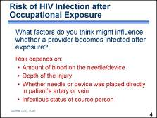 | Discussion question:  What factors do you think might influence whether a provider becomes infected after exposure? █  [Ask for participant responses to the question before clicking the mouse to reveal the correct information.]  Answer: The risk of infection following exposure depends on a number of factors, including the amount of blood on the device, the depth of the injury, whether the needle or device was placed directly in an HIV-positive patient’s artery or vein, and whether the infected blood came from a person with advanced disease or terminal illness – possibly reflecting the higher viral load that occurs in the advanced stage of infection.  On the next several slides we will review the procedures to follow in the event of possible exposure to HIV. █
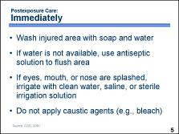 | In the event of possible exposure to HIV, a provider should immediately:  Flush the injured area with running water and wash it with soap and water.  If the eyes, nose, or mouth have been splashed, irrigate with clean water, saline, or sterile irrigation solution. Also, remove any clothing or other items that may have been contaminated.  If water is not available, an antiseptic solution can be used to flush the area – with the exception of the eyes, nose, and mouth. Antiseptic solutions have not been proven to be any more effective than soap and water for wound care, nor is there any evidence that expressing fluid by squeezing the wound further reduces the risk of blood-borne pathogen transmission.  The application of caustic agents, such as bleach, or the injection of antiseptics or disinfectants into the wound is not recommended because it may cause inflammation and potentially facilitate the entry of HIV. █
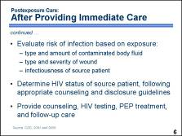 | All occupational exposures do not carry equal risk of postexposure infection. Therefore, after providing immediate care, evaluate the risk of infection to determine the subsequent course of action. █  Evaluate the exposure for the potential to transmit HIV based on the body substance involved and the route and severity of the exposure. Assess the injury, including the depth of the wound and the type of instrument that caused the injury, and determine the type and amount of body fluid involved. █  Find out the HIV status of the source. If the patient has HIV, collect all available information about the patient’s stage of infection – asymptomatic, symptomatic, or AIDS, CD4+ T-cell count, results of viral load testing, current and previous antiretroviral therapy, and results of any viral resistance testing. This information should be considered when choosing an appropriate PEP regimen. If this information is not readily available, initiation of PEP, if indicated, should not be delayed. If the client’s HIV status is not known, follow the appropriate counseling and disclosure guidelines to ensure that the client’s rights are maintained while seeking information on HIV-status. █  If it is known or suspected that the source has HIV and the exposure was such that HIV transmission is possible, seek counseling and HIV testing, and explore the need for ARV prophylaxis and follow-up care. If it is determined that the source client is HIV-negative, it eliminates the need for possible ARV prophylaxis and reduces the emotional stress related to the injury.  For example, a health care worker – who sustained a deep puncture, with a large-bore hollow needle, with a visible amount of blood on it, that had been recently used in the artery or vein of a client whose viral load is high due to advanced HIV disease or acute infection – would be at increased risk of infection and should be counseled, periodically tested, provided with postexposure prophylaxis, and carefully monitored for at least six months. █
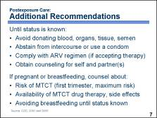 | Some additional recommendations for health care workers who were potentially exposed to HIV include:  - Avoid donating, blood, organs, tissue, semen  - Abstain from intercourse or use a condom to prevent sexual transmission and to avoid pregnancy  - Comply with ARV regimen if accepting therapy and complete suggested health monitoring  - Obtain counseling for self and partner(s) – all exposed health care workers should receive follow-up counseling, postexposure HIV testing, and medical evaluation regardless of whether they receive PEP  These recommendations should be followed until HIV status can be verified through tests. █  If the exposed health care worker is pregnant or breastfeeding, she should also be counseled about:  - The risk of mother-to-child transmission; maximum risk being in the first trimester  - The availability of PEP drug therapy to prevent mother-to-child transmission and its potential risks and benefits  - The need to avoid breastfeeding until HIV status is known to eliminate the risk of mother-to-child transmission █
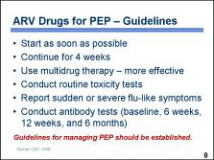 | Postexposure prophylaxis can be used to prevent HIV infection in cases of known occupational exposure to HIV. █  Start PEP as soon as possible after the incident, ideally within hours. █ Continue PEP treatment for four weeks. █  Administer dual or triple drug therapy – it is believed to be more effective than a single agent. █  Conduct routine monitoring for toxicity, including complete blood count, and liver and kidney function tests. █  Report sudden or severe flu-like symptoms including fever, rash, muscle aches, tiredness, malaise, or swollen glands. They may indicate HIV infection, drug reaction, or other medical conditions. █  Conduct antibody tests as soon as possible to establish a baseline, and then again at six weeks, twelve weeks, and six months. █  All facilities should maintain a set of written policies and guidelines that can be followed by staff in cases of potential occupational exposure to HIV. Ideally, the written guidelines include a mechanism for reporting workplace injuries to the facility managers so that actions can be taken to improve safety at the workplace and reduce the likelihood of injuries in the future. █  Discussion questions:  Where are the written guidelines for PEP kept at your facility? Can you describe how your facility guidelines are similar or different from these guidelines? Can you describe the mechanism for reporting workplace injuries and occurrences of occupational exposure at your facility?

