Contraception for Clients with HIV Curriculum

Participant Manual

The Contraception for Clients with HIV Curriculum and the accompanying materials, including this Participant Manual, were developed by Family Health International (FHI) in collaboration with the ACQUIRE Project at EngenderHealth, as one of the resources for Increasing Access to Contraception for Clients with HIV: A Toolkit.
The Toolkit is made possible by the generous support of the American people through the United States Agency for International Development (USAID) under the terms of the cooperative agreement, Contraceptive and Reproductive Health Technologies Research and Utilization (CRTU), No. GPO-A-00-05-00022-00 and, through the ACQUIRE Project, under the terms of cooperative agreement, No. GPO-A-00-03-00006-00. The contents are the responsibility of Family Health International and do not necessarily reflect the views of USAID or the United States Government.

© 2008 by Family Health International



Table of Contents
Session 1: Introduction 1
Session 2: Overview of HIV, AIDS, and ARV Therapy 6
Session 3: Why Integrate Family Planning and HIV Prevention, Care, and Treatment 15
Session 4: Provider Values and Attitudes and Client’s Rights (Stigma Reduction) 19
Session 5: Factors Affecting Contraceptive Method Choice and Overview of Medical
Eligibility Criteria 26
Session 6: Contraceptive Method Options for Clients with HIV
Male and female condoms 29
Other barrier methods 30
Dual protection 31
Session 7: Contraceptive Method Options for Clients with HIV
Hormonal contraceptive method options – Theoretical concerns 38
Oral contraceptives 43
Progestin-only injectables 49
Progestin-only implants and pills and emergency contraceptive pills (ECPs) 56
Session 8: Contraceptive Method Options for Clients with HIV
Intrauterine devices (IUDs) 60
Session 9: Contraceptive Method Options for Clients with HIV
Male and female sterilization 68
Fertility awareness-based (FAB) methods 71
Lactational amenorrhea method (LAM) and infant feeding options 73
Session 10: Integrating FP into HIV Services for Provision of Contraceptive Information,
Counseling, and Methods 77
FP/HIV service integration – client contact opportunities 80
Sexual activity, pregnancy and contraception – raising the subject during counseling 82
Counseling clients with HIV about pregnancy 82
Counseling clients with HIV about contraception 83
Additional counseling topics for clients with HIV 84
Client-centered counseling framework 85
What to say and do during the various stages of counseling 86
Counseling observation checklist 93
Session 11: Creating and Maintaining a Safe and Efficient Work Environment
Standard precautions in health care settings 94
Postexposure care and prophylaxis for injured health care staff 97
Recognizing and coping with stress in health care settings 100
Action plan 101
Fact Sheets 103
Medical Eligibility for Contraceptive Methods for Clients with HIV and AIDS: Summary Chart 119

Contraception for Clients with HIV Curriculum

Participant Manual

SESSION 1: Introduction
This manual is part of a curriculum designed to orient health care providers to the reproductive decisions and concerns of clients with human immunodeficiency virus (HIV). It is believed that providers who adopt an integrated client-centered approach to addressing the concerns of clients with HIV can better meet their clients’ needs. An integrated approach to providing reproductive health (RH) services can create programmatic synergies that may make services more attractive to clients with HIV and reduce the stigma often associated with the disease. It may also afford more job satisfaction for providers who are able to address the needs of their clients in a more holistic manner.
With the growing HIV epidemic, family planning (FP) can play a key role in preventing further transmission of the virus. The training activities included in this course are designed to help providers – nurses, midwives, and physicians – determine how best to incorporate family planning into the integrated reproductive health services that they offer to all their clients, especially those clients with HIV. How services are integrated depends what resources are available, but integrated services can be offered in health centers, clinics, hospitals, or home-based settings that offer primary care; palliative care; maternal and child health; family planning; or HIV prevention, care, and treatment.
The course provides opportunities for providers to acquire knowledge and practice skills specific to the family planning needs of clients with HIV. The activities are designed to challenge providers to consider how these services can best be integrated into the settings where they work. Providers who have never offered contraceptive methods may require additional practice independent of this course to master the skills required for provision of specific methods – this course does not include comprehensive objectives for skills development in the provision of contraceptive methods. It is expected that providers, after completing this course, will have the knowledge, skills, and attitudes required to adopt the job responsibilities described below.
Capabilities upon Completion of Training
Upon completion of this training course, and with appropriate organizational support for their performance, participants should be able to offer integrated FP and HIV services by performing these essential tasks:
- Counsel clients with HIV to enable them to make informed decisions about reproductive health issues (e.g., assess individual risks, determine fertility intentions, make informed decisions regarding contraception).
- Provide contraceptive methods to clients with HIV or refer as appropriate.*
- Maintain a safe, efficient, and welcoming integrated service environment, free from stigma and discrimination, for clients and colleagues.
* The term “refer as appropriate” has been included to accommodate providers with various levels of experience in providing family planning services. Realistic expectations that consider both the provider’s capability and facility’s capacity to offer integrated services must be defined by the facility administrators and the participant’s supervisors (preferably in consultation with the trainer) prior to initiation of training.

Orientation to the Training
This manual is designed to be used as part of a comprehensive training program where supervisors and administrators have defined and revised the job responsibilities of the training participants, have documented their existing knowledge and skills, and have established – in collaboration with the training facilitator – the specific objectives of the training course. The training objectives must be designed specifically to address the knowledge and skills deficits of the participants so that they will be prepared to assume their new job responsibilities after the training. It is strongly suggested that the training participants be involved in the preliminary planning for service integration. At a minimum, participants should meet with their supervisors prior to the training to ensure that the acquired knowledge and skills can be immediately used and supported at the workplace.
Prior to the training, the provider should have a clear understanding of:
- The specific services that will be offered at the facility
- How the community members and clients will be informed about the expanded or integrated services
- What administrative policies, service delivery guidelines, and clinical procedures will be adapted and how these changes will be communicated to all of the facility staff
- Where, when, and by whom the new services will be offered – with a particular emphasis on the specific services that the participant is expected to offer
- Who will supervise the new services and service providers
- How workers will acquire and maintain the knowledge and skills required to assume the new responsibilities
During or immediately following the training, the provider should have an opportunity to gain a clear understanding of:
- How supplies and equipment will be acquired and maintained
- When and where referrals will be made
- How services will be reported, monitored, and evaluated

Training Materials
The curriculum includes the following materials:
Participant Manual. This manual includes materials needed to participate in the training activities and reference information that can be used after the participants return to their workplaces. It also includes an action plan that participants and their supervisors can use to help facilitate the transfer of learning back to the workplace.
Facilitator Manual. This manual includes instructions and resource materials for conducting the training activities.
Collateral materials to facilitate learning and provision of integrated services:
- Counseling Tool: Reproductive Health Choices for Clients with HIV to be used when counseling clients with HIV and their partners to make informed reproductive health decisions (also referred to as the “flip book”)
- Screening checklists to determine medical eligibility for combined oral contraceptives (COCs), injectables (DMPA or NET-EN), intrauterine devices (IUDs), and contraceptive implants
- Fact sheets about contraceptive methods and other HIV or AIDS related topics (included at the back of the participant manual, can be used as job aids)
- Client brochures on various topics that can be adapted to meet the needs of the clients at a specific facility (e.g., materials on infant feeding)
- Facility checklists to help providers and administrators determine what level of integrated services are reasonable or evaluate the quality of the integrated services they are offering
- Supervisory tools for assessing the performance of supervisors at facilities where integrated services are being provided
- Full-text reference materials that can be shared with interested participants (e.g., Family Planning: A Global Handbook for Providers, CCP and WHO, 2008 update)
For a full list of the sources cited or used in this manual, see the references and resources included in the appendices of the Facilitator’s Manual.

Course Objectives
The course objectives are organized into six content areas:
Overview of HIV, AIDS, and ARV Therapy
Participants will be able to:
- Define HIV and AIDS.
- Describe the progression of HIV disease.
- Describe the ways HIV is transmitted and how it may be prevented.
- Describe the scope of the HIV epidemic in their country or community.
- Explain how HIV affects women, especially the factors that make women more vulnerable to HIV infection.
- Explain (in general terms) how ARV drugs work for treatment of AIDS, what is included in highly active antiretroviral therapy (HAART) therapy, and how ARV drugs can be used for prophylaxis.
Why Integrate Family Planning and HIV Prevention, Care, and Treatment
Participants will be able to:
- List the benefits of offering family planning to clients with HIV.
- Explain the potential benefits and challenges of integrating family planning and HIV services.
Provider Values and Attitudes and Client’s Rights (Stigma Reduction)
Participants will be able to:
- Examine their personal values and attitudes toward people with HIV.
- Explain how personal values and attitudes may affect interactions with clients who have HIV.
- Discuss the sexual and reproductive rights of clients with HIV.
- Discuss HIV-related stigma and discrimination as it applies to sexual and reproductive rights.
- Describe how to identify and address stigma and discrimination when providing RH services.
- Explore the range of reproductive health choices for clients with HIV and related issues or concerns that may influence their decisions and fertility intentions.
- Describe how a provider can address the reproductive health concerns of clients with HIV.
Contraceptive Methods and Family Planning for Clients with HIV
Participants will be able to:
- List method characteristics that affect contraceptive method choice.
- Explain the rationale for medical eligibility criteria and how they are applied.
- Provide an overview of available contraceptive methods, including effectiveness, characteristics, mechanisms of action, benefits, side effects, eligibility criteria, protection against sexually transmitted infections (STIs) including HIV, how to use, when to return to the clinic, and common myths and misconceptions.
- List contraceptive methods available to women and couples with HIV.
- Describe how the presence of HIV, AIDS, and the use of or response to ARV therapy affects method eligibility.
- Explain the concerns, theoretical or otherwise, related to the use of hormonal contraception among women with HIV, including those who are taking ARV drugs.
- State the main counseling messages for women on ARV therapy who are planning to use hormonal contraception.
- Explain the concerns related to the use of the lactational amenorrhea method (LAM) by women with HIV, infant feeding options, and recommendations to reduce mother-to-child transmission during breastfeeding.
Counseling and Client-Provider Interaction
Participants will be able to:
- Identify opportunities where family planning messages or services can be offered.
- Describe the process and content of counseling sessions tailored to services provided to clients with HIV.
- Demonstrate the ability to counsel clients with HIV during role-plays while addressing RH issues relevant to the clients described in the case studies.
Safe and Efficient Work Environment
Participants will be able to:
- Describe standard precautions applicable in clinical settings.
- Assess their individual occupational risk for HIV, including risk reduction strategies that should be in place.
- Assess how integrating FP services affects standard precautions currently in place and what measures may need to be added.
- Describe the management of occupational exposure to HIV.
Note: Since the risk of occupational exposure through provision of contraception is minimal, this objective is recommended only for participants providing injectables, IUDs, implants, tubal ligations, or vasectomies.
- Describe measures to minimize stress and enhance support for health workers in integrated service settings.
- Develop a plan to facilitate the transfer of knowledge and skills from the training to their workplace, with a focus on clarifying changes in job expectations with supervisors and colleagues; clarifying procedures for record keeping, resupply, and referral related to the new services; and creating mechanisms for practicing, using, and maintaining new skills.

Optional objective: Participants will be able to track, refer, report, log, order, and maintain supplies for new services using revised record-keeping form. Alternatively, interim record-keeping tools, e.g., log or register book to track FP service activities, can be introduced.

Course Schedule
Day 1 (~8 hours) | Day 2 (~8½ hours) | Day 3 (~8 hours) | Day 4 (~8 hours) | Day 5 (~5 ¼+ hours)
1.1 Welcome/Introductions  30 minutes  1.2 Objectives/Structure/Rules  30 minutes  1.3 Knowledge Pre-test  45 minutes  BREAK – 15 minutes  2.1 HIV and AIDS Overview  45 minutes – Facts Game  2.2 Scope of Epidemic  15 minutes – Presentation  2.3 Impact on Women  15 minutes – Brainstorm/Present  2.4 ARV Therapy Intro  20 minutes – Small Group Present  LUNCH – 60 minutes  3.1 Benefits of FP  15 minutes – Discuss/Present  3.2 Integration Benefit/Challenges  15 minutes – Present/Discuss  4.1 Values/Attitudes to HIV  30 minutes – Reflect/Discuss  4.2 Values/Attitudes to HIV  30 minutes – Small Group  BREAK – 15 minutes  4.3 Attitudes/Opinions about HIV  60 minutes – Agree/Disagree  4.4 HIV+ Clients’ Rights/Stigma  30 minutes – Present/Discuss  DAILY WRAP-UP  Assigned Reading – first half of flip book | 4.5 Identify/Address Stigma  30 minutes – Group Work/Discuss  4.6 Stigma/Facility Evaluation  60 minutes – Evaluate/Discuss  BREAK – 15 minutes  4.7 RH Choices for HIV+ Clients  30 minutes – Group Work/Present  5.1 FP Method Characteristics  10 minutes – Brainstorm  20 minutes – Present/Discuss  5.2 FP Method Overview  30 minutes – Small Group Prep  LUNCH – 60 minutes  6.1 FP Methods – Condoms  15 minutes – Small Group Present  15 minutes – Present/Discuss  6.2 Dual Protection  5 minutes – Brainstorm/Present  10 minutes -- Present/Discuss  6.3 Condom Demonstration  15 minutes – Condom Race  20 minutes – Demo/Practice  6.4 Condom Myths  25 minutes – Small Group/Discuss  6.5 Negotiating Safer Sex  15 minutes – Brainstorm/Negotiate  BREAK – 15 minutes  7.1 HCs and HIV/ARV Concerns  30 minutes – Present  15 minutes – Fact/Theory Game  7.2 FP Methods – COCs  15 minutes – Small Group Present  45 minutes – Present/Discuss  DAILY WRAP-UP  Assigned Reading – second half of flip book | 7.3 FP Methods – Injectables  15 minutes – Small Group Present  45 minutes – Present/Discuss  7.4 FP Methods – Other HCs  45 minutes – Present/Discuss  BREAK – 15 minutes  7.5 HIV/ARV Counseling Messages  5 minutes – Review Key Points  10 minutes – Brainstorm Messages  8.1 FP Methods – IUDs  15 minutes – Small Group Present  30 minutes – Present/Discuss  8.2 IUD Eligibility HIV+  15 minutes – Present/Discuss  9.1 FP Methods – Sterilization/FAB  30 minutes – Present/Discuss  9.2 LAM/Infant Feeding Options  30 minutes – Present/Discuss  9.3 FP Methods – Summary  15 minutes – MEC Matching Game  LUNCH – 60 minutes  10.1 Contact Points  60 minutes – Group Maps/Present  BREAK – 15 minutes  10.2 Counseling Process/Content  60 minutes – Present/Discuss  DAILY WRAP-UP  Assigned Reading – counseling section of Participant Manual | 10.3 Counseling Process/Content  60 minutes – Brainstorm/Group Work  10.4 Counseling Sensitive Topics  60 minutes – Brainstorm/Discuss  BREAK – 15 minutes  10.5 Counseling Practice  90 minutes –Practice Case Sessions  30 minutes –Group Discussion  LUNCH – 60 minutes  10.5 Counseling Practice (continued)  90 minutes –Practice Case Sessions  30 minutes –Group Discussion  BREAK – 15 minutes  11.1 Standard Precautions  30 minutes – Define/Discuss  11.2 FP-related Occupational Risk  30 minutes –Discuss/Share  DAILY WRAP-UP | 11.3 HIV Risk Management  30 minutes –Discuss/Present  11.4 Minimize Stress  45 minutes – Brainstorm/Discuss  BREAK – 15 minutes  11.5 Reporting  TBD – Demonstrate/Discuss  11.6 Action Planning  60 minutes – Develop/Review  LUNCH – 60 minutes  12.1 Review/Ask  5 minutes – Write Question Cards  12.2 Knowledge Post-test  45 minutes  BREAK – 15 minutes  12.3 Review/Answer  15 minutes – Answer Question Cards  12.4 Course Evaluation/Closure  15 minutes – Evaluation  10 minutes – Wrap-up  CLOSE COURSE

SESSION 2: Overview of HIV, AIDS, and ARV Therapy

Facts about HIV and AIDS

What is HIV?
HIV is the human immunodeficiency virus that causes AIDS. A member of a group of viruses called retroviruses, HIV infects human cells and uses the energy and nutrients provided by those cells to grow and reproduce.

What is AIDS?
AIDS is the acquired immunodeficiency syndrome, a disease in which the body’s immune system breaks down and is unable to fight off certain infections, known as opportunistic infections, and other illnesses that take advantage of a weakened immune system.
The virus enters the body and lives and multiplies primarily in the white blood cells, the immune cells that normally protect us from disease. The hallmark of HIV infection is the progressive loss of a specific type of immune cell called T-helper or CD4 cells. As the virus grows, it damages or kills these and other cells, weakening the immune system. AIDS is diagnosed in an HIV-positive person when the immune system is severely damaged or when certain other serious infections or cancer occurs.

How quickly do people infected with HIV develop AIDS?
In some people, the T-cell decline and opportunistic infections that signal AIDS develop soon after initial infection with HIV. Most people remain asymptomatic for 10 to 12 years, and a few for much longer. As with most diseases, early medical care can help prolong a person’s life.

How HIV is transmitted?
- Through the exchange of bodily fluids (blood, semen, and vaginal secretions) during sexual contact
- Through shared drug injection needles (infected blood can be exchanged between people using the same needle and syringe)
- Through accidental sticks with needles that are contaminated with HIV infected blood
- Through the transfusion of infected blood or blood products
- From HIV-positive women to their babies during pregnancy, delivery, or breastfeeding
Contrary to public perception, a person cannot become infected with HIV by drinking from a water fountain, sitting on a toilet seat, hugging or touching a person with HIV, or eating from plates and utensils. Saliva is not considered a transmission route for HIV. Mosquitoes, fleas, and other insects do not transmit HIV.

Why are women more vulnerable to HIV infection?

Women’s vulnerability to HIV has several causes. First, women are more vulnerable to HIV infection because of cultural and societal factors. These factors include gender inequities that limit women’s opportunities, often making them economically dependent on men. Inequitable relations between men and women also make it more difficult for women to refuse unwanted sex or to negotiate safer sex.

Women may also be more susceptible to HIV infection for biological reasons. Their exposure to HIV virus can be greater than men’s because they have a larger surface area, the vagina, exposed to sexual fluids during intercourse. A complicating factor is a preference for “dry sex” among some partners, which makes the vagina more susceptible to tears. In addition, a common physiological condition known as cervical ectopy may increase the risk of chlamydia infection, which may facilitate the acquisition of HIV infection. Cervical ectopy occurs when the regular (squamous) cervical epithelium on the outer surface of the cervix is replaced by thinner, more fragile (columnar) epithelium from the cervical channel.

What are the signs and symptoms of HIV and AIDS?
Often people who are HIV-positive have few or no symptoms. Other times, symptoms of HIV are confused with other illnesses, such as influenza. A few suffer a brief period (three to 14 days) of fever, joint pain, rash, and swollen lymph nodes within a month of being infected. Later, as the immune system grows weaker, a common group of warning signs may appear, including fevers, night sweats, fatigue, weight loss, coughing, and diarrhea. A frequent condition during this time is thrush, a type of yeast infection that causes white spots or sores. Thrush may first show up in the mouth, but can also appear in the vagina or rectum and on the skin.
Once the infection has reached the AIDS stage, certain opportunistic infections and cancers are common. Among them are: Kaposi’s sarcoma, non-Hodgkin’s lymphoma, pneumocystis pneumonia, cytomegalovirus, toxoplasmosis, mycobacterium avium complex, and tuberculosis.

Counseling about HIV prevention
Counselors should encourage and help their clients to:
- Speak openly with your partner about safer sexual techniques and HIV status.
- Get an HIV test to protect yourself and others (if HIV status is not known).
- Get tested with your partner as a way of saying that you care about each other and intend to stay healthy.
- Use a latex condom with each vaginal, oral, or anal sexual encounter (or latex-free condoms for those with latex allergies).
- Avoid sharing needles or syringes if you inject drugs; seek professional help to stop using harmful or addictive drugs.
- If pregnant, get regular prenatal, intrapartum, and postpartum care, including prevention of mother-to-child transmission (PMTCT) services if HIV-positive.
- If postpartum and infected with HIV, breastfeed exclusively for the first six months; or if it is acceptable, feasible, affordable, sustainable, and safe, use replacement feeding (e.g., formula, other milk substitutes) instead of breastfeeding.

HIV and AIDS treatment options
A person who has HIV or AIDS should try to stay healthy, which may require eating nutritious foods, exercising, and getting enough rest. Treatment for HIV and AIDS includes:
- Antiretroviral therapy (ART). While not a cure, ART can slow the illness for many years. The treatment consists of drugs taken every day for the rest of one’s life. A short course of antiretroviral (ARV) drugs taken during pregnancy and/or delivery reduces the risk of transmitting HIV from mother to child.
- Treatment of opportunistic infections. Such infections may occur when ARVs are not available or when they are no longer effective as the person becomes resistant to them.
Adapted from:
American Foundation for AIDS Research (amfAR). Facts about HIV/AIDS.
New York: amfAR, 2001. Available: http://www.thebody.com/amfar/ounce.html
For additional information, see:
Family Health International (FHI). HIV/AIDS Care and Treatment: A Clinical Course for People Caring for Persons Living with HIV/AIDS. Arlington, VA: Family Health International, 2004. Available: http://www.fhi.org/en/HIVAIDS/pub/guide/careandtreatmentclinicalcourse.htm

HIV and AIDS Fact Game
Category 1: General Information about HIV and AIDS
Question | Answer
What do HIV and AIDS stand for?
What is the “window period”?
Name at least four signs or symptoms that suggest a patient may have AIDS.
Category 2: HIV Transmission
Question | Answer
List three main ways in which HIV infection is transmitted. | 1.  2.  3.
What four body fluids may contain high concentrations of HIV?
What specific system of the body does HIV attack?
Category 3: HIV Prevention
Question | Answer
What are the ABCs of prevention?
Name at least four infection prevention techniques that protect both health care providers and patients from HIV.
Why should an individual consider being tested for HIV? Name at least two reasons.
Category 4: Infant Feeding
Question | Answer
Define exclusive breastfeeding.
What is the latest age that WHO recommends switching an infant from breastfeeding to replacement feeding when the mother is an HIV-positive woman who elects to breastfeed?
What are the infant feeding options for women with HIV and what type of feeding is not recommended for infants of HIV-positive women?
Category 5: Mother-to-Child Transmission
Question | Answer
If 100 women with HIV gave birth to100 infants, how many of the infants would typically become infected during pregnancy, delivery, and breastfeeding without any intervention?

Name two maternal factors that increase the risk of HIV transmission during pregnancy.
Name two factors that increase the risk of HIV transmission during breastfeeding.

ARV Therapy Basics
The introduction of antiretroviral drugs as part of HIV clinical care has transformed HIV infection into a manageable chronic illness for many individuals with HIV. ARVs are not a cure. They cannot completely eradicate HIV. But they can inhibit replication of the virus, which effectively slows disease progression and improves a patient’s quality of life.
decrease
viral load
improve
immune
function
ARVs:Vs:
Different ARV drugs attack HIV at different steps in the process of copying itself – first when it enters the cell and then when new copies want to leave the cell. To date, the best results have been achieved by combining three drugs from two different classes of antiretrovirals into a “cocktail.” The cocktail attacks at least two targets, thus increasing the chance of stopping HIV replication and protecting new cells from infection.
This three-drug cocktail is called “highly active antiretroviral therapy,” or HAART. HAART can dramatically reduce the level of virus in the blood. As a result of this decrease in viral load, immune suppression is arrested, followed by improved immune function, which results in fewer opportunistic infections and illnesses and an overall improvement in the quality of life.
=
+
NRTI
NNRTI
NRTI
PI
OR
Standard HAART Regimen
The standard HAART regimen contains two nucleoside reverse transcriptase inhibitors (NRTIs) and one non-nucleoside reverse transcriptase inhibitor (NNRTI) or a protease inhibitor (PI). The World Health Organization (WHO) recommends several regimens for HAART therapy using widely available ARV drugs. Other regimens, using more than three ARV drugs, are currently being explored to counter drug resistance that develops in some patients.
Because of their side effects and the possibility of drug resistance, ARV therapy is not recommended for all patients with HIV. Several indicators are used to determine a patient’s eligibility to receive ARV therapy. Clients with HIV should be evaluated by a provider trained to determine the most appropriate course of action.
For additional information see:
World Health Organization (WHO). Antiretroviral Therapy for HIV Infection in Adults and Adolescents: Recommendations for a Public Health Approach – 2006 Revision. Geneva: WHO, 2006.

WHO HIV Clinical Staging and Criteria for Initiation of ARV Therapy
 | WHO Clinical Stage 1:  Asymptomatic | WHO Clinical  Stage 2:  Mild Disease | WHO Clinical  Stage 3:  Advanced Disease | WHO Clinical  Stage 4:  Severe Disease
Weight | no weight loss | weight loss <10% | weight loss >10% | HIV wasting syndrome
Common symptoms include: | - no symptoms  - or only persistent, generalized lymphade-nopathy | - itching rash  - herpes zoster  - recurrent upper respiratory infections  - recurrent mouth ulcers | - oral thrush  - more than 1 month of diarrhea  - persistent unexplained fever  - severe bacterial infections (e.g., pneumonia)  - current pulmonary tuberculosis | - esophageal thrush  - chronic herpes simplex ulcerations  - lymphoma  - Kaposi’s sarcoma  - invasive cervical cancer  - pneumocystic pneumonia  - extrapulmonary tuberculosis  - cryptococcal meningitis  - HIV encephalopathy
Criteria for ARV initiation: | - treat if CD4 <200 cells/mm³ | - treat if CD4 <200 cells/mm³ | - if CD4 not available, treat all in stage 3  - if CD4 available, treat if <350 cells/mm³ | - all in stage 4 are medically eligible

ARV therapy is complex and should only be offered by trained providers.
For additional information see:
World Health Organization (WHO). WHO Case Definitions of HIV for Surveillance and Revised Clinical Staging and Immunological Classification of HIV-related Disease in Adults and Children. Geneva: WHO, 2007. Available: http://www.who.int/hiv/pub/guidelines/HIVstaging150307.pdf

Classes of ARV Drugs
There are several common classes of ARV drugs currently available.
- NRTIs – Nucleoside Reverse Transcriptase Inhibitors
- NtRTIs – Nucleotide Reverse Transcriptase Inhibitors
- NNRTIs – Non-Nucleoside Reverse Transcriptase Inhibitors
- PIs – Protease Inhibitors
- Entry inhibitors and other new classes of drugs are also becoming available.
Classes | Nucleoside Reverse Transcriptase Inhibitors  (NRTIs) | Nucleotide Reverse Transcriptase Inhibitors  (NtRTIs) | Non-Nucleoside Reverse Transcriptase Inhibitors  (NNRTIs) | Protease  Inhibitors  (PIs) | Entry  Inhibitors  and Other New Classes
Common Drugs | zidovudine  (ZDV or AZT)  didanosine (ddl)  stavudine (d4T)  lamivudine (3TC)  abacavir (ABC)  emtricitabine (FTC) | tenofovir disoproxil fumarate (TDF) | nevirapine (NVP)  efavirenz (EFV, also known as EFZ)  delavirdine (DLV) | indinavir (IDV)  ritonavir (RTV)  lopinavir (LPV)  nelfinavir (NFV)  saquinavir (SQV)  atazanavir (ATV)  amprenavir (APV) | enfuvirtide (T20, also known as Fuzeon®)
Note: ARVs are sometimes available as fixed dose combinations (FDC). In this case, each pill contains a certain amount of two or three different drugs (e.g., Trizivir, an FDC of ZDV+3TC+ABC).

Use of ARV Drugs for HIV Prophylaxis
While HAART therapy is used for the treatment of patients with advanced HIV disease, ARV drugs can also be used for the prophylaxis, or prevention, of HIV infection. ARV drugs play a major role in the prevention of mother-to-child transmission (MTCT) of HIV. Pregnant women with HIV who do not have indications for full-scale antiretroviral treatment or do not have access to treatment should be offered ARV prophylaxis to prevent transmitting HIV to their newborn. Currently, there are many different drug regimens available, and their use depends on the availability of drugs, cost, in-country resistance patterns, and possible side effects. Clinical trials have demonstrated that these regimens can reduce the risk of MTCT by 34 percent to 50 percent. (Dabis, 2000)
ARV drugs can also be used for postexposure prophylaxis, or PEP, in cases of known occupational exposure to HIV, such as a needle stick with infected blood, or when exposure cannot be ruled out, as in the case of rape. PEP should be started as soon as possible after the incident, ideally within hours. Dual or triple drug therapy is administered because it is believed to be more effective than a single agent. A treatment of four weeks is recommended. Other prophylactic uses of ARV drugs to prevent HIV infection are currently under study. (U.S. Centers for Disease Control and Prevention, 2005)

Why ARV Clients Benefit from Contraception
Women with HIV who receive ARV therapy receive the same contraceptive benefits as all other women. Some additional benefits include:
  - Removing the potential for unintended pregnancy in an already complicated life situation. Without concern about pregnancy, women can focus more on their ARV regimens and other demands related to HIV infection.
  - Avoiding complicated pregnancy. Antiretrovirals can aggravate anemia and insulin resistance that are common during pregnancy. When health is already compromised, such effects could be severe.
  - Having access to a wider range of antiretroviral therapy when a woman is protected from pregnancy. This is because some ARV drugs have harmful effects on the fetus and should not be offered to women who may become pregnant while on ARVs.
For example, the drug efavirenz, known as EFZ or EFV, is believed to be a potent early teratogen – that is, an agent that may induce birth defects. WHO guidance states that “EFZ should not be given to women of childbearing potential unless effective contraception can be assured.” (WHO, 2004)

SESSION 3: Why Integrate Family Planning and HIV Prevention, Care, and Treatment
Family planning (FP) plays several roles in helping to maintain the health of individuals, families, and communities. With the AIDS epidemic growing, family planning has expanded its role by helping to prevent the spread of HIV. As shown in the diagram below, comprehensive programs designed to prevent mother-to-child transmission (PMTCT) of HIV, typically employ multiple strategies that focus on preventing the acquisition and transmission of HIV and supporting the needs of a woman and her family. Family planning and effective use of contraceptives play an important role in these multipronged approaches by preventing unintended pregnancies among women with HIV, thus decreasing the likelihood of HIV infection in children and helping to reduce the chance that a child will become an orphan.

Support for mother and family

Prevention of trans-mission from an HIV-positive woman to her infant

Prevention of unintended pregnancies in HIV-positive women

Prevention of HIV in women, especially young women

Family
planning and
effective use of contraceptives

Increasing access to family planning services for women with HIV can reduce births of children who have a high probability of being infected with HIV and dying. (USAID, 2003) Providing integrated reproductive health services that include family planning counseling and access to contraception to women and couples with HIV can improve their lives and those of their families.
- When FP services are accessible, clients with HIV experience the same health benefits as others in their communities. Couples can limit the size of their families to the number of children they desire and are able to care for. Women can space their children effectively and reduce the risks associated with too many pregnancies or pregnancies spaced too closely. Couples with HIV can also time a pregnancy to take place when HIV transmission risk is lowest.
- Family planning can also reduce HIV infections among children by helping women with HIV who do not want to have children avoid pregnancy.
- Women with HIV who are concerned that they may eventually die of AIDS may decide to use contraception to avoid having children who may some day become orphans.
As we have seen, there are many benefits in providing family planning and effective contraception. Unfortunately, there is also a large and growing unmet need for contraception and other family planning services. Surveys estimate that more than
150 million married women of reproductive age worldwide have an unmet need for contraception to postpone or avoid pregnancy. Unmet need for contraception creates a particular hardship for women with HIV who may wish to avoid pregnancy but do not have access to contraceptives or family planning services. (Population Reference Bureau and Demographic and Health Surveys)
One of the largest groups whose reproductive health (RH) needs are not being met is young women. Evidence of unmet need in this group is seen in the high rates of sexually transmitted infections (STIs), including HIV, unintended pregnancy, and mortality and morbidity resulting from unsafe abortion.
Some of the causes of this unmet need include a lack of information and education about sexuality, reproduction, and contraception, as well as limited skills for establishing personal goals, developing strategies, and communicating expectations with partners. Additionally, many young people do not have access to reproductive health services that are prepared to meet the specific needs of adolescents.

Integrated Services Meet the Needs of Clients with HIV
The goal of integrated services is to provide holistic care that meets clients’ needs. Depending on the structure of the health services, integration can be achieved in a number of ways – including in vertical programs. For instance:
- In an HIV and AIDS care facility, the goal of integration is to provide comprehensive HIV prevention, counseling, testing, and treatment services in which family planning is an integral component of care.
- Similarly, in a family planning center, the goal of integration is to provide comprehensive family planning services in which HIV prevention, counseling, testing, and treatment is an integral component of care.
When feasible, some programs are adopting a comprehensive care approach to service provision – thus collapsing their vertical programs and offering all reproductive and primary care services in the same facility. The level of integration that any program can achieve must be carefully considered to ensure that it is feasible and sustainable.

Why Integrate HIV and FP Services
Clients seeking HIV-related services and those seeking FP services share many common needs and concerns which may make service integration appropriate in some situations.
- Women seeking HIV-related services, such as PMTCT, counseling and testing, or ARV treatment, are often sexually active and fertile.
- A significant, though unknown, proportion of individuals seeking family planning services are at risk for HIV infection or are already HIV-positive.
- Some of these individuals know their HIV status, but many have not been tested.
- Both groups need information about and access to contraceptives and possibly information about how HIV affects their contraceptive options.
Therefore, it is important that HIV and AIDS programs provide family planning information and services or referrals. It is equally important that family planning programs take into consideration the needs of women with HIV and, at a minimum, have strong links to HIV care and treatment programs and services.
Programmatic synergies can result from providing family planning and HIV services together. An entry point that provides a range of services – such as family planning; maternal and child health services; and HIV testing, counseling, and treatment – may be more attractive to clients. Clients may benefit when they can have multiple health needs addressed in a single visit by providers who are able to take a more holistic approach to client care. Combining services can also help overcome the stigma related to HIV and AIDS, which is one of the major constraints to accessing HIV services.
In addition, offering more than one service creates richer contact opportunities for clients and providers, giving providers more occasions to followup with clients, provide information and counseling, and support drug and method adherence. It also gives clients chances to ask questions, attend to all their reproductive health needs, and become involved in their own health care.
Providing integrated services to clients with HIV requires that providers be cross-trained in a variety of issues. All providers need to know the different combinations of antiretroviral drugs that may be used to treat HIV. They also need to know which contraceptive methods are appropriate for women with HIV and AIDS and other medical conditions that affect eligibility for specific methods.
It is not always feasible or practical to provide integrated services. In such cases, a referral network should be in place and referrals to specialized services should be offered.

Potential Benefits of Incorporating FP into Existing HIV Services
This section focuses on the benefits of incorporating FP into existing HIV services – recognizing that there are comparable benefits to incorporating HIV services into existing FP programs. Some potential benefits include:
- Access to contraceptive methods can be improved because the number and type of delivery sites are increased. These sites may attract a different customer base – people not normally reached through traditional FP clinics, such as young people (single and married), men (including men who have sex with men and may also have female partners), commercial sex workers, and injecting drug users. This benefit is especially important in communities where the referral system is weak and there are barriers to accessing family planning information and methods.
- When a provider is assured that a client is using a reliable method of contraception, he or she can prescribe ARV drugs that are contraindicated for women who are or may become pregnant.
- Providers may experience increased job satisfaction and improved morale when their capacity to address the needs of their clients in a more holistic manner makes clients more satisfied with the services that they receive. In addition, the new skills that providers develop to meet the needs of clients may provide opportunities for professional growth. However, these “opportunities” must be carefully considered to ensure that providers do not become overwhelmed by unrealistic expectations from clients or administrators.

Benefits of Involving Men
Offering integrated services may also make them more appealing to men and male partners. Individual providers and programs, whether integrated or not, should make an effort to reach out to men with reproductive health messages and services. Involving men in family planning and other reproductive health programs could have several benefits. Male partner cooperation and participation can:
- Encourage male partners to seek HIV counseling and testing and support disclosure of both partners’ HIV status.
- Help women to act on HIV prevention messages delivered through RH services.
- Help couples to make joint informed decisions about their fertility intentions and reproductive health goals including STI/HIV prevention strategies.
- Improve client satisfaction and the adoption, continuation, and successful use of a contraceptive method.
Although attracting men to RH services often presents a challenge, integrated services offer a valuable opportunity to reach men and involve them in RH decisions in a more meaningful way.

Practical Challenges to Integrating FP into Existing HIV Services
Just as there are potential benefits to integrating family planning into existing HIV services there are also potential challenges. Integrating family planning services increases the workload of providers in busy facilities. Provider “burn out” due to unrealistic job expectations can become very costly for programs that fail to consider the implications – especially in facilities that regularly experience staffing shortages and high rates of staff turnover.
Integrating family planning services can also increase the intensity of HIV consultations for both the provider and the client. It increases the amount of information that the provider must share and expands the number of issues that a client must consider and decide. As providers spend more time with each client, the clients’ waiting time also increases.
Ensuring that a sufficient number of staff with appropriate knowledge and skills are available to meet the increased demand for the integrated services presents another challenge. To ensure high-quality family planning services, providers must develop the skills necessary to offer family planning counseling, initiate contraceptive methods, manage possible side effects, and understand when and where to refer clients who require additional help.
Programs that integrate family planning must consider how existing services will be re-structured to accommodate the new services – which providers will offer the services, where and when they will be offered, and how community members and existing clients will learn that the services are available. Program managers and administrators must facilitate the integration of services by adapting the existing record keeping, activity reporting, and logistics systems within the facility to ensure that accurate client records are maintained; family planning commodities, supplies, and storage facilities are available; and supportive supervision to providers is offered on an ongoing basis.

SESSION 4: Provider Values and Attitudes and Client’s Rights (Stigma Reduction)

What if you had HIV or AIDS?
- If you were told that you had HIV, in what ways would it change your life?
- What do you think would be the most difficult part about being HIV positive?
- Would you tell your sexual partner(s) that you have HIV? Why or why not?
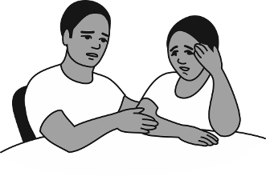
- If you had HIV, whom would you not tell? Why would you want to keep the information from them?
- What would you think about having a(nother) child? Why?
- What factors might make you want to have a(nother) child?
- If you were trying to decide about having a(nother) child, with whom would you discuss this? Why? With whom would you not discuss it? Why?
Illustration: WHO, 2005.
- If you had HIV, how would you want clinic staff to behave toward you?
- How comfortable would you be talking to someone in your facility about having sex, having another child, family planning or family planning methods? Why or why not?

Reproductive Health Rights of People with HIV
Because of the stigma and discrimination so often attached to HIV, it is particularly important that health service providers be able to protect the reproductive rights of women living with HIV. These rights include having access to sexual and reproductive health services and sexuality education, being able to choose a partner, deciding whether to be sexually active or not and deciding freely and responsibly the number, spacing and timing of their children. Women also have the right to make these decisions free of discrimination, coercion and violence.

– Sexual and Reproductive Health of Women Living with HIV/AIDS, WHO and UNFPA, 2006
The statement above concisely describes the reproductive rights of women with HIV and highlights the important role that providers serve in protecting those rights and ensuring that women with HIV are not subjected to stigma and discrimination.

Protecting RH Rights of Clients with HIV
Many people, including providers, incorrectly assume that individuals with HIV will not be interested in or involved in sexual relationships. They may also believe that people with HIV should not have children. As a result of these biases, women are often denied the information and services that they need to prevent pregnancy, plan a safe pregnancy, and prevent mother-to-child transmission of HIV. Provider biases combined with a client’s fear of stigma and discrimination may limit access to family planning services and antenatal and obstetric care.
In societies where couples are expected to produce children, HIV-positive individuals who decide to have no children must contend with social disapproval from their families and communities. In these situations, childlessness gives rise to suspicions of HIV infection and results in an individual being ostracized. For these reasons, protecting the reproductive rights of individuals with HIV is critical to ensuring that their basic human rights are secured.

Clients’ Family Planning Rights
When providing health care services, providers should respect the rights of all their clients, regardless of their HIV status. With regard to family planning, a client’s rights include the right to decide whether to use family planning and which contraceptive method to use.
To exercise that right, all individuals and couples should:
- Have access to information and services, free of any barriers. Barriers to access can be geographic, economic, administrative, medical, psychosocial, or cognitive (that is, not knowing where to obtain services).
- Have a variety of modern contraceptive methods from which to choose. Each person’s method preference is influenced by a number of factors that need to be considered during counseling.
- Be supported to make an informed, voluntary choice of contraceptive method.
- Receive the contraceptive method of their choice whenever possible. Research has shown that a woman who receives her contraceptive choice is more likely to continue using the method.
Women with HIV should be able to exercise their reproductive rights freely, whether they choose to plan a pregnancy, space their children’s births, or limit childbearing.

Factors Affecting Sexual and Reproductive Health Decisions
For individuals with HIV, there are many factors that can influence sexual and reproductive health decisions – including decisions about whether or not to use contraception. For a woman with HIV, these factors may include her own health, her partner’s health, and her children’s health. It may also include whether she and her partner have access to long-term ARV therapy.
Another important factor is whether a woman feels she can disclose her HIV status to her partner or family without risking rejection, violence, or financial loss. Cultural myths and misconceptions may also play a role in decision-making. For example, some women may believe that they cannot get pregnant because of HIV infection.
Fear of disclosing their HIV status, and the stigma generally associated with condom use, makes many clients reluctant to discuss condom use with their partners. Gender issues often affect decisions about contraception and STI/HIV prevention. Partner opposition is one of the most common reasons women cite for not beginning or continuing to use contraception. It is important to involve men in decision-making whenever possible because reproductive health decisions are more likely to be implemented when they are made jointly by both partners. Clear information about contraceptive methods is essential for women and couples to make an informed choice.
When providers are aware of the factors that can affect a client’s decisions and understand the power of these influences, they are better equipped to ensure that clients are making the best possible decisions.

Ensuring Informed Choice
Providers are the key to ensuring that clients’ rights are guaranteed. Effective counselors:
- Listen carefully to the client’s questions and concerns.
- Empathize with the client’s situation.
- Help clients make their own reproductive health decisions without letting personal biases influence the information they present to clients.
Such providers give clients accurate information to enable them to choose the method that best suits their needs and give information that allows clients to use their chosen method safely and effectively. It is of utmost importance that clients be allowed to make their own decisions. Clients are in the best position to decide what is right for them and their particular situation. Providers are obligated to ensure that clients can make an informed decision. Providers then must abide by that decision regardless of whether they personally agree with it or not.

Recognizing Stigmatizing Language and Discriminatory Actions
Instructions: Review the examples of stigmatizing and non-stigmatizing language and discriminatory and non-discriminatory behaviors – add other examples from your own experience.
Stigmatizing Language | Non-stigmatizing Language
- AIDS victims or AIDS sufferers experience opportunistic infections.  - AIDS carriers can infect others with HIV.  - HIV is transmitted from people with bad blood.  - HIV is no longer a death sentence.  - Adolescents are in a high-risk group.  - You wouldn’t want your child to become an AIDS orphan.  - People with HIV/AIDS … | - Individuals living with HIV may experience opportunistic infections.  - People living with HIV or AIDS can transmit infection to others.  - HIV can be transmitted by blood containing the HIV virus.  - People can live positively with HIV.  - Some adolescents may engage in high-risk behaviors.  - Have you thought about what happens if your child loses a parent?  - People who are HIV-positive …
Discriminatory Actions and Practices in Health Care Setting | Non-discriminatory Actions and Practices in Health Care Setting
- Putting on gloves when taking a pulse, blood pressure, or doing other noninvasive tests on a patient with HIV  - Change of facial expression when learning that a patient has HIV  - Denial of full, unconditional, high quality care and treatment  - Isolating patients with HIV in a corner or special ward, simply because they have HIV (Note: It is good medical practice to ensure that HIV patients are not placed near another patient who has an infectious disease, such as TB or diarrhea, to protect the patient with HIV from contracting that infection.)  - Refusing to touch a patient with HIV  - Expressing a fatal prognosis – there are “no options” or “there is nothing that we can do”  - Treating HIV differently from other chronic medical conditions when coding or labeling charts and patient records | - Not wearing gloves during noninvasive exams or when giving pills  - Warm greetings that show care and compassion  - Ensuing that each client’s right to respect, privacy, dignity, and holding an opinion are upheld  - Positive nonverbal communication (nodding, smiling eye contact, touching)  - Emotional support  - Listening  - Ensuring confidentiality
Source: Reducing Stigma and Discrimination Related to HIV and AIDS, Participant’s Handbook, EngenderHealth, 2004.
Facility Checklist: Client’s Rights and Prevention of Stigma and Discrimination
Instructions: Use the items on the facility checklist to evaluate how well your facility meets the standards for ensuring clients rights and preventing stigma and discrimination.
Client’s Rights | Achieved | Prevention of Stigma and Discrimination | Achieved
- Clients are provided with accurate, appropriate, understandable information related to their health care.  - Providers use educational materials to support information sharing.  - Services are affordable and convenient to clients, without physical and social barriers.  - Providers support informed choice by providing accurate, complete, and understandable information with options that promote well-considered decision-making.  - Providers are skilled and practice in accordance with service delivery guidelines.  - Staff maintains client privacy and confidentiality at all times.  - All clients are treated with respect and consideration, ensuring comfort during procedures.  - Continuity of services and supplies are ensured; follow-up and referral are the norm. |  | - Clients are welcome to services regardless of age, class, color, ethnicity, sexual orientation, sexual or drug use behavior, marital status, or HIV status.  - All clients are treated competently, equally, fairly, and respectfully, regardless of age, class, ethnicity, sexual orientation, sexual or drug use behavior, marital status, or HIV status.  - Services are provided to clients known to be HIV-positive without separating them from the general client population.  - Prior to invasive procedures, patients are not selectively tested for HIV without their consent.  - Health care staff do not wear gloves or masks inappropriately with people who are HIV-positive or presumed to be (only use gloves and masks as indicated by standard precautions).  - Providers help clients to develop a personal strategy to improve their health regardless of their HIV status.  - The facility avoids posting labels or signs that would draw attention to clients with HIV.  - Staff avoids nonverbal communication that portrays disgust, scorn, or disrespect (facial expression or hand gestures) when interacting with clients known or thought to be HIV-positive or when handling their utensils or clothing.  - HIV awareness and sensitization training are provided to all staff (as needed).
Source: Reducing Stigma and Discrimination Related to HIV and AIDS, Participant’s Handbook, EngenderHealth, 2004.

Reproductive Choices and Decisions for Clients with HIV
Women with HIV and their partners often need to make a variety of reproductive health decisions about pregnancy, childbearing, and contraceptive practice. They should be free to make these reproductive choices for themselves, just as other women and couples do. However, being HIV-positive may make women more vulnerable to societal, religious, or family pressures than women without HIV. Counselors must take special care to ensure that women with HIV do not feel coerced or pressured into making certain reproductive choices.

Pregnancy in Women with HIV
Based on current research findings, it appears that pregnancy in women with HIV does not accelerate progression of the disease. However, pregnancy often carries serious consequences for the infants. Without treatment, about one-third of HIV-positive mothers pass the virus to their newborns during pregnancy, delivery, and breastfeeding. Some evidence suggests that pregnancy in women with HIV increases the risk of stillbirths and infants with low birth weight. Nonetheless, for many couples with HIV who choose to conceive, the perceived benefits of having a child outweigh the increased risk of adverse pregnancy outcome.
Three positive developments – the impact of ARV therapy on the health and longevity of many people with HIV; the increasing availability of effective means for reducing mother-to-child HIV transmission; and wider availability of support and care services for families dealing with HIV – may encourage women with HIV to reconsider decisions about sex, relationships, and childbearing.
The reasons why many women with HIV consider pregnancy include:
- An intense desire to bear children.
- Societal, familial, and other relationship pressures to have children.
- Fear that the children they already have may die.
People who are unable to have children find it difficult to lead happy lives. – Man on ART

- Concern about reduced fertility related to HIV infection.
- Reassurance that PMTCT programs reduce the risk of having an HIV-positive child.
- Expectations of receiving ARV therapy and living long enough to see their children grow up.
- Concern that avoidance of pregnancy might generate suspicion about one’s HIV status.
- Fear that the potential consequences of disclosing one’s HIV-positive status to a partner might include violence, abandonment, and loss of finances for children.

Avoiding Childbearing among Clients with HIV
Alternatively, many sexually active women and couples with HIV might not want to bear children and therefore desire contraception. Their reasons to avoid or postpone pregnancy are often the same as those of women who are not HIV-positive: maintaining family economic status, achieving desired family size, and healthy spacing and timing of the births of their children – at least 24 months apart.
A woman with HIV may also want to avoid childbearing for other reasons, such as:
- Concern that pregnancy will further compromise her health, especially if it is already compromised by AIDS- related symptoms. Her partner or spouse may be HIV-positive or have symptoms. In the absence of ARV therapy and treatment for opportunistic infections, the length and quality of life may be severely compromised.
The community questions a woman falling pregnant while she knew her HIV status. – Woman with HIV

- Fear of transmitting HIV to children she might conceive.
- Fear of leaving orphans, because HIV infection is likely to shorten her life, particularly without treatment. Parents are naturally concerned about who will care for their children if they are no longer able to do so.
- Fear that others will be unwilling to care for the family during illness, due to AIDS-related stigma and discrimination.

Access to Information and Services is Key
In both resource-poor and resource-rich countries, women who learned that they have HIV reported lower desired fertility levels than did women in the general population. However, HIV-positive women’s knowledge of contraception and their access to family planning services can be limited. Such services help women with HIV consider their reproductive choices, plan for the future, avoid unintended pregnancy, time pregnancy when health is optimal, and reduce HIV transmission to their children. Contraceptive counseling sessions also offer opportunities for prevention counseling to reduce the chances that women will transmit HIV to their partners. When provided access, women with HIV will use family planning. (King, 1995)
Providers should help clients with HIV realize their reproductive health goals by structuring services that are customized to fulfill their needs, including either pregnancy counseling and services or accurate, unbiased counseling about contraception and access to the client’s method of choice. In addition, all clients should receive counseling and information about HIV and AIDS and possible treatment options.
As illustrated above, depending on the circumstances, the decisions a provider should guide a client through may include:
Fertility decision:
desire pregnancy?
Pregnancy
desired
No
Yes
2.Informed decision(s):
contraceptive method? STI/HIV prevention?
Intended
pregnancy
Pregnancy
counseling
Contraceptive
counseling
Ongoing HIV
counseling
Safe/effective
contraception
3.Treatment decision(s): ARV therapy for self
and partner?
PMTCT?
PMTCT
services
No
Yes
ARV
treatment
No
Yes
- A decision about fertility: Is pregnancy desired at this point in time or not?
- If pregnancy is not desired, there are reproductive health decisions, such as which contraceptive method to choose and what to do about STI/HIV prevention.
- If pregnancy is desired, there are decisions about how to achieve pregnancy safely with minimal risk of transmission. If pregnant, there are decisions about PMTCT and considerations related to breastfeeding and the risk of HIV transmission.
- If ARV therapy is available: Is it indicated and desired? (Adapted from: Cates, 2001)

SESSION 5: Factors Affecting Contraceptive Method Choice and Overview of Medical Eligibility Criteria
An individual’s decisions about contraception are shaped by many factors. It is important for providers to understand these factors so that they can help women and couples with HIV make informed decisions about which contraceptive method to use.

Factors Affecting Method Choice
Factors that women and couples with HIV may consider when they decide which contraceptive method to use include:
- How safe and effective the method will be.
- Whether the method meets a desire for short-term, long-term, or permanent protection.
- Possible side effects of the method.
- How easy it will be to use.
- Whether the method is affordable and access to resupply is easy.
- How it may interact with other medications, including ARVs.
- Whether it provides protection from STI/HIV transmission and acquisition.
- Whether partner involvement or negotiation are required.
If a woman is postpartum, the effect that the method may have on breastfeeding could also play a role.

Pregnancy Rates by Method
Oral contraceptives
Percentage of women pregnant in first year of use

Rate during typical use

Rate during perfect use
Female condom
Female sterilization
Implants
DMPA
Spermicides
Standard Days Method
Male condom
IUD (TCu-380A)
0
10
15
20
25
5
30

For women who want to avoid childbearing, contraceptive method effectiveness (how well a method works) is one of the most important characteristics for choosing a method. As depicted in this chart, contraceptive failure can occur with any method; however, some methods are more effective than others. This graph shows pregnancy rates for various contraceptive methods. The black rectangles show pregnancy rates for perfect use, reflecting how often a contraceptive method fails when it is used both correctly and consistently. The gray rectangles show pregnancy rates for typical use, reflecting how often a contraceptive method fails in real-life situations, when it may not always be used correctly and consistently. Typical use rates vary depending on user characteristics, user behavior, the adequacy of counseling, and access to resupply. (Global Handbook, 2007)
Differences between correct and typical use rates are greater for some methods than for others. Client-controlled methods may have low pregnancy rates with correct and consistent use but higher pregnancy rates with typical use. For example, combined oral contraceptives have a pregnancy rate of 0.3 percent when used correctly and consistently but a pregnancy rate of 8 percent with typical use. In contrast, the pregnancy rates for typical use of intrauterine devices (IUDs) or injectable contraceptives are almost the same as those for their correct and consistent use because the effectiveness of these methods depends little on user behavior. For example, the TCu-380A IUD has a pregnancy rate of 0.6 percent with correct and consistent use and a rate of 0.8 percent in typical use. When considering the pregnancy rates for various methods, keep in mind that women who use no method at all have a risk of pregnancy as high as 85 percent over one year.

Medical Eligibility for Contraceptives
The characteristics of contraceptive methods and how these fit with an individual’s lifestyle influence a client’s decisions about method choice. Another consideration is whether the client has any medical conditions that would make the use of a particular method unsafe. Several years ago, WHO assembled a team of experts to review the available evidence and organize the findings in a manner that could be readily used by providers to determine a client’s medical eligibility for a particular method. The recommendations of the expert review team are summarized in the document Medical Eligibility Criteria for Contraceptive Use. The team of experts meets periodically to review new research findings and update their recommendations. The most recent version, the third edition, was published in 2004. Additional changes to the MEC were introduced in April of 2008. These changes are reflected in the technical information included in this manual. (WHO, 2004; updated 2008)
The document provides guidance on the safety of 19 contraceptive methods for women and men with specific characteristics or known medical conditions. These characteristics and conditions range from age, smoking, and parity to cardiovascular disease, cancer, and infections. Of particular interest to users of this curriculum are the recommendations related to infection with HIV, the presence of AIDS, and the use of ARV therapy.

WHO Eligibility Criteria
Category | Description | When clinical judgment is available
1 | No restriction for use | Use the method under any circumstances
2 | Benefits generally outweigh risks | Generally use the method
3 | Risks generally outweigh benefits | Use of method not usually recommended, unless other methods are not available/acceptable
4 | Unacceptable health risk | Method not to be used
For each contraceptive method, medical conditions are classified into categories based on the risks and benefits associated with use of the method among women with those conditions.
The WHO Medical Eligibility Criteria (MEC) uses four categories to classify medical conditions:
- Category 1: For women with these conditions, the method presents no risk and can be used without restrictions.
- Category 2: For women with these conditions, the benefits of using the method generally outweigh the theoretical or proven risks. Women with category 2 conditions generally can use the method, but follow-up by the provider may be appropriate in some cases.
- Category 3: For women with these conditions, the theoretical or proven risks of using the method generally outweigh the benefits. Women with category 3 conditions generally should not use the method. However, if no better options for contraception are available or acceptable, the provider may judge that the method is appropriate, depending on the severity of the condition. In such cases, ongoing access to clinical services and careful follow-up by the provider are required.
- Category 4: For women with these conditions, the method presents an unacceptable health risk and should not be used.
In some cases, a particular condition is assigned to one category for initiation and another for continuation of the method. In other words, the category may depend on whether a woman with the condition wishes to initiate the contraceptive method or was already using that method when she developed the condition.
In situations where clinical judgment is limited, such as community-based distribution programs, the four-category classification framework can be simplified into two categories. When simplified for these situations, categories 1 and 2 indicate that the method can be used, while categories 3 and 4 indicate that the woman is not medically eligible to use the method.
The Quick Reference Chart for the WHO Medical Eligibility Criteria for Contraceptive Use can be found with course materials. It provides an easy reference to some of the more common conditions or characteristics that may affect a client’s medical eligibility for three methods, COCs, DMPA, and IUDs.

SESSION 6: Contraceptive Method Options for Clients with HIV
Contraceptive options for women with HIV are similar to those of women without HIV and include:
- barrier methods
- oral contraceptive pills
Couples with HIV have a wide range of methods from which to choose.

- injectables
- implants
- intrauterine device (IUD)
- female and male sterilization
- lactational amenorrhea method (LAM)
- fertility awareness-based methods

Male and Female Condoms
The condom is the only method that has the ability to prevent transmission of STIs/HIV and prevent pregnancy. However, the effectiveness for both pregnancy and STI/HIV prevention depends greatly on the client’s ability to use condoms consistently and correctly. In real-life situations, correct and consistent use may be difficult to achieve. Condoms may not be used with every act of intercourse or are sometimes used incorrectly. When used correctly every time a couple has intercourse, the male condom has a pregnancy rate as low as 2 percent, and the female condom has a rate of 5 percent. In common use, their pregnancy rates are much higher – around 15 percent for the male condom and 21 percent for female condom. (Hatcher, 2007)
Pregnancy rates: | Male Condom | Female Condom
Perfect use | 2% | 5%
Typical use | 15% | 21%
Condoms Prevent HIV/STI Transmission
Condoms are the only method proven to reduce the risk of all STIs, including HIV. One recent review of multiple studies found that typical condom use results in an 80 percent reduction in HIV incidence, a level of protection slightly less effective than for pregnancy. (Weller, 2002)
The most conclusive evidence of condom effectiveness in reducing HIV transmission has come from studies of serodiscordant couples, in which one person is HIV-positive and the other person is not. One study demonstrated that with consistent condom use, the HIV infection rate among the uninfected partners was less than 1 percent per year. However, in situations where one partner is definitely HIV-positive, inconsistent condom use was shown to be as risky as not using condoms at all – 13.3 percent of inconsistent users became infected compared to 14.4 percent of non-users. (Deschamps, 1996)
Condoms are most effective in preventing STIs that are transmitted through bodily fluids, such as HIV, gonorrhoea, and chlamydia. They are less effective against STIs that are transmitted through skin-to-skin contact, such as genital herpes and warts, because the condom may not cover the entire affected area.

Condom Use by Clients with HIV
The WHO Medical Eligibility Criteria classify the conditions HIV-infected, the presence of AIDS, and use of ARV therapy as category 1 for condom use, meaning that condoms can be used without restrictions.
WHO Eligibility Criteria
Condition | Category
HIV-infected | 1
AIDS | 1
ARV therapy | 1
Male and female condoms are the only methods that prevent HIV and STI transmission between partners. They can also prevent transmission of a different HIV strain to a person who is already HIV-positive, known as superinfection. As typically used, condoms are less effective for pregnancy prevention than some other methods, while other methods provide no protection from STIs/HIV. For these reasons, counseling of clients or couples should focus on strengthening their ability to consistently and correctly use condoms, either alone or in combination with another method, to prevent both STI/HIV and pregnancy.

Other Barrier Methods
Unlike condoms, other barrier methods are not suitable options for clients with HIV. Spermicides alone offer only limited protection from pregnancy. Failure rates for spermicides vary from 18 percent when used consistently and correctly to 29 percent with typical use. In typical use, spermicides are not used on some occasions or are used incorrectly. (Hatcher, 2007)
Spermicides containing nonoxynol-9 do not protect against HIV infection or other STIs. Spermicides may even increase the risk of HIV infection in women using these products frequently. This may be because nonoxynol-9 can disrupt the epithelium, or lining, of the vagina, thereby facilitating invasion by an infective organism. Advise women who have multiple daily acts of intercourse to choose another method of contraception. (Wilkinson, 2002; WHO, 2002; Van Damme 2002)
In typical use, diaphragms are associated with relatively high rates of pregnancy. When diaphragms are used with spermicides, as recommended, about 6 percent of users experience an unintended pregnancy during the first year with correct and consistent use, while the failure rate for typical use is about 16 percent. (Hatcher, 2007)
It is possible that diaphragms offer limited protection from STIs, including HIV. This is because a diaphragm blocks entrance to the cervix, and gonorrhoea and chlamydial infection are acquired in the cervix but not the vagina. The cervix is also an entry point for many HIV infections because the endocervical lining is thinner and more fragile than the lining of the vagina, and therefore more vulnerable to infection. Studies are under way to determine whether the diaphragm reduces the risk of transmission of HIV or other STIs. (Moench, 2001; Hu, 2000; Padian, 2007)

Spermicide and Diaphragm Use by Clients with HIV – Not Recommended
The WHO Medical Eligibility Criteria does not recommend the use of spermicides and diaphragms with spermicides for women with HIV or AIDS. Women with HIV or AIDS, including those who receive ARV treatment, should generally not use spermicides because they may be at increased risk of infection with another strain of HIV, also known as superinfection. Documented instances of superinfection, while rare, have been associated with faster disease progression and failure of antiretroviral therapy. (WHO, 2004; updated 2008; Gottlieb, 2004)
If a woman with HIV desires reliable pregnancy protection, she should be encouraged to consider other, more effective methods of contraception. Because spermicides provide no protection against transmitting STIs/HIV, and it is not clear whether and to what extent the diaphragm provides protection, condom use should be encouraged to prevent infection transmission between partners.

Dual Protection

What is dual protection?
Dual protection is a strategy that protects clients from both unintended pregnancy and STI/HIV infection/re-infection at the same time.
How can clients protect themselves from both unintended pregnancy and STI/HIV infection at the same time?
Clients can do that by:
- Using condoms alone (male or female) consistently and correctly; with emergency contraception for pregnancy prevention should a condom accident occur.
- Using male or female condoms plus another contraceptive method for added protection against pregnancy (dual method use – see below).
- Maintaining a closed sexual relationship between uninfected partners combined with a contraceptive method.*
- Engaging in other satisfying but safe forms of intimacy (actions that avoid contact with a partner’s semen or vaginal secretions).
- Avoiding unprotected penetrative sex (abstinence) and delaying sexual debut.

How does dual protection counseling relate to the concept of “informed choice”?
Dual protection counseling upholds the concept of informed choice by making sure that clients are aware of their risks for both unintended pregnancy and STI/HIV infection or reinfection while making family planning decisions.
Clients are not making truly informed choices about family planning unless they are aware of their risks for STI/HIV infection or reinfection and know how effective the various family planning methods are in preventing STIs/HIV and pregnancy. Dual protection counseling ensures that clients are aware, knowledgeable, and informed.

What are some strategies for promoting dual protection effectively?
- Provide complete, accurate, unbiased information about the effectiveness of condoms in preventing both pregnancy and STI/HIV infection or reinfection.
- During counseling, help women to consider the effects of their decisions – both positive and negative, and recognize the limitations that many women have in negotiating condom use (e.g., insisting on condom use may lead to violence or abandonment).
- During counseling, build clients’ skills and confidence (using demonstration and practice) regarding how to use condoms, communicate with their partners, and negotiate condom use.
- During counseling, suggest ways for making condoms sexy and fun to use.
- Involve men in counseling and education. Conduct ‘couples counseling’ when feasible.

Counseling about Dual Method Use
Providers can help clients understand the benefits of dual method use by considering:
- the limitations of a single-method approach;
- their individual risk of pregnancy and the implications of an unintended pregnancy;
- whether their partners have HIV or another STI; and
- the negative consequences of acquiring or transmitting HIV, especially as resistant strains of the virus emerge.
When counseling about dual method use, the provider is responsible for helping clients determine what method(s) will be effective for them and how confident they are that a partner will use condoms. Providers must also help clients consider what adjustments may need to be made over time because as personal situations change, a client’s need for protection may change as well.
Because clients often find it difficult to negotiate condom use with their partners, it is important for providers to teach skills for negotiation of condom use and the correct use of condoms. This is typically done using demonstrations and role-plays to simulate some of the more challenging obstacles clients may encounter when negotiating with their partners. When possible and with the client’s consent, partner or couple counseling on the importance of condom use can also be an effective approach.
Men who may have intercourse with multiple partners should be counseled to use condoms even when a female partner is using another method of contraception. The advice to use condoms in addition to another method is particularly important for discordant couples. However, concordant couples, where both partners are HIV-positive, should also use condoms to avoid STIs and superinfection with another HIV strain.
Encourage dual method use for all clients with HIV who wish to protect themselves.
Instructions for Using Male Condoms
Remember: To provide effective contraception and protection against STIs, condoms must be used with every act of sexual intercourse. Just one unprotected act can lead to pregnancy or sexually transmitted infection. Keep an adequate supply of condoms available at all times.

 | - Use a new condom for each act of sexual intercourse.  - Check the expiration or manufacturing date. Male condoms should be used within five years of the manufacturing date.  - Open the package carefully by tearing the notched edge. Do not use teeth or sharp objects to open the package.
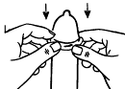  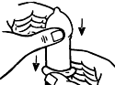 | - Put the condom on the erect penis before the penis touches the vagina.  - Ensure that the rolled edge (rim) is on the outside of the condom. Unroll the condom slightly to make sure it unrolls properly.  3. Place the condom on the tip of the erect penis and unroll it.  - Unroll the condom all the way to the base of the penis.  The condom should unroll easily. If it does not, it is probably backwards – do not turn it over and try again. Throw it away and start with a new one.  Lubricants used with latex condoms should be water-based. Good lubricants include glycerine and specially made products. Lubricants help prevent tearing the condom during intercourse.
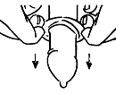 | 4. After intercourse, remove the condom.  - After ejaculation, hold the rim of the condom at the base of the penis so it will not slip off. Remove the penis from the vagina while the penis is still erect.  - Remove the condom without spilling semen on the vaginal opening.
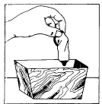 | 5. Dispose of the condom safely.  - Wrap the condom in its package or in a tissue and put it in the rubbish or a pit latrine. Do not put the condom into a flush toilet. Do not leave it where children will find it and play with it. Do not use a condom more than once.  If a condom breaks:  To prevent pregnancy, start a course of emergency contraception as soon as possible, and no later than five days after intercourse. If there is a high risk for HIV infection, postexposure prophylaxis with antiretroviral drugs is available in some areas. To be effective, PEP drugs must be started as soon as possible after exposure. Postexposure prophylaxis does NOT provide complete protection from HIV infection.  Illustrations: Essentials of Contraceptive Technology, 1997.

Tips on Caring for Male Condoms – Special Handling Instructions
- Store condoms in a cool, dark place. Heat, light, and humidity damage condoms.
- Handle condoms carefully. Fingernails and rings can tear them.
- Do not unroll condoms before use. This may weaken them. Also, an unrolled condom is difficult to put on.
- Always use a new condom if the one you have:
- has torn or damaged packaging;
- has a manufacturing date on the package that is more than five years past;
- is uneven or has changed in color;
- feels brittle, dried out, or very sticky.
- Use additional water-based lubrication to prevent condom breakage.

Tips on Reducing Male Condom User Error
Misuse of condoms, rather than poor condom quality, accounts for the majority of breaks and slips. Most users rarely experience breaks or slips. Condom effectiveness depends heavily on the user’s skills and experience.
Common errors that increase the risk of pregnancy and STIs include:
- Failure to use condoms with every act of intercourse
Non-use accounts for most pregnancies attributed to condom use.
- Failure to use condoms throughout intercourse
Some men put condoms on after starting intercourse or may remove condoms before ejaculating. This increases the risk of pregnancy or STIs. In one study, men acquired gonorrhea despite using condoms because they failed to put the condom on before starting intercourse. Condoms must be used every time from “start to finish.”
- Improper lubricant use with male condoms
Unlike water-based lubricants (e.g., K-Y Jelly), oil-based lubricants (e.g., petroleum jelly, baby oil, and hand lotions) weaken latex condoms and increase breakage. Some people use oil-based products as condom lubricants, mistaking them for water-based lubricants because they readily wash off with water.
Note: Vaginal medications (e.g., for yeast infections) often contain oil-based ingredients that can damage latex condoms.
- Incorrect placement of the condom on the penis
Condoms may tear if men are not careful when removing the condom from the package. Some men accidentally place the condom upside-down on the penis, then flip the condom over and use it for intercourse, a practice that may expose their partner to pre-ejaculatory fluid or infectious secretions. Although pregnancy is unlikely to result from exposure to pre-ejaculate, HIV has been detected in pre-ejaculatory fluid.
- Poor withdrawal technique
Slippage during withdrawal, one of the most common reasons for condom failure, may be prevented if the condom’s rim is held at the base of the erect penis while withdrawing after ejaculation. One study found only 71 percent of men held the rim during withdrawal and only 50 percent withdrew immediately after ejaculation.
- Failure to the check expiration or manufacture date and the quality of condoms
Condoms should not be used after their expiration date (printed on the packaging). Users should check that condoms are sealed; and that there are no cracks, holes, or other damage.
- Failure to store condoms properly
Heat damages condoms; therefore, they should never be stored in hot places (e.g., in direct sunlight or in pockets of tight jeans).

Instructions for Using Female Condoms |  |  | 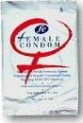
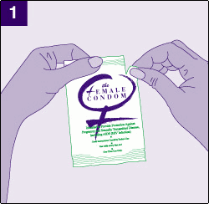 |  | Check the expiration or manufacture date on the package. Female condoms should be used within five years of the manufacturing date.  Open the package carefully. It should be torn at the notch at the top right of the package. Do not use teeth or sharp objects to open the package.
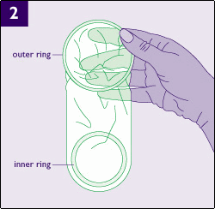 |  | Examine the condom to make sure that it is suitably lubricated.
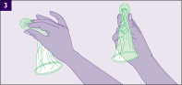 |  | While holding the sheath at the closed end, grasp the flexible inner ring and squeeze it with the thumb and second or middle finger so it becomes long and narrow.
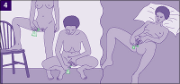 |  | Choose a position that is comfortable for insertion: squatting, raising one leg, sitting, or lying down.  With the other hand, separate the outer lips of the vagina.
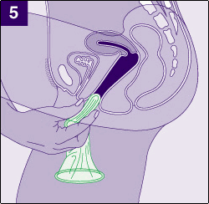 |  | Gently insert the inner ring into the vagina. Feel the inner ring go up and move into place.
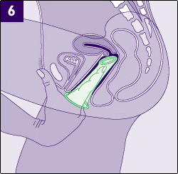 | Place the index finger on the inside of the condom, and push the inner ring up as far as it will go. Be sure the sheath is not twisted. The outer ring should remain on the outside of the vagina.
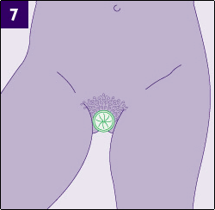 | The female condom is now in place and ready for use with a partner.
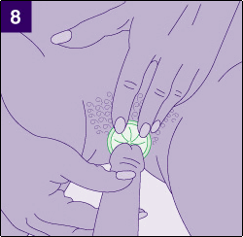 | When you are ready, gently guide your partner’s penis into the sheath’s opening with your hand to make sure that it enters the condom. Be sure that the penis is not entering on the side, between the sheath and the vaginal wall. Use enough lubricant so that the condom stays in place during sex.
 | If the condom is pulled out or pushed in, there is not enough lubricant. Add more to either the inside of the condom or the outside of the penis.
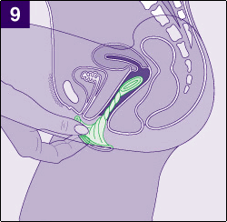 | To remove the condom, twist the outer ring and gently pull the condom out. Try to do this before standing up to avoid spilling any semen.
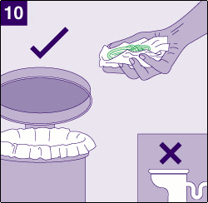 | Wrap the condom in its package or in a tissue and put it in the rubbish or a pit latrine. Do not put the condom into a flush toilet. Do not leave it where children will find it and play with it.
Source: The Female Condom: A Guide for Planning and Programming, WHO and UNAIDS, 2000.

Negotiating Safer Sex
Instructions: Use the blank spaces to write in additional excuses and possible responses.
Steps for Negotiating for Safer Sex
- Decide what you want and what you are willing to offer in return.
- Focus on safety rather than blame or lack of trust.
- Use other people as examples. If others are doing it, it is more acceptable.
- Ask for help if you need it. A trusted person can facilitate difficult partner discussions.
Things Reluctant Partners May Say | Responses to Use During Negotiation
- It will not feel as good. | - It may feel different, but it will still feel good. Here let me show you.  - You can last even longer and then we will both feel good.
- I do not have any diseases! | - I do not think that I have any either. But one of us could and not know it.
- You are already using a family planning method. | - I would like to use a condom anyway. One of us might have an infection from before that we did not know about.  - It will enhance the pregnancy prevention of the other method.
- Just this once without a condom. | - It only takes one time without protection to get an STI or HIV. And I am not ready to be pregnant.
- Condoms are for prostitutes.  Why do you want to use one? | - Condoms are for everyone who wants protection. No condoms, no sex!  - Condoms are for people who care for each other; I care for you and you care for me.

SESSION 7: Hormonal Methods and Theoretical Concerns
Hormonal contraceptives include combined oral contraceptive pills that contain the hormones estrogen and progestin, and a group of methods that contain only progestin and no estrogen. This group includes progestin-only oral contraceptive pills, or POPs; injectables such as Depo-Provera (also known as DMPA); and implants such as Norplant, Jadelle, Sinoplant, and Implanon.
Hormonal methods are appropriate for women with HIV, and most offer excellent pregnancy protection. Pregnancy rates for injectables and implants are less than one-half percent in both perfect and typical use. Oral contraceptives can also be very effective when women remember to take pills on schedule.
Hormonal methods are easy to use, especially injectables and implants, which require very little action on the part of the client. Implants offer long-acting protection for up to five years, while other methods are suitable for both short- and long-term use. All hormonal methods are reversible, although fertility return with DMPA may take somewhat longer than with other methods.
All hormonal methods offer some health benefits, including but not limited to reduced risk of reproductive tract cancers, anemia, and clinical pelvic inflammatory disease. In addition, serious complications are extremely rare with hormonal methods, especially if women meet the eligibility criteria for initiating use.
While hormonal methods are appropriate for women with HIV, several biological concerns regarding the relationship between hormonal contraceptives and HIV exist. These concerns continue to be an important area of research, as new evidence becomes available, changes to some existing family planning practices may be warranted.

Theoretical Concerns about Hormonal Methods
?
?
?
?
?
4
Some antiretroviral drugs can reduce or increase blood levels of contraceptive hormones. (Leitz, 2000; Piscitelli, 1996) Theoretically, lower concentrations could reduce the effectiveness of hormonal contraceptives, while higher concentrations could increase hormone-related side effects. Similarly, contraceptives may affect the efficacy of some ARV drugs.
Other issues that require further research include possible effects of hormonal contraception on HIV-positive women’s infectivity and possible relationships between hormonal contraception and HIV disease progression.
It is important to balance these concerns, which are primarily theoretical, against the real risk of unintended pregnancy and its impact on maternal and infant morbidity and mortality.

How ARVs Interact with COCs
A few, small pharmacokinetic studies have examined the use of certain ARV therapies with limited courses of combined oral contraceptives. These studies showed both positive and negative effects on hormone levels.
The main concern about COCs is that some ARVs affect liver enzymes, which then speed up liver metabolism of contraceptive hormones and could lower blood levels of the hormones. The reduced concentrations of contraceptive hormones in blood theoretically may lead to reduced effectiveness of hormonal contraceptives and increased risk of pregnancy.
Not all classes of ARVs interact with contraceptive hormones because not all ARVs affect liver enzymes. Drugs that do not affect liver enzymes, and therefore probably do not affect hormonal contraceptives, include NRTIs. Drugs that affect liver enzymes include NNRTIs some of which may reduce blood concentration of contraceptive hormones by approximately 20 percent, and ritonavir-boosted protease inhibitors which may reduce concentrations of contraceptive hormones by as much as 40 percent. The charts below summarize what is known to date.
Interactions between COCs and PIs
Protease inhibitors | Contraceptive hormone levels in blood | ARV levels  in blood
Nelfinavir (NFV) | ê | No data
Ritonavir (RTV) | ê | No data
Lopinavir (LPV)/ Ritonavir (RTV) | ê | No data
Atazanavir (ATV) | é | No data
Indinavir (IDV) | é | No data
Saquinavir (SQV) | No data | No change
Concerns about interactions with hormonal contraceptives focus on protease inhibitors (PIs) and NNRTIs. The chart above summarizes the interactions that were observed in the levels of contraceptive steroids and PIs. Notice that in some cases the contraceptive steroid levels decreased while in other cases, they increased.
Limited evidence suggests that ritonavir-boosted protease inhibitors decrease blood concentrations of contraceptive hormones by as much as 40 percent. Although there is no evidence yet of the clinical significance of this interaction, scientists believe that this level of reduction in the blood concentration of contraceptive hormones is likely to reduce the effectiveness of oral contraceptives. In contrast, an increased level of contraceptive hormone may theoretically increase the risk of side effects associated with hormonal contraceptives.
At this time, there is not sufficient data on how blood levels of protease inhibitors may be affected by contraceptive hormones among women who take COCs.
(WHO, 2004; Ouellet, 1998; University of Liverpool, 2008)

Interactions between COCs and NNRTIs
Non-nucleoside reverse transcriptase inhibitors | Contraceptive hormone levels in blood | ARV levels  in blood
Nevirapine (NVP) | ê | No change
Efavirenz (EVF or EFZ) | é | No change
The chart above shows the effects that were observed in the levels of contraceptive steroids and NNRTI drugs when they are taken concurrently. In the case of nevirapine, one study demonstrated a 20 percent decrease in plasma concentration of hormonal contraceptives among women taking concurrent estradiol/norethindrone and nevirapine. While clinical significance of such interaction is unclear, we do know that ultra-low-dose, 20 microgram, oral contraceptives – which contain two-thirds the amount of estrogen found in regular low-dose oral contraceptives – are widely used in countries where they are approved, and highly effective if taken correctly.
In the case of efavirenz, an increase in plasma concentration of hormonal contraceptives was observed. No changes in the blood concentrations of the ARV drugs were found.
Although most of the existing research examines the interaction between ARV drugs and combined oral contraceptives, there is limited research that looks at interactions between ARV drugs and DMPA. Based on information currently available, no significant interaction was found between ARV drugs and progestin-only injectables particularly DMPA. (WHO, 2004; Cohn, 2005)

Clinical Significance of COC/ARV Interaction Is Unknown
Currently, concerns about reduced effectiveness of hormonal contraceptives due to interactions with ARV drugs are based on blood levels of contraceptive hormones and not on clinical outcomes, such as pregnancy rates or indicators of ovulation. Additionally, while there is limited evidence on COCs and DMPA, no studies have been completed to clarify possible interactions between ARVs and other hormonal contraceptives, including combined injectables, vaginal rings, patches, progestin-only pills, emergency contraceptive pills, progestin implants, or progestin intrauterine systems.
It is unlikely that the effectiveness of contraceptive methods is appreciably affected when the blood levels of the hormones are only somewhat reduced, as in the case of the NNRTI, nevirapine. However, with ritonavir-boosted protease inhibitors, the reduction is considered significant enough to decrease contraceptive effectiveness. This is why the 2008 WHO working group decided that ritonavir-boosted protease inhibitors generally should not be used by women taking oral contraceptives or combined injectables. For other types of ARVs, more restrictive changes to clinical guidelines will not be considered unless there is sufficient evidence that the interaction increases the risk of contraceptive method failure. It is important to realize that ritonavir-boosted protease inhibitors are not currently recommended by WHO as part of a first-line ARV regimen and thus are not as commonly used as other ARV drugs.

Hormonal Use – Increases Risk of Cervical Infection
It appears that use of hormonal contraceptives may increase the risk of acquiring cervical STI infections, which, as you will see on the next several slides, may have some implications for women with HIV. A ten-year prospective study of HIV-positive Kenyan sex workers found that use of hormonal contraceptives was associated with a significantly increased risk of cervical chlamydial infection and cervicitis, even after controlling for demographic factors and sexual behavior. Compared to women who used no hormonal contraceptives, women using DMPA had a threefold increased incidence of cervical chlamydial infection and a 1.6-fold increased incidence of nonspecific cervicitis. Women using oral contraceptive pills had more than double the increased incidence of nonspecific cervicitis. Use of hormonal contraceptives was not associated with an increased incidence of gonorrhea infection, however. (Lavreys, 2004)

Hormonal Use – May Increase HIV Shedding
A theoretical concern also exists that hormonal contraceptive use by women with HIV could increase HIV shedding, therefore increasing risk of HIV transmission to an uninfected partner. However, data are conflicting about such a relationship. Some studies showed no increase in HIV shedding. Other data suggest that more HIV shedding does occur when women are using hormonal contraception. (Wang, 1999)
One prospective study conducted among family planning clients in Mombasa, Kenya, detected a modest but statistically significant increase in cervical shedding of HIV-infected cells. Cervical shedding in women with HIV rose from 42 percent to
52 percent after initiation of various hormonal contraceptives. However, no difference was detected in the amount of cell-free virus in genital secretions. (Wang, 2004)
The relative impact of HIV-infected cells versus cell-free virus on infectivity is uncertain. The presence of both in maternal cervical secretions and in breast milk has been found to increase the risk of vertical transmission. (John, 2001)

Relationships between Hormonal Contraceptive Use and HIV
It appears that use of hormonal contraceptives may increase the risk of acquiring STIs and the cervical shedding of HIV. It is also known from research studies that cervical STIs increase HIV shedding in cervical secretions, even in women who are not using hormonal contraceptives. (McClelland , 2001; Ghys, 1997) The increased amount of virus may in turn increase the risk of HIV transmission to a sexual partner. While some concern about an increased risk of HIV transmission among users of hormonal contraceptives is warranted, more data are needed before any changes to current service delivery guidelines are considered.
More HIV virus may increase risk of transmission to partner

Cervical STI infections may also increase cervical shedding of HIV

Using hormonal contraceptives may increase:
risk of acquiring cervical STIs
cervical shedding of HIV

Hormonal Use and Disease Progression – Requires Further Research
Some studies have also raised concerns that hormonal contraceptives may affect disease progression in women with HIV. In a prospective cohort study of HIV acquisition among 1,337 sex workers in Mombasa, Kenya, the use of DMPA at the time of HIV infection was associated with a higher viral load set point.
Viral load set point is an important indicator of HIV disease progression. As illustrated in the graphic below, after a person initially becomes infected, his or her viral load increases. The killer cells of the immune system respond to the HIV virus by attacking infected cells, lowering the viral load to a certain level. This level is known as the viral set point. The higher the viral load set point, the faster HIV-related deterioration of the immune system occurs. Thus, the Mombasa study findings suggest that DMPA use may hasten the natural course of HIV infection. (Lavreys, 2004)
Viral load increases after initial infection
Immune system’s killer cells respond
Viral load is reduced
Higher set point Lower set point
Similarly, Kenyan sex workers using hormonal contraceptives near the time of HIV acquisition were more likely to be infected with multiple genetically diverse subtypes of the same virus than sex workers not using hormones. Infection with multiple subtypes appears to be related to a higher viral set point and to faster CD4 decline, which is another key indicator of HIV disease progression. (Sagar, 2003)
Many of the studies on hormonal contraception and HIV disease progression have been conducted among sex workers in Kenya, and some of the findings have not been corroborated by other studies. Therefore, further research among other populations of women in other geographic locations is needed before any changes to service provision guidelines are made.

Hormonal Use and HIV – What Providers Should Do
Given what is currently known about hormonal contraception and HIV, providers should:
- Counsel their clients that certain ARV drugs reduce the blood concentration of contraceptive hormones, which theoretically may reduce the effectiveness of hormonal contraceptive methods – with the exception of DMPA.
- Encourage clients to always tell their health care providers which medications they are taking. Although a client may not currently be using any drugs that compromise method effectiveness, at some point she may need to switch contraceptive methods to be eligible for other treatment regimens, for example, if ritonavir is added to her ARV regimen.
- When possible, prescribe ARV drugs that do not interact with hormonal contraceptives.
- If this is not possible, encourage women to be very careful about using the methods correctly and consistently, and to consider using condoms for additional protection.
- Keep abreast of updates to clinical practice guidelines. As new research on these and other related topics becomes available, technical experts and policy-makers will make appropriate changes to clinical practice guidelines. For example, the available research on HIV disease progression and possible increased risk of transmission among hormonal contraceptive users is not conclusive. Until additional research on these topics can provide decisive information, there is no reason to change clinical practice or to counsel clients about these theoretical concerns.

Counseling Messages for Women Using Hormonal Contraception and ARV Therapy
- Some ARV drugs have the potential to reduce effectiveness of hormonal contraceptives; this is why it is especially important to use hormonal methods correctly when on ART.
- Women taking COCs need to take the pills on schedule without missing any. If a woman is prescribed ritonavir as part of her ARV regimen, she should talk with her provider about using a method other than COCs. This is because the effectiveness of COCs may be significantly reduced by ritonavir.
- Women on NET-EN need to return for the next injection on time. Although normally the next injection can be given as much as two weeks late; in the presence of ARV therapy, it is safer to closely follow the recommended injection schedule.
- Women should consider using condoms to ensure additional protection from pregnancy because the effectiveness of hormonal contraceptives – other than DMPA which provides a wide margin of effectiveness in each dose – may be compromised by ARV therapy. Focusing on the pregnancy prevention role of condoms may help when negotiating condom use with a partner.

Oral Contraceptives – Note-taking Pages

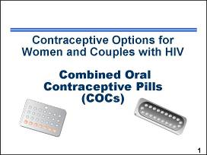 | ___________________________________  ___________________________________  ___________________________________  ___________________________________  ___________________________________  ___________________________________  ___________________________________
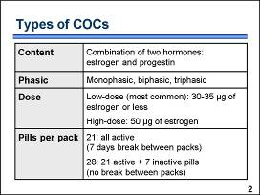 | ___________________________________  ___________________________________  ___________________________________  ___________________________________  ___________________________________  ___________________________________  ___________________________________
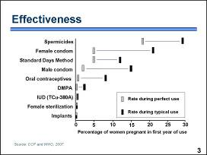 | ___________________________________  ___________________________________  ___________________________________  ___________________________________  ___________________________________  ___________________________________  ___________________________________
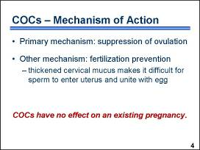 | ___________________________________  ___________________________________  ___________________________________  ___________________________________  ___________________________________  ___________________________________  ___________________________________
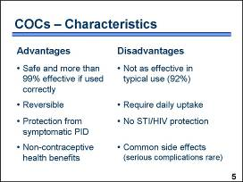 | ___________________________________  ___________________________________  ___________________________________  ___________________________________  ___________________________________  ___________________________________  ___________________________________
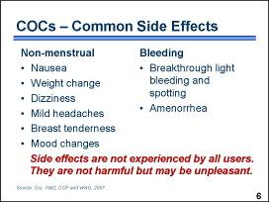 | ___________________________________  ___________________________________  ___________________________________  ___________________________________  ___________________________________  ___________________________________  ___________________________________
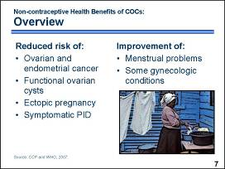 | ___________________________________  ___________________________________  ___________________________________  ___________________________________  ___________________________________  ___________________________________  ___________________________________
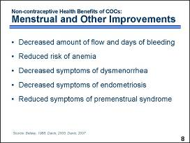 | ___________________________________  ___________________________________  ___________________________________  ___________________________________  ___________________________________  ___________________________________  ___________________________________
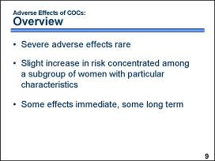 | ___________________________________  ___________________________________  ___________________________________  ___________________________________  ___________________________________  ___________________________________  ___________________________________
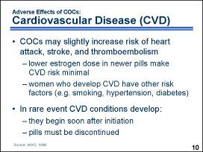 | ___________________________________  ___________________________________  ___________________________________  ___________________________________  ___________________________________  ___________________________________  ___________________________________
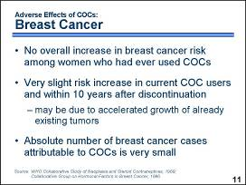 | ___________________________________  ___________________________________  ___________________________________  ___________________________________  ___________________________________  ___________________________________  ___________________________________
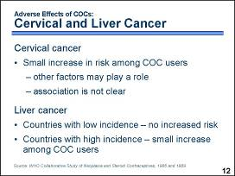 | ___________________________________  ___________________________________  ___________________________________  ___________________________________  ___________________________________  ___________________________________  ___________________________________
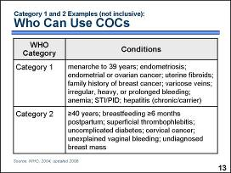 | ___________________________________  ___________________________________  ___________________________________  ___________________________________  ___________________________________  ___________________________________  ___________________________________
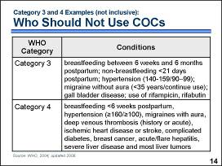 | ___________________________________  ___________________________________  ___________________________________  ___________________________________  ___________________________________  ___________________________________  ___________________________________
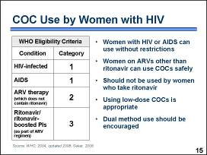 | ___________________________________  ___________________________________  ___________________________________  ___________________________________  ___________________________________  ___________________________________  ___________________________________
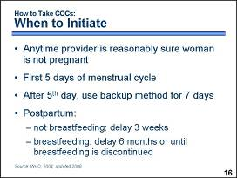 | ___________________________________  ___________________________________  ___________________________________  ___________________________________  ___________________________________  ___________________________________  ___________________________________
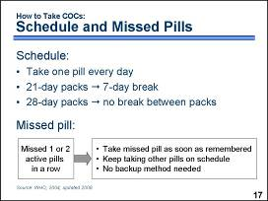 | ___________________________________  ___________________________________  ___________________________________  ___________________________________  ___________________________________  ___________________________________  ___________________________________
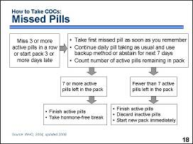 | ___________________________________  ___________________________________  ___________________________________  ___________________________________  ___________________________________  ___________________________________  ___________________________________
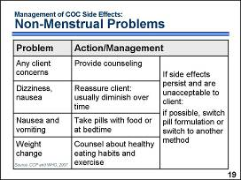 | ___________________________________  ___________________________________  ___________________________________  ___________________________________  ___________________________________  ___________________________________  ___________________________________
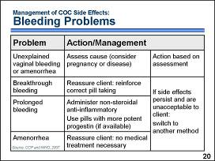 | ___________________________________  ___________________________________  ___________________________________  ___________________________________  ___________________________________  ___________________________________  ___________________________________
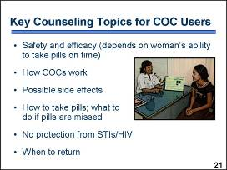 | ___________________________________  ___________________________________  ___________________________________  ___________________________________  ___________________________________  ___________________________________  ___________________________________
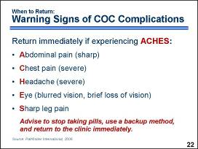 | ___________________________________  ___________________________________  ___________________________________  ___________________________________  ___________________________________  ___________________________________  ___________________________________
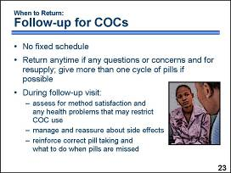 | ___________________________________  ___________________________________  ___________________________________  ___________________________________  ___________________________________  ___________________________________  ___________________________________

Injectable Contraceptives – Note-taking Pages

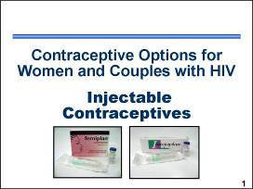 | ___________________________________  ___________________________________  ___________________________________  ___________________________________  ___________________________________  ___________________________________  ___________________________________
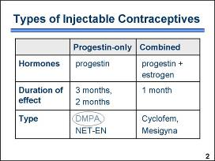 | ___________________________________  ___________________________________  ___________________________________  ___________________________________  ___________________________________  ___________________________________  ___________________________________
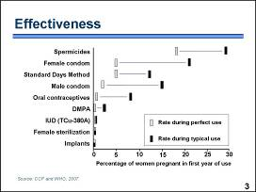 | ___________________________________  ___________________________________  ___________________________________  ___________________________________  ___________________________________  ___________________________________  ___________________________________
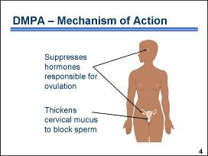 | ___________________________________  ___________________________________  ___________________________________  ___________________________________  ___________________________________  ___________________________________  ___________________________________
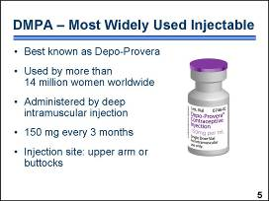 | ___________________________________  ___________________________________  ___________________________________  ___________________________________  ___________________________________  ___________________________________  ___________________________________
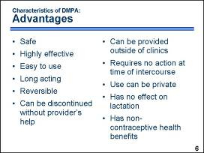 | ___________________________________  ___________________________________  ___________________________________  ___________________________________  ___________________________________  ___________________________________  ___________________________________
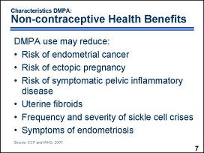 | ___________________________________  ___________________________________  ___________________________________  ___________________________________  ___________________________________  ___________________________________  ___________________________________
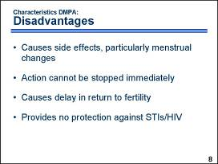 | ___________________________________  ___________________________________  ___________________________________  ___________________________________  ___________________________________  ___________________________________  ___________________________________
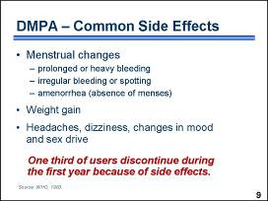 | ___________________________________  ___________________________________  ___________________________________  ___________________________________  ___________________________________  ___________________________________  ___________________________________
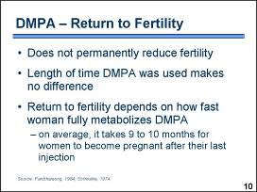 | ___________________________________  ___________________________________  ___________________________________  ___________________________________  ___________________________________  ___________________________________  ___________________________________
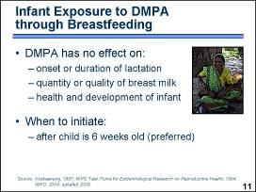 | ___________________________________  ___________________________________  ___________________________________  ___________________________________  ___________________________________  ___________________________________  ___________________________________
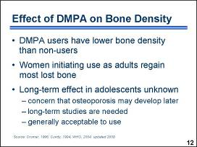 | ___________________________________  ___________________________________  ___________________________________  ___________________________________  ___________________________________  ___________________________________  ___________________________________
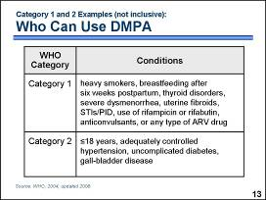 | ___________________________________  ___________________________________  ___________________________________  ___________________________________  ___________________________________  ___________________________________  ___________________________________
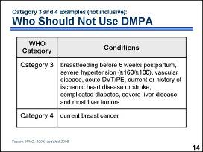 | ___________________________________  ___________________________________  ___________________________________  ___________________________________  ___________________________________  ___________________________________  ___________________________________
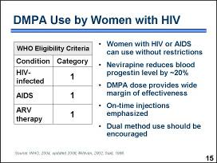 | ___________________________________  ___________________________________  ___________________________________  ___________________________________  ___________________________________  ___________________________________  ___________________________________
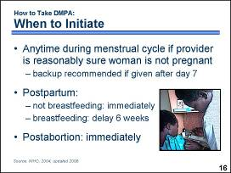 | ___________________________________  ___________________________________  ___________________________________  ___________________________________  ___________________________________  ___________________________________  ___________________________________
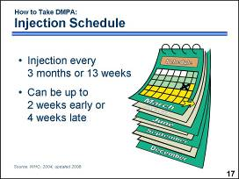 | ___________________________________  ___________________________________  ___________________________________  ___________________________________  ___________________________________  ___________________________________  ___________________________________
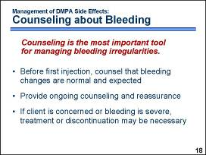 | ___________________________________  ___________________________________  ___________________________________  ___________________________________  ___________________________________  ___________________________________  ___________________________________
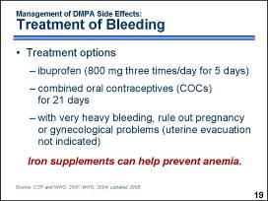 | ___________________________________  ___________________________________  ___________________________________  ___________________________________  ___________________________________  ___________________________________  ___________________________________
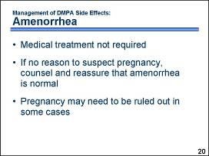 | ___________________________________  ___________________________________  ___________________________________  ___________________________________  ___________________________________  ___________________________________  ___________________________________
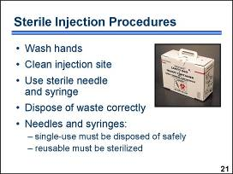 | ___________________________________  ___________________________________  ___________________________________  ___________________________________  ___________________________________  ___________________________________  ___________________________________
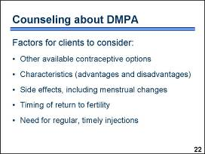 | ___________________________________  ___________________________________  ___________________________________  ___________________________________  ___________________________________  ___________________________________  ___________________________________
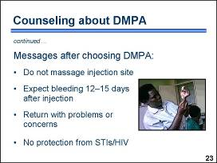 | ___________________________________  ___________________________________  ___________________________________  ___________________________________  ___________________________________  ___________________________________  ___________________________________
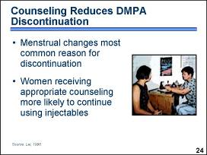 | ___________________________________  ___________________________________  ___________________________________  ___________________________________  ___________________________________  ___________________________________  ___________________________________
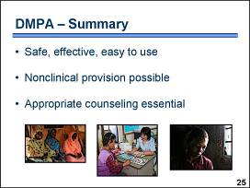 | ___________________________________  ___________________________________  ___________________________________  ___________________________________  ___________________________________  ___________________________________  ___________________________________

Implants, POPs, and Emergency Contraception – Note-taking Pages

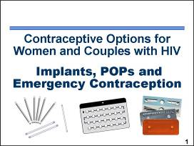 | ___________________________________  ___________________________________  ___________________________________  ___________________________________  ___________________________________  ___________________________________  ___________________________________
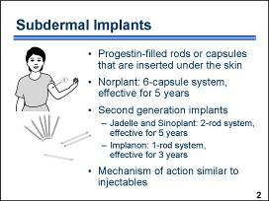 | ___________________________________  ___________________________________  ___________________________________  ___________________________________  ___________________________________  ___________________________________  ___________________________________
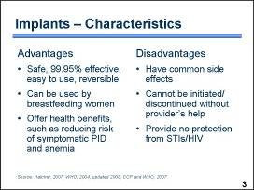 | ___________________________________  ___________________________________  ___________________________________  ___________________________________  ___________________________________  ___________________________________  ___________________________________
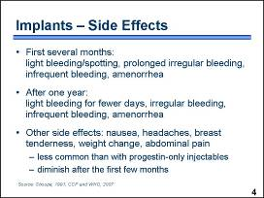 | ___________________________________  ___________________________________  ___________________________________  ___________________________________  ___________________________________  ___________________________________  ___________________________________
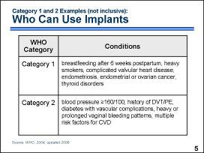 | ___________________________________  ___________________________________  ___________________________________  ___________________________________  ___________________________________  ___________________________________  ___________________________________
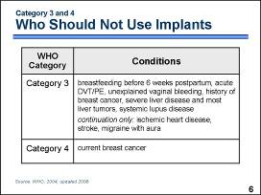 | ___________________________________  ___________________________________  ___________________________________  ___________________________________  ___________________________________  ___________________________________  ___________________________________
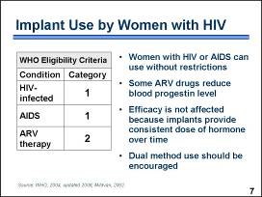 | ___________________________________  ___________________________________  ___________________________________  ___________________________________  ___________________________________  ___________________________________  ___________________________________
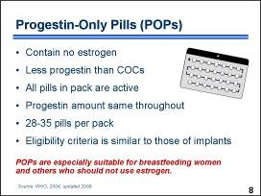 | ___________________________________  ___________________________________  ___________________________________  ___________________________________  ___________________________________  ___________________________________  ___________________________________
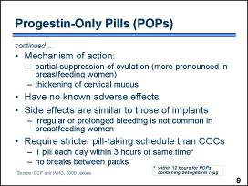 | ___________________________________  ___________________________________  ___________________________________  ___________________________________  ___________________________________  ___________________________________  ___________________________________
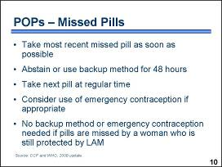 | ___________________________________  ___________________________________  ___________________________________  ___________________________________  ___________________________________  ___________________________________  ___________________________________
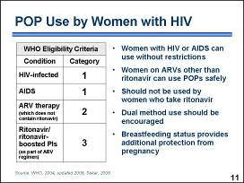 | ___________________________________  ___________________________________  ___________________________________  ___________________________________  ___________________________________  ___________________________________  ___________________________________
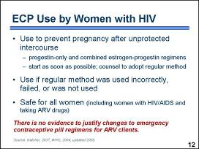 | ___________________________________  ___________________________________  ___________________________________  ___________________________________  ___________________________________  ___________________________________  ___________________________________
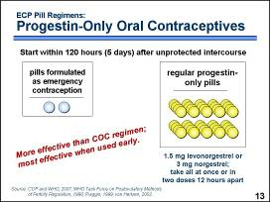 | ___________________________________  ___________________________________  ___________________________________  ___________________________________  ___________________________________  ___________________________________  ___________________________________
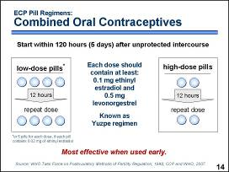 | ___________________________________  ___________________________________  ___________________________________  ___________________________________  ___________________________________  ___________________________________  ___________________________________
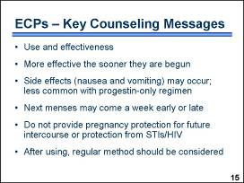 | ___________________________________  ___________________________________  ___________________________________  ___________________________________  ___________________________________  ___________________________________  ___________________________________

SESSION 8: Intrauterine Devices (IUDs)
The IUD, also known in some places as the intrauterine contraceptive device or IUCD, is one of the world’s most widely used family planning methods. It is the second most commonly used form of contraception, with the first being female sterilization. The IUD is the most common form of reversible contraception, used by about 100 million women worldwide. Currently, sixty-seven percent of IUD users live in China. However, IUD acceptance is growing in other parts of the world.
Most IUDs being inserted today are shaped like a T with copper wires or bands on the plastic stem and arms. In the late 1960s, researchers found that adding copper to the plastic frames made IUDs more effective than earlier devices. The copper released into the uterine cavity increases the contraceptive efficacy of the IUD.
The IUD is inserted into a woman’s uterus through her vagina and then cervical opening. Almost all brands of IUD have one or two strings tied to them. The strings hang through the opening of the cervix into the vagina. The user can check that the IUD is still in place by touching the strings. A provider can remove the IUD by pulling gently on the strings with forceps.
Among copper IUDs, the TCu-380A is currently one of the most widely used in the world. Less widely available are hormonal IUDs that steadily release small amounts of progestin, such as levonorgestrel. The information in this manual focuses on the TCu-380A IUD.

IUDs Safe for Women with HIV
Research has found that women with HIV can use IUDs safely. A study conducted in Kenya examined over a two-year period the health of two groups of women who received an IUD: 486 women who were HIV-negative, and 150 women with HIV infection. Researchers looked for problems after insertion, such as IUD removal due to infection, bleeding, and pain; IUD expulsion; pregnancy; and pelvic inflammatory disease.
As shown in this chart, the percentage of women reporting complications after IUD insertion was almost identical for the two groups – 14.7 percent among women with HIV and 14.8 percent among women without HIV. The percentage of women reporting problems related to some type of infection, including pelvic tenderness and IUD removal for infection or pain, was 10.7 percent among those who were HIV-infected and 8.8 percent among those who were HIV-free. While women with HIV tended to have slightly more problems related to infection, they were not significantly different from women in the noninfected group. (Morrison, 2001)
Little difference in complications between IUD acceptors with and without HIV.
Percentage of women in Kenyan study
Little difference in complications between IUD acceptors with and without HIV.
In short, little difference in side effects and infection-related complications was seen between HIV-infected and noninfected IUD acceptors. Overall, 85 percent of women had no problems with IUD use. These findings suggest that the IUD is an appropriate contraceptive method for women with HIV. This is especially true for women who want to limit births for an extended period of time or where access to sterilization services might be limited.

IUD Use Does Not Increase Cervical Shedding of HIV
A theoretical concern about IUD use by women with HIV is that it could increase cervical shedding of HIV, thus increasing the risk of transmission to a sexual partner. In a study conducted in Kenya, researchers calculated rates of cervical shedding of HIV-infected cells before IUD insertion and four months after insertion. Results showed no significant differences in cervical shedding among women with HIV before and after insertion. In other words, current evidence suggests that IUDs do not raise the amount of virus to which a woman’s sexual partner is exposed. (Richardson, 1999)
Reducing the Risk of Pelvic Inflammatory Disease
Pelvic inflammatory disease (PID) is an infection of a woman’s upper genital tract. Overall risk of PID associated with the IUD is very low, although there is a somewhat increased risk of PID during the first 20 days after insertion. Sexually transmitted infections (STIs), such as gonorrhea and chlamydia, are the reason some women develop PID. When the IUD is inserted through an infected cervix, there is a chance that it will carry the infection from the lower to the upper genital tract. However, women with undiagnosed and untreated gonorrhea or chlamydia who are not using the IUD develop PID as well. Based on available evidence, it appears that PID rates are similar among women with STIs with or without the IUD being inserted, and the IUD itself contributes very little to the risk of PID. (Shelton, 2001)
An IUD user’s risk for developing PID can be reduced even further if providers follow important guidelines. Screen women for risk of STIs. While women at risk of STIs can generally use an IUD, more careful follow-up after insertion may be recommended. However, providers should try to screen out women at high individual risk of STIs. This category of women may include those with more than one sexual partner, those whose partner has multiple sex partners, or those whose partners have symptoms of STIs.
Carefully screen women for any symptoms and signs of current STIs. In many cases, good clinical judgment is sufficient to rule out an infection with gonorrhea and chlamydia. Ruling out the possibility of a current STI by medical history and physical examination is essential prior to providing the IUD. Laboratory tests are not required prior to IUD insertion, but they could be offered when available and when the provider has difficulty ruling out an infection by clinical judgment alone. IUDs should never be inserted in women with current STIs. Women at high individual risk of STIs should generally not have an IUD inserted unless other methods are unavailable or unacceptable to the client and careful follow-up is possible.
Counsel all users about the risks of PID. Emphasize that behaviors that place a woman at greater risk for STIs also increase her risk of PID.
Strictly follow infection prevention procedures to reduce the risk of introducing bacteria into the uterus. Antibiotic prophylaxis at the time of IUD insertion is generally not recommended. However, in settings where the prevalence of cervical gonococcal and chlamydial infections is high and screening for STIs is limited, prophylaxis may be considered.
Most service delivery guidelines recommend that the client return after the first the menses or about three to six weeks after the IUD is inserted to check for the presence of infection. Advise the client to return immediately if she experiences symptoms, such as fever or low abdominal pain, during the first month after insertion. (World Health Organization, 2004)

Intrauterine Device (IUD) – Note taking-Pages

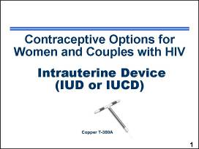 | ___________________________________  ___________________________________  ___________________________________  ___________________________________  ___________________________________  ___________________________________  ___________________________________
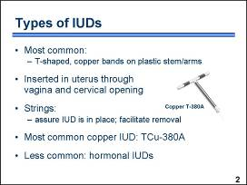 | ___________________________________  ___________________________________  ___________________________________  ___________________________________  ___________________________________  ___________________________________  ___________________________________
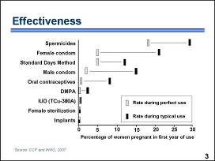 | ___________________________________  ___________________________________  ___________________________________  ___________________________________  ___________________________________  ___________________________________  ___________________________________
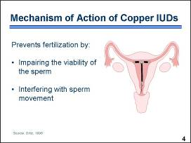 | ___________________________________  ___________________________________  ___________________________________  ___________________________________  ___________________________________  ___________________________________  ___________________________________
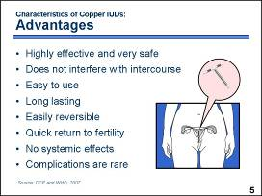 | ___________________________________  ___________________________________  ___________________________________  ___________________________________  ___________________________________  ___________________________________  ___________________________________
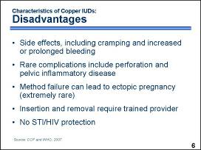 | ___________________________________  ___________________________________  ___________________________________  ___________________________________  ___________________________________  ___________________________________  ___________________________________
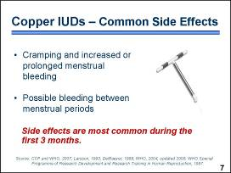 | ___________________________________  ___________________________________  ___________________________________  ___________________________________  ___________________________________  ___________________________________  ___________________________________
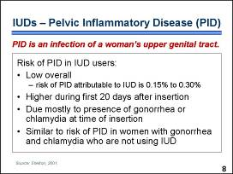 | ___________________________________  ___________________________________  ___________________________________  ___________________________________  ___________________________________  ___________________________________  ___________________________________
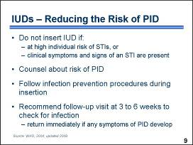 | ___________________________________  ___________________________________  ___________________________________  ___________________________________  ___________________________________  ___________________________________  ___________________________________
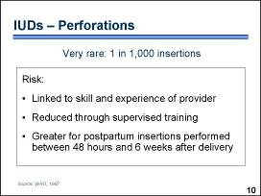 | ___________________________________  ___________________________________  ___________________________________  ___________________________________  ___________________________________  ___________________________________  ___________________________________
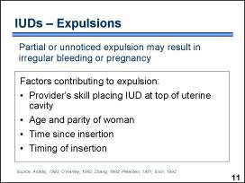 | ___________________________________  ___________________________________  ___________________________________  ___________________________________  ___________________________________  ___________________________________  ___________________________________
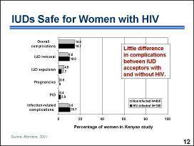 | ___________________________________  ___________________________________  ___________________________________  ___________________________________  ___________________________________  ___________________________________  ___________________________________
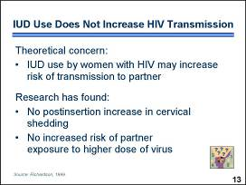 | ___________________________________  ___________________________________  ___________________________________  ___________________________________  ___________________________________  ___________________________________  ___________________________________
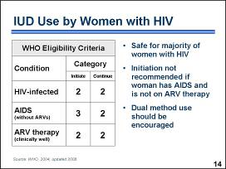 | ___________________________________  ___________________________________  ___________________________________  ___________________________________  ___________________________________  ___________________________________  ___________________________________
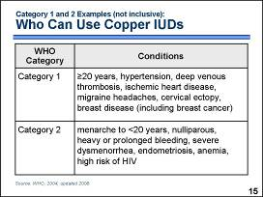 | ___________________________________  ___________________________________  ___________________________________  ___________________________________  ___________________________________  ___________________________________  ___________________________________
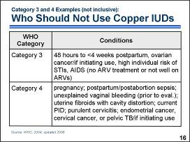 | ___________________________________  ___________________________________  ___________________________________  ___________________________________  ___________________________________  ___________________________________  ___________________________________
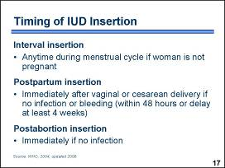 | ___________________________________  ___________________________________  ___________________________________  ___________________________________  ___________________________________  ___________________________________  ___________________________________
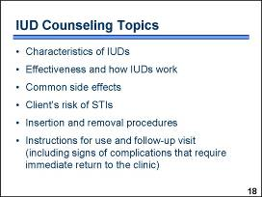 | ___________________________________  ___________________________________  ___________________________________  ___________________________________  ___________________________________  ___________________________________  ___________________________________
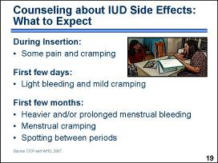 | ___________________________________  ___________________________________  ___________________________________  ___________________________________  ___________________________________  ___________________________________  ___________________________________
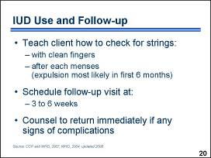 | ___________________________________  ___________________________________  ___________________________________  ___________________________________  ___________________________________  ___________________________________  ___________________________________
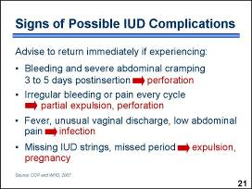 | ___________________________________  ___________________________________  ___________________________________  ___________________________________  ___________________________________  ___________________________________  ___________________________________
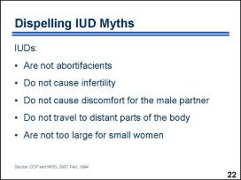 | ___________________________________  ___________________________________  ___________________________________  ___________________________________  ___________________________________  ___________________________________  ___________________________________
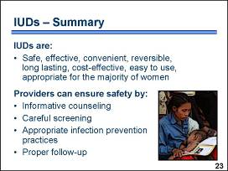 | ___________________________________  ___________________________________  ___________________________________  ___________________________________  ___________________________________  ___________________________________  ___________________________________

SESSION 9: Sterilization, FAB Methods, LAM and
Infant Feeding

Male and Female Sterilization – Counseling is Especially Important

For women and couples with HIV who have decided to have no more children, female or male sterilization may be a good option. As with any family planning method, it is essential that the client be free to exercise an informed, voluntary choice. Even the mildest forms of pressure must be avoided. Providers should give appropriate information about all available contraceptive options and give the preferred method if possible.

Providers should take special care with clients interested in sterilization and carefully discuss the decision to end fertility. Clients who consider sterilization should have a thorough understanding of the alternative long-acting methods available. If a client has any doubts, it is best to recommend delaying the procedure and encouraging the use of other contraceptive methods until a clear decision is made.

Counselors should also:
- Inform clients about possible complications of sterilization procedures. Such complications are infrequent, but they do occasionally occur and may include infection or bleeding, and in the case of female sterilization, adverse reaction to general anesthesia (in the cases where conditions or circumstances prevent the use of local anesthesia).
- Clarify that unlike some other contraceptive methods, sterilization has no systemic side effects.
- Explain time-to-effectiveness. While female sterilization is effective immediately, male sterilization is not. Because it takes time for the vas to become completely clear of sperm, couples should be counseled to use another contraceptive method for 12 weeks – three months – following vasectomy. Although guidelines have typically recommended a waiting period of 12 weeks or 20 ejaculations, recent research has shown that the 12-week waiting period is significantly more reliable. The success of vasectomy also may be determined by sperm analysis, if available.
- Discuss the lack of STI/HIV protection. Providers can help clients to assess their risk of STI/HIV transmission and encourage those at risk to use condoms in addition to sterilization.

The WHO Medical Eligibility Criteria state that there are no medical reasons to deny sterilization to a client with HIV. If a woman or man has an acute AIDS-related illness, sterilization should be delayed until the condition has improved. Because sterilization is a surgical procedure, any acute HIV-related opportunistic infection may complicate or prolong recovery. Because neither male nor female sterilization offers protection from STIs/HIV, couples should be counseled about condom use for STI/HIV prevention.

Dispelling Myths and Misunderstandings

A number of myths and misunderstandings exist regarding female and male sterilization. Some women fear that sterilization will cause them to be less feminine or lose their sexual desire. However, sterilization does not affect appearance or normal sexual function in any way. Some women may even feel their sexual desire increase because they are no longer worried about becoming pregnant. Another myth is that eggs will build up in the body. Sterilized women continue to produce eggs, but the eggs degenerate and are reabsorbed. Women need to understand that after sterilization, menstruation will still occur as previously, although it no longer signals fertility. Also, women may falsely believe that the tubes can be simply united to restore fertility. Reversal is a very complex and expensive procedure that is rarely available, and success is not guaranteed.

In the case of male sterilization, many men incorrectly equate vasectomy with castration – the physical removal of the testes – and a loss of sexual desire. However, male sterilization is not castration and does not affect normal sexual function or the quantity of ejaculate. Some men may falsely believe that vasectomy will cause them to lose male physical traits or strength. However, after vasectomy the production of hormones related to sexual behavior and physical traits remains the same. Another common misconception is that sperm will build up in the body. As with female eggs, sperm do not build up in the body but are reabsorbed on a continual basis.

Sterilization – Note-taking Pages

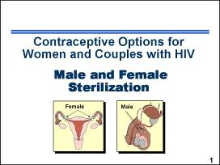 | ___________________________________  ___________________________________  ___________________________________  ___________________________________  ___________________________________  ___________________________________  ___________________________________
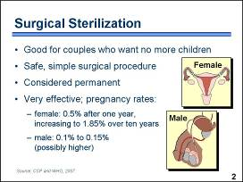 | ___________________________________  ___________________________________  ___________________________________  ___________________________________  ___________________________________  ___________________________________  ___________________________________
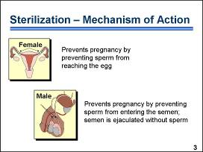 | ___________________________________  ___________________________________  ___________________________________  ___________________________________  ___________________________________  ___________________________________  ___________________________________
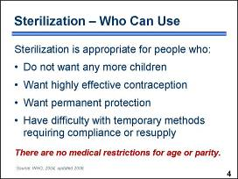 | ___________________________________  ___________________________________  ___________________________________  ___________________________________  ___________________________________  ___________________________________  ___________________________________
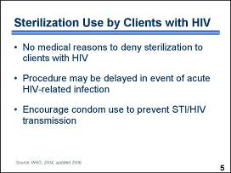 | ___________________________________  ___________________________________  ___________________________________  ___________________________________  ___________________________________  ___________________________________  ___________________________________
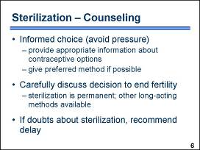 | ___________________________________  ___________________________________  ___________________________________  ___________________________________  ___________________________________  ___________________________________  ___________________________________
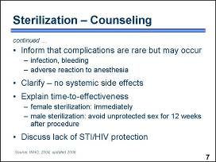 | ___________________________________  ___________________________________  ___________________________________  ___________________________________  ___________________________________  ___________________________________  ___________________________________
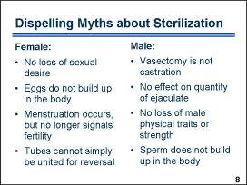 | ___________________________________  ___________________________________  ___________________________________  ___________________________________  ___________________________________  ___________________________________  ___________________________________

Fertility Awareness-based Methods – Note-taking Pages

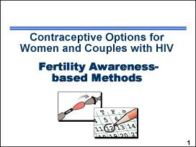 | ___________________________________  ___________________________________  ___________________________________  ___________________________________  ___________________________________  ___________________________________  ___________________________________
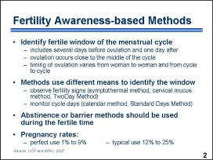 | ___________________________________  ___________________________________  ___________________________________  ___________________________________  ___________________________________  ___________________________________  ___________________________________
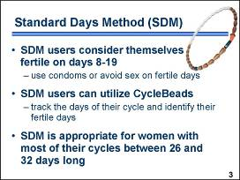 | ___________________________________  ___________________________________  ___________________________________  ___________________________________  ___________________________________  ___________________________________  ___________________________________
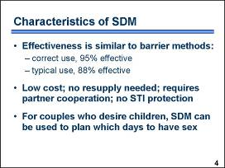 | ___________________________________  ___________________________________  ___________________________________  ___________________________________  ___________________________________  ___________________________________  ___________________________________
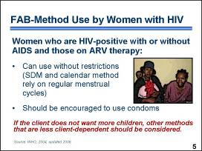 | ___________________________________  ___________________________________  ___________________________________  ___________________________________  ___________________________________  ___________________________________  ___________________________________

Lactational Amenorrhea Method (LAM) and Infant Feeding Options
The lactational amenorrhea method, also known as LAM, is a temporary contraceptive option used for up to six months postpartum by women who are fully or nearly fully breastfeeding and who continue to have no menses. It is safe, convenient, and highly effective. Women who meet all three criteria for using LAM have only a 1 to 2 percent chance of getting pregnant. If any one of the criteria changes, another FP method must be initiated to avoid unintended pregnancy.
LAM is effective if all three criteria are met:
• woman is exclusively
breastfeeding
• infant is less than
six months old
• menstrual periods
have not returned

Recommended Breastfeeding Behaviors
One of the keys to successful use of LAM is maintaining breastfeeding practices that will ensure LAM’s success. Providers should emphasize the following optimal breastfeeding practices to the mother:
- Breastfeed as early as possible after delivery. This immediate gratification for the infant establishes a behavior, breastfeeding, which is easily reinforced. A delay of even a few hours can hinder the successful establishment of breastfeeding.
- Breastfeed without supplements until the infant is about six months of age. This will help to prolong the period of lactational amenorrhea.
- Breastfeed frequently, on request, not on schedule.
A baby will seek as much breast milk as he or she needs. A fixed feeding schedule can be difficult to maintain due to changing nutritional needs and this can frustrate both the mother and the baby.
- Avoid long intervals between feedings. If the mother and the baby are regularly separated for four to six hours or more, the duration of lactational amenorrhea will decrease. For this reason, breastfeeding at night must be maintained.
- Avoid using pacifiers and bottles if you give the baby expressed milk. Pacifiers diminish a baby’s need to suckle for comfort. Bottle use may confuse the infant and can lead the baby to reject the breast. Bottle use also increases the risk of gastric infection; feeding expressed breast milk by cup and spoon is preferable.

Factors that Increase Transmission of HIV to Infant during Breastfeeding
There are specific factors that may put a woman at higher risk of transmitting HIV to her infant during breastfeeding. One factor is the amount of HIV virus in the mother’s blood and breast milk, known as the viral load. The risk of transmission is greatest when the viral load is high, which is often the case with recent HIV infection or advanced HIV and AIDS. Other factors include:
- duration of breastfeeding – the longer the mother continues to breastfeed, the higher the chance of HIV transmission.
- mixed feeding, such as foods or fluids in addition to breast milk.
- breast abscesses, nipple fissures, mastitis – all may increase a baby’s exposure to HIV.
- poor maternal nutrition status – may affect the strength of the immune system and lead to a higher viral load.
- oral disease in the infant, such as thrush or sores.
For more information, see Fact Sheet 8. HIV and Breastfeeding, page 117.

LAM and Infant Feeding Options – Note-taking Pages

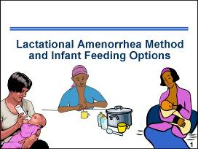 | ___________________________________  ___________________________________  ___________________________________  ___________________________________  ___________________________________  ___________________________________  ___________________________________
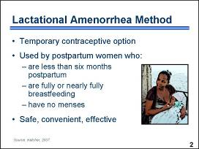 | ___________________________________  ___________________________________  ___________________________________  ___________________________________  ___________________________________  ___________________________________  ___________________________________
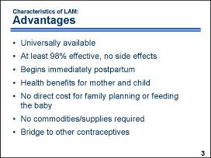 | ___________________________________  ___________________________________  ___________________________________  ___________________________________  ___________________________________  ___________________________________  ___________________________________
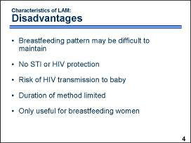 | ___________________________________  ___________________________________  ___________________________________  ___________________________________  ___________________________________  ___________________________________  ___________________________________
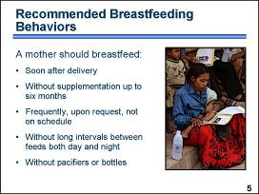 | ___________________________________  ___________________________________  ___________________________________  ___________________________________  ___________________________________  ___________________________________  ___________________________________
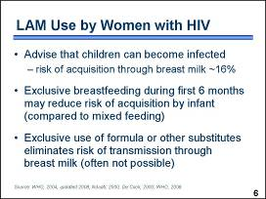 | ___________________________________  ___________________________________  ___________________________________  ___________________________________  ___________________________________  ___________________________________  ___________________________________
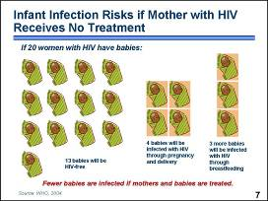 | ___________________________________  ___________________________________  ___________________________________  ___________________________________  ___________________________________  ___________________________________  ___________________________________
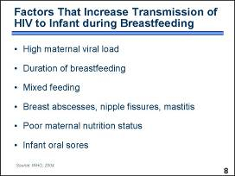 | ___________________________________  ___________________________________  ___________________________________  ___________________________________  ___________________________________  ___________________________________  ___________________________________
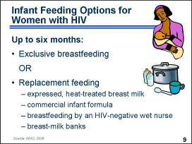 | ___________________________________  ___________________________________  ___________________________________  ___________________________________  ___________________________________  ___________________________________  ___________________________________
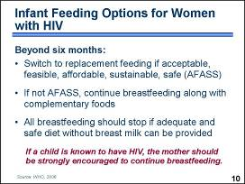 | ___________________________________  ___________________________________  ___________________________________  ___________________________________  ___________________________________  ___________________________________  ___________________________________
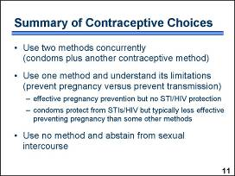 | ___________________________________  ___________________________________  ___________________________________  ___________________________________  ___________________________________  ___________________________________  ___________________________________

SESSION 10: Integrating FP into HIV Services for Provision of Contraceptive Information, Counseling, and Methods
To make the process of integration manageable and practical, consider the range of levels for integrating FP into HIV services. FP services that are integrated with HIV care and treatment services need to be appropriate to the setting and resources. Facilities and programs can aim for a progressive range of integrated services, depending on their capabilities and resources.
The chart below is a program model of five possible levels for integrating FP with HIV services. These levels of integrated services can be offered through mobile service mechanisms, and Levels A through C can be offered by community- or home-based personnel. Refer to the source document for detailed descriptions of service cadres and tasks for each integration level.
Level A | Level B | Level C | Level D | Level E
Provides all of the following functions:  Provides FP information to clients accessing ART, PMTCT, STI, VCT, and tuberculosis services.  Performs risk/intention assessment for pregnancy or spacing.  Counsels on FP methods, methods’ ability to prevent STI and HIV infection, method choices available and where to access, dual protection, and potential drug interactions with hormonal methods.  Provides condoms, instructs for and demonstrates correct use.  Provides emergency contraceptive pills.*  Refers for other methods not offered on-site. | Provides all Level A functions plus:  Provides oral contraceptives* with instructions for use.  Provides follow-up or refers for follow-up.  Counsels on potential drug interactions  with oral contraceptives. | Provides all Level B functions plus:  Provides injectable contraception, with instructions for use, and with caution to return on schedule for reinjection without delay.  Provides follow-up or refers for follow-up. | Provides all Level C functions plus:  Provides intrauterine device (IUD), with instructions for use.  Provides implant, with instructions for use.  Provides follow-up or refers for follow-up. | Provides all Level D functions plus:  Provides surgical contraceptive methods, with instructions for self-care, and provides follow-up.
* If facilities or programs providing Level A functions are not immediately prepared to provide oral contraceptives for ongoing users, they may provide emergency contraceptive pills with referral for ongoing FP management. If the facility or program already provides oral contraceptives (Level B), it can also offer emergency contraceptive pills.
Source: Farrell BL. Family Planning – Integrated HIV Services: A Framework for Integrating Family Planning and Antiretroviral Therapy Services. New York: EngenderHealth, 2007.
Examples of FP Integration with RH Services
The table below contains suggestions for how FP can be integrated into existing RH services.
During any and every client encounter, consider the client’s risk for unintended pregnancy, STI, HIV, and other preventable infections and problems that negatively impact maternal and child health.
HIV services (e.g., VCT, ART):
- Include assessment of client’s fertility desires in VCT activities.
- Provide information about FP and its role in protecting against sexual transmission of HIV, against mother-to-child transmission of HIV, and in supporting effective ART.
- Promote dual protection.
- Provide information on locations for FP services.
- Provide FP methods to the capacity of the sites.
- Facilitate referrals for FP services (e.g., long-acting and permanent methods).
- Assess FP use or continuation during ART.
- Counsel clients on ways to ensure contraceptive effectiveness in the presence of possible drug interactions.
- Inform clients on option and availability of emergency contraception.
Management of Opportunistic Infections (OIs):
- Include assessment of FP method use for developing the treatment plan for OIs.
- Counsel clients on ways to ensure contraceptive effectiveness in the presence of possible drug interactions.
- Provide referral or FP counseling and method if client does not desire a pregnancy.
Postabortion Care:
- Establish staff presence, skill, and availability to provide FP counseling, method provision, and referral before discharge from postabortion care.
- Include dual-protection counseling in client counseling.
- Explore client’s risk for STIs and HIV during FP counseling, to appropriately refer for VCT as a preventive measure against HIV infection and to prevent MTCT in a subsequent pregnancy.
Antenatal Care (e.g., PMTCT, malaria prevention, and management):
- Promote VCT to plan for positive maternal and child health outcomes in the presence of HIV infection, in the context of informed choice.
- Promote VCT to develop strategies for HIV-negative women to remain uninfected.
- Promote benefits of spacing pregnancies for maternal and child health.
- Counsel on methods available immediately postpartum (lactational amenorrhea method, IUD, condoms, voluntary sterilization).
- Maintain follow-up through FP or child health services for women to continue with their postpartum method or access another ongoing method (e.g., transition from the lactational amenorrhea method to another FP method).
- Teach newly delivered women correct techniques of breastfeeding to maintain intact nipples (and thus prevent HIV transmission through broken skin and blood) and stimulate an adequate supply of breast milk.
- Provide condoms for use during the antenatal and postnatal period.
- Provide informed consent counseling for immediate postpartum tubal occlusion and postpartum IUD, where available.
- Assess risk of malaria and counsel about risk during pregnancy with or without HIV;
counsel to develop prevention strategies and treat aggressively to prevent anemia.
Postnatal Services (e.g., immediately, at 2 weeks, and at 4 to 6 weeks):
- Provide postnatal FP counseling and provision of methods that support exclusive breastfeeding.
- Provide immediate postpartum tubal ligation.
- Provide immediate postpartum IUD.
- Provide postnatal FP counseling and methods that do not compound anemia and do not inhibit lactation.
- Monitor client success with FP methods during the immediate postnatal period and assess client’s risk for STIs and HIV.
- Promote VCT for health and fertility management planning.
- Include dual-protection information during client counseling.
Fistula Services:
- Include assessment of the client’s fertility desires in postoperative fistula repair counseling, as well as at discharge and during follow-up.
- Provide FP counseling to assist the client or couple to achieve fertility desires, including dual-protection information and information on the necessity to abstain from sexual intercourse for three months postoperatively.
- Provide the client’s chosen method, including condoms, where appropriate and accepted (or facilitate referrals for FP methods not available at the fistula repair facility).
- Monitor the client’s success with FP methods during the fistula rehabilitation period.
- Facilitate referrals for FP methods not available at fistula repair sites.
- Incorporate FP information during fistula-prevention outreach activities, include when referring to FP services facilities (public or private) and community-based providers.
- Include information to clients on emergency contraception during fistula-prevention outreach activities.
Child Health Services (e.g., nutrition, immunization, prevention and management of childhood infections):
- Assess the client’s exclusive breastfeeding practices.
- Assess the client’s risk of HIV infection to prevent MTCT.
- Assess the client’s fertility desires (spacing, limiting, ending).
- Include dual-protection information during FP assessment and counseling.
- Assess the client’s needs to transition to another method of FP when the criteria for use of LAM no longer exist or when indicated by the client’s desire.
- Provide FP counseling and methods or referral for FP methods during client encounters for child health services.
Source: Farrell BL. Family Planning – Integrated HIV Services: A Framework for Integrating Family Planning and Antiretroviral Therapy Services. New York: EngenderHealth, 2007.

FP/HIV Service Integration – Client Contact Opportunities
Instructions: Examine the sample map and read the explanation below and then develop (on a separate sheet of paper) a map that reflects the client contact opportunities in the community or facility where you work. The map is an abstract representation (rather than floor plan of the facility) that depicts a “client’s path” through various health care settings and specific locations where services are provided at each facility. After completing the map showing points of contact with a typical client, identify where family planning (or HIV-related messages, depending on the current focus of the services offered) can be incorporated into a client’s visit. Depending on the setting, points of contact may include group talks; reception; individual and couple counseling; history-taking; testing; follow-up appointments; or community outreach as part of PMTCT, VCT, FP, ART services – any contact with clients.
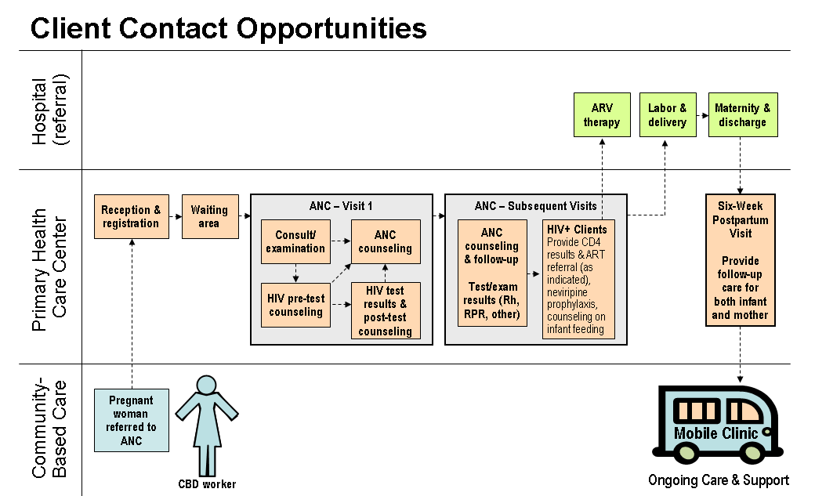
Consider your current role in interacting with clients at these points of contact and how your role will change as you begin offering integrated services. Be creative as you develop your map and consider discussions that you may have had with your supervisor and colleagues about changes that are occurring as a result of integrating services (e.g., new or reassigned staff, expanded services, revised job descriptions, or changes in client flow and the location of specific services).
There are a number of opportunities where family planning can be integrated with other services for clients. In the example depicted above, the client may receive encouragement from a CBD worker to seek care at the primary health care (PHC) center to confirm her pregnancy or acquire contraception if not pregnant and desiring to postpone pregnancy. At the PHC center, the receptionist can provide information about the services offered, and a sign describing the services can be posted on the wall. The waiting area can include brochures and posters that describe healthy behaviors, contraceptive options, and other information of interest to clients. This area may also be a place where providers give group health talks or show videos about topics of interest.
The antenatal care (ANC) visit gives providers an opportunity to provide information tailored to the individual’s primary reason for coming to the facility but can also be an opportunity to query clients about secondary RH issues that may also be of concern to them. Although a pregnant woman has no need for contraception, she can be considering what contraceptive method she would like to use after delivery to ensure that her next pregnancy is spaced as desired. Counseling about this can occur during any ANC visit. Women seeking care for incomplete abortion should also receive counseling and the method of their choice.
For any client interested in family planning, including those with HIV, ensure that the client is prepared to make a fully informed decision about a contraceptive method (use flip charts and brochures to share information) and that the client is medically eligible to use her chosen method (use eligibility checklists). Be sure to note the client’s RH decisions or method choices in the client’s chart or record – this is especially important for women who plan to initiate a method immediately postpartum (e.g., LAM, IUD, female sterilization). Clients who are referred for ARV therapy should be encouraged to share their decisions about contraceptive methods with their ARV providers.
Labor and delivery generally do not a present a good opportunity for sharing information that is not directly related to the birth (unless the woman has previously made a decision about immediate postpartum IUD insertion or female sterilization during a caesarian section). However, the maternity ward provides an opportunity to counsel a woman about contraceptive options and to ensure that she leaves the hospital with her method of choice. The six-week postpartum visit at the PHC center presents another opportunity to reach women with messages about the importance of contraception for maintaining their health and that of their infants. At six-weeks postpartum, women can initiate most contraceptive methods (except those that contain estrogen if they are breastfeeding). A mobile clinic or other community-based program can provide easy access to contraceptive resupply and ongoing support for contraceptive continuation and uptake.
Sexual Activity, Pregnancy, and Contraception –
Raising the Subject with HIV-positive Clients during Counseling
HIV-positive women and men have the same sexual thoughts, desires, and feelings as people their own age who do not have HIV. Some have an overwhelming desire to have children. Many however, are confused, ashamed and afraid of these feelings.
They have heard about the risks of transmitting HIV infection to others, but they still have strong desires and needs to have sexual relations. They have heard about the importance of disclosing their HIV status to their partners, but may feel unable to do so. Moreover, they assume that health providers expect that all people with HIV should avoid sexual relations completely, regardless of their circumstances, and that they certainly should never get pregnant.
As a result, men and women with HIV are often reluctant to raise issues concerning sexual activity, pregnancy, and contraception with health providers, even though they want to discuss these issues. It is therefore important that health providers raise these topics with their HIV-positive clients regardless of their age, marital status, ethnicity, sex, religion, race, educational level, or sexual orientation.
Informed and voluntary choice is the foundation of effective sexual and reproductive health counseling. Well-informed clients, who voluntarily make knowledgeable decisions, from a range of possible options, are more likely to be satisfied.
Talking about these subjects is challenging for health providers, too. Health providers must:
- be knowledgeable of the medical and social issues involved.
- acknowledge that they may not but are willing to try to understand how their clients are thinking and feeling.
- provide factual, unbiased, and complete information that allow their clients to make free, informed choices.
- remain non-judgmental while treading the fine line of not condoning or re-enforcing behaviors that may put others unknowingly at risk of HIV infection.
Not surprisingly, it is often difficult for providers to ask personal, sensitive questions. The guidelines included on the next few pages may help facilitate these interactions.

Counseling Clients with HIV about Pregnancy
Providers who counsel clients with HIV who are considering pregnancy should explain that pregnancy does not appear to accelerate HIV progression, even among women not receiving antiretroviral therapy. Although pregnant women do not need contraception, condom use should be encouraged to prevent the transmission of HIV and other STIs between partners. For discordant couples where the male partner is positive, it is also very important to continue using condoms during pregnancy. Although evidence is inconsistent, one large study demonstrates that pregnant women may have higher risk of HIV acquisition.
Providers should also emphasize the risk of transmitting HIV from mother to child. Rates of mother-to-child HIV transmission range from 15 percent to over 40 percent in the absence of antiretroviral treatment. Providers should advise that ARV treatment around the time of delivery can substantially reduce HIV transmission risks during childbirth and immediately postpartum.
Other issues the provider should address during counseling include:
- infection with malaria during pregnancy may increase the risk of HIV transmission to the infant and also lead to miscarriage.
- the fact that artificial feeding or exclusive breastfeeding for the first six months can reduce postpartum HIV transmission to the child. However, it is important to keep in mind that while artificial feeding can reduce HIV transmission, it increases the risk of the infant dying from other infectious diseases, particularly in the first two months of life.
- the implications of rearing a HIV-positive child, including the course of the child’s infection and likelihood of premature death.
- the need to consider whether family members will be available to raise children if the mother dies of AIDS, as may happen without treatment.
- where to go for care and treatment during and after pregnancy.

Safer Ways to Achieve Pregnancy for Clients with HIV
Even in low-resource settings, there are a number of steps that a discordant couple can take to avoid HIV acquisition and transmission while trying to achieve pregnancy. When counseling discordant couples who desire pregnancy, encourage them to:
- Avoid trying to achieve pregnancy if viral load is high; there are two periods when high viral load is typical – during early HIV infection and among people with AIDS who are not receiving ARV treatment – although an individual’s viral load can be high at other times as well.
- Consider artificial insemination in cases where the male partner is not infected.
- In cases where the female partner is not infected, limit unprotected sex to the time during the woman’s menstrual cycle when she is ovulating and most likely to conceive. It is also very important to continue using condoms after conception to avoid contracting HIV during the time the woman is pregnant and breastfeeding. This is because when a person is newly infected with HIV, the viral load is very high and the risk of transmitting HIV is increased. Therefore, if a woman acquires HIV while pregnant or breastfeeding, the likelihood of transmitting HIV infection to the infant is greater.

Counseling Clients with HIV about Contraception
When counseling women with HIV about their contraceptive options, providers should consider the client’s medical eligibility for particular contraceptive methods and:
- Provide an overview of method characteristics, including possible side effects and complications of available contraceptive methods.
- Discuss the effectiveness of available contraceptive methods and how effectiveness may be affected by a client’s ability to use a method correctly, such as remembering to take a pill daily. Because unintended pregnancy often presents greater challenges for women with HIV, they may want to choose a client-independent method.
- Help women who plan to use hormonal contraception consider the implications of possible interactions between contraceptive hormones and ARV drugs. For women taking particular ARV drugs, these interactions include the potential for reduced contraceptive effectiveness or increased hormonal side effects. Also, make sure that women with HIV who are planning to use oral contraceptives are not taking the antituberculosis antibiotics, rifampicin or rifabutin. Coinfection with tuberculosis is common among patients with HIV, and these antibiotics speed up the metabolism of contraceptive hormones, reducing the effectiveness of oral contraceptives.
- Discuss the limitations of methods to prevent pregnancy and STI/HIV transmission, emphasizing that methods that are most effective in preventing pregnancy do not offer protection from HIV and other STIs.
- Emphasize the advantages of dual protection, including dual method use particularly for discordant couples and for those with multiple partners. When a client chooses one of the more effective methods for pregnancy prevention, encourage the client to also use condoms to prevent STI/HIV transmission.
- Help a client consider her partner’s willingness to use condoms, discuss possible condom negotiation strategies, and offer couples’ counseling.
- Ensure that women know when to return for regular follow-up; if they have questions, concerns, or problems with the method, and if they need resupply. In the event that a client’s chosen method cannot be provided on-site, refer the client to a facility where the method is offered.

Counseling about ARVs and Hormonal Contraception
The issues that should be addressed when a woman on ARV treatment plans to use hormonal contraception include:
- The ability to take oral contraceptive pills correctly. Because some ARV drugs decrease blood concentration of contraceptive hormones, the risk of contraceptive failure may be greater if a woman forgets to take pills.
- The need to come back for the next NET-EN injection on time. Although the next injection usually can be given as much as two weeks late, in the presence of ARV therapy it is safer to follow a strict injection schedule.
- Willingness to use condoms to ensure additional protection from pregnancy because the effectiveness of hormonal contraceptives – other than DMPA which provides a wide margin of effectiveness in each dose – may be compromised by ARV therapy. Focusing on the pregnancy prevention role of condoms may help when negotiating condom use with a partner.

Additional Counseling Topics for Clients with HIV

During counseling a provider should explore whether a client knows his or her partner’s HIV status. When a partner’s HIV status is unknown, a provider should encourage clients to bring their partners for counseling and testing or provide referrals. Knowing a partner’s HIV status is important when making decisions about whether to have a child, what contraceptive methods to use, and how best to prevent STI/HIV transmission. Health implications and prevention strategies should be discussed for situations when either one or both partners has HIV infection.

A provider should also discuss whether the client has disclosed her HIV status to her partner or family. If a woman’s status is undisclosed, counselors should help her determine whether disclosure of HIV status or use of contraceptives would pose a risk of abandonment, violence, or loss of financial support for herself and her children.

Depending on the individual situation and needs of the client, the provider should be able to offer referrals to other reproductive health services if they are not provided on-site. These services may include STI management and treatment; postpartum, postabortion, and antenatal care; and HIV care and treatment services, including ARV therapy and prophylaxis.

Providers should also discuss what family, community, social, legal, nutritional, and child health supports are available to clients. If clients are interested in these services, discuss how to access them and provide written referrals if needed.

Client-centered Counseling Framework

BEGINNING STAGE: Introductions and Exploration
- Welcome the client and introduce yourself.
- Help the client to relax and feel comfortable, assure privacy and confidentiality, and inform the client about what will be happening during the session.
- Make general inquiries of the client – primary and secondary reason(s) for coming to the facility, marital status, children, and home life.
- Explore the client’s reproductive health goals, needs and concerns, fertility intentions, sexual life, relevant medical history, social context, and circumstances.
- Assist the client in determining his or her own risk for STI/HIV acquisition or transmission, unintended pregnancy, or other reproductive health-related liabilities, as indicated.
- Determine existing knowledge and experience about the concerns raised by the client.

MIDDLE STAGE: Discussing Options and Making an Informed Decision
- Identify the RH decisions that the client needs to make.
- Provide information to facilitate informed decision-making related to the client’s concerns.
- Discuss options related to the client’s decision.
- Assist the client to make realistic decisions, including determining medical eligibility for the method of choice if contraception is desired.
- Help the client to anticipate the potential outcomes of her or his decisions.

END STAGE: Confirm Decision, Build Skills, Take Action
- Confirm the client’s decision and ensure understanding of its implications.
- Develop communication and negotiation skills for interacting with partner(s) and other family members.
- Develop skills to support the client’s decision and provide memory aids as appropriate.
- Develop a plan for carrying out decisions.
GATHER
G–greet
A–ask
T–tell
H–help
E–explain
R–return
Five As
A–assess
A–advise
A–agree
A–assist
A–arrange
REDI
R–rapport-building
E–exploration
D–decision making
I–implementing
Balanced Model
Greet
Diagnose needs
Discuss/choose
Screen
Give information
Verify comprehension
Ensure follow-up
- Refer as required to other health or community support services.

The Client-centered
Reproductive Health Counseling Framework described above has features similar to other counseling frameworks shown here.

What to Say and Do during the Various Stages of Counseling
Note: This is not a checklist – it is a guide to help you remember what actions you want to accomplish and what information you may want to elicit from clients during the various counseling stages. The questions that you ask during a counseling session will depend on the interests of the client and should be part of a relaxed, two-way exchange. Examples of possible statements and questions to facilitate exploration of a client’s sexual and RH concerns are included in italics. Practice using these examples during counseling sessions; it may help relieve the anxiety that you experience when attempting to formulate appropriate questions about sensitive issues. You may prefer to make notes during interactions with clients so that you can be sure to address all of the concerns the client raises.

BEGINNING STAGE: Introductions and Exploration
- Welcome the client and introduce yourself.
- Be polite and cordial during the initial contact; it can help establish a good rapport for the entire interaction.
- Greet the client in a culturally appropriate and respectful manner.
- Tell the client your name and your role at the facility.
Welcome to the ________ Clinic. We are very happy to serve you today.
My name is Nurse________ and I am your health care provider. What is your name? I am pleased to meet you, Mrs.__________. Mrs._______, please come with me and I will show you to the consultation room.
- Help the client to relax and feel comfortable, assure privacy and confidentiality, and inform the client about what will be happening during the session.
- Be sure that the client is physically comfortable (e.g., seated in a chair near the provider so that eye contact and information sharing are facilitated).
- Talk to the client about sensitive issues only in a private space where the conversation cannot be overheard.
- Reassure the client that everything she or he talks about will be kept confidential and private.
- Provide a general overview of the goals of the session and what the session will be like.
Please have a seat here. Are you comfortable? Before we get started, I just want to assure you that anything we discuss will be confidential. The information that you share becomes part of your medical record and will only be available to other health care workers directly involved in your care and treatment on an as-needed basis – unless you give permission to discuss your concerns or conditions with someone else, such as your husband or partner, during couple counseling. I want to do all I can to help you during our time together. What we discuss and do is up to you – I will ask you some questions to help us get started, but ultimately we want to make sure your needs are met. Initially, we will explore your needs and concerns and identify what you would like to accomplish, then we will look at your options and figure out how best to help you meet your goals. How does that sound to you?
- Make general inquiries of the client (e.g., primary and secondary reason(s) for coming to the facility, marital status, children, and home life).
- Identify the reason for the client’s visit.
Mrs. ________, please tell me why you came to the clinic – what can I help you with today?
- Ask general questions such as age, partner’s name, number of children.
Very good – I’m sure that I can assist you with <restate reason(s) for coming>. But first let me learn a little more about you so that I can respond appropriately to your needs. How old are you? Please tell me about your family. Do you have any children – what are their ages? Tell me about your partner/spouse. How are you feeling today?
- Reassure the client that she or he should feel comfortable discussing any sexual and reproductive health concerns.
I know that sexual and reproductive health issues are of concern to many of my clients, and they often do not know with whom they can talk about them. I want you to feel comfortable telling or asking me whatever is on your mind so that I can help you as much as possible.
- Explain to the client that there are some standard questions that you ask all clients. Assure the client that the questions are routine and that everyone is asked the same questions.
I am going to ask you some personal questions now. I ask these questions of all my clients, because for me to help you, I need to fully understand your situation.
- Reassure the client that the questions will have a direct bearing on the client’s health care and the decisions made during the visit. Let the client know that this information is very important because it helps you determine how to help the client to think about his or her concerns. Talk to the client about the importance of being honest and reassure the client that you are not there to judge.
It is important for me to ask you these questions so that I can help you to make decisions that are right for you. It is important that you answer the questions honestly so that we can discuss the issues fully. Do not worry about what I might think; I am not here to judge you. Remember, anything we discuss today will be completely confidential and private.
- Acknowledge that these are sensitive issues and that some questions may be asking for more information than a client feels like sharing.
If there are any particular questions you do not feel comfortable answering, please let me know.
- If a client is unwilling for any reason to discuss a particular issue, you could speak about the issue hypothetically or use other anonymous clients as examples.
I know women who are HIV-positive who have not yet disclosed their HIV status to their husbands and who continue to have sexual intercourse without using condoms. When they tell me this, I advise them to …
- If a client reveals that she or he (or a partner) has HIV, explain that having HIV does not stop one from having thoughts and desires about sex, or that one stops thinking about having children. Explain that you understand that many people with HIV continue to have sexual relations and that you support the right to plan lives and families as the client desires.
Being HIV-positive does not stop you from having exactly the same sexual feelings, desires, and thoughts about having children as other men and women of your age. I will support your rights to achieve your reproductive health goals in whatever way I can.
- Explore the client’s reproductive health goals, needs and concerns, fertility intentions, sexual life, relevant medical history, social context, and circumstances.
- Explore the client’s reproductive health goals, pregnancy history, fertility intentions, and knowledge of and use of family planning methods, including condoms. Investigate interest in short-term, long-term, or permanent contraception.
Earlier you mentioned that you and your husband have ____ children, is that your ideal family? How would you describe your ideal family? Would you like to have a child/more children?
Do you think that you might change your mind about having a child? What factors might make you change your mind?
Are you hoping to get pregnant soon or would you like to delay pregnancy? How do you feel about (another) pregnancy at this time? How does your partner feel?
Are there any questions or concerns about pregnancy that you would like to discuss? If you are hoping to become pregnant, what concerns do you have about being pregnant or trying to conceive?
If you are hoping to delay pregnancy, have you thought about using a contraceptive method? Have you used a method(s) previously?
Are you using a method now?
If you are hoping to start a method, do you have a method in mind?
If you do not have a method in mind, the answers to these questions can help you narrow down the available options:
Do you wish to have children in the future?
Are you breastfeeding an infant less than six months old?
Do you have the cooperation of your partner in family planning?
Are there any methods that you do not want to use or have not tolerated in the past?
Do you need a method that provides protection from STIs/HIV?
How do you and your partner(s) feel about using condoms?
Have you used condoms? How often do you and your partner(s) use condoms?
Have you talked with your partner(s) about using condoms? How did he or she respond?
Have you had any problems with using condoms? What problems? What did you do about them?
Do you have any questions or concerns about using condoms that you would like to discuss?
- Explore the context of the client’s sexual relationships.
- Ask about the client’s sexual relationship(s), what is the nature of the relationship(s) (including any violence or abuse), and how do they feel about it.
Are you currently in, or are you thinking about starting, a sexual relationship?
Can you tell me how you feel about your current sexual relationship?
Although you may not currently be involved in a sexual relationship, how do you feel about having one? Do you think that you might change your mind about having a sexual relationship in the future? What might make you change your mind?
Do you have any questions or concerns that you would like to discuss about your sexual relationship with your partner(s)?
What concerns do you have? Does your partner treat you the way you would like to be treated? What would you like to be different?
- Determine a client’s ability to communicate with partners about sexual activity, family planning, HIV and STIs.
How do you feel about your ability to communicate with your partner about sexual activity? – using contraceptives? – using condoms?
– seeking treatment for STIs? – disclosing HIV status?
Do you have any questions or concerns about telling people (e.g., family friends, partners) that you are HIV-positive that you would like to discuss?
What do you think would help you to feel more comfortable communicating with your partner?
- Discuss the client’s knowledge of the partner’s sexual behavior outside of the relationship.
Do you think that your partner may have other partners as well as you? Why do you think that?
- Inquire about sexual practices and safe sex.
(Note: A client will often provide a nonspecific response to these queries. However, it is important to be specific about what “sex” or “intercourse” means to the client, as it is essential for determining individual risk. Find out if sex is vaginal or anal, as well as whether the client has performed or received oral sex.)
What kinds of sexual practices do you and your partner(s) do together? How do you have sex?
How many partners do you have now? How many in the past?
How often do you engage in unprotected intercourse?
Have you heard about safe sex? What does safe sex mean to you?
If you avoid having sex, how do you feel about that? How does avoiding sex affect your relationship(s) with other people?
- Inquire about the client’s sexual pleasure and problems.
How would you describe your satisfaction with your sex life?
What sexual problems do you or your partner have?
- Explore the client’s and partner’s STI history, present symptoms, and HIV status.
Have you ever been diagnosed with or treated for a sexually transmitted disease? Do you, or have ever you had, an unusual discharge from your (penis/vagina)? Do you currently feel any itching, burning, or other discomfort?
Have you ever had an HIV test? If yes, when was the last time that you had an HIV test? What was the result of your HIV test?
What care or treatment, if any, are you currently receiving or taking for HIV? What treatment, if any, are you taking for other infections, for example, tuberculosis?
Have you told anyone else that you are HIV-positive? Whom have you told? How did it go when you told the person? How did the person react?
Have you told your sexual partner that you are HIV-positive? How did it go when you told your partner? How did your partner react?
How do you feel about not telling your partner? How is not revealing your status affecting your relationship?
- Explore the client’s overall health.
How is your health in general? Please describe any recent illness or chronic problems. As indicated, probe for: date of last menstrual period and characteristics of the bleeding cycle, smoking or other harmful behaviors, breastfeeding, current or previous illnesses
(e.g., STIs, HIV, TB, cancers, diabetes, hypertension, pain during intercourse, difficulties during pregnancy or delivery, surgeries), possible exposure and current symptoms (e.g., discharges, abnormal bleeding, feeling tired, fever, headaches), relevant test results, current medications, and nutritional status. As indicated, also probe for the partner’s pertinent history and symptoms.
- Explore the client’s current living and family situation (e.g., number of children living at home, extended family, social networks, sources of support in family and community).
Please tell me about your situation at home. How many people live in the house? Do you have enough help with childcare and household chores? Whom can you call for help if you need it?
Do you have friends in the community to talk with about personal and family problems?
- Explore other factors about the client’s circumstances that may limit her power to make decisions (e.g., financial dependence on partner(s), tensions within an extended family, fear of violence).
Do you have sufficient money to do the things that you need to do, such as provide food, medicine, and school fees? Can you describe what happens when there are not sufficient funds to cover the household’s expenses? Can you describe how you resolve disagreements with your spouse, partner, or other relatives?
- Explore the client’s current work situation.
Please describe how you feel about work. Do you find the work satisfying, challenging, or stressful? Do you feel fairly compensated for your efforts? Do you get along well with your supervisor and colleagues? Does your work schedule accommodate your other commitments?
- Assist the client in determining his or her risk for STI/HIV acquisition or transmission, unintended pregnancy, or other reproductive health-related liabilities, as indicated.
Given what we discussed about your partner(s), the sexual activities that you engage in, and your history of sexually transmitted infections – what do you feel is your level of individual risk for STI/HIV infection? – unintended pregnancy?
There are some other factors that can also contribute to your individual risk of acquiring HIV infection, including drug and alcohol abuse and exposure to contaminated blood during invasive procedures (e.g., traditional circumcision). Are any of these concerns relevant in your situation?
What concerns do you have about transmission of STI/HIV to your partner during intercourse? – fetus during pregnancy or delivery?
– or infant during breastfeeding?
Given your level of risk, would you like to consider some options to lower it, or do you find the risk acceptable?
- Determine existing knowledge and experience about the issues and concerns raised by the client.
What do you think you can do to lower your risk for STI/HIV infection?
– unintended pregnancy?
What do you know about dual protection? – safer sex and using condoms? – infant feeding? – proper nutrition during pregnancy?
– compliance with ARV therapy?
What topics do you want to learn more about?
Adapted from Sexuality and Sexual Health: On-line Mini-course. New York: EngenderHealth, 2001.
MIDDLE STAGE: Discussing Options and Making an Informed Decision
- Identify the RH decisions that the client needs to make.
- Review the issues and concerns raised by the client during the beginning stage.
- Confirm which issues and concerns the client would like to focus on during this session.
- Explain the importance of the client making her or his own decisions.
- Provide information to facilitate informed decision-making related to the client’s concerns (e.g., STI/HIV transmission and prevention of infection or re-infection, achieving or preventing pregnancy, recommendations for antenatal and postpartum care, dual protection, other topics relevant to the client’s issues).
- Explain health risks and benefits relevant to the client’s personal circumstances (e.g., STI/HIV infection or reinfection risks, pregnancy risks).
- For clients making a decision regarding a contraceptive method, provide a brief overview of the contraceptive options that match the client’s stated desires.
- Discuss the importance of condoms as the only method that protects against both pregnancy and STI/HIV infection or reinfection.
- For clients wanting to achieve pregnancy, explain how to achieve pregnancy while reducing risk to the uninfected partner; explain infant feeding options and MTCT risk; and discuss options for healthy living and other concerns expressed by the client.
- Discuss options related to the client’s decision (e.g., appropriate methods to achieve or prevent pregnancy, alternatives for achieving dual protection, strategies for preventing STIs/HIV, ARV therapy requirements, infant feeding options, other client interests).
- Make sure that the discussion centers on options that are appropriate to the client’s individual needs and desires.
- Ensure that the relevant options are presented in an unbiased manner (e.g., pros and cons of a pregnancy, benefits and side effects of ARV therapy, breastfeeding versus alterative feeding, benefits and anxieties of knowing HIV status).
- For clients making a decision regarding a contraceptive method, focus on the method of interest to the client and provide more detailed information on how to use the method, potential side effects, the method’s potential impact on sexual relations, and possible need for STI/HIV protection.
- Assist the client to make realistic decisions, including determining medical eligibility for the method of choice if contraception is desired.
  - Help the client to assess whether her or his decisions are feasible given her or his relationship(s), family life, economic situation, and medical history (e.g., using medical eligibility screening checklist for client’s method of choice).
  - Brainstorm with the client about overcoming potential barriers to her or his decisions.
- Help the client to anticipate the potential outcomes of her or his decisions.
- Assist the client to identify the possible outcomes (positive or negative) of the actions that she or he chooses to take.
- Explore with the client how a partner(s) or family member(s) may react to the actions being considered (e.g., suggesting condom use, discussing sexuality, revealing HIV status).
- Help the client to determine the incremental steps that can be taken over time to improve the likelihood of carrying the decision to completion.
- Help the client to consider other options when the client is unable to talk with a partner(s) (e.g., indirect communication or avoiding risky situations).
- Discuss the local community resources that are available to support the client (e.g., PLWA groups, mothers’ groups).

END STAGE: Confirm Decision, Build Skills, Take Action
- Confirm the client’s decision and ensure understanding of its implications.
- Confirm decision(s) the client made and reiterate the implications of the decision (i.e., acceptability of side effects, willingness to deal with partner reaction).
- Encourage the client to reflect on the decision by talking about what the decision means to her or him and describing any necessary behavior changes or reservations in her or his own words.
- Develop communication and negotiation skills for interacting with partner(s) and other family members. Refer to the Counseling Tool, page 46 for additional guidance.
- Discuss the client’s concerns about talking with partner(s) and family members about sensitive issues and offer ideas for improving communication and negotiation.
- Teach negotiation skills and discuss ways to make the client’s decision more appealing and easy to implement. For example, if a client finds it difficult to ask a partner to use condoms for STI/HIV prevention, discuss whether it might be easier to talk about condoms as a family planning method.
  - Role-play with the client possible situations that may occur up when talking about sensitive issues with a partner or family member.
- Develop skills to support the client’s decision and provide memory aids as appropriate (e.g., using condoms, contraceptive methods, ARV drugs; infant feeding techniques; ensuring safe pregnancy and delivery; and other issues related to the client’s decision).
- Ensure that the client has the basic knowledge to implement the decision. Confirm understanding by asking the client to describe the key messages, steps, or instructions for use and clarify questions raised by the client.
- If the client will be using condoms, demonstrate correct male or female condom use on penis and vagina models. Ask the client to repeat the demonstration to be sure that the client understands. Provide condoms to the client and make sure the client knows where and how to obtain more.
- If the client has selected a contraceptive method, ensure the client understands how to use the method by repeating basic information, including when to return to the clinic for resupply or problems.
- Provide the client with a brochure that includes written and illustrative “how to” information to reinforce new knowledge and skills.
- Develop a plan for carrying out decisions.
- Develop a step-by-step plan of action for the decision (e.g., obtain condoms and/or another family planning method today, talk with your partner about the decision tonight after the children are asleep, begin taking COCs every night at dinner, use condoms during sex, and obtain ARV drugs at pharmacy and follow therapy regimen).
- Identify social supports or barriers and what the client can do to use or overcome them.
- Invite the client back for a follow-up visit to provide ongoing support and encouragement.
- Refer as required to other health and community support services.
- Encourage the client to seek assistance from specialized support services – for concerns addressed during the session and any that were identified but not addressed.
- Provide a written referral and information on these services as needed.

Training Resource 10.5. Counseling Observation Checklist
Case: ____________________________ Provider: _______________________________ Client: _______________________________ Observer: _______________________________ Date: ___________________________
Overall  Establishes and maintains rapport  Shows respect and is nonjudgmental  Uses simple, clear language  Actively listens to client  Attends to client’s emotional needs  Encourages client participation  Explains what will occur during session or procedure  Ensures client understanding and corrects misunderstandings  Uses appropriate nonverbal communication (body language)  Ensures confidentiality and privacy  Offers to involve client’s partner (as appropriate)  Uses job aids appropriately (if available)  Assess Client’s Needs and Concerns  Asks about reason for visit  Asks about client’s partner(s), children, family relationships  Reviews RH goals and concerns (fertility intentions, FP, STIs)  Explores sexual behavior and risks, sexuality, physical changes  Queries pregnancy status and other pertinent medical history  Identifies areas to evaluate during physical exam (if indicated)  Provide Information and Options Related to Client’s Concerns  Advises on safer sex, STI and HIV prevention  Advises on achieving desired pregnancy as safely as possible  Advises on use of contraceptive methods and preventing pregnancy  Advises on client’s other identified issues or concerns | Yes | No | N/A | Facilitate Informed Decision-making and Problem-solving  Facilitates analysis of options in context of client’s situation  Determines if medically eligible or appropriate  Reaches agreement on decision or plan in collaboration with client  Provide Assistance to Support Client’s Decision  Helps to plan, rehearse, carry out decision  Provides contraceptive method and instructions on correct use  Reinforces correct use, including when to return  Gives instructions and demonstrates correct condom use  Corrects and reinforces demonstration of condom use by client  Gives condoms  Gives treatment, supplies, medications (as indicated)  Ensures comprehension of facts and implications  Arranges follow-up visit for supplies, health check, etc.  Offers referral to support group (if applicable)  Arranges referral to outside services (for client or partner as applicable)  Case-Specific Observations or Questions: | Yes | No | N/A

SESSION 11: Creating and Maintaining a Safe and Efficient Work Environment

Standard Precautions in Health Care Settings
The following is a summary of standard precautions for health care and home settings, offering a broad set of recommendations to help minimize the risk of exposure to infectious material, such as blood and other body fluids. Standard precautions help break the disease transmission cycle at the “mode of transmission” step and decrease the risk of infection for both clients and health care workers.

Handwashing
Wash your hands with soap and running water after contact with blood, body fluids, secretions, excretions, and contaminated items, whether you have worn gloves or not. Wash hands immediately after gloves have been removed and between client contacts to avoid transferring microorganisms among clients as well as to the environment.

Gloves
Wear gloves when coming in contact with blood, body fluids, secretions, excretions, or contaminated items. Put on clean gloves just before touching mucous membranes and non-intact skin. Change into a new, clean pair of gloves between tasks and procedures on the same client after contact with material that may contain a high concentration of microorganisms. Rinse gloved hands in 0.5 percent chlorine solution before removing gloves. Then remove gloves immediately before touching uncontaminated items and surfaces. Note: Health care staff with open lesions, cuts, weeping dermatitis, rashes, or severely chapped hands should avoid direct client contact and should not handle contaminated equipment because breaks in the skin provide points for microorganisms to enter the bloodstream and cause infection.

Eye Protection
Wear eye protection and a mask, or a face shield, to protect mucous membranes of the eyes, nose, and mouth during procedures (e.g., during delivery or cutting of the umbilical cord) and client-care activities that might produce splashes or sprays of blood, body fluids, secretions, and excretions.

Protective Clothing
Wear clean, non-sterile gowns to protect the skin and prevent the soiling of clothing during procedures and client-care activities that might produce splashes or sprays of blood, body fluids, secretions, or excretions. If feasible, use a plastic or rubber barrier (e.g., apron) to protect clothing if large amounts of soiling are anticipated (e.g., during delivery). Remove a soiled gown immediately, place it in a designated container for decontamination, and wash hands.

Instrument Processing
Process used instruments consistent with accepted infection-prevention guidelines for decontamination, cleaning, high-level disinfection, or sterilization. Make sure that a reusable instrument is not used on another client until it has been appropriately processed.

Handling Sharps
Handle sharps with care to avoid injury and reduce the risk of infection.
- Avoid recapping needles (use the one-hand capping technique if recapping is absolutely necessary).
- Do not bend, break, or cut needles after use.
- Do not remove the needle from the syringe before disposal.
- Dispose of used sharps in a puncture-resistant container that is not overly full immediately after use.
- Wear utility gloves when disposing of sharps containers.
If injured by a contaminated needle or sharp instrument, wash the area immediately with soap and water and follow your facility’s postexposure prophylaxis guidelines.

Environmental Cleanliness and Waste Disposal
Maintain environmental cleanliness and waste-disposal practices according to appropriate infection-prevention guidelines. Make sure that liquid waste is placed in a container with enough disinfecting solution to effectively kill organisms. Make sure that all contaminated waste (bloody dressings, swabs, tissues, gauze, cloths soiled with body fluids) is placed in designated and clearly marked bags or containers, collected, and taken for incineration or other safe disposal. Immediately clean surface spills of blood, body fluids, secretions, and excretions with a disinfectant solution such as 0.5 percent chlorine solution. Then clean the area with detergent and water.

Handling and Processing Linen
When handling linen soiled by blood, body fluids, secretions, or excretions, always wear gloves and place linen in designated and clearly marked bags or containers. If using a plastic bag, place linen in one bag and then place that bag inside another plastic bag (double bag). Transport soiled linen in a way that avoids puncturing the bag or losing soiled items on the way to the laundry. Launder soiled linen using detergent and germicide according to appropriate infection-prevention guidelines.

Preventing Needlestick and Sharp-Instrument Injuries
In most countries, exact data are not available on the number of needlestick and sharp instrument injuries experienced by health care workers each year. Most reported needlestick injuries involve nurses, but midwives, laboratory staff, physicians, housekeepers, and other health care workers are also injured, resulting in exposure to bloodborne organisms (e.g., hepatitis B and C viruses, or HIV). The emotional and physical impact is serious, whether or not infection is transmitted. It is far simpler and more cost-effective to prevent injuries from sharp instruments than it is to manage the emotional and financial costs of trauma to the worker and her or his partner, such as extensive counseling, drugs (if available), and follow-up monitoring. Injuries by sharp instruments can be prevented. To better understand how to prevent these injuries, it is important to understand how they occur.

How Injuries with Needles and Other Sharps Commonly Occur
Injuries by needles and sharp instruments occur in many circumstances including when:
- Suture needles or other items are manipulated by hand (e.g., when a suture needle is repositioned in a needle holder or a scalpel is mounted on a scalpel holder)
- Instruments are dismantled after use
- Needles or sharps are placed into disposal containers that are full or do not allow for easy insertion of the item
- Needles are removed from IV tubing ports
- Needles are recapped, bent, cut, or broken after use
- Blood is transferred from a syringe into a test tube
- Fingers are used as a guide by surgeons or surgical assistants
- Tissue is hand-held during suturing or sutures are tied with the needle still attached
- Needles are left exposed on needle holders
- A scalpel or other sharp instrument is handed from the user to an assistant or from the assistant to the user

Injury-Prevention Strategies
There are many strategies that can be used to reduce the risk of injury during health care services.

Needles
- Let the client know when you are going to give an injection to avoid startling the client and causing an injury.
- Avoid capping needles after use. Use the one-hand capping method if recapping is absolutely necessary. Do not bend, break, cut, or remove needles from syringes after use.
- Dispose of used needles immediately in a puncture-resistant container.
- Place sharps disposal containers close to work areas so that staff do not have to cross the room or leave the area to find one.
- Burn or bury the container when it is three-quarters full.
- When transferring blood from a syringe into a test tube, place the test tube in a holder and insert the needle into the test tube using one hand.
- Promote safety awareness during in-service trainings, focusing on behavior change to prevent or minimize needlestick and sharp-instrument injuries.

Scalpels and Other Sharps
- Manipulate or reposition scalpel blades and suture needles using forceps rather than your fingers to grasp the blade or needle.
- Consider using staples rather than sutures and suture needles, if it would be an appropriate option.
- Use curved needles with a needle holder as a safer option to straight, hand-held needles.
- Blunt instruments, such as rounded-point scissors, non-penetrating towel clips, blunt retractors, and synthetic sutures instead of wire sutures, can be an alternative for preventing injuries.
- When transferring sharps between personnel, avoid hand-to-hand transfer. Create a safety zone using a flat tray, mat, part of the instrument stand, or designated area on the field where the user can place instruments and the assistant can safely pick them up. Do not use a kidney basin, because it can be hard to pick up items from inside the basin.

Team Efforts for Prevention of Injuries
- When moving, communicate verbally with those around you to prevent collisions between hand or body and sharps.
- During surgical procedures, announce the transfer of sharps to avoid injury. For example, always say “needle back” or “sharp back” when passing these instruments to the safety zone.
- Avoid reflex sponging of tissue unanticipated by the surgeon when a sharp is in use.
- Keep hands away from the incision during cutting and suturing.
- Avoid manual retraction; use retractors whenever possible.
- Maintain a well-lit surgical field to facilitate visibility of sharp items and instruments.
- Keep an eye on all sharps in use until they are returned to the safety zone and removed from the field. Meet as a team to analyze patterns of injury and to develop strategies for their prevention.
Keep in mind that along with protecting providers and clients, injury-prevention strategies protect housekeeping, maintenance, and other staff working in health care facilities.
Source: Reducing Stigma and Discrimination Related to HIV and AIDS, Participant’s Handbook. New York: EngenderHealth, 2004. For more detailed information about infection prevention practices, refer to: Infection Prevention: A Reference Booklet for Health Care Providers. New York: EngenderHealth, 2001.

Postexposure Care and Prophylaxis for Injured Health Care Staff
The risk of becoming infected with HIV following a needlestick or sharp-instrument injury when the source is known to be infected with HIV averages 1 in 300. Most injuries do not result in infection. The risk of becoming infected with HIV after mucous membrane or non-intact skin has been exposed is about 1 in 1,000.
The risk of infection with HIV after an occupational exposure is related to:
• The amount of blood on the needle or device
• The depth of the injury
• Whether the needle or device was placed directly in a patient’s artery or vein
• The infectious status of the source person
Following an injury with a contaminated needle or sharp instrument, or a mucous membrane exposure, immediate action should be taken to reduce the risk of infection.
WHO, UNAIDS, and the U.S. Centers for Disease Control and Prevention recommend postexposure prophylaxis (PEP) for health care workers exposed to blood and other body fluids that may be contaminated with HIV – where antiretroviral drugs are available – if it is determined that the risk of infection is significant. Treatment is not recommended after every occupational exposure because most exposures do not result in infection and the side effects of the treatment may be serious.
Estimated Risk of HIV Transmission Following Different Types of Exposure
Type of Exposure | Estimated Risk
Needlestick or sharp- instrument injury | 0.3%
Mucous membrane or non-intact skin | 0.1%
Needle-sharing exposure with an infected source | 0.67%
Receptive anal intercourse with an infected source | 0.5 – 3.0%
Receptive vaginal intercourse with an infected source | 0.1%
Insertive anal intercourse with an infected source | 0.065%
Insertive vaginal intercourse with an infected source | 0.05%
Oral sex with ejaculation with an infected source | <0.05%  Conflicting data; risk is considered extremely low
Bell DM. Occupational risk of human immunodeficiency virus infection in healthcare workers: an overview. Am J Med 1997;102(5B):9-15.
Mayer KH, Anderson DJ. Heterosexual HIV transmission. Infect Agents Dis 1995;4:273-84.
Postexposure care should be guided by local policies and is dependent on the availability of counseling, HIV testing, and ARV drugs. But generally, taking a triple ARV drug regimen significantly lowers the risk of acquiring infection. However, health care workers have become HIV-positive following occupational exposure even though they received postexposure prophylaxis.
    - Immediately following possible exposure:
      - Flush the injured area with running water and wash with soap and water. There is no evidence that squeezing the wound decreases the risk of transmitting bloodborne organisms.
      - If a mucous membrane has been injured or splashed – such as the eyes, nose, or mouth – flush with a large amount of clean water, saline, or sterile irrigation solution. Also, remove any clothing or other items that may have been contaminated.
      - In the absence of water, an antiseptic solution can be used to flush the area (with the exception of the eyes, nose, and mouth), although antiseptic solutions have not been proven to be any more effective than soap and water. Do not apply any caustic agents (e.g., bleach) because it may cause inflammation and potentially facilitate the entry of HIV.
    - Assess the injured health worker’s risk for infection following exposure.
If feasible, determine the HIV status of the source patient following appropriate counseling and informed consent (see Testing the Source Patient and Related Issues, next page). This is particularly important in settings with limited resources, where antiretroviral drugs may not be readily available. Determining that the source patient is HIV-negative will eliminate the need for drug therapy, its attendant side effects, and costs, and the emotional stress of not knowing either the risk posed by the exposure or whether the drug therapy will work.
The risk of infection following occupational exposure is increased when:
- The needle or instrument is visibly contaminated with blood
- The needle was used directly in an artery or vein before the injury occurred
- The injury is deep
- The source patient has very advanced AIDS
    - If, following counseling, the injured worker decides to undergo postexposure prophylaxis:
      - Draw blood for a baseline HIV-antibody test as soon as possible.
      - Start multi-drug treatment as soon as possible, within one to two hours or at most 24 hours after the injury, and continue for four weeks from the day of exposure.
      - Review possible side effects associated with the drugs.
      - Instruct the health care worker to report sudden or severe flu-like symptoms, including fever, rash, muscle aches, tiredness, malaise, or swollen glands, as they may indicate HIV infection, drug reaction, or other medical conditions.
      - Give information about behaviors to prevent transmission of HIV, such as not donating blood, semen, organs, or tissue and practicing safer sex. Also, in settings where breast milk substitutes are affordable and accessible, and can be used safely, nursing women may be advised to avoid breastfeeding until their status is known.
      - Provide counseling to address the injured worker’s emotional response, fears, and concerns about the reactions of her or his partner or spouse.
    - Follow-up care for those undergoing postexposure prophylaxis should include:
      - Periodic HIV testing for up to six months after exposure (e.g., at six weeks, 12 weeks, and six months)
      - Routine monitoring for toxicity with complete blood count, kidney, and liver-function tests
      - Ongoing counseling and support as needed; often the emotional toll following occupational exposure is substantial

Special Considerations for Pregnant Women
A pregnant health care worker who becomes occupationally exposed to HIV must be given full information about what the injury means to her and her baby, and the known and unknown potential risks and benefits to her and her baby associated with the use of antiretroviral drugs. Counseling sessions with the pregnant health care worker should include discussions about:
- The potential risk for HIV transmission based on the type of exposure
- Risk relative to the stage of pregnancy (the first trimester is the period of maximal risk)
- What is known about how prophylactic drugs work in the body, their safety, and tolerability
Studies are under way to determine the safety of various ARV drugs during pregnancy. However, at this time, efavirenz is the only drug that should be avoided in the first trimester due to concerns that it may induce birth defects; use after the second trimester of pregnancy can be considered if other alternatives are not available.
Postexposure care should not be withheld for exposed health care staff because they are pregnant.
Testing the Source Patient and Related Issues
When the HIV status of the source patient is not known, this person must be informed about the accident in order to obtain consent to test for HIV. Confidentiality of the results is an important quality of care element and must be maintained. The source patient has the right to refuse testing.
If the person refuses or consent is not possible (e.g., the patient is unconscious), prophylaxis should be considered if there are indications of possible infection (e.g., high prevalence of infection among patients in the institution or suspicion of a risk factor in the source patient). When the HIV status is unknown and a decision about initiating PEP must be made, assume that the source patient is infected if the exposure occurs in a country with a high prevalence of HIV.

Postexposure Care Recommendations for Facilities
- Have in place or create a mechanism for reporting workplace injuries to facility authorities, noting the type of exposure and the actions taken. If completion of accident forms is required, complete and submit them to the appropriate authorities. Accident forms should include information about how the incident occurred, who witnessed the incident, and the name of the source patient if known.
- Provide written guidelines for health care supervisors and staff regarding recommended immediate care, HIV risk assessment, voluntary counseling, HIV testing, prophylaxis, and follow-up, based on international standards for accidental exposure to blood and other body fluids. Periodically review policies for consistency with international standards.
- Provide in-service training of all health care staff on prevention and management of occupational exposure to blood and other body fluids.
- Establish a system to manage postexposure care at all hours, with access to counseling and available antiretroviral drugs.

Sources:
Reducing Stigma and Discrimination Related to HIV and AIDS, Participant’s Handbook. New York: EngenderHealth, 2004.
U.S. Centers for Disease Control and Prevention. Updated U.S. Public Health Service guidelines for the management of occupational exposures to HIV and recommendations for postexposure prophylaxis. MMWR 2005;54(RR9).
U.S. Centers for Disease Control and Prevention. Updated U.S. Public Health Service guidelines for the management of occupational exposures to HBV, HCV, and HIV and recommendations for postexposure prophylaxis. MMWR 2001;50(RR11).
Sherer R, Agins B, Teter C. Chapter 11: Postexposure prophylaxis. In Bartlett J, Cheever L, Johnson M, Paauw D, eds.
A guide to Primary Care of People with HIV/AIDS 2004 Edition. Washington, DC: U.S. Department of Health and Human Services, Health Resources and Services Administration, HIV/AIDS Bureau, 2004.
Public Health Service Task Force. Recommendations for Use of Antiretroviral Drugs in Pregnant HIV-Infected Women for Maternal Health and Interventions to Reduce Perinatal HIV Transmission in the United States. November 2, 2007.

Recognizing and Coping with Stress in Health Care Settings
Counseling and treating clients with HIV is difficult and produces many emotions. Emotional factors can influence how a counselor performs her or his job. Providers must effectively cope with emotional issues to perform their jobs and maintain a commitment to their workplace. In the course of their work, a provider may experience some of the following emotions:

Confusion
• Being unsure of what to do or how to act with a client
• Being too involved with the life and problems of a client
• Confusing one’s feelings with those of a client
• Feeling a conflict between the desire to help and the fear of acquiring HIV

Fatigue
Positive experiences –
hold on to and value them.
Negative experiences –
uncover and manage them.
• Becoming physically and emotionally tired
• Needing to relax and to have a way of recovering strength

Exhaustion
• Becoming chronically weary
• Losing empathy for clients and the joy of work

Impatience and frustration
• With a client who has difficulty understanding
• With a client who has difficulty expressing herself or himself
• With a client who disagrees with you or the institution
• With a client whose attitudes or behavior bother you
• With the work environment, coworkers, or management
• With a health system that does not have adequate resources to help people

Anger
• Frustration leading to anger
• Feeling so angry that you no longer want or are able to go on (unconsciously or not)

Impotence
• Not knowing how to help a client when her or his needs go beyond the institutional or professional resources available
Develop creative ways to restore strength and enthusiasm
• Sharing a client’s despair about the incurability of HIV

Boredom
• Work becomes routine and the mystique surrounding it is gone

Burnout
• The emotional toll of listening to clients’ problems becomes distressing, overwhelming, or depressing

Ambivalence
• Feelings conflict – you may sympathize but avoid expressing feelings or making a commitment

Competition or envy
• Differences in power or status among medical staff, community health agents, or aides generate struggles or friction; work and clients suffer as a result

Stress and pressure are provoked by
• Working with a disease that carries a stigma due to religious, cultural, or social norms
• Overwork, the demands of a challenging job, or the negative attitudes of coworkers
• Difficulty in communicating about sexuality and the social consequences of breaking taboos

Fear of contracting the HIV virus
• Fear of contracting HIV from clients with HIV generates anxiety in general and uneasiness around patients in particular

Positive feelings and emotions
• A counselor may have positive experiences, such as reaching goals and earning appreciation from the client, but if such successes are accompanied by a heavy workload and a lack of recognition by management, their positive impact is diminished

Source: Trainer’s Guide in Sexual Health, Section 1, Exercise 5. New York: IPPF/WHR, 2002.
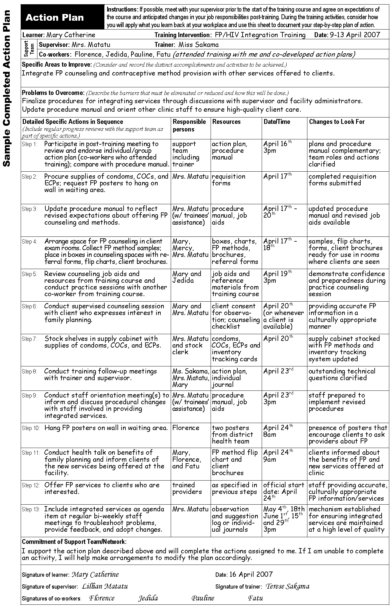

Adapted from: Transfer of Learning: A Guide to Strengthening the Performance of Health Care Providers, IntraHealth, 2002.
FACT SHEET 1. Male and Female Condoms
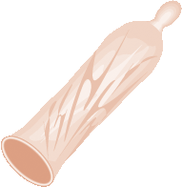
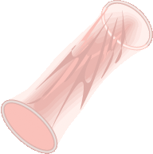
The male condom is a thin sheath usually made of rubber (latex) that is placed on an erect penis before intercourse.
The female condom is a thin, soft, loose-fitting plastic (polyurethane) pouch that lines the vagina. It has two flexible rings: an inner ring at the closed end, used to insert the device inside the vagina and to hold it in place, and an outer ring which remains outside the vagina and covers the external genitalia. Because the device is made from polyurethane, the female condom can be used with any type of lubricant (water- or oil-based) without compromising the integrity of the device.
Condoms are the only method of contraception that also provide protection from sexually transmitted infections (STIs), including HIV.

Mechanisms of action
Condoms serve as a physical barrier, preventing sperm from entering the female reproductive tract. They also serve as a barrier for infectious microorganisms, preventing transmission of STIs/HIV from one sexual partner to another.

Characteristics of condoms (includes both male and female condoms)
- Safe
- Prevent both pregnancy and STIs/HIV (when used consistently and correctly)
- Not as effective for pregnancy prevention as other methods in typical use
- Easy to initiate and discontinue
- Require motivation to use consistently and correctly
- Require partner’s cooperation
- Immediate return to fertility
- Have virtually no side effects
- May interrupt sexual activity or reduce sexual pleasure
- Require proper storage and resupply

Additional characteristics of the female condom
- Female-controlled
- May be more comfortable to men, less decrease in sensation than with the male latex condom
- Provides additional protection to external genitalia
- Can be inserted before intercourse
- Stronger (polyurethane is 40 percent stronger than latex)

Possible side effects (generally not signs of a health problem)
- Allergic reactions to latex (in male condoms) can occur in rare cases.
- There are no known side effects with the female condom.

Who can use condoms
Women and men of any reproductive age who:
- want to use this method for STI/HIV prevention, contraception, or both.
- have no severe allergy to latex (male condom only). However, if the client is at risk of STIs/HIV, he or she may want to continue using condoms despite the allergy.

Provide follow-up and counseling for
- Correct and consistent use
- Common problems in use and how to overcome those
- Use of emergency contraception as a backup method for pregnancy prevention in case condom was not used or breaks or slips
Assess the client’s risk for STIs/HIV and discuss the need for condom use for disease prevention.

Dispelling myths regarding condoms

Condoms do not:
- make men weak or impotent
- get lost in a woman’s vagina (if they slip)

FACT SHEET 2. Combined Oral Contraceptives (COCs)

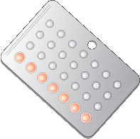
Combined oral contraceptives (COCs) are pills that are taken once per day to prevent pregnancy. They contain the hormones estrogen and progestin.

Primary mechanisms of action
    - Prevent ovulation (release of eggs from the ovaries)
    - Thicken cervical mucus (make it difficult for sperm to penetrate)

Characteristics of COCs
- Safe and very effective if used consistently and correctly
- Reversible, rapid return to fertility
- Do not interfere with intercourse
- Easy to discontinue use
- Have beneficial non-contraceptive effects (regular menstrual cycles; lighter menses; fewer menstrual cramps; protection from ectopic pregnancy, ovarian and endometrial cancer, and symptomatic pelvic inflammatory disease; may help protect against ovarian cysts and anemia; reduce symptoms of endometriosis)
- Require daily use
- Incorrect use is common (easy to miss taking a pill)
- Require resupply
- No protection against sexually transmitted infections including HIV
- Have common side effects
- Serious complications very rare

Possible side effects of COCs (generally not signs of a health problem)
- Headaches, dizziness
- Nausea
- Breakthrough bleeding or spotting
- Breast tenderness
- Mood changes
- Weight change
- Amenorrhea

Who can use COCs
Women of any parity or reproductive age who:
- want to use this method of contraception
- have no health conditions that preclude the use of COCs

Who should not use COCs (for a complete list, see WHO eligibility criteria)
Women who have the following conditions (contraindications):
- breastfeeding, during the first six weeks postpartum (also not a good method for women who want to continue breastfeeding up to six months)
- first three weeks postpartum if not breastfeeding
- age 35 or older, who smoke heavily (15 cigarettes/day or more)
- current breast cancer
- severe cirrhosis; malignant liver tumors; or benign liver tumors, with the exception of focal nodular hyperplasia (which is a tumor that consists of scar tissue and normal liver cells)
- cardiovascular conditions (i.e., high blood pressure; diabetes with vascular complications; history of or current deep venous thrombosis, stroke, or ischemic heart disease)
- migraine with aura or any migraine in women older than age 35
- taking drugs that affect liver enzymes: rifampicin or rifabutin (for tuberculosis), anticonvulsants (for epilepsy), or ritonavir (as part of an antiretroviral regimen).

COC use by women with HIV and AIDS
- Women with HIV and AIDS can use COCs without restrictions.
- Women with AIDS who take antiretroviral drugs (ARVs), other than ritonavir, can generally use COCs. (There is some evidence that ritonavir reduces the blood levels of contraceptive hormones to a much greater extent than other ARV drugs.)
- Women with HIV who choose to use COCs should be counseled about dual method use and consider using condoms in addition to COCs. In addition to preventing the spread of HIV, condoms may be especially beneficial to women on ARVs because condoms provide additional protection from pregnancy in the event that COC effectiveness is reduced by ARVs.

Provide follow-up and counseling for
- Any client concerns or questions
- Common side effects
- Correct COC use (ability to take pills on schedule, what to do when pills
are missed)
- Any signs of complications (thrombosis or thromboembolism); counsel the woman to come back immediately if any of the following symptoms develop:
  - severe chest pain or shortness of breath
  - severe headache with vision problems
  - sharp pain in leg or abdomen

Dispelling myths regarding COCs
Contraceptive pills do not:
- cause birth defects
- cause infertility
- require a “rest” period
- decrease sex drive
- build up in a woman’s body

FACT SHEET 3. Progestin-Only Injectables
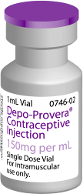
Progestin-only injectable contraceptives (e.g., Depo-Provera, Noristerat) contain no estrogen. To prevent pregnancy, a shot is given every two or three months, depending on the type of injectable.

Primary mechanisms of action
- Prevent ovulation (release of eggs from the ovaries)
- Thicken cervical mucus (make it difficult for sperm to penetrate)

Characteristics of progestin-only injectables
- Highly effective
- Easy to use
- Reversible with some delay in return to fertility (pregnancy occurs on average four months later than other modern methods)
- Do not interfere with intercourse, private
- Have no affect on quality or quantity of breast milk
- Have beneficial non-contraceptive effects (protection from endometrial cancer, uterine fibroids, ectopic pregnancy, and symptomatic pelvic inflammatory disease; may reduce sickle crises in women with sickle cell anemia)
- Have common side effects
- Provide no protection from sexually transmitted infections including HIV

Possible side effects (generally not signs of a health problem)
- Irregular menstrual bleeding or spotting or heavy bleeding (more common during the first few months of use)
- Amenorrhea (common, especially after the first year of use)
- Weight gain
- Headaches and dizziness (less common than with combined oral contraceptives)
- Changes in mood and sex drive

Who can use progestin-only injectables
Women of any parity or reproductive age who:
- want to use this method of contraception
- have no contraindications

Who should not use progestin-only injectables (for a complete list, see WHO eligibility criteria)
Women who have the following conditions (contraindications):
- breastfeeding while less than six weeks postpartum
- multiple risk factors for cardiovascular disease
- blood pressure more than 160/100 mmHg
- acute deep venous thrombosis (unless on established anticoagulant therapy)
- current or history of ischemic heart disease or stroke
- unexplained vaginal bleeding (before evaluation)
- history of or current breast cancer
- diabetes with vascular complications
- severe cirrhosis; malignant liver tumors; or benign liver tumors, with the exception of focal nodular hyperplasia (which is a tumor that consists of scar tissue and normal liver cells)

Use of progestin-only injectables by women with HIV and AIDS
DPMA:
- Can be used without restrictions by women with HIV who may or may not have AIDS including those taking antiretroviral drugs (ARVs).
- Women with HIV who choose to use DMPA should be counseled about dual method use and consider using condoms in addition to DMPA to prevent transmission of HIV.
NET-EN:
- Can generally be used, however, women on ARV therapy should be encouraged to receive the next injection on time (by the end of the two-month period).
- Women with HIV who choose to use NET-EN should be counseled about dual method use and consider using condoms in addition to injectable contraceptives. In addition to preventing the spread of HIV, condoms may be especially beneficial to women on ARVs because condoms provide additional protection from pregnancy in the event that the effectiveness of the injectable is reduced by ARVs.

Provide follow-up and counseling for
- Any client concerns or questions
- Common side effects, especially irregular bleeding or spotting, or amenorrhea
- Importance of timely injection

Dispelling myths regarding progestin-only injectables
Progestin-only injectables do not:
- cause birth defects
- cause permanent infertility

FACT SHEET 4. Progestin-Only Implants

Progestin-only implants consist of hormone-filled capsules or rods that are inserted under the skin in a woman’s upper arm. The Norplant implant system is a set of six thin, flexible capsules made of silicone that is effective for five years. Jadelle was designed to deliver the same daily dose of levonorgestrel that Norplant delivers but is two rods instead of six and is effective for five years. Sinoplant is nearly identical to Jadelle but contains more levonorgestrel. Implanon – a single-rod system – continually releases a low, steady dose of the progestin etonogestrel for a period of up to three years.

Primary mechanisms of action
- Thicken cervical mucus (make it difficult for sperm to penetrate)
- Partially prevent ovulation (in about half of menstrual cycles)

Characteristics of progestin-only implants
- Highly effective
- Easy to use
- Long-acting pregnancy protection but easily reversible
- Do not interfere with intercourse, private
- Have no affect on quality or quantity of breast milk
- Have beneficial non-contraceptive effects (help prevent ectopic pregnancy and iron deficiency anemia)
- Substantially reduce the risk of ectopic pregnancy
- Have common side effects
- Insertion involves minor surgical procedure and some discomfort for a day or two
- Provider needed to initiate and discontinue use
- Provide no protection from sexually transmitted infections including HIV

Possible side effects (generally not signs of a health problem)
- Light spotting or bleeding between monthly periods
- Prolonged bleeding (less common)
- Amenorrhea
- Weight change
- Headaches, nausea, and breast tenderness (less common than with combined oral contraceptives)

Who can use progestin-only implants
Women of any parity or reproductive age who:
- want to use this method of contraception
- have no contraindications

Who should not initiate progestin-only implants (for a complete list, see WHO eligibility criteria)
Women who have the following conditions (contraindications):
- breastfeeding while less than six weeks postpartum
- acute deep venous thrombosis (unless on established anticoagulant therapy)
- unexplained vaginal bleeding (before evaluation)
- history of or current breast cancer
- severe cirrhosis; malignant liver tumors; or benign liver tumors, with the exception of focal nodular hyperplasia (which is a tumor that consists of scar tissue and normal liver cells)

Use of progestin-only implants by women with HIV and AIDS
- Women with HIV and AIDS who do not take antiretroviral drugs (ARVs) can use progestin-only implants without restrictions.
- Women with AIDS on antiretroviral drugs (ARVs) generally can use progestin-only implants but should be counseled about dual method use and consider using condoms in addition to implants. Besides preventing the spread of HIV, condoms may be especially beneficial to women on ARVs because condoms provide additional protection from pregnancy in the event that the effectiveness of the implant is reduced by ARVs.

Provide follow-up and counseling for
- Any client concerns or questions
- Common side effects, especially irregular bleeding or spotting or amenorrhea
- Any signs of complications; counsel the woman to come back immediately if any of the following symptoms develop:
  - unusually heavy or prolonged bleeding
  - severe pain in the lower abdomen (ectopic pregnancy)
  - infection at the insertion site
  - very bad headaches that start or become worse after initiation
  - unusually yellow skin or eyes
Explain to client that implants can be removed any time for any reason.

Dispelling myths regarding progestin-only implants
Progestin-only implants do not:
- break and move around within a woman’s body
- cause birth defects
- cause cancer

FACT SHEET 5. Emergency Contraceptive Pills (ECPs)
Emergency contraceptive pills (ECPs) refer to the special regimen of oral contraceptives used to prevent pregnancy after unprotected intercourse. Two common regimens of ECPs are:
- Progestin-only regimen
- Combined estrogen-progestin (Yuzpe) regimen
ECPs prevent between 75 percent and 95 percent of expected pregnancies with the progestin-only regimen being more effective than the Yuzpe regimen. ECPs should be started as soon as possible but generally not later than 120 hours after unprotected intercourse. The sooner ECPs are taken, the more effective they are (e.g., the progestin-only regimen taken within 24 hours after unprotected intercourse prevents 95 percent of expected pregnancies).

Mechanism of action of ECPs
- Prevent or delay ovulation (main mechanism)
- May also have effects after ovulation, possibly preventing fertilization
Once implantation has occurred, ECPs are no longer effective. They do not interrupt an established pregnancy and, if accidentally taken, do not pose any danger to the mother or fetus. Thus, ECPs are not abortifacients.

When to use ECPs
Emergency contraception may be considered in a number of situations when unprotected intercourse occurs. These situations include occasions when:
- No regular contraceptive method was used.
- A method was used, but failed, e.g., the condom broke or slipped during intercourse.
- A method was used incorrectly, e.g., forgetting to take contraceptive pills on time or miscalculating the safe time during the menstrual cycle when using fertility awareness-based methods.
- A woman was coerced into having sex or was raped.

How to take the progestin-only regimen

Take 2 pills containing 0.75 mg of levonorgestrel within 120 hours after unprotected intercourse.
OR

Take one pill containing 0.75 mg of levonorgestrel within 120 hours after unprotected intercourse.

Take another pill containing 0.75 mg of levonorgestrel 12 hours after the
first pill.
Where pre-packaged ECPs containing 0.75 mg of levonorgestrel are not available, the required amount of hormone for each dose could be obtained, for example, by taking 20 progestin-only pills (POPs) containing 0.0375 mg of levonorgestrel each (40 total pills).

Characteristics of ECPs
- Safe, effective, and easy to use

How to take the combination estrogen-progestin regimen (Yuzpe)
Regular combined oral contraceptive pills (COCs) can be used for this purpose. The number of COC pills taken for each dose will vary depending on the amount of hormones in each pill; however, each dose should contain at least 0.1 mg of ethinyl estradiol and 0.5 mg of levonorgestrel.
When “low-dose” COCs are used (containing 0.03 mg of ethinyl estradiol each):
- Take 4 pills within 120 hours after unprotected intercourse.
- Take another 4 pills 12 hours after the first dose.
When “high-dose” COCs are used (containing 0.05 mg of ethinyl estradiol each):
- Take 2 pills within 120 hours after unprotected intercourse.
- Take another 2 pills 12 hours after the first dose.
- Can be used at any time during the menstrual cycle
- Can be provided without a prescription
- Do not prevent sexually transmitted infections (STIs) including HIV
- Have short-term side effects
Possible side effects of ECPs (generally not signs of a health problem)
- Nausea
- Vomiting
- First menstruation after use of ECPs is likely to come a few days earlier or later than usual
Nausea and vomiting both are more common for the Yuzpe regimen than for the progestin-only regimen.

Who can use ECPs
- Any woman who does not want to become pregnant, including women with HIV and AIDS and those who take antiretroviral drugs (ARVs)
Even if the blood levels of hormones are reduced by ARVs, ECPs still should provide some level of protection from unwanted pregnancy.
There are no known contraindications for ECPs.

Provide follow-up and counseling for
- Any symptom or concern of the client
- Common side effects
- Ongoing contraception if client wants to avoid pregnancy
- Prevention of STIs and HIV

Dispelling myths regarding emergency contraceptive pills
- ECPs do not cause abortion and will not harm an established pregnancy.

FACT SHEET 6. Intrauterine Device – TCu-380A
An intrauterine device (IUD) is a small device inserted into a woman’s uterine cavity to prevent pregnancy. The IUD containing copper (TCu-380A) is the most commonly used and is effective for up to 12 years.

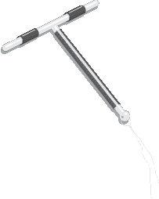
Primary mechanisms of action
Prevents fertilization by:
- impairing viability of sperm
- interfering with sperm movement

Characteristics of IUDs
- Highly effective
- No constant supplies needed
- Easy to use
- Does not interfere with intercourse
- Rapid return to fertility
- Have beneficial non-contraceptive effects (protection from endometrial cancer and ectopic pregnancy)
- Provider needed to initiate and discontinue use
- May cause minor pain or discomfort during insertion and removal procedures
- Has common side effects
- Complications are rare (i.e., pelvic inflammatory disease and uterine perforation)
- Small risk of expulsion (woman needs to check for IUD strings after menses)
- No protection against sexually transmitted infections including HIV

Possible side effects (generally not signs of a health problem)
- Pain or cramping during menses
- Prolonged and heavy menstrual bleeding
- Bleeding or spotting between monthly periods

Who can have an IUD inserted
- Women of any parity or reproductive age, including young and nulliparous women.
- Women who have no health conditions that preclude the use of an IUD.

Who should not have an IUD inserted (for a complete list, see WHO eligibility criteria)
Women who have the following conditions (contraindications):
- pregnancy
- septic infection following childbirth or abortion (if insertion is immediately postpartum or postabortion)
- unexplained vaginal bleeding (before evaluation)
- cervical, endometrial, or ovarian cancer
- current pelvic inflammatory disease
- current purulent cervicitis (gonorrhoea or chlamydia)
- malignant gestational trophoblastic disease
- known pelvic tuberculosis
- uterine fibroid or other anatomical abnormalities resulting in distortion of the uterine cavity, which is incompatible with IUD insertion

IUD use by women with HIV and AIDS
- An IUD can be provided to a woman with HIV if she has no symptoms of AIDS.
- An IUD generally should not be initiated in a woman with AIDS who is not taking antiretroviral drugs (ARVs).
- A woman who develops AIDS while using an IUD can continue to use the device.
- A woman with AIDS who is doing clinically well on ARV therapy can both initiate and continue IUD use, but follow-up may be required.
- Women with HIV who choose to use an IUD should be counseled about dual method use and consider using condoms in addition to the IUD.

Provide follow-up and counseling for
- Any client concerns or questions
- Common side effects
- Any signs of complications; counsel the woman to come back immediately if any of the following symptoms develop:
  - bleeding or severe abdominal cramping during the first three to five days after insertion (perforation)
  - irregular bleeding or pain in every cycle (possible dislocation, partial expulsion, or perforation)
  - fever and chills, unusual vaginal discharge, or low abdominal pain (possible infection)
  - missing strings (possible expulsion)
  - missing or delayed menstrual period (possible pregnancy)

Dispelling myths regarding IUDs

IUDs do not:
- migrate from the woman’s uterus to other parts of her body
- prevent a woman from having children after it is removed
- require a “rest” period (a new IUD can be inserted the same day the existing IUD is removed)

FACT SHEET 7. Female and Male Sterilization

Female sterilization is a surgical procedure where the fallopian tubes, which carry eggs from the ovaries to the uterus, are blocked (tied and cut, cauterized, or interrupted by a ring or clip). Sterilization ends fertility permanently (less than 2 percent failure over 10 years).

A vasectomy is a minor surgical procedure that permanently ends fertility in men by making a small opening in the man’s scrotum and closing off both tubes that carry sperm from his testicles.

Primary mechanisms of action
- Female sterilization: blocks the fallopian tubes to prevent sperm from uniting with an egg, thereby preventing fertilization.
- Male sterilization: interrupts the vas deferens, preventing the sperm from entering the semen, so that semen is ejaculated without sperm.

Characteristics of sterilization
- Highly effective
- Permanent
- Has no systemic side effects
- Does not interfere with intercourse
- Easy to use
- Female sterilization has beneficial non-contraceptive effects (partial protection from ovarian cancer and pelvic inflammatory disease)
- Chance of regret
- Surgical procedure (associated discomfort)
- No protection from sexually transmitted infections including HIV
- Female sterilization: high chance of ectopic pregnancy in rare case where the operation fails and the woman becomes pregnant
- Male sterilization: effectiveness is delayed by approximately three months; must use another method for the three months immediately following the procedure

Possible side effects of sterilization (generally not signs of a health problem)
- Some pain and discomfort during and immediately after the procedure
- Rare complications associated with the procedure itself

Who can use sterilization
Women and men of any reproductive age or parity who:
- are certain they do not want or must not have more children and desire permanent protection from pregnancy
- have no conditions that may require sterilization to be delayed
Who should delay sterilization (for a complete list, see WHO eligibility criteria)
Women who have the following conditions:
- pregnancy
- between seven and 42 days postpartum
- postpartum or postabortal sepsis or severe hemorrhage or genital trauma
- severe pre-eclampsia/eclampsia
- prolonged rupture of membranes (24 hours or more)
- current unexplained vaginal bleeding, suspicious for a serious condition but not yet evaluated
- acute deep venous thrombosis (unless on established anticoagulant therapy)
- current ischemic heart disease
- gynecological cancer
- current gonorrhea, chlamydia, or pelvic inflammatory disease
- current gall-bladder disease or acute viral hepatitis
- acute respiratory disease
- abdominal skin infection
- systemic infection or gastroenteritis

Men who have the following conditions:
- local infection (scrotal skin infection, active sexually transmitted infection, balanitis, epididymitis, or orchitis)
- systemic infection or gastroenteritis
- intrascrotal mass

Sterilization use by clients with HIV and AIDS
- Clients with HIV and AIDS and those on antiretroviral therapy can use sterilization unless they have acute AIDS-related illness that may require that the procedure be delayed.

Provide follow-up and counseling for
- Any client concerns or questions.
- Permanent nature of the procedure. Thorough counseling is very important as clients most likely to regret sterilization can be identified through counseling.
- Time-to-effectiveness with male sterilization. Because it takes approximately three months for sperm to clear the vas, emphasize the need to use another contraceptive method (e.g., condom) for three months after vasectomy.
- Signs of infection (follow-up one week after the procedure to check the surgical site or any time soon after the procedure if signs of infection are present).

Dispelling myths regarding sterilization

Sterilization is not:
- a castration
- associated with loss of masculinity
- associated with a decreased sex drive
- easily reversible; although reversal is possible in some cases, it is very expensive, requires a specially trained provider and, even then, the success rates are low

FACT SHEET 8. HIV and Breastfeeding

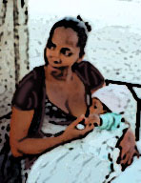
Risk of mother-to-child transmission
  - Without treatment, about a third of HIV-positive mothers pass the virus to their newborns during pregnancy, delivery, and breastfeeding.
  - In the absence of any interventions, approximately
16 percent of infants born to HIV-positive women will be infected through breastfeeding.
  - HIV transmission may continue for as long as a child is breastfed.
  - The risk of HIV transmission through breastfeeding is nearly twice as high among women who have been recently infected with HIV.
Women with HIV face the dilemma of trying to prevent HIV transmission to their infants during feeding while reducing the risk of malnutrition and other illnesses if they do not breastfeed.

Health risks for non-breastfed infants
- Not breastfeeding, compared with any breastfeeding, has been shown to expose children to an increased risk of malnutrition and life-threatening infectious diseases other than HIV, especially in the first year of life.
- Exclusive breastfeeding appears to offer greater protection against disease than any breastfeeding.
- In developing countries, as many as 54 percent of all deaths among children under the age of five are associated with malnutrition.
- In developing countries, not breastfeeding during the first two months of life is associated with a six-fold increase in mortality due to infectious diseases. This increased risk drops to two-and-a-half-fold at six months, and continues to decrease with time.

Types of infant feeding

Exclusive breastfeeding
Means the infant receives only breast milk from the mother or a wet nurse, or expressed breast milk and no other liquids or solids (with the exception of drops or syrups consisting of vitamins, mineral supplements, or medicines). A child may be exclusively breastfed with expressed human milk from the mother, a breast-milk donor, or a milk bank.
Replacement feeding
Means the process of feeding a child who is not receiving any breast milk with a diet that provides all the nutrients the child needs. During the first six months, this should be with a suitable breast-milk substitute – commercial formula or home-prepared formula with micronutrient supplements. After six months, the diet should consist of a suitable breast-milk substitute and complementary foods made from appropriately prepared and nutrient-enriched family foods, given two to three times per day. If suitable breast-milk substitutes are not available, appropriately prepared family foods should be further enriched and given five times a day.
Partial breastfeeding or mixed feeding
Means giving a baby some breastfeeds and some artificial feeds, either milk, cereal, or other food.

Breastfeeding options for women with HIV
- The most appropriate infant-feeding option for an HIV-positive mother should continue to depend on her individual circumstances, including her health status and the local situation, but should take greater consideration of the health services available and the counseling and support she is likely to receive.
- Exclusive breastfeeding is recommended for HIV-positive women for the first six months of the infant’s life unless replacement feeding is acceptable, feasible, affordable, sustainable, and safe for them and their infants before that time.
- When replacement feeding is acceptable, feasible, affordable, sustainable, and safe, avoidance of all breastfeeding by HIV-positive women is recommended.
- At six months, if replacement feeding is still not acceptable, feasible, affordable, sustainable, and safe, continuation of breastfeeding with additional complementary foods is recommended, and the mother and baby should continue to be regularly assessed. All breastfeeding should stop once a nutritionally adequate and safe diet without breast milk can be provided.
- Mixed feeding with both breast milk and other feeds has been associated with a higher risk of HIV infection for the infant than exclusive breastfeeding and should be avoided because it increases the risks of both HIV infection and the risks of diarrhea and other infectious diseases.
- In cases where an infant or young child is known to be HIV-positive, the mother should be strongly encouraged to continue breastfeeding because it has been shown to improve child survival.

To make the best choice, HIV-positive women should
- Receive counseling that includes information about both the risks and benefits of various infant-feeding options.
- Receive guidance in selecting the most suitable option for their situation.
- Have access to follow-up care and support, including family planning and nutritional support, particularly at key points when feeding decisions may be reconsidered, such as the time of early infant diagnosis and at six months of age.

Source:
UNICEF, UNAIDS, WHO, UNFPA. HIV and Infant Feeding: Guidelines for decision-makers.
Geneva: WHO, 2003.
World Health Organization (WHO). Consensus Statement – WHO HIV and Infant Feeding Technical Consultation. Held on behalf of the Inter-agency Task Team (IATT) on Prevention of HIV Infections in Pregnant Women, Mothers and their Infants, October 25-27, 2006. Geneva: WHO, 2006.
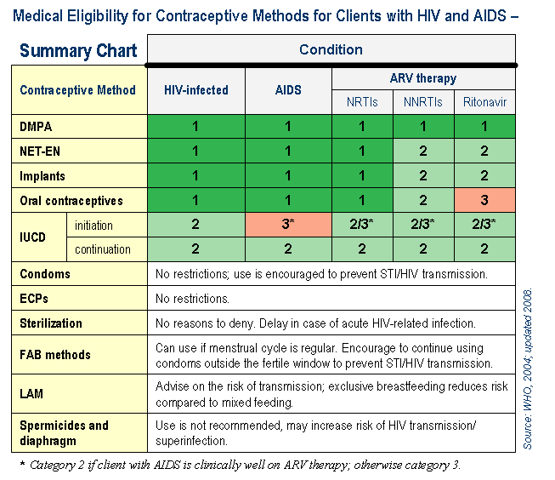

* A closed sexual relationship is one in which partners stay faithful to each other and have no other sexual partners.

